Assignment-14
To determine the FQDN the user accessed, I started by analyzing DNS traffic in the packet capture.When a user opens a browser and enters a URL, the operating system first performs a DNS resolution to convert the human-readable domain name
In wireshark i used dns as filter sorted it by time from starting
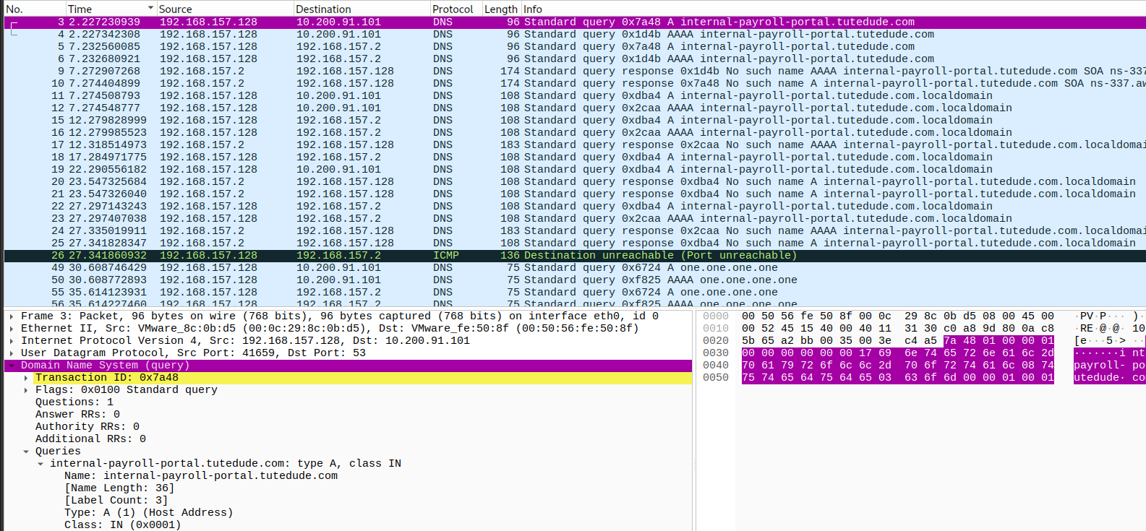
And the first one shows the domain related query that the user accessed named as internal-payroll-portal.tutedude.com
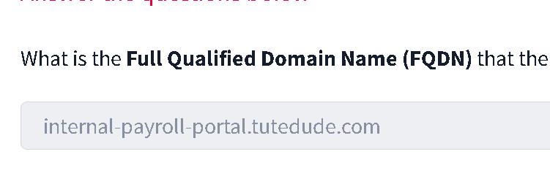
From this previous finding we find out the ip addr of the user 192.168.157.128, so to further find the shell script file that the user request would be thought the http get clause so we can enter a new filter
ip.addr == 192.168.157.128 Or if we want to further simplify it down we can ip.addr == 192.168.157.128 and http.request.method == "GET"
This will only show the request by the user
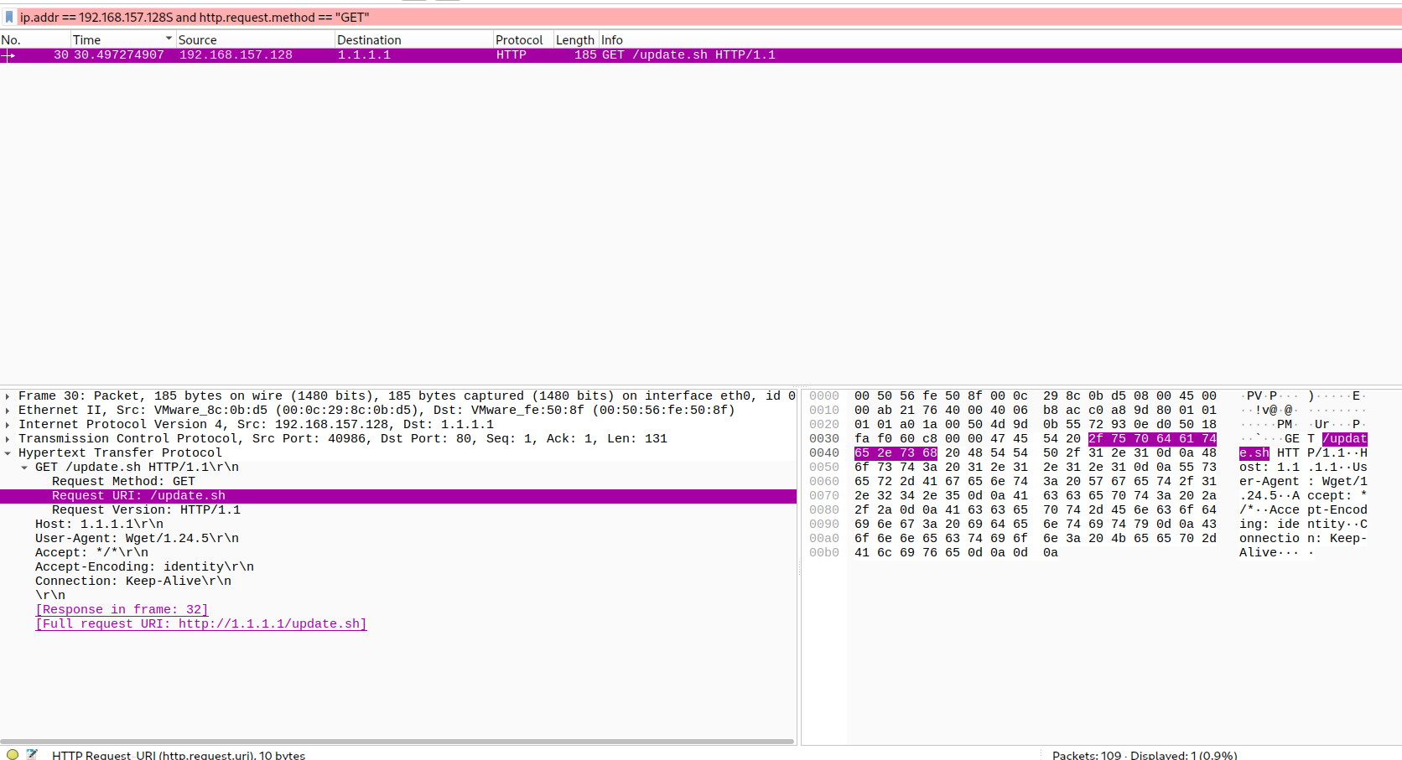
Update.sh is the shell script requested by the user
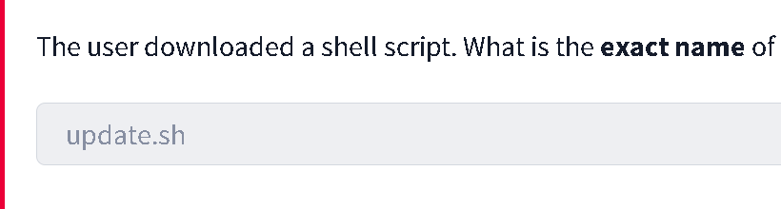
To find out what the server header was we need to check the http request in port 80 as it is not encrypted
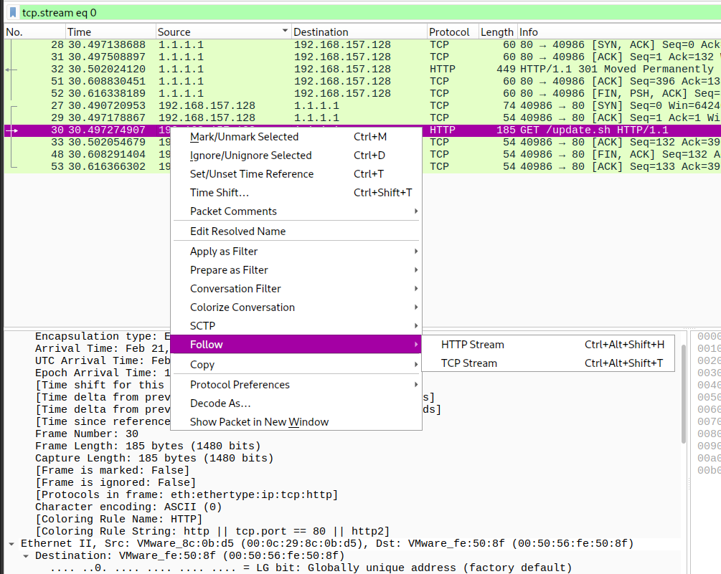
We select the http request and right click to follow the http stream and inside it we can find the server header which is cloudflare
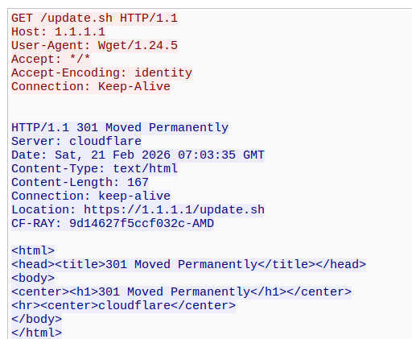
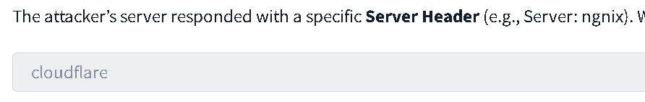
For the next one we have been given a port 4444 and need to check the password exfiltrated from it.
ip.addr == 192.168.157.128 && tcp.port == 4444
In this filter we first narrow it with the ip addr and add the port that is required for us to check which is 4444
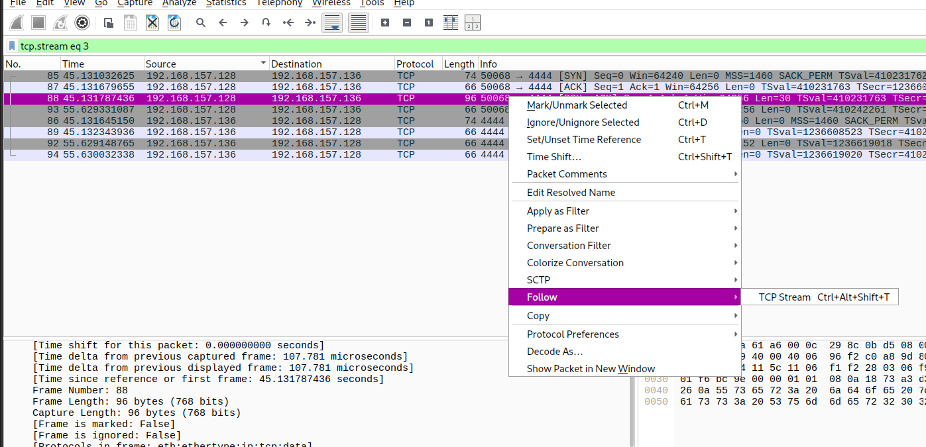
Click on any one of these and follow the tcp stream inside that we will find the password that is summer2026
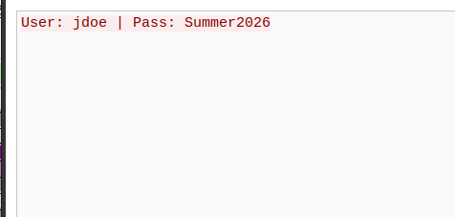
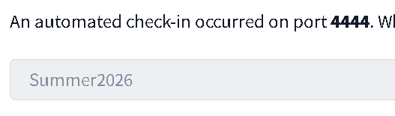
For the last one we need to check the flag that was sent on port 9999 as burst of data
We filter the search with tcp.port == 9999
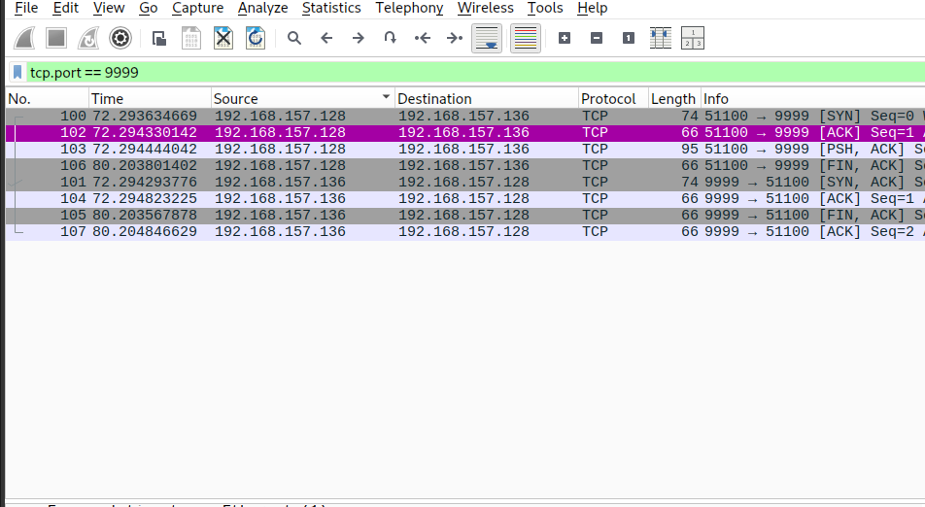
Right click any one and follow tcp stream there will be our flag
FLAG{W1RESHARK_D3TECTIVE_77}
