Assignment-6
First capture a login request random credentials and forward it to repeater and manually send the request.

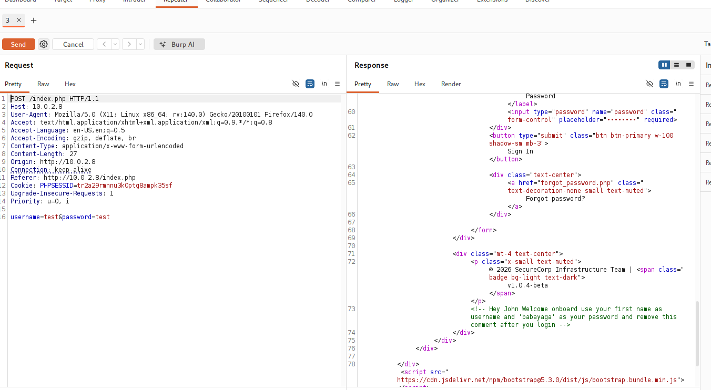
Scroll down the response and you will find a credentials flaw there.
Login with these credentials and in the dashboard.php page refresh it to capture it in burpsuite and it to repeater.
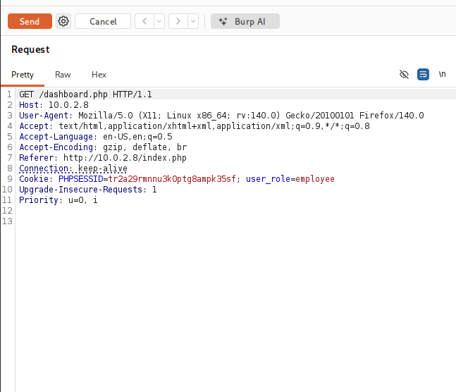
Before sending the request change the user_role to admin and the send the request, when you will scroll down you will see the flag there
