Assignment-12
First lets check is the machine in online and get some basic detail about the machine.

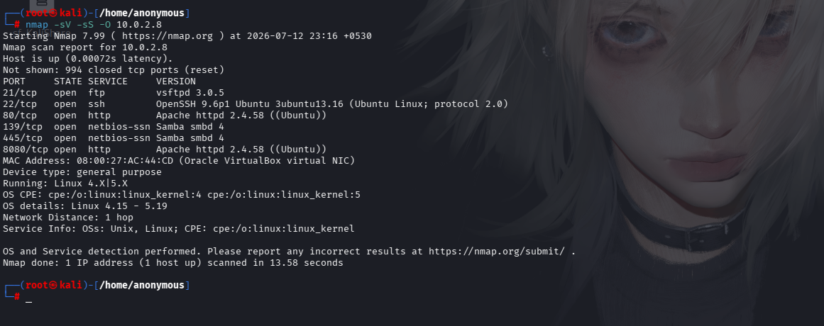
In this, -sS is Fast and stealthier than a full connection.
-O checks the operating system of the machine
-sV checks the version of the services on the ports.
Now in order to find the flag we need to do an advanced level scan for that we will use the -sC default scripting engine (NSE) scripts and -p- to scan all the ports for flags.
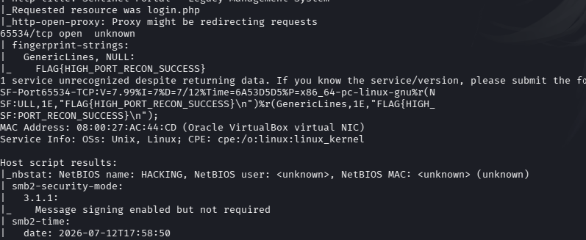
In the end we have our flag in port 65534.
FLAG{HIGH_PORT_RECON_SUCCESS}

