Assignment-9
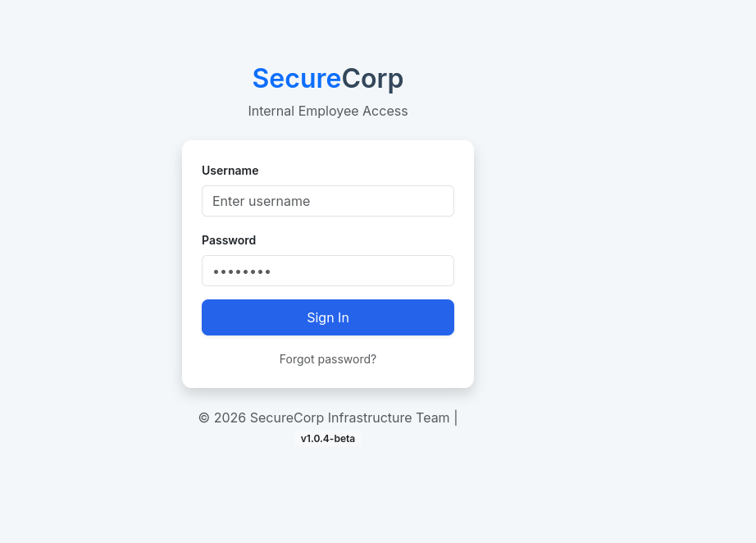
Click the forgot password button, and on the next page add the user admin as we are trying to change its password.
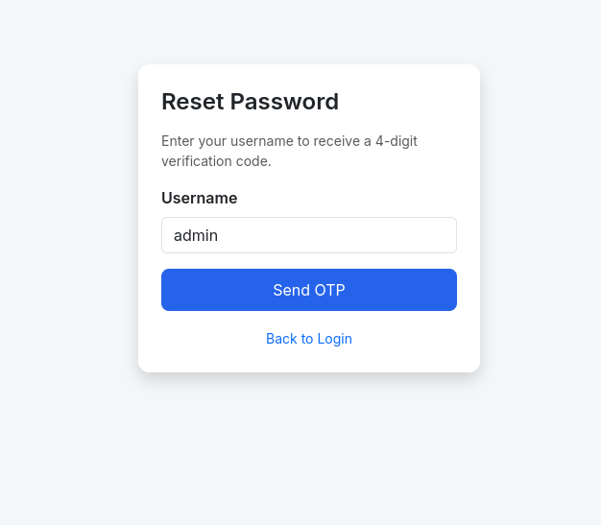
Click send OTP.
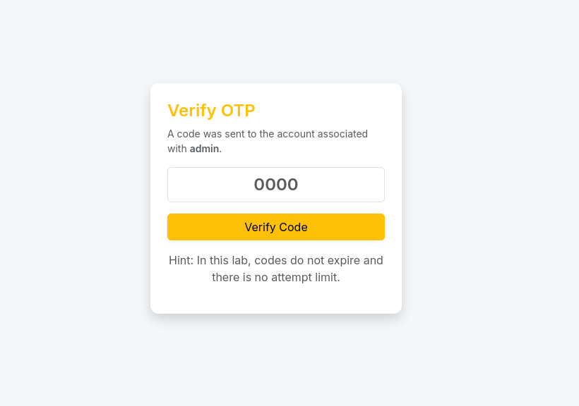
In this page we can see one vulnerability that this lab the code will not expire and we have unlimited attempts to guess the password, so we can use the bruteforce approach to try and guess the otp.
For that enter a dummy OTP 0000 and capture it through burpsuite.
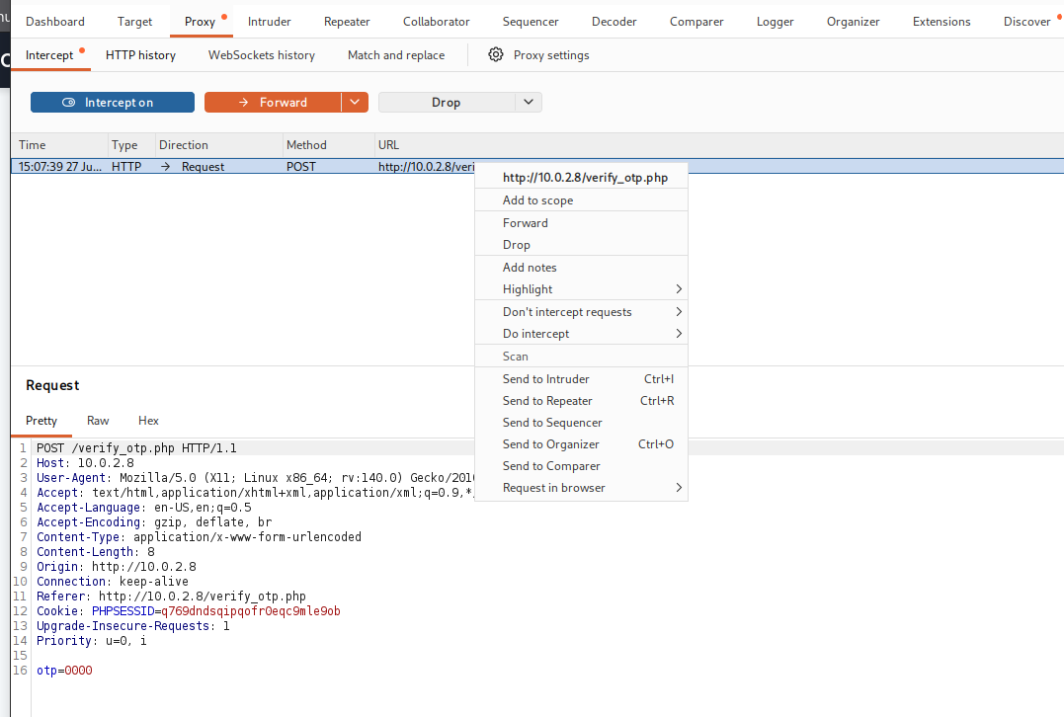
Right click and send to intruder.
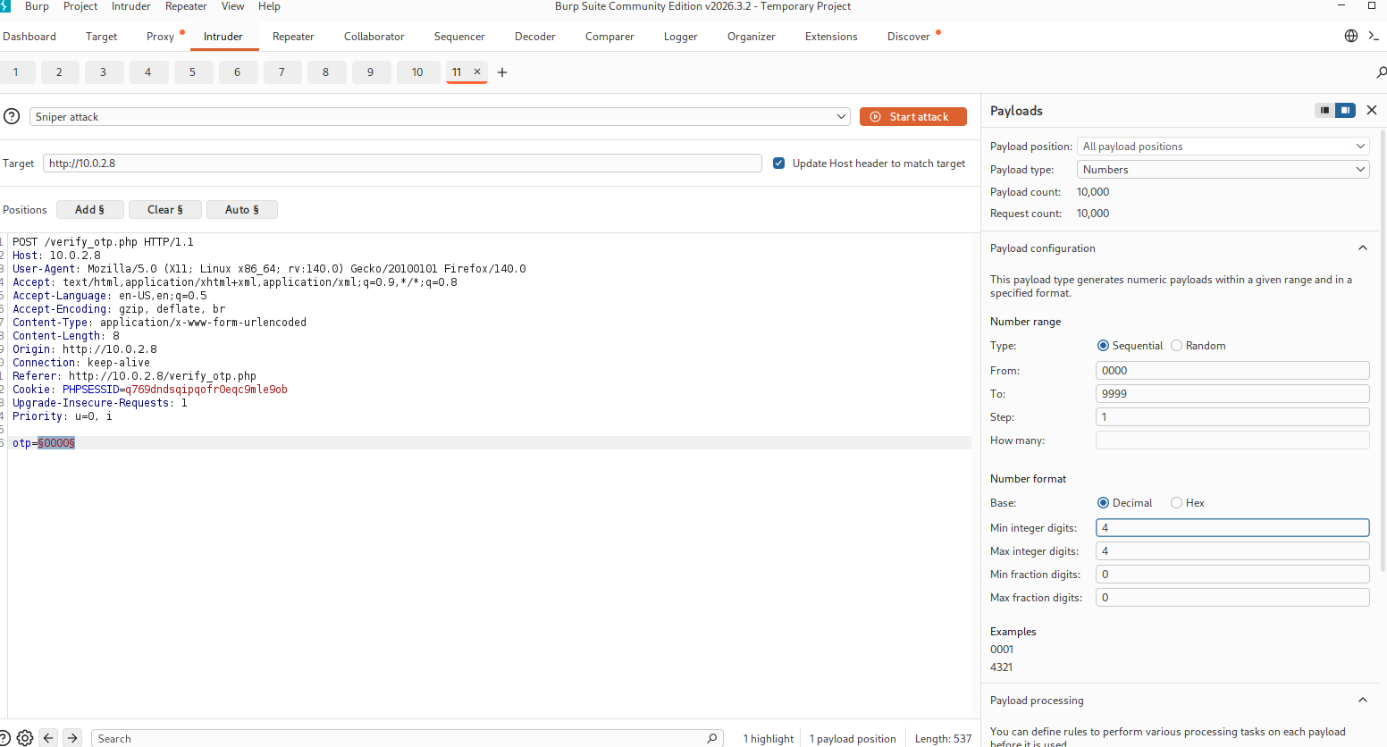
Select the otp value and click the add§ button,then on the right side select payload type to numbers, your number range form 0000 to 9999, min and max integer value to 4 and keep the attack default sniper attack.
What this will do is try every OTP value from 0000 to 9999 until one gets accepted.
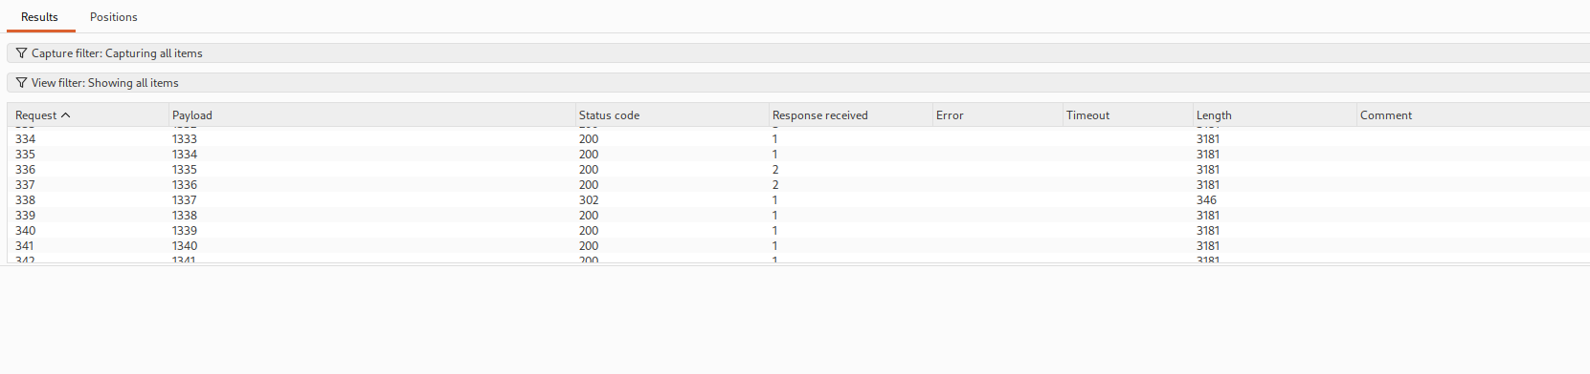
The request number 338 where payload is 1337 this is the otp, we can see the status code is 302 means that our otp is founded and there is a change in length value meaning that this is the right otp.
Enter the otp and set a new password
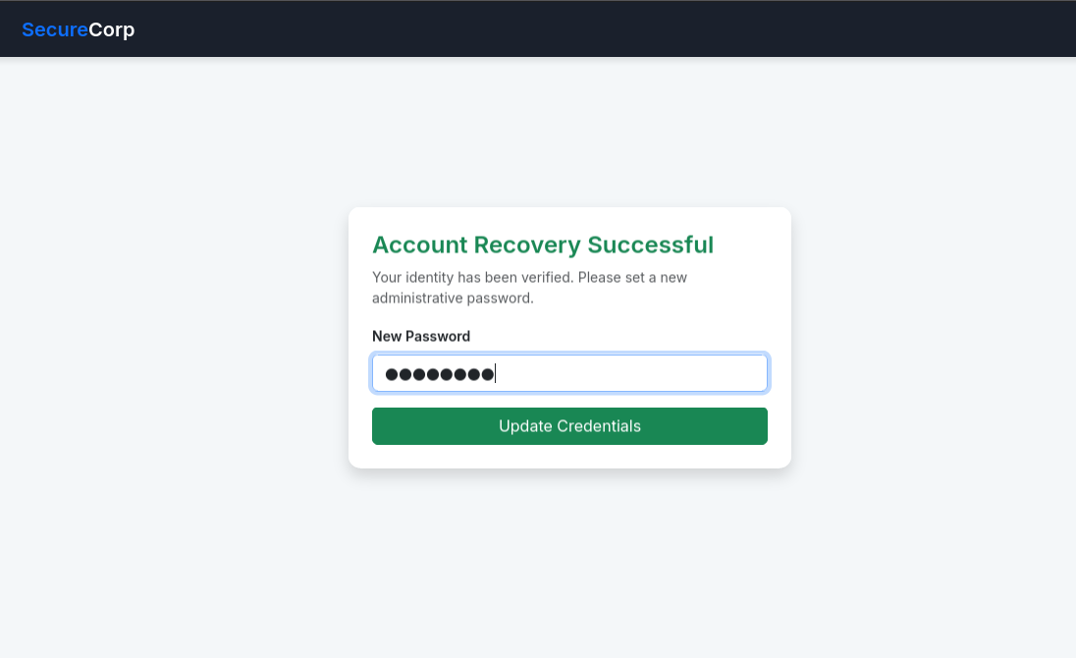
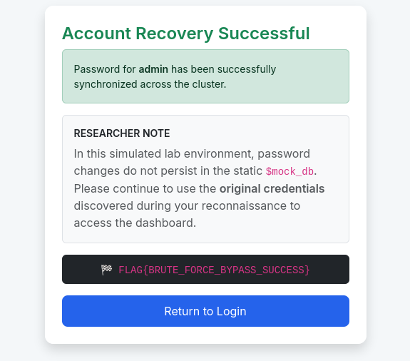
There is our flag .