Assignment-19

Go to 10.0.2.8:8080 and login as john look around the site you will see the data archives is forbidden for me to access.
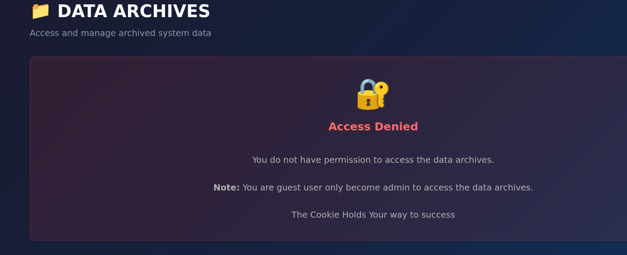
It is given hint that cookies holds the way to success so press ctrl+shift+i and go to cookies .
In cookies we have a authentication token with a signature verification, go to jwt.io and paste that token there in the JWT encoder and change the role to admin in payload and copy paste the new token.
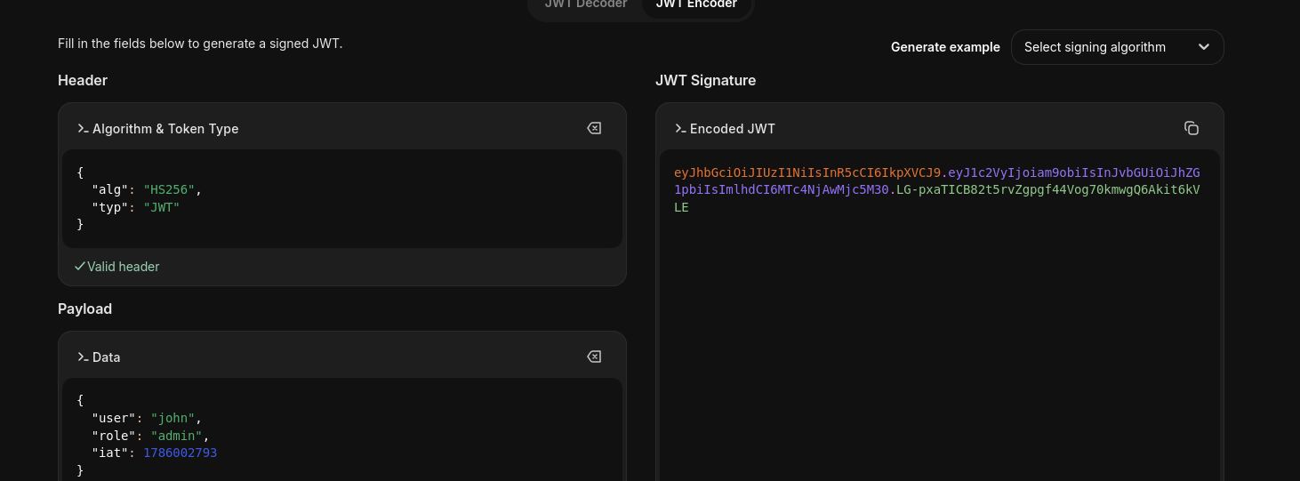
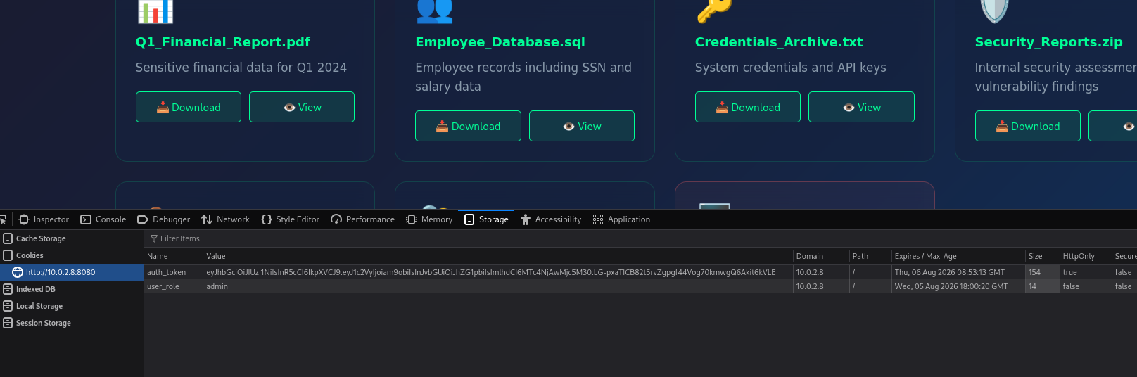
Running a dirb scan on http://10.0.2.8:8080 to discover hidden pages we find a phpinfo.php page
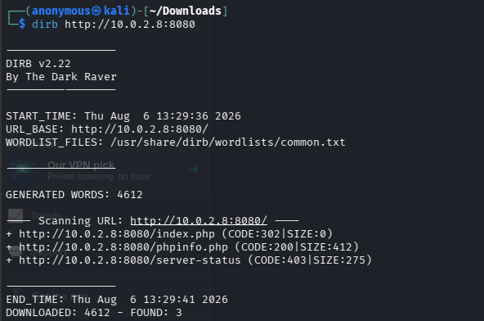
Open http://10.0.2.8:8080/phpinfo.php
Scroll down till Environment there you will find the leaked ssh credentials.
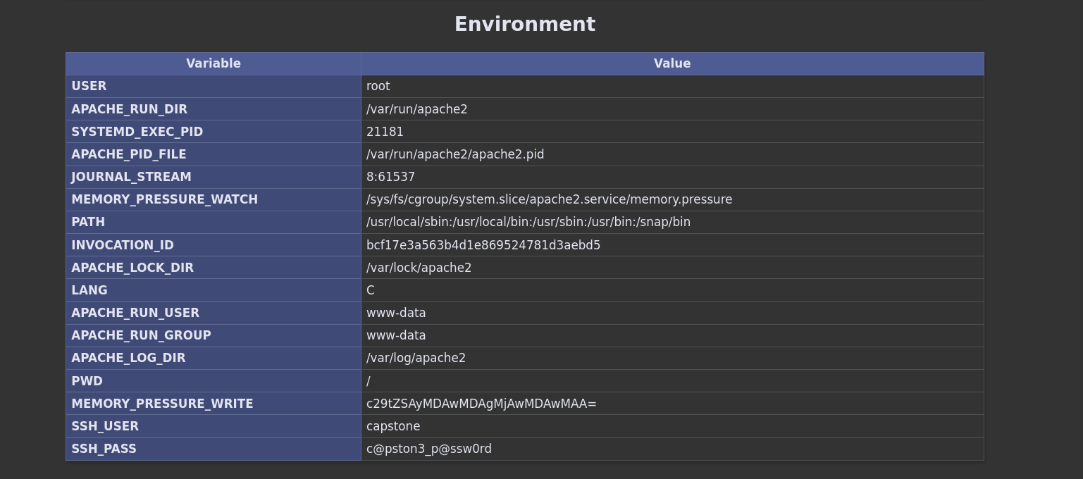
Establish a ssh connection with the credentials we just found
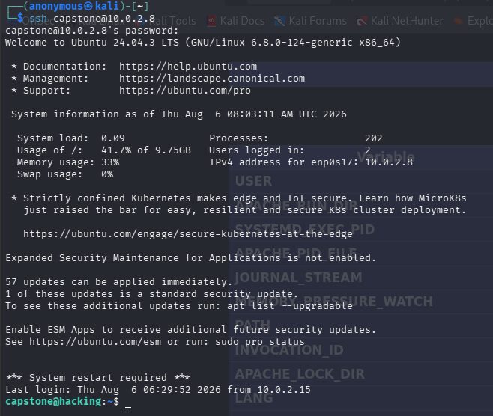
Explore the system checking the files in the directory.
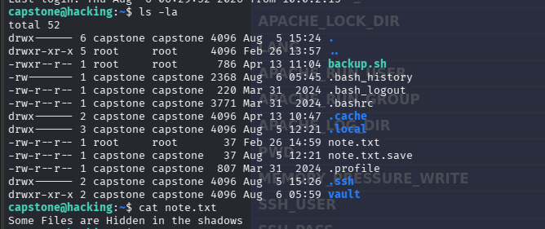
We found a note.txt and it hints that the files might be hidden somewhere.
So we will cd to vault and find hidden files there.
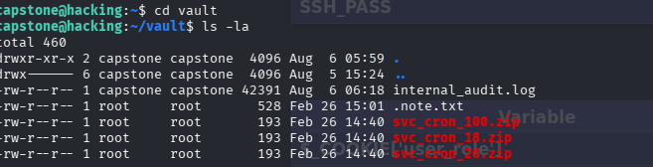
We find a .note.txt and some zip files (note ignore the internal_audit.log as i forgot to take ss before)
Read the .note.txt file
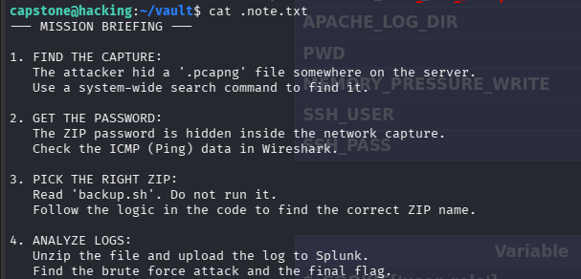
We have been briefed with what we need to do so for first step we need to find a .pcapng file to get the zip password that is somewhere in the data.
Search for that file through out the whole server
And download it to your local machine by opening a terminal where you want to download it
Using scp secure copy protocol we can download it to our local machine.
After download open it in wireshark and filter by icmp
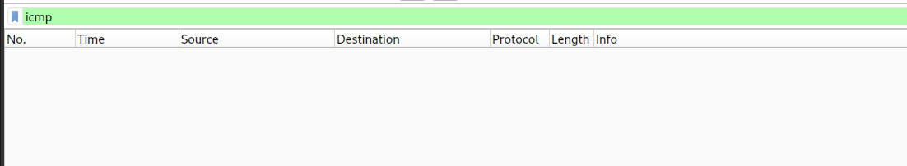
The icmp had no result so it might be somewhere else first lets try http GET request because it sometimes contain parameter in the url or header
http.request.method == "GET
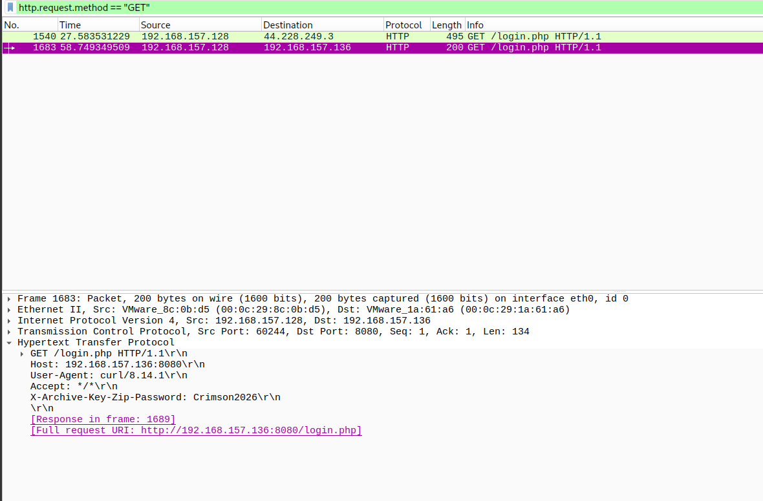
We get 2 request and under the http section we can see the zip password as Crimson2026
Now that we have the password for the next step we need to open the backup.sh and read it and solve a logic puzzle to get the correct zip file with the log file.
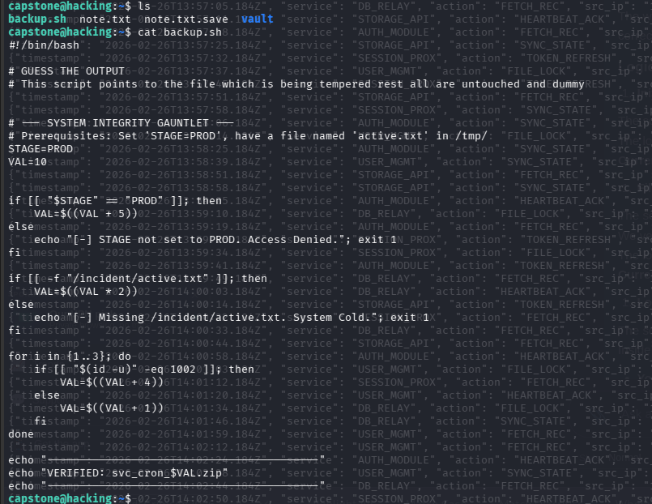
This is the puzzle that we need to solve in order for us to get the correct zip file name
The script sets STAGE=PROD.
The logic is: VAL = 10 + 5.
Current VAL = 15.
The script checks: if [[ -f "/incident/active.txt" ]].
We verified that /incident/active.txt exists.
The logic is: VAL = VAL * 2.
Current VAL = 15 * 2 = 30
The script loops 3 times (for i in 1 2 3).
Inside the loop, it checks the User ID: if [[ "$(id -u)" -eq 1002 ]].

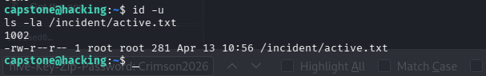
Your User ID: We ran id -u and got 1002.
- Condition Met: Since 1002 == 1002, the if condition is true.
- Action: VAL = VAL + 4.
Iteration 1:
- VAL = 30 + 4
- Current VAL = 34
Iteration 2:
- VAL = 34 + 4
- Current VAL = 38
Iteration 3:
- VAL = 38 + 4
- Current VAL = 42
- Final Result:
The script uses VAL to name the zip file: svc_cron_${VAL}.zip.
Therefore, the correct file is svc_cron_42.zip
Now we need to unzip the file svc_cron-42.zip to get the log file then perform the last step to analyze the log in splunk
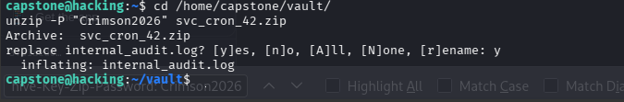
Download the zip file to your local machine through scp in the directory you like
For the final step start your splunk and add this log file in it
Select the source type to json and index to main and start searching the logs.
We need to look for src ip as it has asked to check the brute force attempts so we need to find the ip with the most login attempts or count.
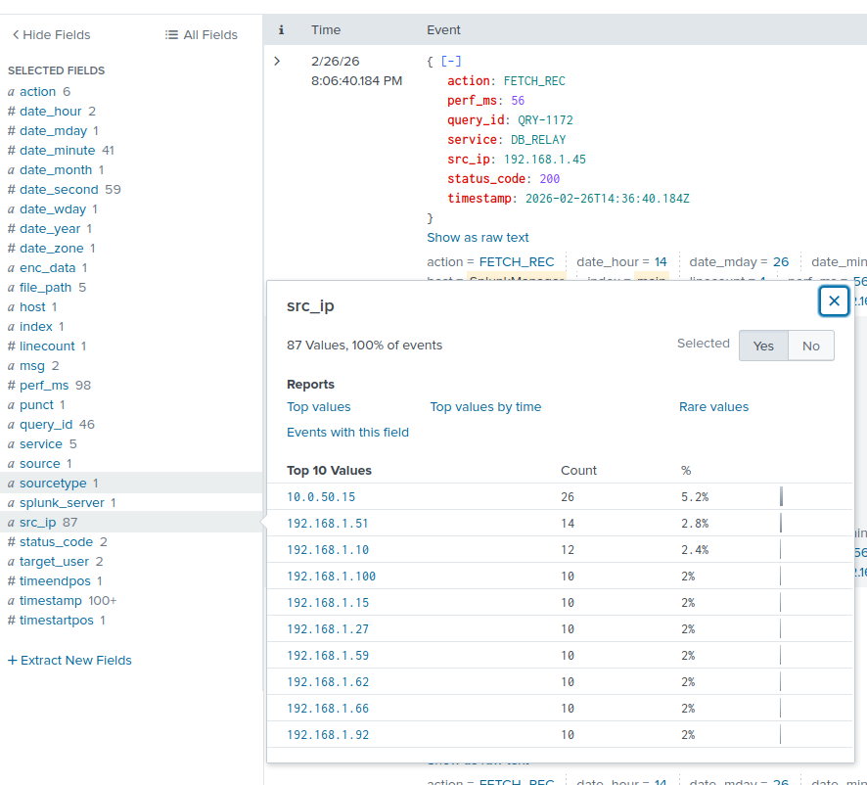
From the fields section click on src_ip and select the highest count scroll through it to find a successful login.
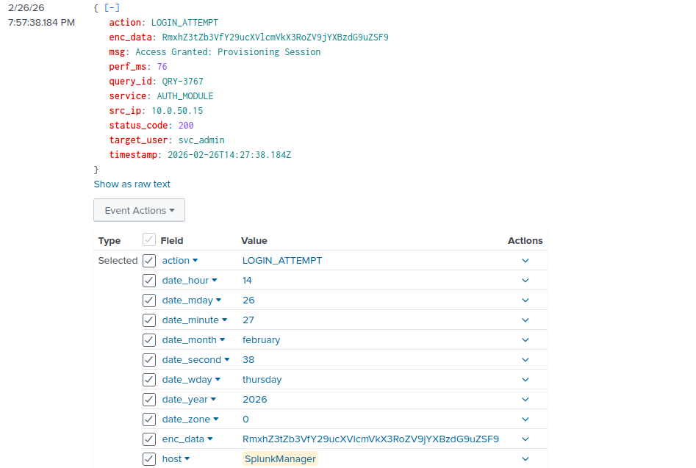
We found the successful login and find the enc data which is in base64 encoding.
Go to a base64 decoding site and paste this encrypted hash and we will find our flag
