Assignment-18
Upload the log file into your splunk and select the severity field from the side bar
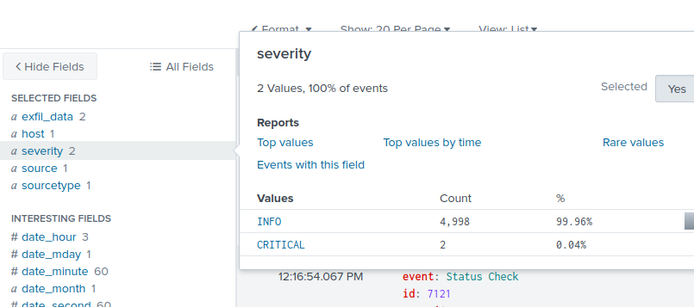
Click on critical and as we can also get our first answer as the total number of critical severity is 2.
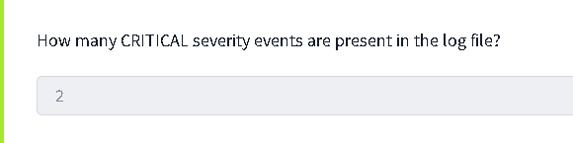
For the username of the incident we can see 2 user service_bot which cant be the user as it is a bot and the second svc_admin_acc
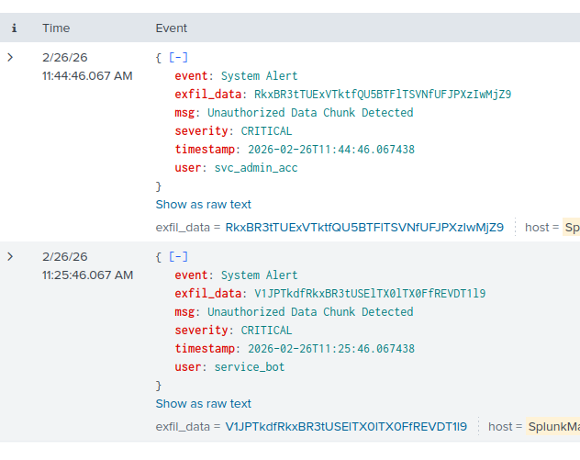
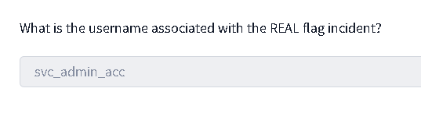
From the dropdown menu select the exfil_data and copy the base64 converted value
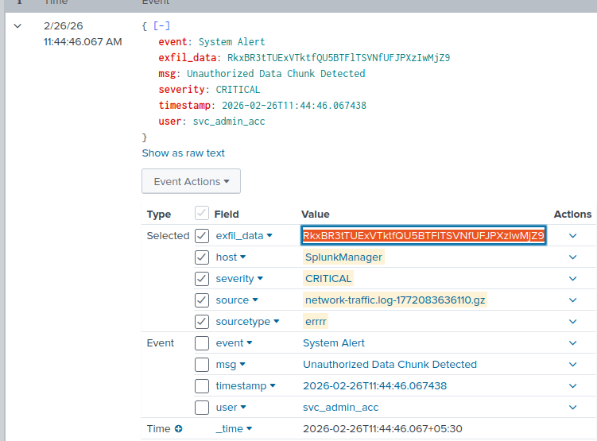
Search decode base64 and decode the value to get the flag
