Assignment-17
From the credentials discovered from the previous task login with those credentials.
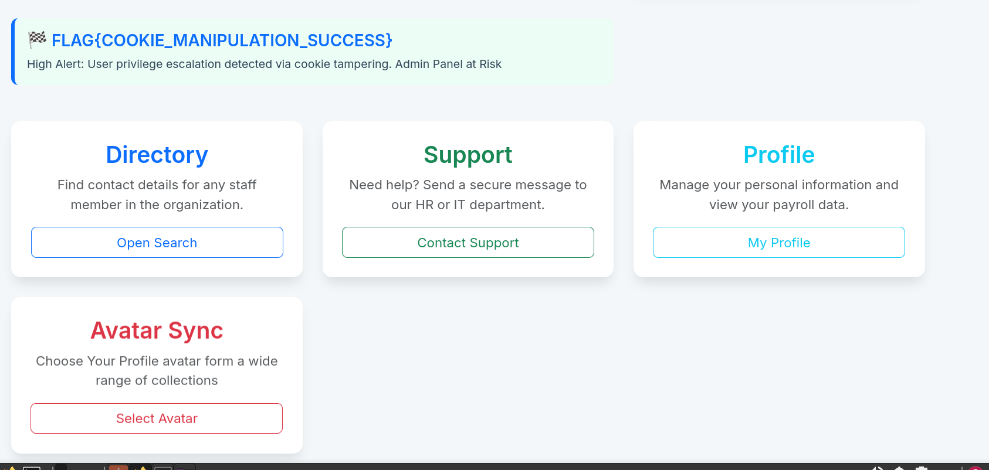
Visit the avatar sync page and upload the internal server address and check the response.
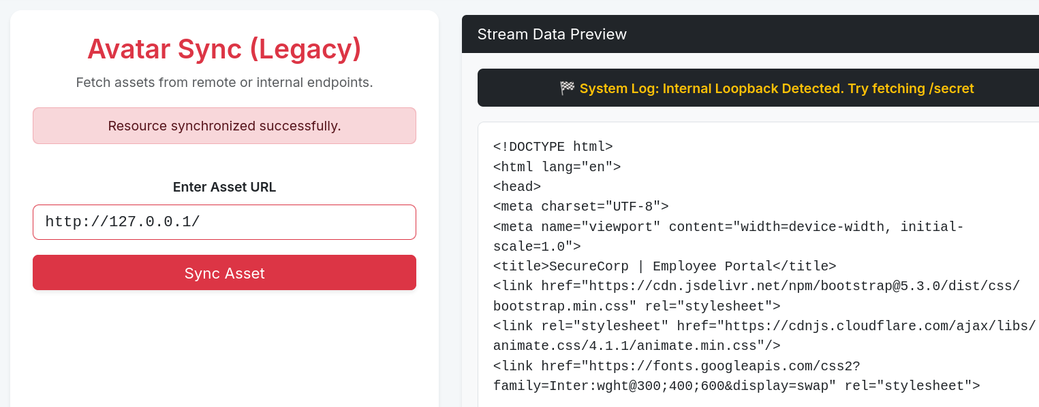
Here we can see the vulnerability it showed for us to try and fetch /secret
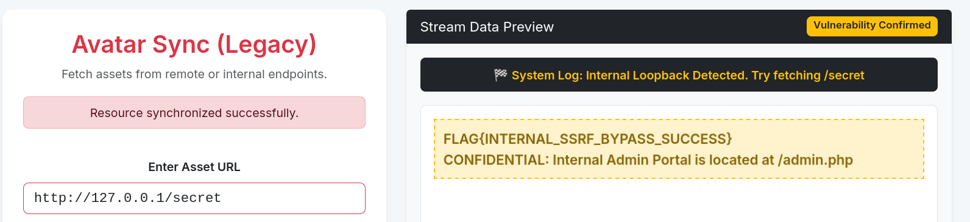
And here we have are flag .
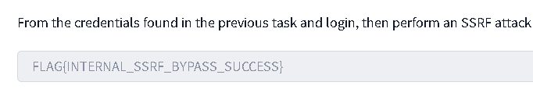
*Note : I am stuck in assignment 16 from the past 1 month please tell me where to do parameter fuzzing i tried everything i know respond in feedback

