Assignment-16
Lets start by finding the hidden page by using gobuster
gobuster dir -u http://10.0.2.8 -w /usr/share/wordlists/dirb/common.txt -t 10
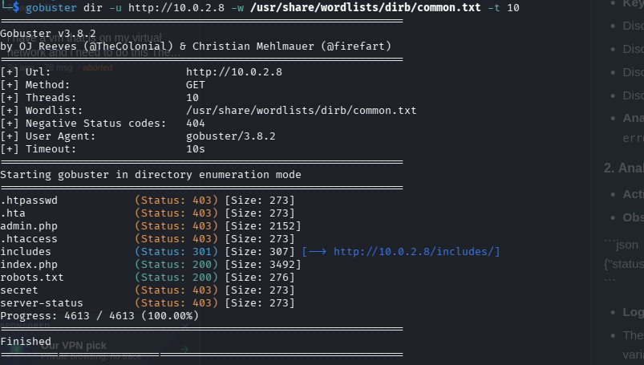
From the scan only the includes index.php and robots.txt is viewable index.php is the main webpage includes is just a directory only thing left is robots.txt
Lets perform curl to find the content of robots.txt
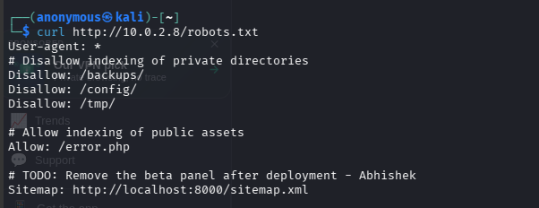
Only the error.php is allowed so lets fetch the content of error.php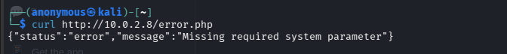
It suggest the a system parameter is missing and the task has asked us to perform parameter fuzzing .
The message "Missing required system parameter" implied the page expected a query string variable to trigger a specific state.
In web development, common parameters that toggle system-level outputs are ?debug, ?verbose, ?mode, or ?action.
The parameter name is likely debug or system and the value is true.
Lets start by doing “curl http://10.0.2.8/error.php?system=true”
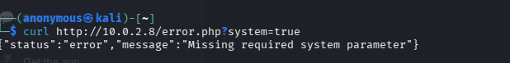
It did not work lets try with debug
“curl http://10.0.2.8/error.php?debug=true”
The server returned a large JSON object containing sensitive system information.
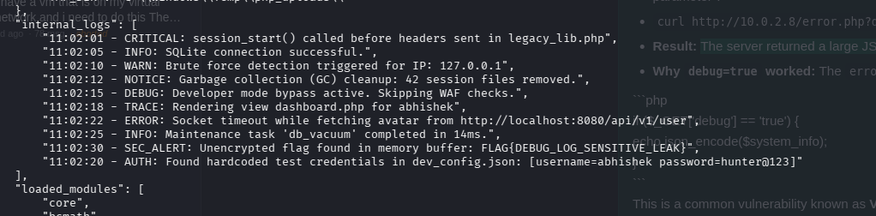
Here we our able to get our flag and the second set of credentials
username=abhishek password=hunter@123

FLAG{DEBUG_LOG_SENSITIVE_LEAK}
