Assignment-13
To check the highest cvss score we will run a credentialed patch audit scan in nessus.
So open your Nessus and click new scan
And select credentialed patch audit in vulnerabilities.
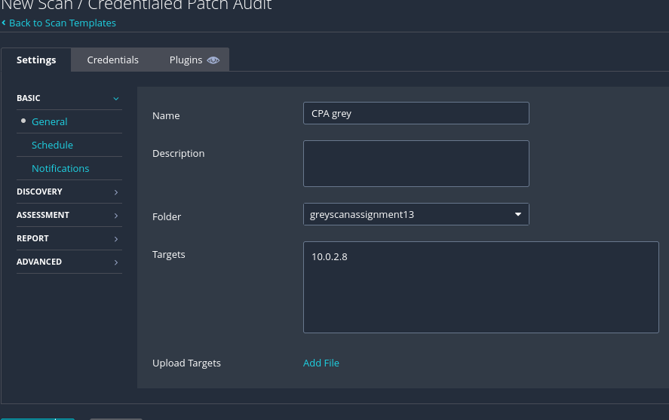
Set a name for the scan and give the target ip, then in credentials select ssh and change authentication method to password give the required username and password and save the scan.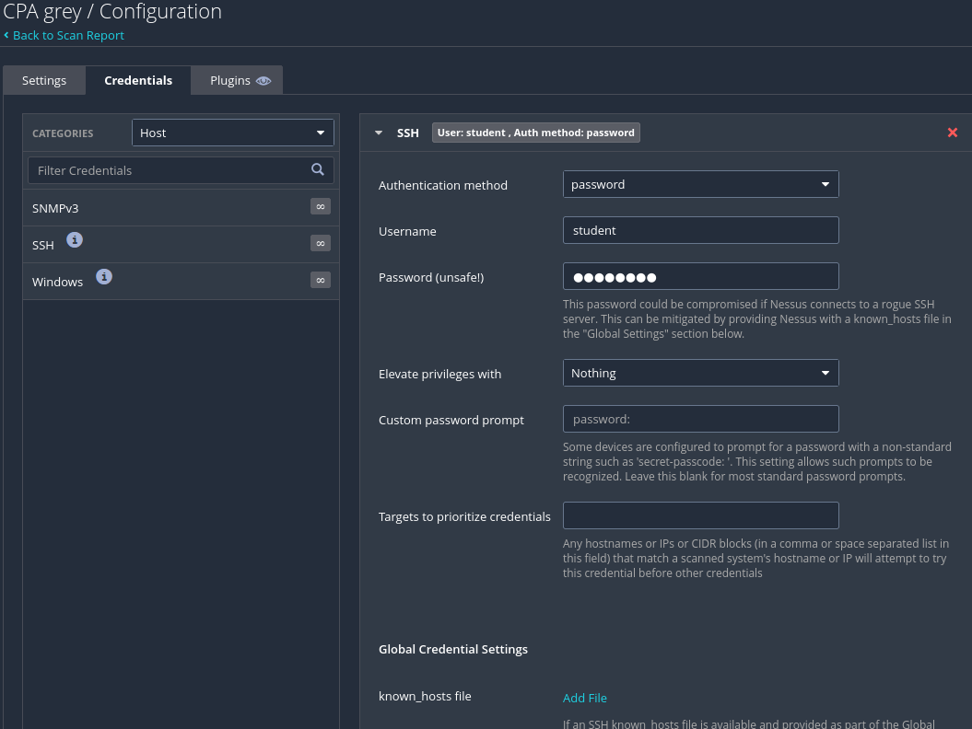
Go back and the scan and wait for it to complete.
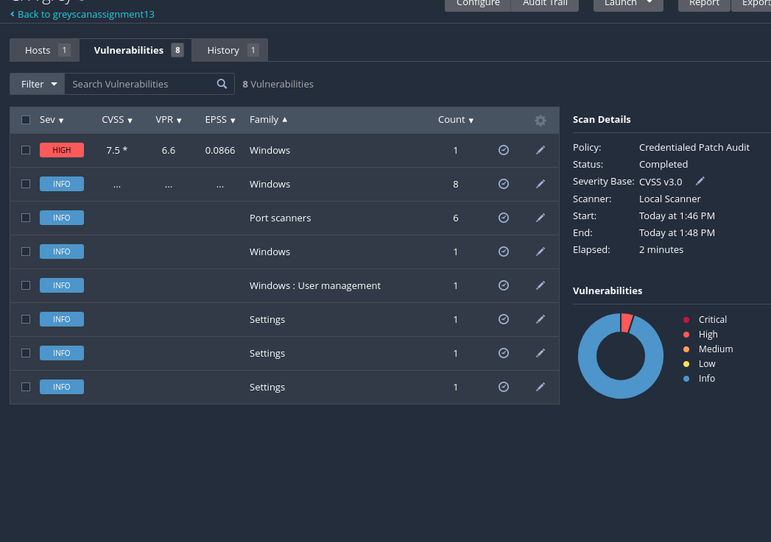
After the scan is done open and check the vulnerability where we can find cvss score.
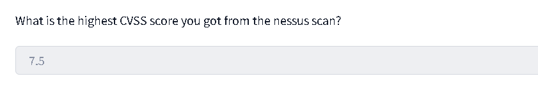

Now for the second part to exploit the vulnerability detected by nessus.
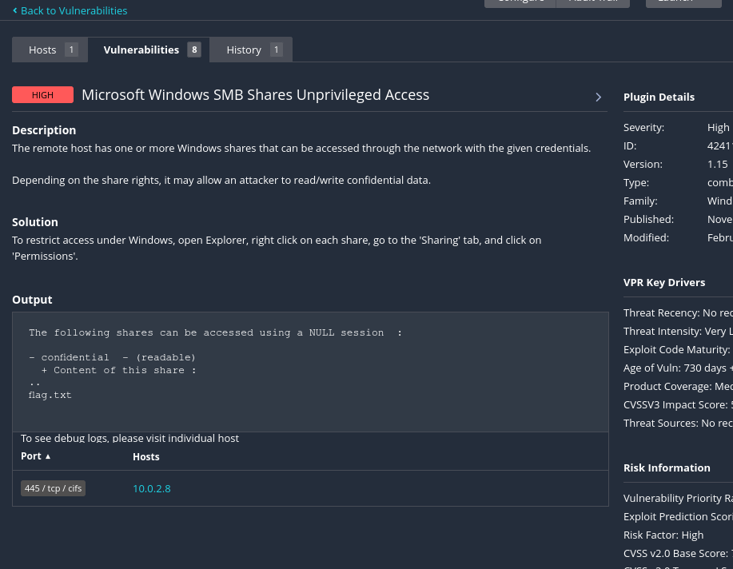
In this vulnerability we can see that it is given in the output that it can be accessed with a null session anonymous session so we will have a smb connection with no user name with just the confidential share as the folder is to share to public.
Using this command
smbclient //10.0.2.8/confidential -N
Where confidential is the folder and -N tell the prompt to try a null or anonymous session.
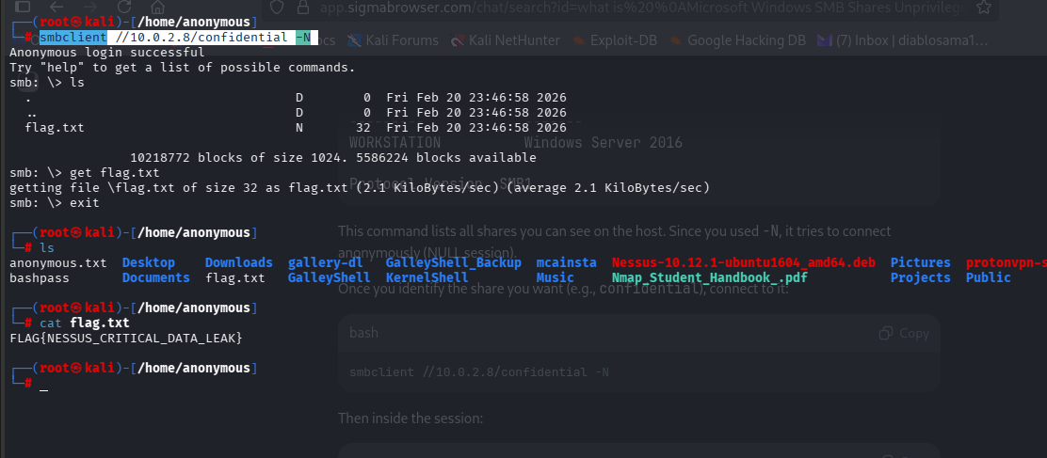
With the anonymous session we can ls the files and download it to our system and get the flag
FLAG{NESSUS_CRITICAL_DATA_LEAK}
