Assignment-8
Form your dashboard go to directories and search for admin.
You will see that it provides you with the ID of that user.
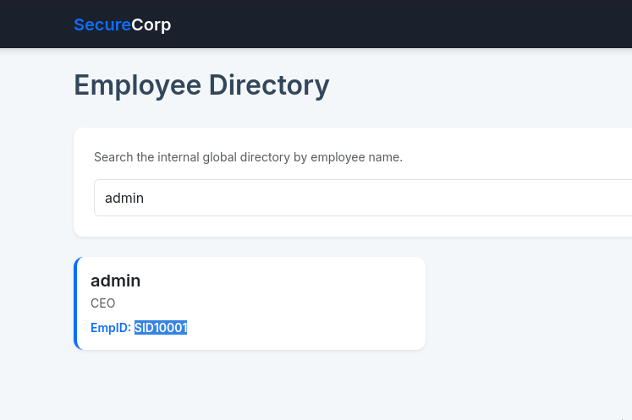
Copy the empid and go to your my profile page.
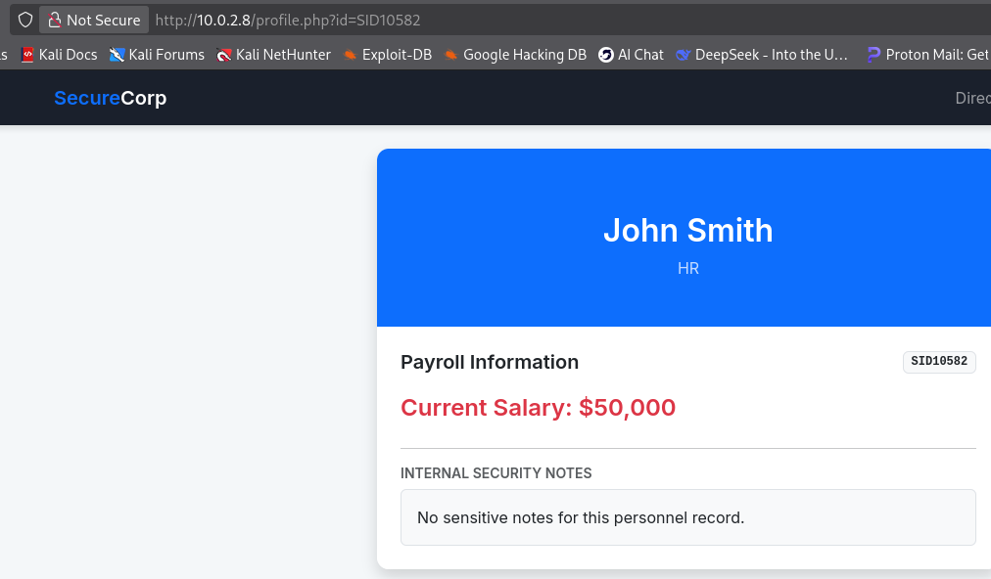
In the url we can see that there is an id flaw simply select the whole SID and replace it with the one we copied before of the admin.
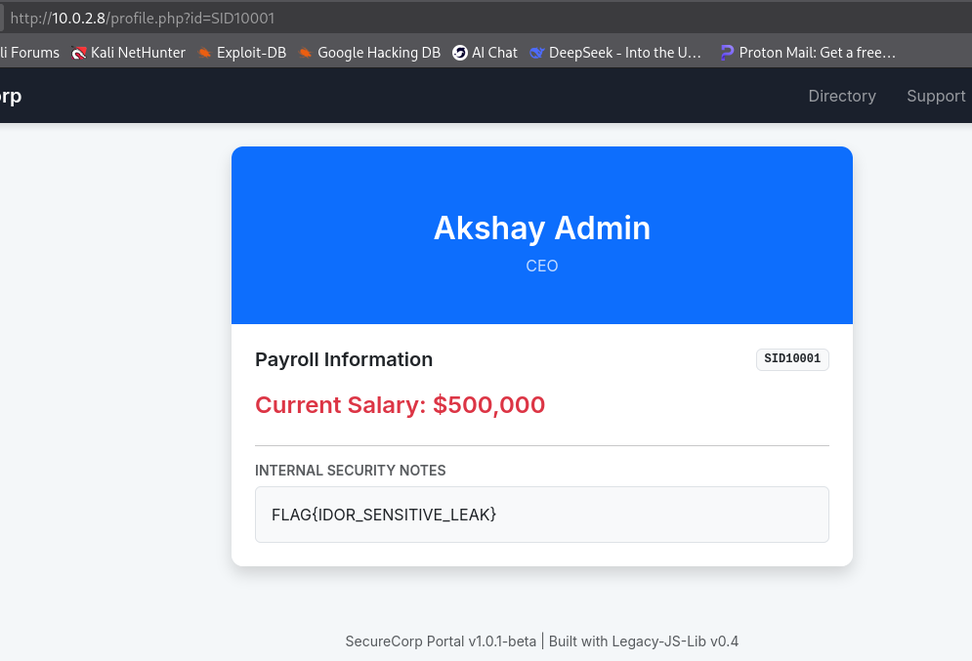
There you have it the flag we were looking for.
FLAG{IDOR_SENSITIVE_LEAK}
