Assignment-15
The first thing that it has asked us is to find the “MAC Address of the device sending excessive ARP "Who has" requests”
From this alone we get that we need to filter our captured pcap file with arp as arp protocol was used and it is sending excessive ARP request that means we need to focus on the source that has sent multiple of these requests.
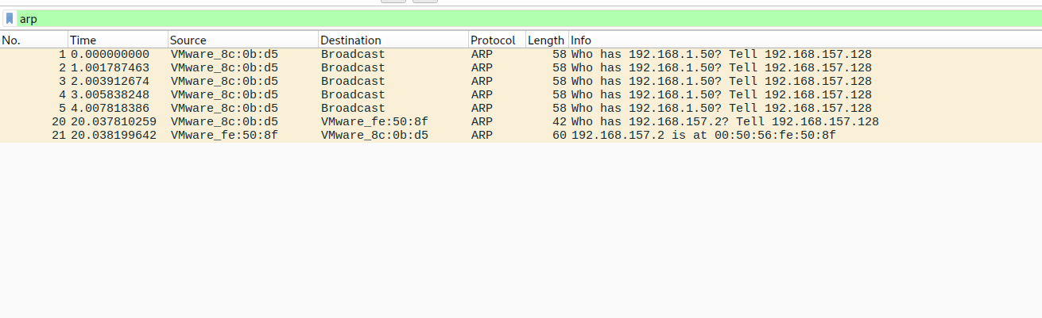
From this we see that the source VMware_8c:0b:d5 has sent multiple req.
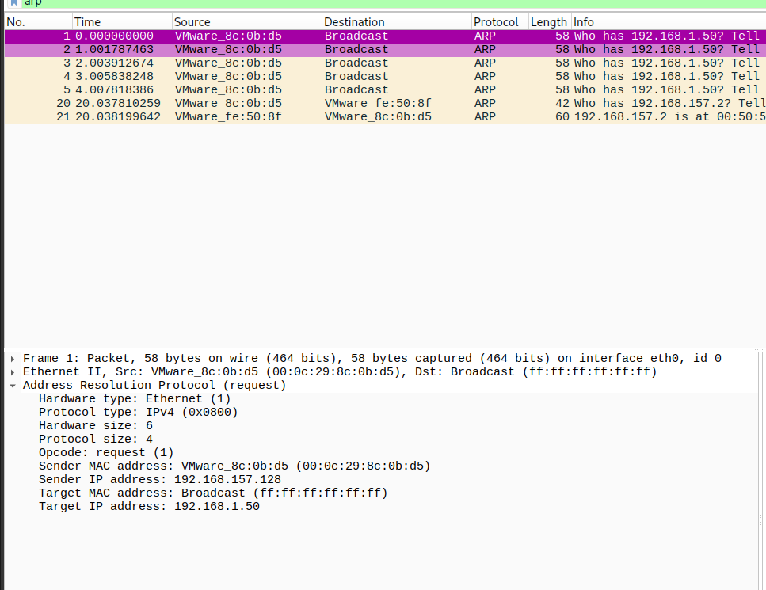
Click on the first one and under the arp drop down menu we can find the sender mac address = 00:0c:29:8c:0b:d5
Under the same arp drop down menu has the targets ip address = 192.168.1.50
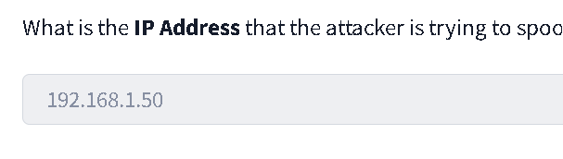
Next we have been asked to check the total number of ICMP(ping) request that were sent, for this we will filter it by icmp
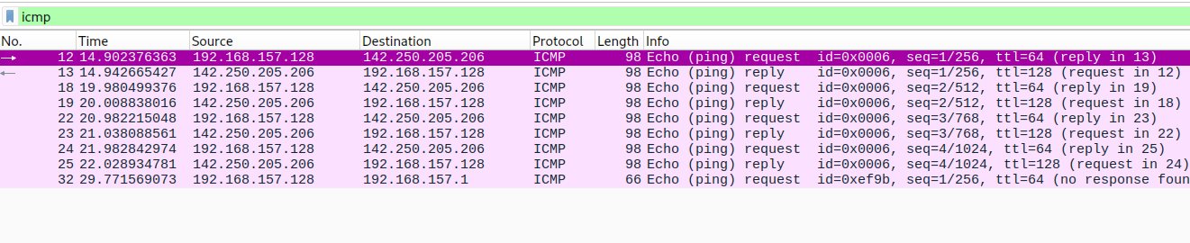
From this list we can count the total ping request that is 5.
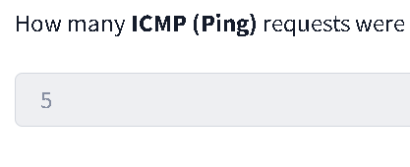

Select the last icmp request and click on the icmp drop down menu then click on data
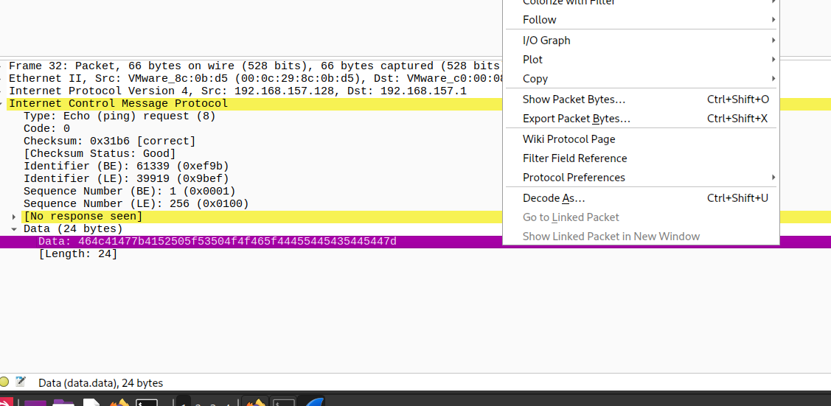
Click on show packet bytes and you will have your flag
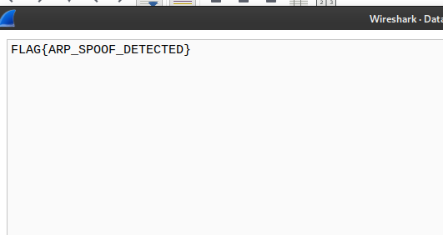
Or click on protocol preference and then select show data as text
