More details: [*https://medium.com/@pouryaayria/k-fold-target-encoding-dfe9a594874b*](https://medium.com/@pouryaayria/k-fold-target-encoding-dfe9a594874b)

Mainly, get one section of the code and do some math and apply to other sections.

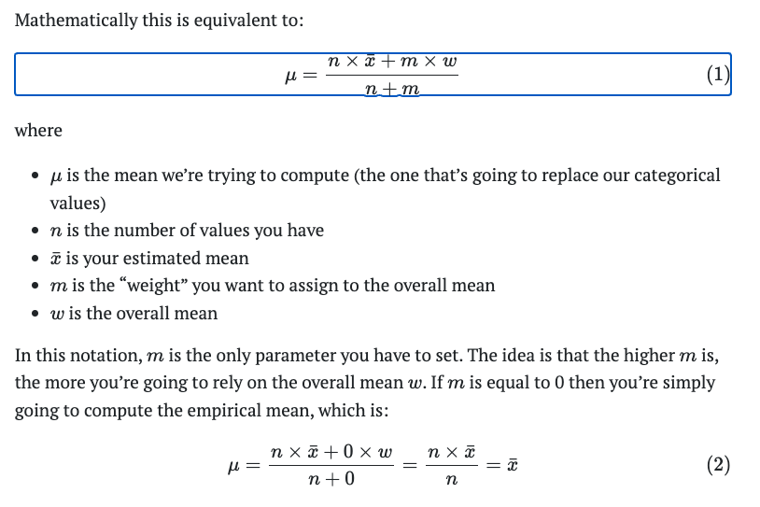

This is also the same as target encoding but in this, when we apply this formula to one section. We cannot use this value for this section. We use this value to others.