- 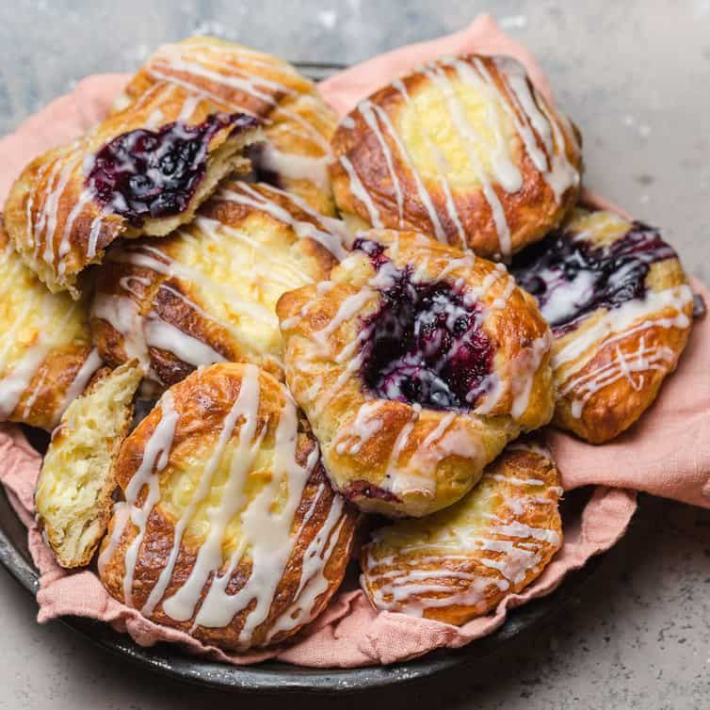2 cups unsalted butter, softened
- ⅔ cup all-purpose flour
- 8 cups all-purpose flour, divided
- 4 ½ teaspoons active dry yeast
- 2 ½ cups milk
- ½ cup white sugar
- 2 teaspoons salt
- 2 large eggs
- 1 teaspoon lemon extract
- 1 teaspoon almond extract
- 2 cups fruit preserves, any flavor
- 1 large egg white, beaten

Directions
- Cream butter and 2/3 cup flour in a medium bowl until well combined. Divide into 2 equal parts, then roll each half between 2 pieces waxed paper into a 6x12-inch sheet. Chill sheets in the refrigerator.
- Mix 3 cups flour with active dry yeast in a mixing bowl; set aside.
- Stir together milk, sugar, and salt in a small saucepan over medium heat. Heat until warm, but not hot to the touch, about 115 degrees F (43 degrees C).
- Pour warm milk mixture over flour mixture. Add eggs, lemon extract, and almond extract. Stir for 3 minutes. Knead in remaining flour, 1/2 cup at a time, until dough is firm and pliable. Cover and let rise at room temperature until doubled in size, 30 minutes to 1 hour.
- Cut dough in half. Roll each half out to a 14-inch square. Place 1 sheet cold butter over each dough square off to one side, then fold dough over it like the cover of a book. Pinch the edges of dough together with your fingers.
- Roll each piece out to a 20x12-inch rectangle. Fold into thirds like a letter. Repeat rolling and folding one more time. Wrap in plastic and refrigerate for at least 30 minutes.
- Roll and fold each piece of dough two more times. Wrap in plastic and refrigerate for at least 30 minutes.
- Roll dough out to 1/4-inch thickness. Cut dough into squares. Place a dollop of fruit preserves in the center. Fold 2 opposite corners over the center to form a filled diamond shape. Place danishes on an ungreased baking sheet. Allow to rise at room temperature until doubled in size, about 30 minutes.
- Preheat the oven to 450 degrees F (220 degrees C).
- Brush beaten egg white over pastries.
- Bake in the preheated oven until the bottoms are golden brown, 8 to 10 minutes.

Tips

