**[03] 레이아웃**

1. 레이아웃의 종류

* 제약 레이아웃(ConstraintLayout) : 제약 조건을 사용해 화면에 위젯을 배치한다
* 렐레티브레이아웃(상대레이아웃) : 위젯 자신이 속한 레이아웃의 상하좌우 위치를 지정하여 배치하거나 다른 위젯으로부터 상대적인 위치를 지정
* 리니어레이아웃(선형레이아웃) : 레이아웃의 왼쪽부터 오른쪽 또는 위부터 아래쪽으로 차례로 배치
* 테이블레이아웃 : 위젯을 행과 열의 개수를 지정한 테이블 형태로 배열
* 그리드레이아웃 : 테이블 레이아웃과 유사. 행 또는 열을 확장하여 다양하게 배치할 수 있다
* 프레임레이앙웃 : 위젯들을 왼쪽 위에 일률적으로 겹쳐서 배치하여 중복해서 보이는 효과를 냄

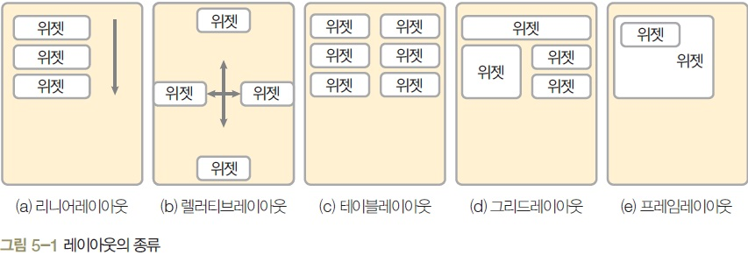

프레임 레이아웃



*<?***xml version="1.0" encoding="utf-8"***?>*<**android.support.constraint.ConstraintLayout xmlns:android="http://schemas.android.com/apk/res/android"  
 xmlns:app="http://schemas.android.com/apk/res-auto"  
 xmlns:tools="http://schemas.android.com/tools"  
 android:layout_width="match_parent"  
 android:layout_height="match_parent"  
 tools:context=".MainActivity"**>  
 <**Button  
 android:id="@+id/button"  
 android:layout_width="wrap_content"  
 android:layout_height="wrap_content"  
 android:layout_marginTop="32dp"  
 android:text="이미지 바꾸기"  
 app:layout_constraintEnd_toEndOf="parent"  
 app:layout_constraintHorizontal_bias="0.498"  
 app:layout_constraintStart_toStartOf="parent"  
 app:layout_constraintTop_toTopOf="parent"** />  
 <**FrameLayout  
 android:layout_width="300dp"  
 android:layout_height="100dp"  
 android:layout_marginTop="24dp"  
 android:layout_marginEnd="8dp"  
 android:layout_marginRight="8dp"  
 app:layout_constraintEnd_toEndOf="parent"  
 app:layout_constraintStart_toStartOf="parent"  
 app:layout_constraintTop_toBottomOf="@+id/button"**>  
 <**ScrollView  
 android:id="@+id/sView1"  
 android:layout_width="match_parent"  
 android:layout_height="match_parent"  
 android:visibility="invisible"**>  
 <**ImageView  
 android:layout_width="match_parent"  
 android:layout_height="match_parent"  
 android:src="@drawable/dream01"** />  
 </**ScrollView**>  
 <**ScrollView  
 android:id="@+id/sView2"  
 android:layout_width="match_parent"  
 android:layout_height="match_parent"  
 android:visibility="visible"**>  
 <**ImageView  
 android:layout_width="match_parent"  
 android:layout_height="match_parent"  
 android:src="@drawable/dream02"** />  
 </**ScrollView**>  
 </**FrameLayout**>  
</**android.support.constraint.ConstraintLayout**>

**public class** MainActivity **extends** AppCompatActivity {  
 **private** Button **button**;  
 **private** ScrollView **sView1**, **sView2**;  
 **private int idx** = 0;  
 @Override  
 **protected void** onCreate(Bundle savedInstanceState) {  
 **super**.onCreate(savedInstanceState);  
 setContentView(R.layout.***activity_main***);  
 **button** = (Button)findViewById(R.id.***button***);  
 **sView1** = (ScrollView)findViewById(R.id.***sView1***);  
 **sView2** = (ScrollView)findViewById(R.id.***sView2***);  
 **button**.setOnClickListener(**new** View.OnClickListener() {  
 @Override  
 **public void** onClick(View v) {  
 **if**(**idx**==0){  
 **sView2**.setVisibility(View.***VISIBLE***);  
 **sView1**.setVisibility(View.***INVISIBLE***);  
 **idx**=1;  
 }**else if**(**idx**==1){  
 **sView1**.setVisibility(View.***VISIBLE***);  
 **sView2**.setVisibility(View.***INVISIBLE***);  
 **idx** = 0;  
 }  
 }  
 });  
 }  
}

테이블 레이아웃 예제

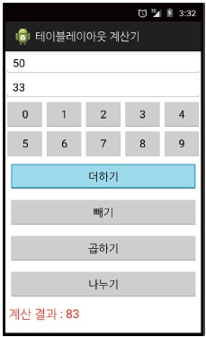

* **TableLayout 1개와 TableRow 9개로 구성**
* **에디트텍스트 2개, 숫자 버튼 10개, 연산 버튼 4개, 텍스트뷰 1개를 생성**
* **연산 버튼 위젯에는 layout_margin을 적절히 지정**
* **결과를 보여줄 TextView는 색상을 빨간색, 글자 크기는 20에**
* **각 위젯의 id는 위에서부터 Edit1, Edit2, BtnNum0~9, BtnAdd, BtnSub, BtnMul, BtnDiv, TextResult**

activity_main.xml

*<?***xml version="1.0" encoding="utf-8"***?>*<**TableLayout xmlns:android="http://schemas.android.com/apk/res/android"  
 android:layout_width="match_parent"  
 android:layout_height="match_parent"  
 android:stretchColumns="0,1,2,3,4"**>  
 <**TableRow  
 android:layout_width="match_parent"  
 android:layout_height="wrap_content"**> *<!-- TableRow의 width와 height 생략가능 -->* <**EditText  
 android:id="@+id/Edit1"  
 android:layout_span="5"  
 android:hint="숫자1 입력"** />  
 </**TableRow**>  
 <**TableRow**>  
 <**EditText  
 android:id="@+id/Edit2"  
 android:layout_span="5"  
 android:hint="숫자2 입력"** />  
 </**TableRow**>  
 <**TableRow**>  
 <**Button  
 android:id="@+id/BtnNum0"  
 android:layout_width="50dp"  
 android:text="0"**/>  
 <**Button  
 android:id="@+id/BtnNum1"  
 android:layout_width="50dp"  
 android:text="1"**/>  
 <**Button  
 android:id="@+id/BtnNum2"  
 android:layout_width="50dp"  
 android:text="2"**/>  
 <**Button  
 android:id="@+id/BtnNum3"  
 android:layout_width="50dp"  
 android:text="3"**/>  
 <**Button  
 android:id="@+id/BtnNum4"  
 android:layout_width="50dp"  
 android:text="4"**/>  
 </**TableRow**>  
 <**TableRow**>  
 <**Button  
 android:id="@+id/BtnNum5"  
 android:layout_width="0dp"  
 android:text="5"**/>  
 <**Button  
 android:id="@+id/BtnNum6"  
 android:layout_width="0dp"  
 android:text="6"**/>  
 <**Button  
 android:id="@+id/BtnNum7"  
 android:layout_width="0dp"  
 android:text="7"**/>  
 <**Button  
 android:id="@+id/BtnNum8"  
 android:layout_width="0dp"  
 android:text="8"**/>  
 <**Button  
 android:id="@+id/BtnNum9"  
 android:layout_width="0dp"  
 android:text="9"**/>  
 </**TableRow**>  
 <**TableRow**>  
 <**Button  
 android:id="@+id/BtnAdd"  
 android:text="더하기"  
 android:layout_span="5"  
 android:layout_margin="5dp"**/>  
 </**TableRow**>  
 <**TableRow**>  
 <**Button  
 android:id="@+id/BtnSub"  
 android:text="빼기"  
 android:layout_span="5"  
 android:layout_margin="5dp"**/>  
 </**TableRow**>  
 <**TableRow**>  
 <**Button  
 android:id="@+id/BtnMul"  
 android:text="곱하기"  
 android:layout_span="5"  
 android:layout_margin="5dp"**/>  
 </**TableRow**>  
 <**TableRow**>  
 <**Button  
 android:id="@+id/BtnDiv"  
 android:text="나누기"  
 android:layout_span="5"  
 android:layout_margin="5dp"**/>  
 </**TableRow**>  
  
 <**TableRow**>  
 <**TextView  
 android:id="@+id/TextResult"  
 android:text="계산결과 : "  
 android:textColor="#FFFF0000"  
 android:textStyle="bold"** />  
 </**TableRow**>  
</**TableLayout**>

MainActivity.java

**public class** MainActivity **extends** AppCompatActivity {  
 **private** EditText **edit1**, **edit2**;  
 **private** Button **btnAdd**, **btnSub**, **btnMul**, **btnDiv**;  
 **private** TextView **textResult**;  
 **private** Button[] **numButtons** = **new** Button[10];  
 **private int**[] **IDs** = {R.id.***BtnNum0***, R.id.***BtnNum1***, R.id.***BtnNum2***, R.id.***BtnNum3***,  
 R.id.***BtnNum4***,R.id.***BtnNum5***,R.id.***BtnNum6***,R.id.***BtnNum7***,  
 R.id.***BtnNum8***,R.id.***BtnNum9***};  
 **private** String **num1**, **num2**;  
 **private int result**;  
 @Override  
 **protected void** onCreate(Bundle savedInstanceState) {  
 **super**.onCreate(savedInstanceState);  
 setContentView(R.layout.***activity_main***);  
 setTitle(**"테이블 레이아웃 계산기"**);  
 **edit1** = (EditText)findViewById(R.id.***Edit1***);  
 **edit2** = (EditText)findViewById(R.id.***Edit2***);  
 **for**(**int** i=0 ;i <**IDs**.**length** ; i++){  
 **numButtons**[i] = (Button)findViewById(**IDs**[i]);  
 }  
 **btnAdd** = (Button)findViewById(R.id.***BtnAdd***);  
 **btnSub** = (Button)findViewById(R.id.***BtnSub***);  
 **btnMul** = (Button)findViewById(R.id.***BtnMul***);  
 **btnDiv** = (Button)findViewById(R.id.***BtnDiv***);  
 **textResult** = (TextView)findViewById(R.id.***TextResult***);  
 **for**(**int** i=0 ; i<**IDs**.**length** ; i++){  
 **final int** idx = i;  
 **numButtons**[i].setOnClickListener(**new** View.OnClickListener() {  
 @Override  
 **public void** onClick(View view) {  
 **if**(**edit1**.isFocused()){  
 **num1** = **edit1**.getText().toString() + **numButtons**[idx].getText().toString();  
 **edit1**.setText(**num1**);  
 }**else if**(**edit2**.isFocused()){  
 **num2** = **edit2**.getText().toString() + **numButtons**[idx].getText().toString();  
 **edit2**.setText(**num2**);  
 }**else** {  
 Toast.*makeText*(getApplicationContext(), **"에디터를 선택하세요"**, Toast.***LENGTH_LONG***).show();  
 }  
 }  
 });  
 }*//for* **btnAdd**.setOnTouchListener(**new** View.OnTouchListener() {  
 @Override  
 **public boolean** onTouch(View view, MotionEvent motionEvent) {  
 **num1** = **edit1**.getText().toString();  
 **num2** = **edit2**.getText().toString();  
 **result** = Integer.*parseInt*(**num1**)+Integer.*parseInt*(**num2**);  
 **textResult**.setText(**"덧셈 계산 결과 : "**+**result**);  
 **return false**;  
 }  
 });  
 **btnSub**.setOnTouchListener(**new** View.OnTouchListener() {  
 @Override  
 **public boolean** onTouch(View view, MotionEvent motionEvent) {  
 **num1** = **edit1**.getText().toString();  
 **num2** = **edit2**.getText().toString();  
 **result** = Integer.*parseInt*(**num1**)-Integer.*parseInt*(**num2**);  
 **textResult**.setText(**"뺄셈 계산 결과 : "**+**result**);  
 **return false**;  
 }  
 });  
 **btnMul**.setOnTouchListener(**new** View.OnTouchListener() {  
 @Override  
 **public boolean** onTouch(View view, MotionEvent motionEvent) {  
 **num1** = **edit1**.getText().toString();  
 **num2** = **edit2**.getText().toString();  
 **result** = Integer.*parseInt*(**num1**)*Integer.*parseInt*(**num2**);  
 **textResult**.setText(**"곱셈 계산 결과 : "**+**result**);  
 **return false**;  
 }  
 });  
 **btnDiv**.setOnTouchListener(**new** View.OnTouchListener() {  
 @Override  
 **public boolean** onTouch(View view, MotionEvent motionEvent) {  
 **num1** = **edit1**.getText().toString();  
 **num2** = **edit2**.getText().toString();  
 **result** = Integer.*parseInt*(**num1**)/Integer.*parseInt*(**num2**);  
 **textResult**.setText(**"나눗셈 계산 결과 : "**+**result**);  
 **return false**;  
 }  
 });  
 }  
}

cf. 그리드 레이아웃

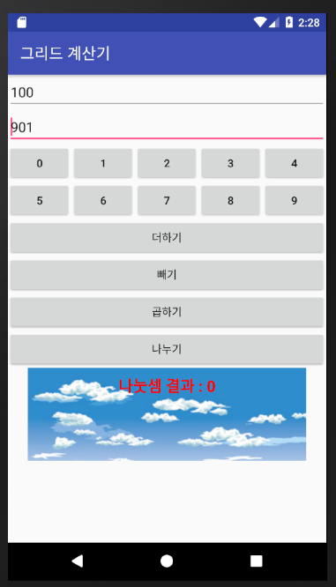 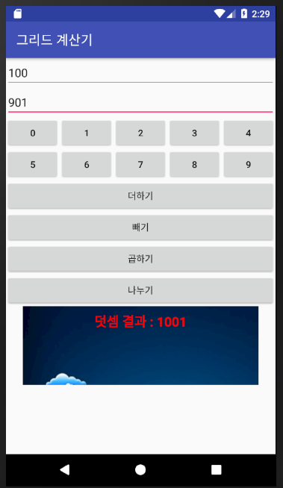

*<?***xml version="1.0" encoding="utf-8"***?>*<**GridLayout xmlns:android="http://schemas.android.com/apk/res/android"  
 xmlns:app="http://schemas.android.com/apk/res-auto"  
 android:layout_width="match_parent"  
 android:layout_height="match_parent"  
 android:columnCount="5"  
 android:rowCount="9"**>  
 <**EditText  
 android:id="@+id/Edit1"  
 android:layout_width="wrap_content"  
 android:layout_height="wrap_content"  
 android:layout_row="0"  
 android:layout_column="0"  
 android:layout_columnSpan="5"  
 android:layout_gravity="fill_horizontal"  
 android:hint="@string/edit1_hit"**/>  
 <**EditText  
 android:id="@+id/Edit2"  
 android:layout_width="match_parent"  
 android:layout_height="wrap_content"  
 android:layout_row="1"  
 android:layout_column="0"  
 android:layout_columnSpan="5"  
 android:hint="@string/edit2_hint"**/>  
 <**Button  
 android:id="@+id/BtnNum0"  
 android:text="0"  
 android:layout_row="2"  
 android:layout_column="0"  
 android:layout_width="0dp"  
 android:layout_columnWeight="1"**/>  
 <**Button  
 android:id="@+id/BtnNum1"  
 android:text="1"  
 android:layout_row="2"  
 android:layout_column="1"  
 android:layout_width="0dp"  
 android:layout_columnWeight="1"**/>  
 <**Button  
 android:id="@+id/BtnNum2"  
 android:text="2"  
 android:layout_row="2"  
 android:layout_column="2"  
 android:layout_width="0dp"  
 android:layout_columnWeight="1"**/>  
 <**Button  
 android:id="@+id/BtnNum3"  
 android:text="3"  
 android:layout_row="2"  
 android:layout_column="3"  
 android:layout_width="0dp"  
 android:layout_columnWeight="1"**/>  
 <**Button  
 android:id="@+id/BtnNum4"  
 android:text="4"  
 android:layout_row="2"  
 android:layout_column="4"  
 android:layout_width="0dp"  
 android:layout_columnWeight="1"**/>  
 <**Button  
 android:id="@+id/BtnNum5"  
 android:text="5"  
 android:layout_row="3"  
 android:layout_column="0"  
 android:layout_width="0dp"  
 android:layout_columnWeight="1"**/>  
 <**Button  
 android:id="@+id/BtnNum6"  
 android:text="6"  
 android:layout_row="3"  
 android:layout_column="1"  
 android:layout_width="0dp"  
 android:layout_columnWeight="1"**/>  
 <**Button  
 android:id="@+id/BtnNum7"  
 android:text="7"  
 android:layout_row="3"  
 android:layout_column="2"  
 android:layout_width="0dp"  
 android:layout_columnWeight="1"**/>  
 <**Button  
 android:id="@+id/BtnNum8"  
 android:text="8"  
 android:layout_row="3"  
 android:layout_column="3"  
 android:layout_width="0dp"  
 android:layout_columnWeight="1"**/>  
 <**Button  
 android:id="@+id/BtnNum9"  
 android:text="9"  
 android:layout_row="3"  
 android:layout_column="4"  
 android:layout_width="0dp"  
 android:layout_columnWeight="1"**/>  
 <**Button  
 android:id="@+id/BtnAdd"  
 android:text="더하기"  
 android:layout_row="4"  
 android:layout_column="0"  
 android:layout_columnSpan="5"  
 android:layout_width="match_parent"**/>  
 <**Button  
 android:id="@+id/BtnSub"  
 android:text="빼기"  
 android:layout_row="5"  
 android:layout_column="0"  
 android:layout_columnSpan="5"  
 android:layout_width="match_parent"**/>  
 <**Button  
 android:id="@+id/BtnMul"  
 android:text="곱하기"  
 android:layout_row="6"  
 android:layout_column="0"  
 android:layout_columnSpan="5"  
 android:layout_width="match_parent"**/>  
 <**Button  
 android:id="@+id/BtnDiv"  
 android:text="나누기"  
 android:layout_row="7"  
 android:layout_column="0"  
 android:layout_columnSpan="5"  
 android:layout_width="match_parent"**/>  
 <**FrameLayout  
 android:layout_width="match_parent"  
 android:layout_height="120dp"  
 android:layout_column="0"  
 android:layout_columnSpan="5"  
 android:layout_row="8"**>  
 <**ScrollView  
 android:id="@+id/ScrollView1"  
 android:layout_width="match_parent"  
 android:layout_height="120dp"**>  
 <**ImageView  
 android:id="@+id/imageView1"  
 android:layout_width="match_parent"  
 android:layout_height="wrap_content"  
 app:srcCompat="@drawable/dream01"** />  
 </**ScrollView**>  
 <**ScrollView  
 android:id="@+id/ScrollView2"  
 android:layout_width="match_parent"  
 android:layout_height="120dp"**>  
 <**ImageView  
 android:id="@+id/imageView2"  
 android:layout_width="match_parent"  
 android:layout_height="wrap_content"  
 app:srcCompat="@drawable/dream02"** />  
 </**ScrollView**>  
 <**TextView  
 android:id="@+id/TextResult"  
 android:layout_width="match_parent"  
 android:layout_height="wrap_content"  
 android:text="계산 결과 :"  
 android:gravity="center"  
 android:textColor="#FFFF0000"  
 android:textSize="20sp"  
 android:textStyle="bold"  
 android:layout_margin="10dp"** />  
 </**FrameLayout**>  
</**GridLayout**>

**public class** MainActivity **extends** AppCompatActivity {  
 **private** EditText **edit1**, **edit2**;  
 **private** Button **btnAdd**, **btnSub**, **btnMul**, **btnDiv**;  
 **private** TextView **textResult**;  
 **private** Button[] **btnNum** = **new** Button[10];  
 **private int**[] **IDs** = {R.id.***BtnNum0***, R.id.***BtnNum1***,R.id.***BtnNum2***,  
 R.id.***BtnNum3***,R.id.***BtnNum4***,R.id.***BtnNum5***,  
 R.id.***BtnNum6***,R.id.***BtnNum7***,R.id.***BtnNum8***,R.id.***BtnNum9***};  
 **private** ScrollView **scrollView1**, **scrollView2**;  
 **private** String **num1**, **num2**;  
 **private int result**;  
 @Override  
 **protected void** onCreate(Bundle savedInstanceState) {  
 **super**.onCreate(savedInstanceState);  
 setContentView(R.layout.***activity_main***);  
 setTitle(**"그리드 계산기"**);  
 **edit1** = (EditText)findViewById(R.id.***Edit1***);  
 **edit2** = (EditText)findViewById(R.id.***Edit2***);  
 **for**(**int** i=0 ; i< **IDs**.**length** ; i++){  
 **btnNum**[i] = (Button)findViewById(**IDs**[i]);  
 }  
 **btnAdd** = (Button)findViewById(R.id.***BtnAdd***);  
 **btnSub** = (Button)findViewById(R.id.***BtnSub***);  
 **btnMul** = (Button)findViewById(R.id.***BtnMul***);  
 **btnDiv** = (Button)findViewById(R.id.***BtnDiv***);  
 **scrollView1** = (ScrollView)findViewById(R.id.***ScrollView1***);  
 **scrollView2** = (ScrollView)findViewById(R.id.***ScrollView2***);  
 **textResult** = (TextView)findViewById(R.id.***TextResult***);  
 **for**(**int** i=0 ; i<**IDs**.**length** ; i++){  
 **final int** idx = i; *//이너 메소드에서 필요한 final 변수* **btnNum**[i].setOnClickListener(**new** View.OnClickListener() {  
 @Override  
 **public void** onClick(View view) {  
 **if**(**edit1**.isFocused()){  
 **num1** = **edit1**.getText().toString() + **btnNum**[idx].getText().toString();  
 **edit1**.setText(**num1**);  
 }**else if**(**edit2**.isFocused()){  
 **num2** = **edit2**.getText().toString() + **btnNum**[idx].getText().toString();  
 **edit2**.setText(**num2**);  
 }**else**{  
 Toast.*makeText*(getApplicationContext(), **"먼저 에디터텍스트를 선택하세요"**, Toast.***LENGTH_LONG***).show();  
 }  
 }  
 });  
 }*// 숫자 버튼 이벤트 처리 for문* **btnAdd**.setOnClickListener(**new** View.OnClickListener() {  
 @Override  
 **public void** onClick(View view) {  
 **num1** = **edit1**.getText().toString();  
 **num2** = **edit2**.getText().toString();  
 **result** = Integer.*parseInt*(**num1**)+Integer.*parseInt*(**num2**);  
 **textResult**.setText(**"덧셈 결과 : "**+**result**);  
 **if**(**result**>=1000){  
 **scrollView1**.setVisibility(View.***INVISIBLE***);  
 **scrollView2**.setVisibility(View.***VISIBLE***); *//결과가 1000이상이면 밤 이미지가 1000이하면 낮이미지가 보임* }**else**{  
 **scrollView1**.setVisibility(View.***VISIBLE***);  
 **scrollView2**.setVisibility(View.***INVISIBLE***);  
 }  
 }  
 });  
 **btnSub**.setOnClickListener(**new** View.OnClickListener() {  
 @Override  
 **public void** onClick(View view) {  
 **num1** = **edit1**.getText().toString();  
 **num2** = **edit2**.getText().toString();  
 **result** = Integer.*parseInt*(**num1**)-Integer.*parseInt*(**num2**);  
 **textResult**.setText(**"뺄셈 결과 : "**+**result**);  
 **if**(**result**>=1000){  
 **scrollView1**.setVisibility(View.***INVISIBLE***);  
 **scrollView2**.setVisibility(View.***VISIBLE***); *//결과가 1000이상이면 밤 이미지가 1000이하면 낮이미지가 보임* }**else**{  
 **scrollView1**.setVisibility(View.***VISIBLE***);  
 **scrollView2**.setVisibility(View.***INVISIBLE***);  
 }  
 }  
 });  
 **btnMul**.setOnClickListener(**new** View.OnClickListener() {  
 @Override  
 **public void** onClick(View view) {  
 **num1** = **edit1**.getText().toString();  
 **num2** = **edit2**.getText().toString();  
 **result** = Integer.*parseInt*(**num1**)*Integer.*parseInt*(**num2**);  
 **textResult**.setText(**"곱셈 결과 : "**+**result**);  
 **if**(**result**>=1000){  
 **scrollView1**.setVisibility(View.***INVISIBLE***);  
 **scrollView2**.setVisibility(View.***VISIBLE***); *//결과가 1000이상이면 밤 이미지가 1000이하면 낮이미지가 보임* }**else**{  
 **scrollView1**.setVisibility(View.***VISIBLE***);  
 **scrollView2**.setVisibility(View.***INVISIBLE***);  
 }  
 }  
 });  
 **btnDiv**.setOnClickListener(**new** View.OnClickListener() {  
 @Override  
 **public void** onClick(View view) {  
 **num1** = **edit1**.getText().toString();  
 **num2** = **edit2**.getText().toString();  
 **result** = Integer.*parseInt*(**num1**)/Integer.*parseInt*(**num2**);  
 **textResult**.setText(**"나눗셈 결과 : "**+**result**);  
 **if**(**result**>=1000){  
 **scrollView1**.setVisibility(View.***INVISIBLE***);  
 **scrollView2**.setVisibility(View.***VISIBLE***); *//결과가 1000이상이면 밤 이미지가 1000이하면 낮이미지가 보임* }**else**{  
 **scrollView1**.setVisibility(View.***VISIBLE***);  
 **scrollView2**.setVisibility(View.***INVISIBLE***);  
 }  
 }  
 });  
 }  
}