**[05] 고급위젯**

1. 웹뷰 : 사용자가 웹브라우저 기능을 앱 안에 직접 포함할 수 있는 위젯

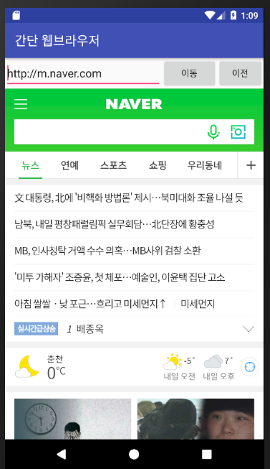

**Androidmanifest.xml**

*<?***xml version="1.0" encoding="utf-8"***?>*<**manifest xmlns:android="http://schemas.android.com/apk/res/android"  
 package="com.tj.ch05_webview"**>  
 <**uses-permission android:name="android.permission.INTERNET"**/>  
 <**application  
 android:allowBackup="true"  
 android:icon="@mipmap/ic_launcher"  
 android:label="간단한 웹브라우저"  
 android:roundIcon="@mipmap/ic_launcher_round"  
 android:supportsRtl="true"  
 android:theme="@style/AppTheme"  
 android:usesCleartextTraffic="true"**>  
 <**activity android:name=".MainActivity"**>  
 <**intent-filter**>  
 <**action android:name="android.intent.action.MAIN"** />  
  
 <**category android:name="android.intent.category.LAUNCHER"** />  
 </**intent-filter**>  
 </**activity**>  
 </**application**>  
</**manifest**>

**activity_main.xml**

*<?***xml version="1.0" encoding="utf-8"***?>*<**LinearLayout xmlns:android="http://schemas.android.com/apk/res/android"  
 android:layout_width="match_parent"  
 android:layout_height="match_parent"  
 android:orientation="vertical"**>  
 <**LinearLayout  
 android:layout_width="match_parent"  
 android:layout_height="wrap_content"  
 android:orientation="horizontal"**>  
 <**EditText  
 android:id="@+id/editUrl"  
 android:layout_width="250dp"  
 android:layout_height="wrap_content"  
 android:text="http://m.naver.com"**/>  
 <**Button  
 android:id="@+id/btnGo"  
 android:layout_width="wrap_content"  
 android:layout_height="wrap_content"  
 android:text="이동"**/>  
 <**Button  
 android:id="@+id/btnBack"  
 android:layout_width="wrap_content"  
 android:layout_height="wrap_content"  
 android:text="이전"**/>  
 </**LinearLayout**>  
 <**WebView  
 android:id="@+id/webView"  
 android:layout_width="match_parent"  
 android:layout_height="match_parent"**/>  
</**LinearLayout**>

**MainActivity.java**

**public class** MainActivity **extends** AppCompatActivity {  
 **private** EditText **editUrl**;  
 **private** Button **btnGo**, **btnBack**;  
 **private** WebView **webView**;  
 @Override  
 **protected void** onCreate(Bundle savedInstanceState) {  
 **super**.onCreate(savedInstanceState);  
 setContentView(R.layout.***activity_main***);  
 **editUrl** = (EditText)findViewById(R.id.***editUrl***);  
 **btnGo** = (Button)findViewById(R.id.***btnGo***);  
 **btnBack** = (Button)findViewById(R.id.***btnBack***);  
 **webView** = (WebView)findViewById(R.id.***webView***);  
 *// 실행하면 webView에 "http://m.naver.com" 화면 보이기* **webView**.setWebViewClient(**new** CookWebViewClient());  
 WebSettings webSettings = **webView**.getSettings();  
 webSettings.setBuiltInZoomControls(**true**);  
 **webView**.loadUrl(**"http://192.168.10.101:8181/bookup"**);  
 **btnGo**.setOnClickListener(**new** View.OnClickListener() {  
 @Override  
 **public void** onClick(View v) {  
 **webView**.loadUrl(**editUrl**.getText().toString().trim());  
 }  
 });  
 **btnBack**.setOnClickListener(**new** View.OnClickListener() {  
 @Override  
 **public void** onClick(View v) {  
 **webView**.goBack();  
 }  
 });  
 }  
}

**class** CookWebViewClient **extends** WebViewClient{  
 @Override  
 **public boolean** shouldOverrideUrlLoading(WebView view, String url) {  
 **return super**.shouldOverrideUrlLoading(view, url);  
 }  
}

2. 날짜/시간 관련 위젯 ; TimePicker, DatePicker, CalenderView, Chronometer, AnalogClock, DigitalClock 등

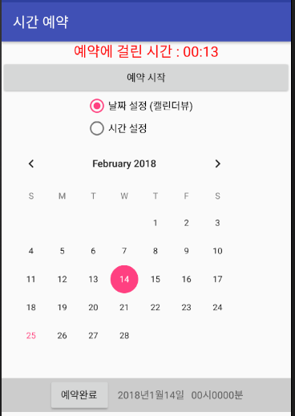 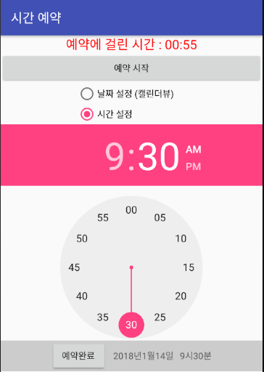

LinearLayout

(vertical)

LinearLayout

(horizontal)

**activity_main.xml**

*<?***xml version="1.0" encoding="utf-8"***?>*<**LinearLayout xmlns:android="http://schemas.android.com/apk/res/android"  
 android:layout_width="match_parent"  
 android:layout_height="match_parent"  
 android:orientation="vertical"  
 android:gravity="center"**>  
 <**LinearLayout  
 android:layout_width="match_parent"  
 android:layout_height="wrap_content"  
 android:orientation="vertical"  
 android:gravity="center"**>  
 <**Chronometer  
 android:id="@+id/chronometer"  
 android:layout_width="wrap_content"  
 android:layout_height="wrap_content"  
 android:format="예약에 걸린 시간 : %s"  
 android:textSize="20sp"  
 android:layout_marginTop="10dp"**/>  
 <**Button  
 android:id="@+id/btnStart"  
 android:layout_width="match_parent"  
 android:layout_height="wrap_content"  
 android:text="예약 시작"**/>  
 <**RadioGroup  
 android:layout_width="wrap_content"  
 android:layout_height="wrap_content"**>  
 <**RadioButton  
 android:id="@+id/rdoCal"  
 android:layout_width="wrap_content"  
 android:layout_height="wrap_content"  
 android:text="날짜 설정(캘렌더뷰)"**/>  
 <**RadioButton  
 android:id="@+id/rdoTime"  
 android:layout_width="wrap_content"  
 android:layout_height="wrap_content"  
 android:text="시간 설정"**/>  
 </**RadioGroup**>  
 <**FrameLayout  
 android:layout_width="wrap_content"  
 android:layout_height="wrap_content"**>  
 <**CalendarView  
 android:id="@+id/calendarView"  
 android:layout_width="wrap_content"  
 android:layout_height="wrap_content"**/>  
 <**TimePicker  
 android:id="@+id/timePicker"  
 android:layout_width="wrap_content"  
 android:layout_height="wrap_content"**/>  
 </**FrameLayout**>  
 </**LinearLayout**>  
 <**LinearLayout  
 android:layout_width="match_parent"  
 android:layout_height="wrap_content"  
 android:orientation="horizontal"  
 android:background="#DDDDDDDD"  
 android:gravity="center"**>  
 <**Button  
 android:id="@+id/btnEnd"  
 android:layout_width="wrap_content"  
 android:layout_height="wrap_content"  
 android:text="예약완료"  
 android:layout_marginRight="10dp"**/>  
 <**TextView  
 android:id="@+id/tvYear"  
 android:layout_width="wrap_content"  
 android:layout_height="wrap_content"  
 android:text="0000"**/>  
 <**TextView  
 android:layout_width="wrap_content"  
 android:layout_height="wrap_content"  
 android:text="년 "**/>  
 <**TextView  
 android:id="@+id/tvMonth"  
 android:layout_width="wrap_content"  
 android:layout_height="wrap_content"  
 android:text="00"**/>  
 <**TextView  
 android:layout_width="wrap_content"  
 android:layout_height="wrap_content"  
 android:text="월 "**/>  
 <**TextView  
 android:id="@+id/tvDay"  
 android:layout_width="wrap_content"  
 android:layout_height="wrap_content"  
 android:text="00"**/>  
 <**TextView  
 android:layout_width="wrap_content"  
 android:layout_height="wrap_content"  
 android:text="일 "**/>  
 <**TextView  
 android:id="@+id/tvHour"  
 android:layout_width="wrap_content"  
 android:layout_height="wrap_content"  
 android:text="00"**/>  
 <**TextView  
 android:layout_width="wrap_content"  
 android:layout_height="wrap_content"  
 android:text="시 "**/>  
 <**TextView  
 android:id="@+id/tvMinute"  
 android:layout_width="wrap_content"  
 android:layout_height="wrap_content"  
 android:text="00"**/>  
 <**TextView  
 android:layout_width="wrap_content"  
 android:layout_height="wrap_content"  
 android:text="분 "**/>  
 </**LinearLayout**>  
</**LinearLayout**>

**MainActivity.java**

**public class** MainActivity **extends** AppCompatActivity {  
 **private** Chronometer **chronometer**;  
 **private** Button **btnStart**, **btnEnd**;  
 **private** RadioButton **rdoCal**, **rdoTime**;  
 **private** CalendarView **calendarView**;  
 **private** TimePicker **timePicker**;  
 **private** TextView **tvYear**, **tvMonth**, **tvDay**, **tvHour**, **tvMinute**;  
 **private long pauseTime**;  
 @Override  
 **protected void** onCreate(Bundle savedInstanceState) {  
 **super**.onCreate(savedInstanceState);  
 setContentView(R.layout.***activity_main***);  
 setTitle(**"수명주기 및 고급 위젯 예제"**);  
 Log.*i*(**"★ 메인액티비티 생명주기 ★"**, **"onCreate() 호출됨"**);  
 **chronometer** = (Chronometer)findViewById(R.id.***chronometer***);  
 **btnStart** = (Button)findViewById(R.id.***btnStart***);  
 **btnEnd** = (Button)findViewById(R.id.***btnEnd***);  
 **rdoCal** = (RadioButton)findViewById(R.id.***rdoCal***);  
 **rdoTime** = (RadioButton)findViewById(R.id.***rdoTime***);  
 **calendarView** = (CalendarView)findViewById(R.id.***calendarView***);  
 **timePicker** = (TimePicker)findViewById(R.id.***timePicker***);  
 **tvYear** = (TextView)findViewById(R.id.***tvYear***);  
 **tvMonth** = (TextView)findViewById(R.id.***tvMonth***);  
 **tvDay** = (TextView)findViewById(R.id.***tvDay***);  
 **tvHour** = (TextView)findViewById(R.id.***tvHour***);  
 **tvMinute** = (TextView)findViewById(R.id.***tvMinute***);  
 **calendarView**.setVisibility(View.***INVISIBLE***); *// 안보이게* **timePicker**.setVisibility(View.***INVISIBLE***); *// 안보이게* **rdoCal**.setOnClickListener(**new** View.OnClickListener() {  
 @Override  
 **public void** onClick(View v) {  
 **calendarView**.setVisibility(View.***VISIBLE***); *// 캘렌더뷰 보이게* **timePicker**.setVisibility(View.***INVISIBLE***); *// timePicker는 안보이게* }  
 });  
 **rdoTime**.setOnClickListener(**new** View.OnClickListener() {  
 @Override  
 **public void** onClick(View v) {  
 **calendarView**.setVisibility(View.***INVISIBLE***);  
 **timePicker**.setVisibility(View.***VISIBLE***);  
 }  
 });  
 **calendarView**.setOnDateChangeListener(**new** CalendarView.OnDateChangeListener() {  
 @Override  
 **public void** onSelectedDayChange(@NonNull CalendarView view,  
 **int** year, **int** month, **int** dayOfMonth) {  
 **tvYear**.setText(String.*valueOf*(year));  
 **tvMonth**.setText(String.*valueOf*(month));  
 **tvDay**.setText(String.*valueOf*(dayOfMonth));  
 **tvYear**.setTextColor(Color.***BLUE***);  
 **tvMonth**.setTextColor(Color.***BLUE***);  
 **tvDay**.setTextColor(Color.***BLUE***);  
 }  
 });  
 **timePicker**.setOnTimeChangedListener(**new** TimePicker.OnTimeChangedListener() {  
 @Override  
 **public void** onTimeChanged(TimePicker view, **int** hourOfDay, **int** minute) {  
 **tvHour**.setText(String.*valueOf*(hourOfDay));  
 **tvMinute**.setText(Integer.*toString*(minute));  
 **tvHour**.setTextColor(Color.***BLUE***);  
 **tvMinute**.setTextColor(Color.***BLUE***);  
 }  
 });  
 **btnStart**.setOnClickListener(**new** View.OnClickListener() {  
 @Override  
 **public void** onClick(View v) {  
 *//SystemClock.elapsedRealtime() : 지금현재의 clockTime(밀리세컨)* **chronometer**.setBase(SystemClock.*elapsedRealtime*());  
 **chronometer**.start();  
 **chronometer**.setTextColor(Color.***RED***);  
 }  
 });  
 **btnEnd**.setOnClickListener(**new** View.OnClickListener() {  
 @Override  
 **public void** onClick(View v) {  
 **chronometer**.stop();  
 **chronometer**.setTextColor(Color.***BLACK***);  
 }  
 });  
 }  
 @Override  
 **protected void** onStart() {  
 **super**.onStart();  
 Log.*i*(**"★ 메인액티비티 생명주기 ★"**, **"onStart() 호출됨"**);  
 }  
 @Override  
 **protected void** onResume() {  
 **super**.onResume();  
 Log.*i*(**"★ 메인액티비티 생명주기 ★"**, **"onResume() 호출됨"**);  
 }  
 @Override  
 **protected void** onPause() {  
 **super**.onPause();  
 Log.*i*(**"★ 메인액티비티 생명주기 ★"**, **"onPause() 호출됨"**);  
 *// 중지 상태일 때 타이머를 멈추고 멈춘 시간을 pauseTime 변수에 저장* **pauseTime** = SystemClock.*elapsedRealtime*() - **chronometer**.getBase();  
 **chronometer**.stop();  
 }  
 @Override  
 **protected void** onStop() {  
 **super**.onStop();  
 Log.*i*(**"★ 메인액티비티 생명주기 ★"**, **"onStop() 호출됨"**);  
 }  
 @Override  
 **protected void** onRestart() {  
 **super**.onRestart();  
 Log.*i*(**"★ 메인액티비티 생명주기 ★"**, **"onRestart() 호출됨"**);  
 *// 중지상태에서 멈춘 chronometer를 pauseTime부터 다시 재개* **chronometer**.setBase(SystemClock.*elapsedRealtime*()-**pauseTime**);  
 **chronometer**.start();  
 }  
 @Override  
 **protected void** onDestroy() {  
 **super**.onDestroy();  
 Log.*i*(**"★ 메인액티비티 생명주기 ★"**, **"onDestroy() 호출됨"**);  
 }  
}