**[06] 액티비티와 인덴트**

1. 액티비티의 생명주기 : 시작, 실행, 정지, 종료 등의 생명주기(Life Cycle)을 가지고 있다. 액티비티의 이러한 생명주기를 개발자 입장에서는 정확히 파악하여 액티비티 상태에 맡게 로직을 구성하는 것이 필요하다

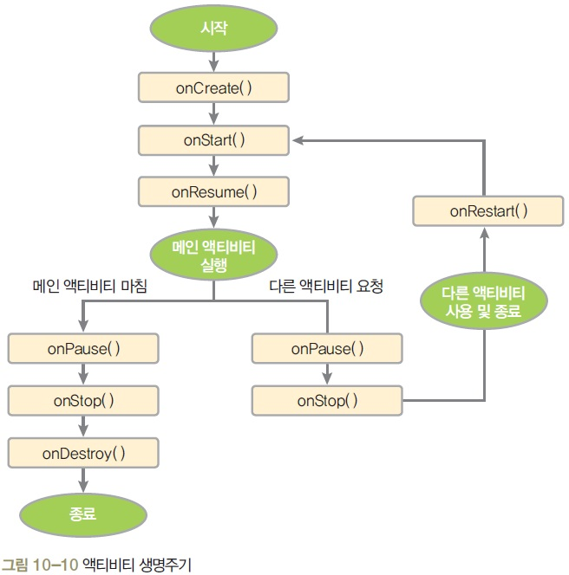

영구적으로 보존해야 할 데이터나 환경들은 onPause()에 저장해 놓는다.

1. 액티비티 추가 : 레이아웃(xml) 제작 → AppCompatActivity을 상속받아 액티비티 java Class 파일 제작 → AndroidManifest.xml파일에 환경 설정
2. 인텐트 : 액티비티 전환시 정보 전달을 목적으로 만들어진 장치이며 사용방법은 다음과 같다
   1. 정보전달이 없는 인텐트 사용

* 인텐트 객체 생성 - Intent intent = new Intent(MainActivity.this, SubActivity.class);
* 호출 메소드를 이용하여 액티비티 호출 - startAcitivity(intent);
  1. 단방향 정보 전달 : 액티비티 간에 통신 수단으로 사용되는 인텐트에 특정정보를 전달 할 수 있다
     + 인텐트 객체 생성 - Intent intent = new Intent(MainActivity.this, SubActivity.class);
     + 인텐트에 특정 정보를 넣는다 intent.putExtra(“키”,값);
     + 호출 메소드를 이용하여 액티비티 호출 - startAcitivity(intent);

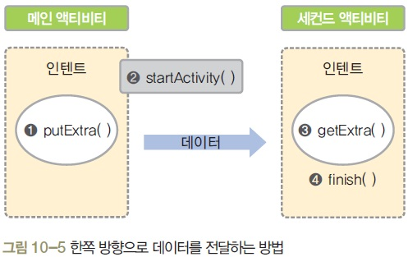

* 1. 양방향 정보 전달
     + 인텐트 객체 생성 - Intent intent = new Intent(MainActivity.this, SubActivity.class);
     + 인텐트에 특정 정보를 넣는다 intent.putExtra(“키”,값);
     + 호출 메소드를 이용하여 액티비티 호출 - startAcitivityForResult(intent, 코드값);
     + Intent inIntent = getIntent();
     + getIntExtra(“키”)나 getStringExtra(“키”)나 getBooleanExtra(“키”) 등 넘어온 데이터의 타입에 따라 넘어온 값을 받는다.
     + Intent outIntent = new Intent();
     + outIntent.putExtra(“키”,값);
     + setResult(RESULT_OK, outIntent);
     + finish();

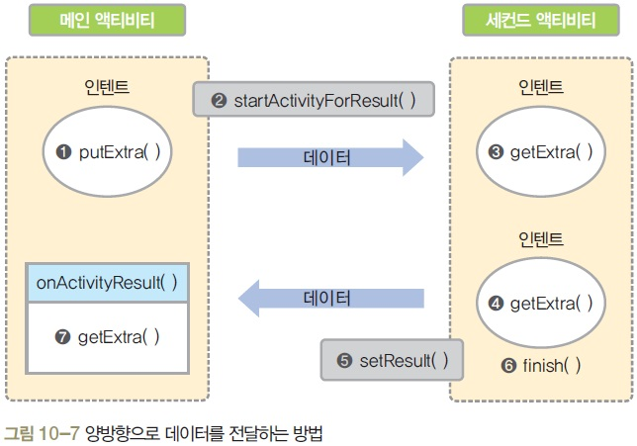

1. 예제

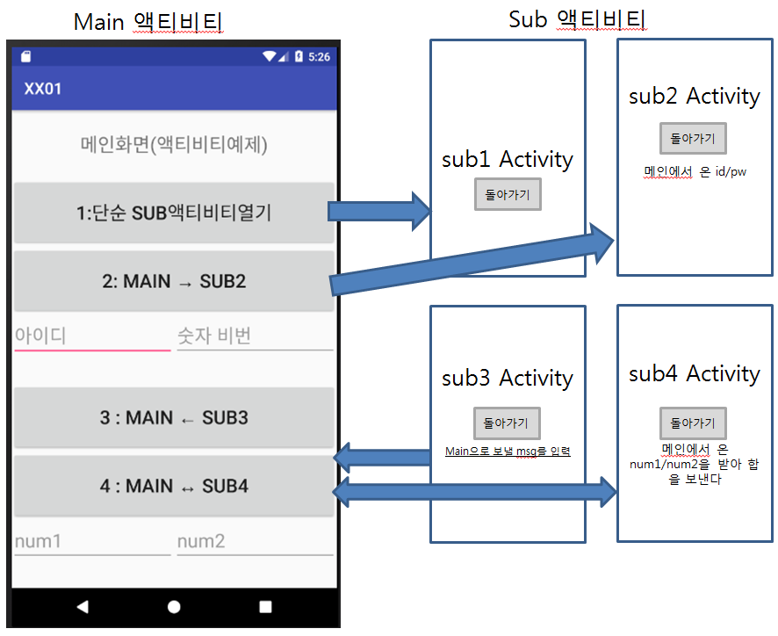

**strings.xml**

<**resources**>  
 <**string name="app_name"**>xx</**string**>  
 <**string name="btn1_title"**>1.단순 SUB액티비티열기</**string**>  
 <**string name="btn2_title"**>2:MAIN-<![CDATA[>]]>SUB2</**string**>  
 <**string name="btn3_title"**><![CDATA[3.MAIN<-SUB3]]></**string**>  
 <**string name="btn4_title"**><![CDATA[4.MAIN<->SUB4]]></**string**>  
 <**string name="main_title"**>메인화면(액티비티예제)</**string**>  
</**resources**>

**activity_main.xml**

*<?***xml version="1.0" encoding="utf-8"***?>*<**LinearLayout xmlns:android="http://schemas.android.com/apk/res/android"  
 android:layout_width="match_parent"  
 android:layout_height="match_parent"  
 android:orientation="vertical"**>  
 <**TextView  
 android:layout_width="match_parent"  
 android:layout_height="0dp"  
 android:layout_weight="1"  
 android:text="@string/main_title"  
 android:textSize="25sp"  
 android:gravity="center"**/>  
 <**Button  
 android:id="@+id/btn1"  
 android:layout_width="match_parent"  
 android:layout_height="0dp"  
 android:layout_weight="1"  
 android:text="@string/btn1_title"  
 android:textSize="25sp"**/>  
 <**Button  
 android:id="@+id/btn2"  
 android:layout_width="match_parent"  
 android:layout_height="0dp"  
 android:layout_weight="1"  
 android:text="@string/btn2_title"  
 android:textSize="25sp"**/>  
 <**LinearLayout  
 android:layout_width="match_parent"  
 android:layout_height="0dp"  
 android:layout_weight="1"**>  
 <**EditText  
 android:id="@+id/editId"  
 android:layout_width="0dp"  
 android:layout_height="wrap_content"  
 android:layout_weight="1"  
 android:hint="아이디"  
 android:textSize="20sp"**/>  
 <**EditText  
 android:id="@+id/editPw"  
 android:layout_width="0dp"  
 android:layout_height="wrap_content"  
 android:layout_weight="1"  
 android:hint="숫자 비번"  
 android:textSize="20sp"**/>  
 </**LinearLayout**>  
 <**Button  
 android:id="@+id/btn3"  
 android:layout_width="match_parent"  
 android:layout_height="0dp"  
 android:layout_weight="1"  
 android:text="@string/btn3_title"  
 android:textSize="25sp"**/>  
 <**Button  
 android:id="@+id/btn4"  
 android:layout_width="match_parent"  
 android:layout_height="0dp"  
 android:layout_weight="1"  
 android:text="@string/btn4_title"  
 android:textSize="25sp"**/>  
 <**LinearLayout  
 android:layout_width="match_parent"  
 android:layout_height="0dp"  
 android:layout_weight="1"**>  
 <**EditText  
 android:id="@+id/editNum1"  
 android:layout_width="0dp"  
 android:layout_height="wrap_content"  
 android:layout_weight="1"  
 android:hint="num1"  
 android:textSize="20sp"**/>  
 <**EditText  
 android:id="@+id/editNum2"  
 android:layout_width="0dp"  
 android:layout_height="wrap_content"  
 android:layout_weight="1"  
 android:hint="num2"  
 android:textSize="20sp"**/>  
 </**LinearLayout**>  
</**LinearLayout**>

**public class** MainActivity **extends** AppCompatActivity {  
 **private** Button **btn1**, **btn2**, **btn3**, **btn4**;  
 **private** EditText **editId**, **editPw**, **editNum1**, **editNum2**;  
 @Override  
 **protected void** onCreate(Bundle savedInstanceState) {  
 **super**.onCreate(savedInstanceState);  
 setContentView(R.layout.***activity_main***);  
 **btn1** = (Button)findViewById(R.id.***btn1***);  
 **btn2** = (Button)findViewById(R.id.***btn2***);  
 **btn3** = (Button)findViewById(R.id.***btn3***);  
 **btn4** = (Button)findViewById(R.id.***btn4***);  
 **editId** = (EditText)findViewById(R.id.***editId***);  
 **editPw** = (EditText)findViewById(R.id.***editPw***);  
 **editNum1** = (EditText)findViewById(R.id.***editNum1***);  
 **editNum2** = (EditText)findViewById(R.id.***editNum2***);  
 **btn1**.setOnClickListener(**new** View.OnClickListener() {  
 @Override  
 **public void** onClick(View v) {  
 Intent intent = **new** Intent(getApplicationContext(), Sub1.**class**);  
 startActivity(intent);  
 }  
 });  
 **btn2**.setOnClickListener(**new** View.OnClickListener() {  
 @Override  
 **public void** onClick(View v) {  
 Intent intent = **new** Intent(getApplicationContext(), Sub2.**class**);  
 intent.putExtra(**"id"**,**editId**.getText().toString());  
 **if**(!**editPw**.getText().toString().equals(**""**)){

intent.putExtra(**"pw"**,Integer.*parseInt*(**editPw**.getText().toString()));  
 }  
 startActivity(intent);  
 }  
 });  
 **btn3**.setOnClickListener(**new** View.OnClickListener() {  
 @Override  
 **public void** onClick(View v) {  
 Intent intent = **new** Intent(getApplicationContext(), Sub3.**class**);  
 startActivityForResult(intent, 103);  
 }  
 });  
 **btn4**.setOnClickListener(**new** View.OnClickListener() {  
 @Override  
 **public void** onClick(View v) {  
 Intent intent = **new** Intent(getApplicationContext(), Sub4.**class**);  
 **if**(!**editNum1**.getText().toString().equals(**""**)){  
 **int** num1 = Integer.*parseInt*(**editNum1**.getText().toString());  
 intent.putExtra(**"num1"**, num1);  
 }  
 **if**(!**editNum2**.getText().toString().equals(**""**)){  
 **int** num2 = Integer.*parseInt*(**editNum2**.getText().toString());  
 intent.putExtra(**"num2"**, num2);  
 }  
 startActivityForResult(intent, 104);  
 }  
 });  
 }*//onCreate* @Override  
 **protected void** onActivityResult(**int** requestCode, **int** resultCode, @Nullable Intent data) {  
 **super**.onActivityResult(requestCode, resultCode, data);  
 **if**(requestCode==103 && resultCode==***RESULT_OK***){  
 String fromSub3Msg = data.getStringExtra(**"fromSub3Msg"**);  
 Toast.*makeText*(getApplicationContext(), **"sub3에서 넘어온 msg:"**+fromSub3Msg, Toast.***LENGTH_SHORT***).show();  
 }**else if**(requestCode==104 && resultCode==***RESULT_OK***){  
 **int** sum = data.getIntExtra(**"sum"**,0);  
 Toast.*makeText*(getApplicationContext(), **"sub4에서 넘어온 sum:"**+sum, Toast.***LENGTH_SHORT***).show();  
 }  
 }  
}

**sub1.xml**

*<?***xml version="1.0" encoding="utf-8"***?>*<**android.support.constraint.ConstraintLayout xmlns:android="http://schemas.android.com/apk/res/android"  
 xmlns:app="http://schemas.android.com/apk/res-auto"  
 xmlns:tools="http://schemas.android.com/tools"  
 android:layout_width="match_parent"  
 android:layout_height="match_parent"  
 tools:context=".Sub1"**>  
 <**TextView  
 android:id="@+id/textView"  
 android:layout_width="wrap_content"  
 android:layout_height="wrap_content"  
 android:layout_marginTop="200dp"  
 android:text="sub1 Activity"  
 android:textSize="50sp"  
 app:layout_constraintEnd_toEndOf="parent"  
 app:layout_constraintStart_toStartOf="parent"  
 app:layout_constraintTop_toTopOf="parent"** />  
 <**Button  
 android:id="@+id/btnBack"  
 android:layout_width="wrap_content"  
 android:layout_height="wrap_content"  
 android:text="돌아가기"  
 android:textSize="50sp"  
 app:layout_constraintBottom_toBottomOf="parent"  
 app:layout_constraintEnd_toEndOf="parent"  
 app:layout_constraintStart_toStartOf="parent"  
 app:layout_constraintTop_toTopOf="parent"** />  
</**android.support.constraint.ConstraintLayout**>

**public class** Sub1 **extends** AppCompatActivity {  
 @Override  
 **protected void** onCreate(Bundle savedInstanceState) {  
 **super**.onCreate(savedInstanceState);  
 setContentView(R.layout.***sub1***);  
 findViewById(R.id.***btnBack***).setOnClickListener(**new** View.OnClickListener() {  
 @Override  
 **public void** onClick(View v) {  
 finish();  
 }  
 });  
 }  
}

**sub2.xml**

*<?***xml version="1.0" encoding="utf-8"***?>*<**LinearLayout xmlns:android="http://schemas.android.com/apk/res/android"  
 android:layout_width="match_parent"  
 android:layout_height="match_parent"  
 android:orientation="vertical"  
 android:gravity="center"**>  
 <**TextView  
 android:layout_width="wrap_content"  
 android:layout_height="wrap_content"  
 android:text="sub2 Activity"  
 android:textSize="50sp"**/>  
 <**Button  
 android:id="@+id/btnBack"  
 android:layout_width="wrap_content"  
 android:layout_height="wrap_content"  
 android:text="돌아가기"  
 android:textSize="50sp"  
 android:layout_margin="10dp"**/>  
 <**TextView  
 android:id="@+id/tvFromMain"  
 android:layout_width="wrap_content"  
 android:layout_height="wrap_content"  
 android:text="메인에서 온 id/pw : "  
 android:textSize="25sp"**/>  
</**LinearLayout**>

**public class** Sub2 **extends** AppCompatActivity {  
 **private** Button **btnBack**;  
 **private** TextView **tvFromMain**;  
 @Override  
 **protected void** onCreate(Bundle savedInstanceState) {  
 **super**.onCreate(savedInstanceState);  
 setContentView(R.layout.***sub2***);  
 **btnBack** = (Button)findViewById(R.id.***btnBack***);  
 **tvFromMain** = (TextView)findViewById(R.id.***tvFromMain***);  
 Intent inIntent = getIntent();  
 String id = inIntent.getStringExtra(**"id"**);  
 **int** pw = inIntent.getIntExtra(**"pw"**,0);  
 **tvFromMain**.append(id+**"/"**+pw);  
 **btnBack**.setOnClickListener(**new** View.OnClickListener() {  
 @Override  
 **public void** onClick(View v) {  
 finish();  
 }  
 });  
 }  
}

**sub3.xml**

*<?***xml version="1.0" encoding="utf-8"***?>*<**LinearLayout xmlns:android="http://schemas.android.com/apk/res/android"  
 android:layout_width="match_parent"  
 android:layout_height="match_parent"  
 android:orientation="vertical"  
 android:gravity="center"**>  
 <**TextView  
 android:layout_width="wrap_content"  
 android:layout_height="wrap_content"  
 android:text="sub3 Activity"  
 android:textSize="50sp"**/>  
 <**Button  
 android:id="@+id/btnBack"  
 android:layout_width="wrap_content"  
 android:layout_height="wrap_content"  
 android:text="돌아가기"  
 android:textSize="50sp"  
 android:layout_margin="10dp"**/>  
 <**EditText  
 android:id="@+id/tvToMain"  
 android:layout_width="wrap_content"  
 android:layout_height="wrap_content"  
 android:hint="Main으로 보낼 msg를 입력"  
 android:textSize="25sp"**/>  
</**LinearLayout**>

**public class** Sub3 **extends** AppCompatActivity {  
 **private** Button **btnBack**;  
 **private** EditText **tvToMain**;  
 @Override  
 **protected void** onCreate(Bundle savedInstanceState) {  
 **super**.onCreate(savedInstanceState);  
 setContentView(R.layout.***sub3***);  
 **btnBack** = (Button)findViewById(R.id.***btnBack***);  
 **tvToMain** = (EditText)findViewById(R.id.***tvToMain***);  
 **btnBack**.setOnClickListener(**new** View.OnClickListener() {  
 @Override  
 **public void** onClick(View v) {  
 Intent outIntent = **new** Intent();  
 outIntent.putExtra(**"fromSub3Msg"**,**tvToMain**.getText().toString());  
 setResult(***RESULT_OK***, outIntent);  
 finish();  
 }  
 });  
 }  
}

**sub4.xml**

*<?***xml version="1.0" encoding="utf-8"***?>*<**LinearLayout xmlns:android="http://schemas.android.com/apk/res/android"  
 android:layout_width="match_parent"  
 android:layout_height="match_parent"  
 android:orientation="vertical"  
 android:gravity="center"**>  
 <**TextView  
 android:layout_width="wrap_content"  
 android:layout_height="wrap_content"  
 android:text="sub4 Activity"  
 android:textSize="50sp"**/>  
 <**Button  
 android:id="@+id/btnBack"  
 android:layout_width="wrap_content"  
 android:layout_height="wrap_content"  
 android:text="돌아가기"  
 android:textSize="50sp"  
 android:layout_margin="10dp"**/>  
 <**TextView  
 android:id="@+id/tvFromMain"  
 android:layout_width="wrap_content"  
 android:layout_height="wrap_content"  
 android:text="메인에서 온 num1,num2받아 계산해서 보낸다"  
 android:textSize="25sp"  
 android:gravity="center"**/>  
</**LinearLayout**>

**public class** Sub4 **extends** AppCompatActivity {  
 **private** Button **btnBack**;  
 **private** TextView **tvFromMain**;  
 @Override  
 **protected void** onCreate(Bundle savedInstanceState) {  
 **super**.onCreate(savedInstanceState);  
 setContentView(R.layout.***sub4***);  
 Intent inIntent = getIntent();  
 **final int** num1 = inIntent.getIntExtra(**"num1"**,0);  
 **final int** num2 = inIntent.getIntExtra(**"num2"**,0);  
 **btnBack** = (Button)findViewById(R.id.***btnBack***);  
 **tvFromMain** = (TextView)findViewById(R.id.***tvFromMain***);  
 **tvFromMain**.setText(**"넘어온 num1="**+num1+**"/ num2="**+num2+**"을 받아 합을 보낸다"**);  
 **btnBack**.setOnClickListener(**new** View.OnClickListener() {  
 @Override  
 **public void** onClick(View v) {  
 Intent outIntent = **new** Intent();  
 outIntent.putExtra(**"sum"**, num1+num2);  
 setResult(***RESULT_OK***, outIntent);  
 finish();  
 }  
 });  
 }  
}

1. 총예제

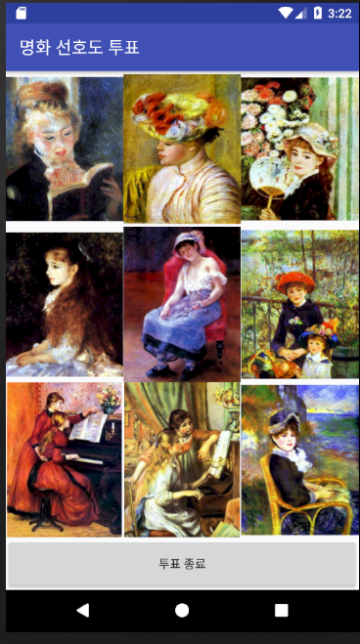 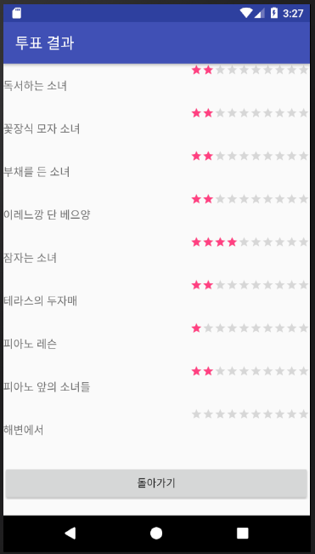

*<?***xml version="1.0" encoding="utf-8"***?>*<**LinearLayout xmlns:android="http://schemas.android.com/apk/res/android"  
 android:layout_width="match_parent"  
 android:layout_height="match_parent"  
 android:orientation="vertical"**>  
 <**LinearLayout  
 android:layout_width="match_parent"  
 android:layout_height="0dp"  
 android:layout_weight="3"**>  
 <**ImageView  
 android:id="@+id/iv1"  
 android:layout_width="0dp"  
 android:layout_height="match_parent"  
 android:layout_weight="1"  
 android:src="@drawable/pic1"**/>  
 <**ImageView  
 android:id="@+id/iv2"  
 android:layout_width="0dp"  
 android:layout_height="match_parent"  
 android:layout_weight="1"  
 android:src="@drawable/pic2"**/>  
 <**ImageView  
 android:id="@+id/iv3"  
 android:layout_width="0dp"  
 android:layout_height="match_parent"  
 android:layout_weight="1"  
 android:src="@drawable/pic3"**/>  
 </**LinearLayout**>  
 <**LinearLayout  
 android:layout_width="match_parent"  
 android:layout_height="0dp"  
 android:layout_weight="3"**>  
 <**ImageView  
 android:id="@+id/iv4"  
 android:layout_width="0dp"  
 android:layout_height="match_parent"  
 android:layout_weight="1"  
 android:src="@drawable/pic4"**/>  
 <**ImageView  
 android:id="@+id/iv5"  
 android:layout_width="0dp"  
 android:layout_height="match_parent"  
 android:layout_weight="1"  
 android:src="@drawable/pic5"**/>  
 <**ImageView  
 android:id="@+id/iv6"  
 android:layout_width="0dp"  
 android:layout_height="match_parent"  
 android:layout_weight="1"  
 android:src="@drawable/pic6"**/>  
 </**LinearLayout**>  
 <**LinearLayout  
 android:layout_width="match_parent"  
 android:layout_height="0dp"  
 android:layout_weight="3"**>  
 <**ImageView  
 android:id="@+id/iv7"  
 android:layout_width="0dp"  
 android:layout_height="match_parent"  
 android:layout_weight="1"  
 android:src="@drawable/pic7"**/>  
 <**ImageView  
 android:id="@+id/iv8"  
 android:layout_width="0dp"  
 android:layout_height="match_parent"  
 android:layout_weight="1"  
 android:src="@drawable/pic8"**/>  
 <**ImageView  
 android:id="@+id/iv9"  
 android:layout_width="0dp"  
 android:layout_height="match_parent"  
 android:layout_weight="1"  
 android:src="@drawable/pic9"**/>  
 </**LinearLayout**>  
 <**Button  
 android:id="@+id/btnFinish"  
 android:layout_width="match_parent"  
 android:layout_height="0dp"  
 android:layout_weight="1"  
 android:text="투표 종료"**/>  
</**LinearLayout**>

**public class** MainActivity **extends** AppCompatActivity {  
 **private** Button **btnResult**;  
 @Override  
 **protected void** onCreate(Bundle savedInstanceState) {  
 **super**.onCreate(savedInstanceState);  
 setContentView(R.layout.***activity_main***);  
 setTitle(**"명화 선호도 투표"**);  
 **final int** voteCount[] = **new int**[9];  
 **for**(**int** i=0 ; i<voteCount.**length** ; i++){  
 voteCount[i] = 0;  
 }  
 ImageView image[] = **new** ImageView[9];  
 **int** imageId[] = {R.id.***iv1***, R.id.***iv2***,R.id.***iv3***,R.id.***iv4***,R.id.***iv5***,  
 R.id.***iv6***,R.id.***iv7***,R.id.***iv8***,R.id.***iv9***};  
 **final** String imgName[] = {**"독서하는 소녀"**, **"꽃장식 모자 소녀"**,**"부채를 든 소녀"**,**"이레느깡 단 베으양"**,  
 **"잠자는 소녀"**,**"테라스의 두자매"**,**"피아노 레슨"**,**"피아노 앞의 소녀들"**,**"해변에서"**};  
 **for**(**int** i=0 ; i<imageId.**length** ; i++){  
 **final int** idx = i;  
 image[i] = (ImageView)findViewById(imageId[i]);  
 image[i].setOnClickListener(**new** View.OnClickListener() {  
 @Override  
 **public void** onClick(View view) {  
 voteCount[idx]++;  
 Toast.*makeText*(MainActivity.**this**,  
 imgName[idx]+**" : 총 "**+voteCount[idx]+**"표"**,  
 Toast.***LENGTH_SHORT***).show();  
 }  
 });  
 }  
 Button btnFinish = (Button)findViewById(R.id.***btnFinish***);  
 btnFinish.setOnClickListener(**new** View.OnClickListener() {  
 @Override  
 **public void** onClick(View view) {  
 Intent intent = **new** Intent(MainActivity.**this**, ResultActivity.**class**);  
 intent.putExtra(**"voteCount"**, voteCount);  
 intent.putExtra(**"imgName"**, imgName);  
 startActivity(intent);  
 }  
 });  
 }  
}

result.xml

*<?***xml version="1.0" encoding="utf-8"***?>*<**TableLayout xmlns:android="http://schemas.android.com/apk/res/android"  
 android:layout_width="match_parent" android:layout_height="match_parent"  
 android:stretchColumns="0"**>  
 <**TableRow  
 android:layout_weight="1"  
 android:gravity="center"**>  
 <**TextView  
 android:id="@+id/tv1"  
 android:layout_gravity="center_vertical"  
 android:text="그림1"  
 android:textSize="15sp"** />  
 <**RatingBar  
 android:id="@+id/rbar1"  
 style="?android:attr/ratingBarStyleSmall"  
 android:numStars="10"  
 android:layout_gravity="right"**/>  
 </**TableRow**>  
 <**TableRow  
 android:layout_weight="1"  
 android:gravity="center"**>  
 <**TextView  
 android:id="@+id/tv2"  
 android:layout_gravity="center_vertical"  
 android:text="그림2"  
 android:textSize="15sp"** />  
 <**RatingBar  
 android:id="@+id/rbar2"  
 style="?android:attr/ratingBarStyleSmall"  
 android:numStars="10"  
 android:layout_gravity="right"**/>  
 </**TableRow**>  
 <**TableRow  
 android:layout_weight="1"  
 android:gravity="center"**>  
 <**TextView  
 android:id="@+id/tv3"  
 android:layout_gravity="center_vertical"  
 android:text="그림3"  
 android:textSize="15sp"** />  
 <**RatingBar  
 android:id="@+id/rbar3"  
 style="?android:attr/ratingBarStyleSmall"  
 android:numStars="10"  
 android:layout_gravity="right"**/>  
 </**TableRow**>  
 <**TableRow  
 android:layout_weight="1"  
 android:gravity="center"**>  
 <**TextView  
 android:id="@+id/tv4"  
 android:layout_gravity="center_vertical"  
 android:text="그림4"  
 android:textSize="15sp"** />  
 <**RatingBar  
 android:id="@+id/rbar4"  
 style="?android:attr/ratingBarStyleSmall"  
 android:numStars="10"  
 android:layout_gravity="right"**/>  
 </**TableRow**>  
 <**TableRow  
 android:layout_weight="1"  
 android:gravity="center"**>  
 <**TextView  
 android:id="@+id/tv5"  
 android:layout_gravity="center_vertical"  
 android:text="그림5"  
 android:textSize="15sp"** />  
 <**RatingBar  
 android:id="@+id/rbar5"  
 style="?android:attr/ratingBarStyleSmall"  
 android:numStars="10"  
 android:layout_gravity="right"**/>  
 </**TableRow**>  
 <**TableRow  
 android:layout_weight="1"  
 android:gravity="center"**>  
 <**TextView  
 android:id="@+id/tv6"  
 android:layout_gravity="center_vertical"  
 android:text="그림6"  
 android:textSize="15sp"** />  
 <**RatingBar  
 android:id="@+id/rbar6"  
 style="?android:attr/ratingBarStyleSmall"  
 android:numStars="10"  
 android:layout_gravity="right"**/>  
 </**TableRow**>  
 <**TableRow  
 android:layout_weight="1"  
 android:gravity="center"**>  
 <**TextView  
 android:id="@+id/tv7"  
 android:layout_gravity="center_vertical"  
 android:text="그림7"  
 android:textSize="15sp"** />  
 <**RatingBar  
 android:id="@+id/rbar7"  
 style="?android:attr/ratingBarStyleSmall"  
 android:numStars="10"  
 android:layout_gravity="right"**/>  
 </**TableRow**>  
 <**TableRow  
 android:layout_weight="1"  
 android:gravity="center"**>  
 <**TextView  
 android:id="@+id/tv8"  
 android:layout_gravity="center_vertical"  
 android:text="그림8"  
 android:textSize="15sp"** />  
 <**RatingBar  
 android:id="@+id/rbar8"  
 style="?android:attr/ratingBarStyleSmall"  
 android:numStars="10"  
 android:layout_gravity="right"**/>  
 </**TableRow**>  
 <**TableRow  
 android:layout_weight="1"  
 android:gravity="center"**>  
 <**TextView  
 android:id="@+id/tv9"  
 android:text="그림9"  
 android:textSize="15sp"** />  
 <**RatingBar  
 android:id="@+id/rbar9"  
 style="?android:attr/ratingBarStyleSmall"  
 android:numStars="10"  
 android:layout_gravity="right"**/>  
 </**TableRow**>  
 <**TableRow  
 android:layout_weight="1"  
 android:gravity="center"**>  
 <**Button  
 android:id="@+id/btnReturn"  
 android:layout_span="2"  
 android:text="돌아가기"**/>  
 </**TableRow**>  
</**TableLayout**>

**public class** ResultActivity **extends** AppCompatActivity {  
 @Override  
 **protected void** onCreate(Bundle savedInstanceState) {  
 **super**.onCreate(savedInstanceState);  
 setContentView(R.layout.***result***);  
 setTitle(**"투표 결과"**);  
 Intent intent = getIntent();  
 **int**[] voteResult = intent.getIntArrayExtra(**"voteCount"**);  
 String[] imgName = intent.getStringArrayExtra(**"imgName"**);  
 TextView[] tv = **new** TextView[imgName.**length**];  
 RatingBar[] rbar = **new** RatingBar[imgName.**length**];  
 **int**[] tvID = {R.id.***tv1***, R.id.***tv2***, R.id.***tv3***, R.id.***tv4***,R.id.***tv5***,  
 R.id.***tv6***,R.id.***tv7***,R.id.***tv8***,R.id.***tv9***};  
 **int**[] rbarID = {R.id.***rbar1***, R.id.***rbar2***,R.id.***rbar3***,R.id.***rbar4***,R.id.***rbar5***,R.id.***rbar6***,R.id.***rbar7***,R.id.***rbar8***,R.id.***rbar9***};  
 **for**(**int** i=0;i<voteResult.**length** ; i++){  
 tv[i] = (TextView)findViewById(tvID[i]);  
 rbar[i] = (RatingBar)findViewById(rbarID[i]);  
 tv[i].setText(imgName[i]);  
 rbar[i].setRating(voteResult[i]);  
 }  
 Button btnReturn = (Button)findViewById(R.id.***btnReturn***);  
 btnReturn.setOnClickListener(**new** View.OnClickListener() {  
 @Override  
 **public void** onClick(View view) {  
 finish();  
 }  
 });  
 }  
}