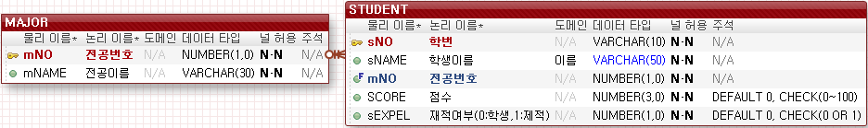

-- 테이블 DROP

DROP TABLE STUDENT;

DROP TABLE MAJOR;

-- 테이블 생성

CREATE TABLE MAJOR(

mNO NUMBER(1,0),

mNAME VARCHAR2(30) NOT NULL,

PRIMARY KEY(MNO));

INSERT INTO MAJOR VALUES (1, '컴퓨터공학');

INSERT INTO MAJOR VALUES (2, '경영정보');

INSERT INTO MAJOR VALUES (3, '산업디자인');

INSERT INTO MAJOR VALUES (4, '실용음악');

INSERT INTO MAJOR VALUES (5, '디지털콘텐츠');

CREATE TABLE STUDENT(

sNO VARCHAR2(10),

sNAME VARCHAR2(50) NOT NULL,

mNO NUMBER(1,0),

SCORE NUMBER(3,0) DEFAULT 0 NOT NULL,

sEXPEL NUMBER(1,0) DEFAULT 0 NOT NULL,

PRIMARY KEY(SNO),

FOREIGN KEY(MNO) REFERENCES MAJOR(MNO),

CHECK(SCORE>=0 AND SCORE<=100),

CHECK(sEXPEL=0 OR sEXPEL=1));

-- 1. 학번 검색 (학번, 이름, 전공명(전공번호), 점수)

SELECT S.*, mNAME FROM STUDENT S, MAJOR M WHERE S.MNO=M.MNO AND sNO='201901';

-- 2. 이름 검색 (학번, 이름, 전공명(전공번호), 점수)

SELECT S.*, mNAME FROM STUDENT S, MAJOR M WHERE S.MNO=M.MNO AND sNAME='홍길동';

-- 3. 전공 검색 (학번, 이름, 전공명(전공번호), 점수)

SELECT S.*, mNAME FROM STUDENT S, MAJOR M WHERE S.MNO=M.MNO AND MNAME='컴퓨터공학';

-- 4. 학생 입력 (학번, 이름, 전공명, 점수)

INSERT INTO STUDENT (sNO, sNAME, mNO, SCORE) VALUES

('201902','홍길순', (SELECT mNO FROM MAJOR WHERE mNAME='경영정보'),96);

INSERT INTO STUDENT (sNO, sNAME, mNO, SCORE) VALUES

('201901','홍길동',1,100);

SELECT * FROM STUDENT;

-- 5. 학생수정 (학번을 보고, 이름, 전공명, 점수 수정)

UPDATE STUDENT SET sNAME='홍길똥', mNO=(SELECT mNO FROM MAJOR WHERE mNAME='경영정보'),

SCORE=99

WHERE sNO='201901';

-- 6. 학생출력 (제적자제외 학번, 이름, 전공명(전공번호), 점수)

SELECT S.*, mNAME FROM STUDENT S, MAJOR M WHERE S.mNO=M.mNO AND sEXPEL=0;

-- 7. 제적처리 (학번을 보고 그 학생 제적자 처리)

UPDATE STUDENT SET sEXPEL=1 WHERE sNO='201902';

-- 8. 제적자 출력 (제적자만 학번, 이름, 전공명(전공번호), 점수, 제적상태)

SELECT S.*, mNAME FROM STUDENT S, MAJOR M WHERE S.mNO=M.mNO AND sEXPEL=1;

--0. 전공명 검색

SELECT MNAME FROM MAJOR;

select * from student;

commit;

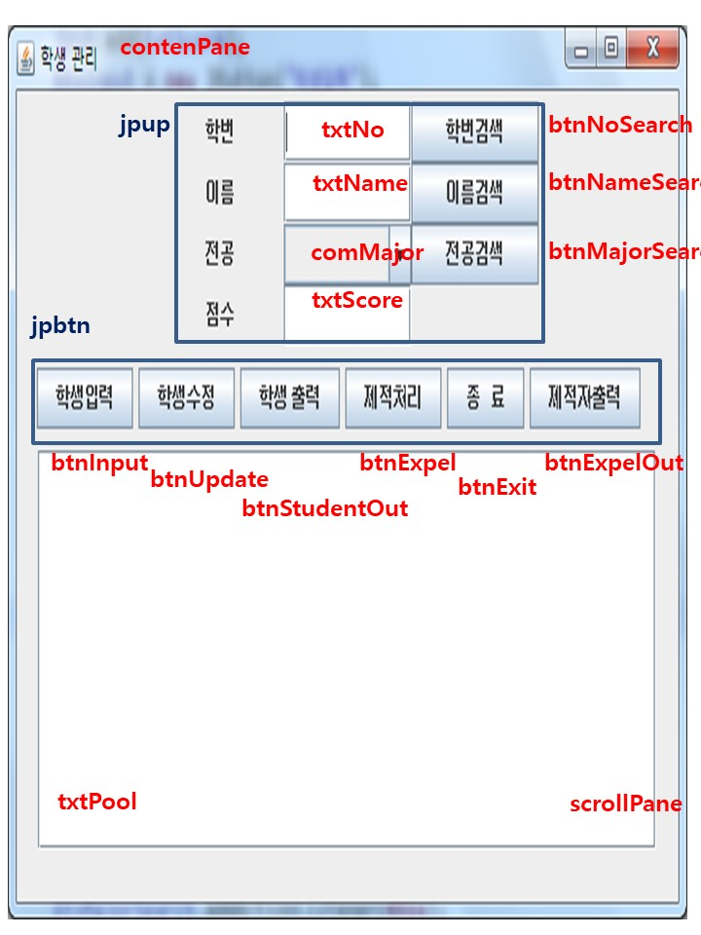

**package** com.tj.ex2;

**public** **class** StudentDto {

**private** String sNo;

**private** String sName;

**private** **int** mNo;

**private** **int** score;

**private** String sExpel;

**private** String mName;

**public** StudentDto() {}

**public** StudentDto(String sNo, String sName, **int** mNo, **int** score,

**int** sExpel, String mName) {

**this**.sNo = sNo;

**this**.sName = sName;

**this**.mNo = mNo;

**this**.score = score;

**if**(sExpel==0) {

**this**.sExpel = "학생";

}**else** {

**this**.sExpel = "제적자";

}

**this**.mName = mName;

}

@Override

**public** String toString() {

**return** "\t" + sNo + "\t" + sName + "\t" + mName + "(" +mNo+")\t"+ score

+ "\t"+ sExpel +"\n";

}

**public** **void** setsNo(String sNo) {**this**.sNo = sNo; }

**public** **void** setsName(String sName) {**this**.sName = sName;}

**public** **void** setmNo(**int** mNo) {**this**.mNo = mNo;}

**public** **void** setScore(**int** score) {**this**.score = score;}

**public** **void** setsExpel(String sExpel) {**this**.sExpel = sExpel;}

**public** **void** setmName(String mName) {**this**.mName = mName;}

}

**package** com.tj.ex2;

**import** java.awt.Container;

**import** java.awt.Dimension;

**import** java.awt.FlowLayout;

**import** java.awt.GridLayout;

**import** java.awt.event.ActionEvent;

**import** java.awt.event.ActionListener;

**import** java.sql.Connection;

**import** java.sql.DriverManager;

**import** java.sql.PreparedStatement;

**import** java.sql.ResultSet;

**import** java.sql.SQLException;

**import** java.util.ArrayList;

**import** java.util.Vector;

**import** javax.swing.JButton;

**import** javax.swing.JComboBox;

**import** javax.swing.JFrame;

**import** javax.swing.JLabel;

**import** javax.swing.JPanel;

**import** javax.swing.JScrollPane;

**import** javax.swing.JTextArea;

**import** javax.swing.JTextField;

**public** **class** StudentMng **extends** JFrame **implements** ActionListener {

// GUI 컴포넌트 변수

**private** Container contenPane;

**private** JPanel jpup, jpbtn;

**private** JTextField txtNo, txtName, txtScore;

**private** Vector<String> jobs;

**private** JComboBox<String> comMajor;

**private** JButton btnNoSearch, btnNameSearch, btnMajorSearch;

**private** JButton btnInput, btnUpdate, btnStudentOut;

**private** JButton btnExpel, btnExit, btnExpelOut;

**private** JTextArea txtPool;

**private** JScrollPane scrollPane;

// JDBC 관련변수

**private** String driver;

**private** String url;

**private** Connection conn;

**private** PreparedStatement pstmt;

**private** ResultSet rs;

**private** ArrayList<StudentDto> students;

**public** StudentMng(String title) {

**super**(title);

setDefaultCloseOperation(***EXIT_ON_CLOSE***);

students = **new** ArrayList<StudentDto>();

driver= "oracle.jdbc.driver.OracleDriver";

url ="jdbc:oracle:thin:@127.0.0.1:1521:xe";

contenPane = getContentPane();

contenPane.setLayout(**new** FlowLayout());

jpup = **new** JPanel(**new** GridLayout(4,3));

jpbtn = **new** JPanel();

txtNo = **new** JTextField(10);

txtName = **new** JTextField(10);

jobs = **new** Vector<String>();

jobs.add("");

**try** {

Class.*forName*(driver);

conn = DriverManager.*getConnection*(url, "scott", "tiger");

pstmt = conn.prepareStatement("SELECT MNAME FROM MAJOR");

rs = pstmt.executeQuery();

**while**(rs.next()) {

jobs.add(rs.getString("mname"));

}

} **catch** (ClassNotFoundException e) {

System.***out***.println(e.getMessage());

} **catch** (SQLException e) {

System.***out***.println(e.getMessage());

}**finally** {

**try** {

**if**(rs !=**null**) rs.close();

**if**(pstmt!=**null**) pstmt.close();

**if**(conn!=**null**) conn.close();

} **catch** (SQLException e1) { }

}

comMajor = **new** JComboBox<String>(jobs);

txtScore = **new** JTextField(10);

btnNoSearch = **new** JButton("학번검색");

btnNameSearch = **new** JButton("이름검색");

btnMajorSearch = **new** JButton("전공검색");

btnInput = **new** JButton("학생입력");

btnUpdate = **new** JButton("학생수정");

btnStudentOut = **new** JButton("학생출력");

btnExpel = **new** JButton("제적처리");

btnExit = **new** JButton("종료");

btnExpelOut = **new** JButton("제적자출력");

txtPool = **new** JTextArea(10, 50);

scrollPane = **new** JScrollPane(txtPool);

jpup.add(**new** JLabel("학번", (**int**) ***CENTER_ALIGNMENT***));

jpup.add(txtNo);

jpup.add(btnNoSearch);

jpup.add(**new** JLabel("이름", (**int**) ***CENTER_ALIGNMENT***));

jpup.add(txtName);

jpup.add(btnNameSearch);

jpup.add(**new** JLabel("전공", (**int**) ***CENTER_ALIGNMENT***));

jpup.add(comMajor);

jpup.add(btnMajorSearch);

jpup.add(**new** JLabel("점수", (**int**) ***CENTER_ALIGNMENT***));

jpup.add(txtScore);

jpbtn.add(btnInput);

jpbtn.add(btnUpdate);

jpbtn.add(btnStudentOut);

jpbtn.add(btnExpel);

jpbtn.add(btnExit);

jpbtn.add(btnExpelOut);

contenPane.add(jpup);

contenPane.add(jpbtn);

contenPane.add(scrollPane);

setSize(**new** Dimension(600, 400));

setLocation(200,150);

setVisible(**true**);

btnNoSearch.addActionListener(**this**);

btnNameSearch.addActionListener(**this**);

btnMajorSearch.addActionListener(**this**);

btnInput.addActionListener(**this**);

btnUpdate.addActionListener(**this**);

btnStudentOut.addActionListener(**this**);

btnExpel.addActionListener(**this**);

btnExit.addActionListener(**this**);

btnExpelOut.addActionListener(**this**);

}

@Override

**public** **void** actionPerformed(ActionEvent e) {

**if**(e.getSource()==btnNoSearch) {//학번검색

String sql = "SELECT S.*, mNAME FROM STUDENT S, MAJOR M "

+ "WHERE S.MNO=M.MNO AND sNO=?";

String sno = txtNo.getText().trim();

**if**(!sno.equals("")) {

// 학번 입력했으면 학번 검색 시작(conn, pstmt, rs ... close)

**try** {

conn = DriverManager.*getConnection*(url, "scott", "tiger");

pstmt = conn.prepareStatement(sql);

pstmt.setString(1, sno);

rs = pstmt.executeQuery();

**if**(rs.next()) {

txtNo.setText(rs.getString("sno"));

txtName.setText(rs.getString("sname"));

comMajor.setSelectedItem(rs.getString("mname"));

txtScore.setText(String.*valueOf*(rs.getInt("score")));

//txtScore.setText(rs.getString("score"));

txtPool.setText(sno+"검색 완료");

}**else** {

txtPool.setText("없는 학번입니다");

txtName.setText("");

comMajor.setSelectedIndex(0);

txtScore.setText("");

}

} **catch** (SQLException e1) {

System.***out***.println(e1.getMessage());

} **finally** {

**try** {

**if**(rs !=**null**) rs.close();

**if**(pstmt!=**null**) pstmt.close();

**if**(conn !=**null**) conn.close();

} **catch** (SQLException e1) { }

}

}**else** {

txtPool.setText("학번을 입력 후 학번 검색하세요");

}

}**else** **if**(e.getSource()==btnNameSearch){ // 이름검색

String sql = "SELECT S.*, mNAME FROM STUDENT S, MAJOR M "

+ "WHERE S.MNO=M.MNO AND sNAME=?";

String sname = txtName.getText().trim();

**if**(sname.length()!=0) {

**try** {

conn = DriverManager.*getConnection*(url, "scott", "tiger");

pstmt = conn.prepareStatement(sql);

pstmt.setString(1, sname);

rs = pstmt.executeQuery();

students.clear();

**while**(rs.next()) {

String sno = rs.getString("sno");

**int** mno = rs.getInt("mno");

String mname = rs.getString("mname");

**int** score = rs.getInt("score");

**int** sexpel = rs.getInt("sexpel");

txtNo.setText(sno);

txtName.setText(sname);

comMajor.setSelectedItem(mname);

txtScore.setText(String.*valueOf*(score));

students.add(**new** StudentDto(sno, sname, mno, score, sexpel, mname));

}

String temp = "\t학번\t이름\t학과명\t점수\t제적여부\n";

temp += "────────────────────────────────────────────\n";

**if**(students.size()==0) {

temp += "\t 해당 이름의 학생이 없습니다";

}**else** **if**(students.size()>1){

**for**(StudentDto s : students) {

temp += s.toString();

}

}

txtPool.setText(temp);

} **catch** (SQLException e1) {

System.***out***.println(e1.getMessage());

} **finally** {

**try** {

**if**(rs != **null**) rs.close();

**if**(pstmt!= **null**) pstmt.close();

**if**(conn != **null**) conn.close();

} **catch** (Exception e1) {System.***out***.println(e1.getMessage());}

}

}**else** {

txtPool.setText("이름은 입력하고 검색해야지");

}

}**else** **if**(e.getSource()==btnMajorSearch) { //전공검색

String sql = "SELECT S.*, mNAME FROM STUDENT S, MAJOR M "

+ "WHERE S.MNO=M.MNO AND MNAME=?";

**if**(comMajor.getSelectedIndex()!=0) {

**try** {

conn = DriverManager.*getConnection*(url, "scott", "tiger");

pstmt = conn.prepareStatement(sql);

pstmt.setString(1, comMajor.getSelectedItem().toString());

rs = pstmt.executeQuery();

students.clear();

**while**(rs.next()) {

String sno = rs.getString("sno");

String sname = rs.getString("sname");

**int** mno = rs.getInt("mno");

String mname = rs.getString("mname");

**int** score = rs.getInt("score");

**int** sexpel = rs.getInt("sexpel");

students.add(**new** StudentDto(sno, sname, mno, score, sexpel, mname));

}

String temp = "\t학번\t이름\t학과명\t점수\t제적여부\n";

temp += "────────────────────────────────────────────\n";

**if**(students.size()!=0) {

**for**(StudentDto s : students) {

temp += s.toString();

}

}**else** {

temp += "\t 해당 학생이 없습니다";

}

txtPool.setText(temp);

} **catch** (SQLException e1) {

System.***out***.println(e1.getMessage());

} **finally** {

**try** {

**if**(rs != **null**) rs.close();

**if**(pstmt!= **null**) pstmt.close();

**if**(conn != **null**) conn.close();

} **catch** (Exception e1) {System.***out***.println(e1.getMessage());}

}

}**else** {

txtPool.setText("전공은 선택하고 검색해야지");

}

}**else** **if**(e.getSource()==btnInput){ // 학생입력

String sql = "INSERT INTO STUDENT (sNO, sNAME, mNO, SCORE) VALUES " +

" (?,?, (SELECT mNO FROM MAJOR WHERE mNAME=?),?)";

String sno = txtNo.getText().trim();

String sname = txtName.getText().trim();

**if**(sno.length()!=0 && sname.length()!=0 && comMajor.getSelectedIndex()!=0) {

**try** {

conn = DriverManager.*getConnection*(url, "scott", "tiger");

pstmt = conn.prepareStatement(sql);

pstmt.setString(1, sno);

pstmt.setString(2, sname);

pstmt.setString(3, comMajor.getSelectedItem().toString());

**int** score = 0;

**try** {

score = Integer.*parseInt*(txtScore.getText());

**if**(score<0 || score>100) {

System.***out***.println("유효한 점수가 아니면 0점처리");

score = 0;

}

}**catch** (Exception e1) {

System.***out***.println("입력안하거나 문자면 0점");

}

pstmt.setInt(4, score);

**int** result = pstmt.executeUpdate();

System.***out***.println(result>0? "학생입력성공":"학생입력실패");

txtPool.setText(result>0? "학생입력성공":"학생입력실패");

txtNo.setText("");

txtName.setText("");

comMajor.setSelectedIndex(0);

txtScore.setText("");

} **catch** (SQLException e1) {

System.***out***.println(e1.getMessage());

} **finally** {

**try** {

**if**(pstmt!= **null**) pstmt.close();

**if**(conn != **null**) conn.close();

} **catch** (Exception e1) {System.***out***.println(e1.getMessage());}

}

}**else** {

txtPool.setText("학생입력시 학번, 이름, 전공을 입력해야해");

}

}**else** **if**(e.getSource()==btnUpdate) { //학생수정

String sql = "UPDATE STUDENT SET sNAME=?, " +

" mNO=(SELECT mNO FROM MAJOR WHERE mNAME=?), " +

" SCORE=? " +

" WHERE sNO=?";

String sno = txtNo.getText().trim();

String sname = txtName.getText().trim();

**if**(sno.length()!=0 && sname.length()!=0 && comMajor.getSelectedIndex() !=0) {

**try** {

conn = DriverManager.*getConnection*(url, "scott", "tiger");

pstmt = conn.prepareStatement(sql);

pstmt.setString(1, sname);

pstmt.setString(2, comMajor.getSelectedItem().toString());

**int** score = 0;

**try** {

score = Integer.*parseInt*(txtScore.getText());

**if**(score<0 || score>100) {

System.***out***.println("유효한 점수가 아니면 0점처리");

score = 0;

}

}**catch** (Exception e1) {

System.***out***.println("입력안하거나 문자면 0점");

}

pstmt.setInt(3, score);

pstmt.setString(4, sno);

**int** result = pstmt.executeUpdate();

System.***out***.println(result>0? "학생수정성공":"학생수정실패");

txtPool.setText(result>0? "학생수정성공":"학생수정실패");

} **catch** (SQLException e1) {

System.***out***.println(e1.getMessage());

} **finally** {

**try** {

**if**(pstmt!= **null**) pstmt.close();

**if**(conn != **null**) conn.close();

} **catch** (Exception e1) {System.***out***.println(e1.getMessage());}

}

}**else** {

txtPool.setText("학생수정시 학번, 이름, 전공을 입력해야해");

}

}**else** **if**(e.getSource()==btnStudentOut){ // 학생출력

String sql = "SELECT S.*, mNAME FROM STUDENT S, MAJOR M "

+ "WHERE S.mNO=M.mNO AND sEXPEL=0";

**try** {

conn = DriverManager.*getConnection*(url, "scott", "tiger");

pstmt = conn.prepareStatement(sql);

rs = pstmt.executeQuery();

students.clear();

**while**(rs.next()) {

StudentDto student = **new** StudentDto();

student.setsNo(rs.getString("sno"));

student.setsName(rs.getString("sname"));

student.setmNo(rs.getInt("mno"));

student.setScore(rs.getInt("score"));

**int** sexpel = rs.getInt("sexpel");

student.setsExpel(sexpel==0? "학생":"제적자");

student.setmName(rs.getString("mname"));

students.add(student);

}

/*while(rs.next()) {

String sNo = rs.getString("sno");

String sName = rs.getString("sname");

int mNo = rs.getInt("mno");;

int score = rs.getInt("score");;

int sExpel = rs.getInt("sexpel");

String mName = rs.getString("mname");

students.add(new StudentDto(sNo, sName, mNo, score, sExpel, mName));

}*/

txtPool.setText("\t학번\t이름\t학과명\t점수\t제적여부\n");

txtPool.append("────────────────────────────────────────────\n");

**if**(!students.isEmpty()) {

**for**(StudentDto s : students) {

txtPool.append(s.toString());

}

}**else** {

txtPool.append("\t 해당 학생이 없습니다");

}

txtNo.setText("");

txtName.setText("");

comMajor.setSelectedIndex(0);

txtScore.setText("");

} **catch** (SQLException e1) {

System.***out***.println(e1.getMessage());

}**finally** {

**try** {

**if**(rs != **null**) rs.close();

**if**(pstmt!= **null**) pstmt.close();

**if**(conn != **null**) conn.close();

} **catch** (Exception e1) {System.***out***.println(e1.getMessage());}

}

}**else** **if**(e.getSource()==btnExpel) { // 제적처리

String sql = "UPDATE STUDENT SET sEXPEL=1 WHERE sNO=?";

String sno = txtNo.getText().trim();

**if**(sno.length()!=0) {

**try** {

conn = DriverManager.*getConnection*(url, "scott", "tiger");

pstmt = conn.prepareStatement(sql);

pstmt.setString(1, sno);

**int** result = pstmt.executeUpdate();

**if**(result>0) {

System.***out***.println("제적처리 성공");

txtPool.setText("제적처리 성공");

}**else** {

System.***out***.println("해당 학번이 없어 제적처리 불가");

txtPool.setText("해당 학번이 없어 제적처리 불가");

}

txtNo.setText("");

txtName.setText("");

comMajor.setSelectedIndex(0);

txtScore.setText("");

} **catch** (SQLException e1) {

System.***out***.println(e1.getMessage());

} **finally** {

**try** {

**if**(pstmt!= **null**) pstmt.close();

**if**(conn != **null**) conn.close();

} **catch** (Exception e1) {System.***out***.println(e1.getMessage());}

}

}**else** {

txtPool.setText("학번은 입력하고 제적처리해야지");

}

}**else** **if**(e.getSource()==btnExit){ // 종료

setVisible(**false**);

dispose();

System.*exit*(0);

}**else** **if**(e.getSource()==btnExpelOut) { //제적자 출력

String sql = "SELECT S.*, mNAME FROM STUDENT S, MAJOR M "

+ "WHERE S.mNO=M.mNO AND sEXPEL=1";

**try** {

conn = DriverManager.*getConnection*(url, "scott", "tiger");

pstmt = conn.prepareStatement(sql);

rs = pstmt.executeQuery();

students.clear();

**while**(rs.next()) {

String sNo = rs.getString("sno");

String sName = rs.getString("sname");

**int** mNo = rs.getInt("mno");;

**int** score = rs.getInt("score");;

**int** sExpel = rs.getInt("sexpel");

String mName = rs.getString("mname");

students.add(**new** StudentDto(sNo, sName, mNo, score, sExpel, mName));

}

txtPool.setText("\t학번\t이름\t학과명\t점수\t제적여부\n");

txtPool.append("────────────────────────────────────────────\n");

**if**(!students.isEmpty()) {

**for**(StudentDto s : students) {

txtPool.append(s.toString());

}

}**else** {

txtPool.append("\t 해당 학생이 없습니다");

}

txtNo.setText("");

txtName.setText("");

comMajor.setSelectedIndex(0);

txtScore.setText("");

} **catch** (SQLException e1) {

System.***out***.println(e1.getMessage());

}**finally** {

**try** {

**if**(rs != **null**) rs.close();

**if**(pstmt!= **null**) pstmt.close();

**if**(conn != **null**) conn.close();

} **catch** (Exception e1) {System.***out***.println(e1.getMessage());}

}

}

}

**public** **static** **void** main(String[] args) {

**new** StudentMng("학생관리");

}

}