[ 13 ] 회원인증 프로그램 예제

1. DAO(데이터 Access하는 Object를 따로 관리), DTO(데이터베이스에서 나온 추출된 데이터를 변환해서 모듈화해서 저장)
2. 회원인증 프로그램 전체 흐름도

로그인

login.jsp

회원정보 update

modifyOk.jsp

회원가입

join.jsp

로그아웃

logout.jsp

로그인

loginOk.jsp

회원가입인증

JoinOk.jsp

회원정보 수정

modify.jsp

메인

main.jsp

DAO

MemberDao

1. Members 테이블 생성

**DROP** **TABLE** MEMBERS **CASCADE** CONSTRAINTS;

**CREATE** **TABLE** MEMBERS(

id VARCHAR2(30) **PRIMARY** **KEY**, -- ID

pw VARCHAR2(30) **NOT** **NULL**, -- PW

name VARCHAR2(30) **NOT** **NULL**, -- 이름

email VARCHAR2(30), -- 메일

birth **DATE** **NOT** **NULL**, -- 생년월일

rdate **DATE** **NOT** **NULL**, -- 가입한 날짜와 시간

address VARCHAR2(50)); -- 주소

**SELECT** * **FROM** MEMBERS;

-- 회원가입 할 때 ID가 있는지 없는지 판단

**SELECT** * **FROM** MEMBERS **WHERE** ID='aaa';

-- 회원가입 시 INSERT

**INSERT** **INTO** MEMBERS (ID, PW, NAME, EMAIL, BIRTH, RDATE, ADDRESS)

**VALUES** ('aaa','111','홍','hong@go.kr','1990-01-01', SYSDATE, '서울 종로');

**INSERT** **INTO** MEMBERS

**VALUES** ('aaa','111','홍','hong@go.kr','1990-01-01', SYSDATE, '서울 종로');

**DELETE** **FROM** MEMBERS;

**COMMIT**;

-- 로그인할 때 ID를 검색한 후 PW 확인

**SELECT** * **FROM** MEMBERS **WHERE** ID='aaa';

-- 회원정보 수정 할 때, ID로 DTO 반환해서 JSP화면에 뿌려지는 용도

**SELECT** * **FROM** MEMBERS **WHERE** ID='aaa';

-- 회원정보 수정 할 때, UPDATE

**UPDATE** MEMBERS **SET** PW='111', NAME='홍길', EMAIL='H@go.kr', BIRTH='1990-01-02',

ADDRESS='서울 용산'

**WHERE** ID='aaa';

1. context.xml 파일을 아래와 같이 수정 후 publish to server 작업 수행

<Resource name = *"jdbc/Oracle11g"*

auth=*"Container"*

type = *"javax.sql.DataSource"*

driverClassName = *"oracle.jdbc.driver.OracleDriver"*

url = *"jdbc:oracle:thin:@localhost:1521:xe"*

username = *"scott"*

password = *"tiger"*

maxActive = *"50"*

maxWait = *"1000"*

/>

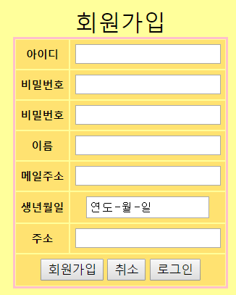 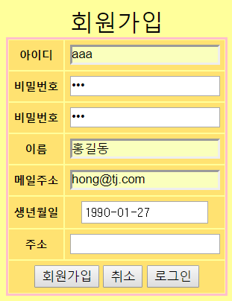

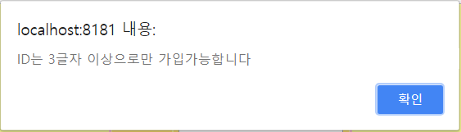

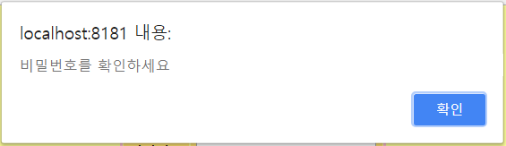

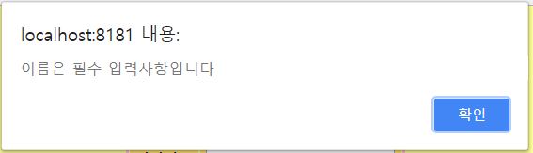

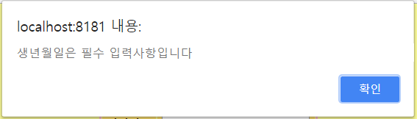

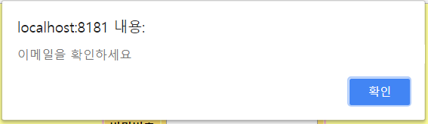

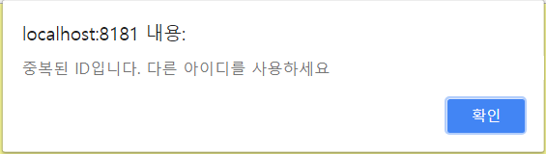

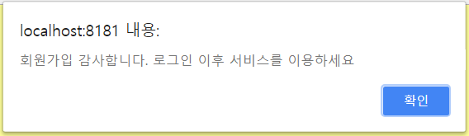

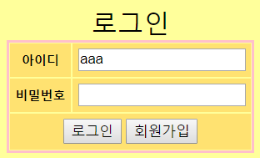 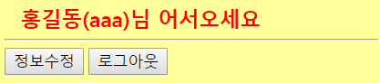

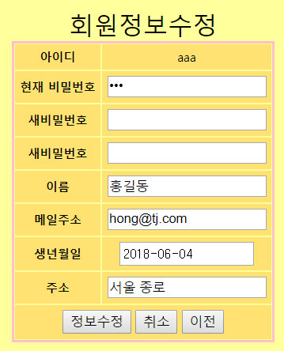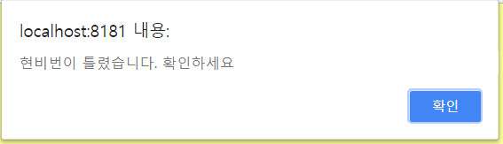

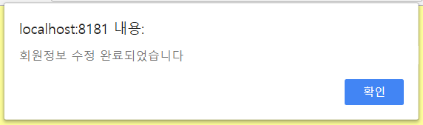

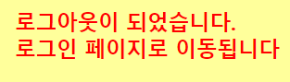

1. DTO

**package** com.tj.members;

**import** java.sql.Timestamp;

//DTO - 속성변수, setters&getters, 매개변수없는생성자, toString()

**public** **class** MembersDto {

**private** String id;

**private** String pw;

**private** String name;

**private** String email;

**private** Timestamp birth;

**private** Timestamp rDate;

**private** String address;

**public** MembersDto() { }

**public** MembersDto(String id, String pw, String name, String email, Timestamp birth, Timestamp rDate,

String address) {

**this**.id = id;

**this**.pw = pw;

**this**.name = name;

**this**.email = email;

**this**.birth = birth;

**this**.rDate = rDate;

**this**.address = address;

}

**public** String getId() {**return** id;}

**public** **void** setId(String id) {**this**.id = id;}

**public** String getPw() {**return** pw;}

**public** **void** setPw(String pw) {**this**.pw = pw;}

**public** String getName() {**return** name;}

**public** **void** setName(String name) {**this**.name = name;}

**public** String getEmail() {**return** email;}

**public** **void** setEmail(String email) {**this**.email = email;}

**public** Timestamp getBirth() {**return** birth;}

**public** **void** setBirth(Timestamp birth) {**this**.birth = birth;}

**public** Timestamp getrDate() {**return** rDate;}

**public** **void** setrDate(Timestamp rDate) {**this**.rDate = rDate;}

**public** String getAddress() {**return** address;}

**public** **void** setAddress(String address) {**this**.address = address;}

@Override

**public** String toString() {

**return** "회원정보 [id=" + id + ", pw=" + pw + ", name=" + name + ", email=" + email + ", birth=" + birth

+ ", rDate=" + rDate + ", address=" + address + "]";

}

}

1. DAO

**package** com.tj.members;

**import** java.sql.Connection;

**import** java.sql.PreparedStatement;

**import** java.sql.ResultSet;

**import** java.sql.SQLException;

**import** java.sql.Timestamp;

**import** javax.naming.Context;

**import** javax.naming.InitialContext;

**import** javax.naming.NamingException;

**import** javax.sql.DataSource;

**public** **class** MembersDao {

**public** **static** **final** **int** ***MEMBER_NONEXISTENT*** = 0; //없는 ID

**public** **static** **final** **int** ***MEMBER_EXISTENT*** = 1; //있는 ID

**public** **static** **final** **int** ***FAIL*** = 0; // 실패

**public** **static** **final** **int** ***SUCCESS*** = 1; // 성공

**public** **static** **final** **int** ***LOGIN_FAIL_ID*** = -1; // 로그인오류(id)

**public** **static** **final** **int** ***LOGIN_FAIL_PW*** = 0; // 로그인오류(pw)

**public** **static** **final** **int** ***LOGIN_SUCCESS*** = 1; // 로그인성공

**private** **static** MembersDao *instance*;

**public** **static** MembersDao getInstance() {

**if**(*instance*==**null**) {

*instance* = **new** MembersDao();

}

**return** *instance*;

}

**private** MembersDao() {}

**private** Connection getConnection() **throws** SQLException {

Connection conn = **null**;

// 커넥션풀에 있는 dataSource객체 가져와 getConnection()한다

**try** {

Context context = **new** InitialContext();

DataSource ds =

(DataSource) context.lookup("java:comp/env/jdbc/Oracle11g");

conn = ds.getConnection();

} **catch** (NamingException e) {

System.***out***.println(e.getMessage());

}

**return** conn;

}

// id 중복체크

**public** **int** confirmId(String id) {

**int** result = ***MEMBER_EXISTENT***;

// DB에 해당 id가 있는지 검색해서 결과에 따라 result값을 조정

Connection conn = **null**;

PreparedStatement pstmt = **null**;

ResultSet rs = **null**;

String sql = "SELECT * FROM MEMBERS WHERE ID=?";

**try** {

conn = getConnection();

pstmt = conn.prepareStatement(sql);

pstmt.setString(1, id);

rs = pstmt.executeQuery();

**if**(rs.next()) { // 있는 ID

result = ***MEMBER_EXISTENT***;

}**else** { // 없는 ID

result = ***MEMBER_NONEXISTENT***;

}

} **catch** (SQLException e) {

System.***out***.println(e.getMessage());

} **finally** {

**try** {

**if**(rs!=**null**) rs.close();

**if**(pstmt!=**null**) pstmt.close();

**if**(conn!=**null**) conn.close();

}**catch** (Exception e) {System.***out***.println(e.getMessage());}

}

**return** result;

}

// 회원가입

**public** **int** insertMember(MembersDto dto) {

**int** result = ***FAIL***;

// dto를 DB에 insert하고 결과를 result에 넣는다

Connection conn = **null**;

PreparedStatement pstmt = **null**;

String sql = "INSERT INTO MEMBERS VALUES (?,?,?,?,?,?,?)";

// id, pw, name, email, birth, rdate, address

**try** {

conn = getConnection();

pstmt = conn.prepareStatement(sql);

pstmt.setString(1, dto.getId());

pstmt.setString(2, dto.getPw());

pstmt.setString(3, dto.getName());

pstmt.setString(4, dto.getEmail());

pstmt.setTimestamp(5, dto.getBirth());

pstmt.setTimestamp(6, dto.getrDate());

pstmt.setString(7, dto.getAddress());

pstmt.executeUpdate();

result = ***SUCCESS***;

} **catch** (SQLException e) {

System.***out***.println(e.getMessage());

} **finally** {

**try** {

**if**(pstmt!=**null**) pstmt.close();

**if**(conn!=**null**) conn.close();

}**catch** (Exception e) {System.***out***.println(e.getMessage());}

}

**return** result;

}

// 로그인체크

**public** **int** loginCheck(String id, String pw) {

**int** result = ***LOGIN_FAIL_ID***;

// id, pw로 db접속해서 적당한 결과를 result에 조정

Connection conn = **null**;

PreparedStatement pstmt = **null**;

ResultSet rs = **null**;

String sql = "SELECT * FROM MEMBERS WHERE ID=?";

**try** {

conn = getConnection();

pstmt = conn.prepareStatement(sql);

pstmt.setString(1, id);

rs = pstmt.executeQuery();

**if**(rs.next()) { // id는 맞게 쳤네

String dbPw = rs.getString("pw");

**if**(dbPw.equals(pw)) { // id,pw를 맞게 쳤네. 로그인성공

result = ***LOGIN_SUCCESS***;

}**else** { //id는 맞고 pw는 틀려

result = ***LOGIN_FAIL_PW***;

}

}**else** { // id를 틀리게 쳤네

result = ***LOGIN_FAIL_ID***;

}

} **catch** (SQLException e) {

System.***out***.println(e.getMessage());

} **finally** {

**try** {

**if**(rs!=**null**) rs.close();

**if**(pstmt!=**null**) pstmt.close();

**if**(conn!=**null**) conn.close();

}**catch** (Exception e) {System.***out***.println(e.getMessage());}

}

**return** result;

}

// id를 매개변수로 받아 members DTO반환

**public** MembersDto getMember(String id) {

MembersDto dto = **null**;

// id로 select 한 결과를 dto에 넣어 return

Connection conn = **null**;

PreparedStatement pstmt = **null**;

ResultSet rs = **null**;

String sql = "SELECT * FROM MEMBERS WHERE ID=?";

**try** {

conn = getConnection();

pstmt = conn.prepareStatement(sql);

pstmt.setString(1, id);

rs = pstmt.executeQuery();

**if**(rs.next()) {

String pw = rs.getString("pw");

String name = rs.getString("name");

String email = rs.getString("email");

Timestamp birth = rs.getTimestamp("birth");

Timestamp rDate = rs.getTimestamp("rdate");

String address = rs.getString("address");

dto = **new** MembersDto(id, pw, name, email, birth,

rDate, address);

/*dto = new MembersDto();

dto.setId(rs.getString("id"));

dto.setPw(rs.getString("pw"));

dto.setName(rs.getString("name"));

dto.setEmail(rs.getString("email"));

dto.setBirth(rs.getTimestamp("birth"));

dto.setrDate(rs.getTimestamp("rdate"));

dto.setAddress(rs.getString("address"));*/

}

} **catch** (SQLException e) {

System.***out***.println(e.getMessage());

} **finally** {

**try** {

**if**(rs!=**null**) rs.close();

**if**(pstmt!=**null**) pstmt.close();

**if**(conn!=**null**) conn.close();

}**catch** (Exception e) {System.***out***.println(e.getMessage());}

}

**return** dto;

}

// 회원정보 수정

**public** **int** updateMember(MembersDto dto) {

**int** result = ***FAIL***;

// dto를 이용해서 update 문을 실행하고 result에 결과를 조정

Connection conn = **null**;

PreparedStatement pstmt = **null**;

String sql =

"UPDATE MEMBERS SET PW=?, NAME=?, EMAIL=?, BIRTH=?, ADDRESS=? "

+ " WHERE ID=?";

**try** {

conn = getConnection();

pstmt = conn.prepareStatement(sql);

pstmt.setString(1, dto.getPw());

pstmt.setString(2, dto.getName());

pstmt.setString(3, dto.getEmail());

pstmt.setTimestamp(4, dto.getBirth());

pstmt.setString(5, dto.getAddress());

pstmt.setString(6, dto.getId());

/*int temp = pstmt.executeUpdate();

if(temp>0)

result = SUCCESS;*/

result = pstmt.executeUpdate();

} **catch** (SQLException e) {

System.***out***.println(e.getMessage());

} **finally** {

**try** {

**if**(pstmt!=**null**) pstmt.close();

**if**(conn!=**null**) conn.close();

}**catch** (Exception e) {System.***out***.println(e.getMessage());}

}

**return** result;

}

}

1. test.jsp

<%@page import=*"java.sql.Timestamp"*%>

<%@page import=*"com.tj.members.MembersDao,com.tj.members.MembersDto"*%>

<%@ page language=*"java"* contentType=*"text/html; charset=UTF-8"*

pageEncoding=*"UTF-8"*%>

<!DOCTYPE html>

<html>

<head>

<meta http-equiv=*"Content-Type"* content=*"text/html; charset=UTF-8"*>

<title>Insert title here</title>

</head>

<body>

<% MembersDao dao = MembersDao.getInstance();

MembersDto dto = **new** MembersDto("aaa","111","홍","h@h",

Timestamp.valueOf("2018-06-15 13:00:00"),**new** Timestamp(System.currentTimeMillis()),

"서울 종로");

**int** result = dao.confirmId("aaa");

**if**(result==MembersDao.MEMBER_EXISTENT){

out.println("<h2>ID중복테스트 : aaa는 중복된 id야</h2>");

}**else**{

out.println("<h2>ID중복테스트 : aaa는 사용가능한 id야</h2>");

}

out.println("<hr>");

result = dao.insertMember(dto);

out.print("<h2>회원가입테스트 : ");

out.print(result==MembersDao.SUCCESS? "가입성공</h2>":"가입실패</h2>");

out.println("<hr>");

result = dao.loginCheck("aaa", "111");

**if**(result==MembersDao.LOGIN_FAIL_ID)

out.println("<h2>로그인테스트:ID오류</h2>");

**else** **if**(result==MembersDao.LOGIN_FAIL_PW)

out.println("<h2>로그인테스트:PW오류</h2>");

**else** **if**(result==MembersDao.LOGIN_SUCCESS)

out.println("<h2>로그인테스트:로그인 성공</h2>");

out.println("<hr>");

dto = dao.getMember("aaa");

out.println("<h2>특정ID로 DTO가져오기 테스트 :");

out.println(dto.toString()+"</h2>");

out.println("<hr>");

MembersDto modiDto = **new** MembersDto("aaa","xxx","마","ma@go.kr",

Timestamp.valueOf("2018-06-05 14:35:00"), **null**, "전남 목포");

result = dao.updateMember(modiDto);

**if**(result==MembersDao.SUCCESS){

out.println("<h2>회원정보 수정 성공</h2>");

out.println("<h6>수정된 내용 : "+dao.getMember("aaa").toString()+"</h6>");

}

%></body>

</html>

1. join.jsp

<%@ page language=*"java"* contentType=*"text/html; charset=UTF-8"*

pageEncoding=*"UTF-8"*%>

<!DOCTYPE html>

<html>

<head>

<meta http-equiv=*"Content-Type"* content=*"text/html; charset=UTF-8"*>

<title>Insert title here</title>

<link href=*"../css/style.css"* rel=*"stylesheet"*>

<script src=*"../js/join.js"*></script>

</head>

<body>

<form action=*"joinOk.jsp"* method=*"post"* name=*"join_frm"*>

<table>

<caption>회원가입</caption>

<tr><th>아이디</th><td><input type=*"text"* name=*"id"*></td></tr>

<tr><th>비밀번호</th><td><input type=*"password"* name=*"pw"*></td>

</tr>

<tr><th>비밀번호</th><td><input type=*"password"* name=*"pwChk"*></td>

</tr>

<tr><th>이름</th><td><input type=*"text"* name=*"name"*></td></tr>

<tr><th>메일주소</th>

<td><input type=*"email"* name=*"email"* ></td>

</tr>

<tr><th>생년월일</th>

<td><input type=*"date"* name=*"bbirth"*></td>

</tr>

<tr><th>주소</th>

<td><input type=*"text"* name=*"address"*></td>

</tr>

<tr><td colspan=*"2"*>

<input type=*"button"* value=*"회원가입"* onclick="infoConfirm()">

<input type=*"reset"* value=*"취소"*>

<input type=*"button"* value=*"로그인"* onclick="location='login.jsp'">

</td>

</tr>

</table>

</form>

</body>

</html>

1. joinOk.jsp

<%@page import=*"com.tj.members.MembersDao,java.sql.Timestamp"*%>

<%@ page language=*"java"* contentType=*"text/html; charset=UTF-8"*

pageEncoding=*"UTF-8"*%>

<!DOCTYPE html PUBLIC "-//W3C//DTD HTML 4.01 Transitional//EN" "http://www.w3.org/TR/html4/loose.dtd">

<html>

<head>

<meta http-equiv=*"Content-Type"* content=*"text/html; charset=UTF-8"*>

<title>Insert title here</title>

</head>

<body>

<% request.setCharacterEncoding("utf-8"); %>

<jsp:useBean id=*"dto"* class=*"com.tj.members.MembersDto"*/>

<jsp:setProperty name=*"dto"* property=*"*"*/>

<%

Timestamp birth =

Timestamp.valueOf(request.getParameter("bbirth")+" 00:00:00");

dto.setBirth(birth);

dto.setrDate(**new** Timestamp(System.currentTimeMillis()));

MembersDao dao = MembersDao.getInstance();

// id가 가입가능한 id인지 체크후 insert

**if**(dao.confirmId(dto.getId())==MembersDao.MEMBER_NONEXISTENT){//없는id가입가능

**int** result = dao.insertMember(dto);

**if**(result==MembersDao.SUCCESS){ // insert 성공

session.setAttribute("id", dto.getId());

%> <script>

alert('회원가입 감사합니다. 로그인 이후 서비스를 이용하세요');

location.href='login.jsp';

</script>

<% }**else**{ // insert 실패%>

<script>

alert('회원가입이 실패되었습니다');

location.href='join.jsp';

</script>

<% }

}**else**{ // 있는 id라서 가입 불가%>

<script>

alert('중복된 ID입니다. 다른 아이디를 사용하세요');

history.go(-1);

</script>

<% }%>

</body>

</html>

1. login.jsp

<%@ page language=*"java"* contentType=*"text/html; charset=UTF-8"*

pageEncoding=*"UTF-8"*%>

<!DOCTYPE html>

<html>

<head>

<meta http-equiv=*"Content-Type"* content=*"text/html; charset=UTF-8"*>

<title>Insert title here</title>

<link href=*"../css/style.css"* rel=*"stylesheet"*>

</head>

<%**if**(session.getAttribute("validMember")!=**null**){

response.sendRedirect("main.jsp");

}

%>

<body>

<form action=*"loginOk.jsp"* method=*"post"*>

<table>

<caption>로그인</caption>

<tr><th>아이디</th>

<td><input type=*"text"* name=*"id"* required=*"required"*

value=*"*<%

**if**(session.getAttribute("id")!=**null**)

out.print(session.getAttribute("id"));

%>*"*></td>

</tr>

<tr><th>비밀번호</th>

<td><input type=*"password"* name=*"pw"* required=*"required"*></td>

</tr>

<tr><td colspan=*"2"*>

<input type=*"submit"* value=*"로그인"*>

<input type=*"button"* value=*"회원가입"* onclick="location='join.jsp'"></td>

</tr>

</table>

</form>

</body>

</html>

1. loginOk.jsp

<%@page import=*"com.tj.members.MembersDto,com.tj.members.MembersDao"*%>

<%@ page language=*"java"* contentType=*"text/html; charset=UTF-8"*

pageEncoding=*"UTF-8"*%>

<!DOCTYPE html PUBLIC "-//W3C//DTD HTML 4.01 Transitional//EN" "http://www.w3.org/TR/html4/loose.dtd">

<html>

<head>

<meta http-equiv=*"Content-Type"* content=*"text/html; charset=UTF-8"*>

<title>Insert title here</title>

</head>

<body>

<%request.setCharacterEncoding("utf-8");

String id = request.getParameter("id");

String pw = request.getParameter("pw");

MembersDao dao = MembersDao.getInstance();

**int** result = dao.loginCheck(id, pw);

**if**(result==MembersDao.LOGIN_SUCCESS){ // 로그인 성공

MembersDto dto = dao.getMember(id);

session.setAttribute("validMember", "ok");

session.setAttribute("id", id);

session.setAttribute("pw", pw);

session.setAttribute("name", dto.getName());

session.setAttribute("member", dto);

response.sendRedirect("main.jsp");

}**else** **if**(result==MembersDao.LOGIN_FAIL_ID){%>

<script>

alert('존재하지 않는 ID입니다');

history.back();

</script>

<%}**else** **if**(result==MembersDao.LOGIN_FAIL_PW){%>

<script>

alert('비밀번호를 확인하세요');

history.go(-1);

</script>

<%}%>

</body>

</html>

1. main.jsp

<%@ page language=*"java"* contentType=*"text/html; charset=UTF-8"*

pageEncoding=*"UTF-8"*%>

<!DOCTYPE html PUBLIC "-//W3C//DTD HTML 4.01 Transitional//EN" "http://www.w3.org/TR/html4/loose.dtd">

<html>

<head>

<meta http-equiv=*"Content-Type"* content=*"text/html; charset=UTF-8"*>

<title>Insert title here</title>

<link href=*"../css/style.css"* rel=*"stylesheet"*>

</head>

<body>

<%

**if**(session.getAttribute("validMember")==**null**){

response.sendRedirect("login.jsp");

}

String name = (String)session.getAttribute("name");

String id = (String)session.getAttribute("id");

%>

<h2><%=name %>(<%=id%>)님 어서오세요</h2>

<%

**if**(name!=**null** && id!=**null**) out.println("<h2>"+name+"("+id+")님 어서오세요</h2>");

%>

<hr>

<form action=*"modify.jsp"*>

<input type=*"submit"* value=*"정보수정"*>

<input type=*"button"* value=*"로그아웃"* onclick="location='logout.jsp'">

</form>

</body>

</html>

1. modify.jsp

<%@page import=*"com.tj.members.MembersDto, com.tj.members.MembersDao"*%>

<%@ page language=*"java"* contentType=*"text/html; charset=UTF-8"*

pageEncoding=*"UTF-8"*%>

<!DOCTYPE html>

<html>

<head>

<meta http-equiv=*"Content-Type"* content=*"text/html; charset=UTF-8"*>

<title>Insert title here</title>

<link href=*"../css/style.css"* rel=*"stylesheet"*>

<script src=*"../js/update.js"*></script>

</head>

<body>

<%

String id = (String)session.getAttribute("id");

MembersDao dao = MembersDao.getInstance();

MembersDto dto = dao.getMember(id);

%>

<form action=*"modifyOk.jsp"* method=*"post"* name=*"modify_frm"*>

<input type=*"hidden"* name=*"id"* value=*"*<%=dto.getId()%>*"*>

<table>

<caption>회원정보수정</caption>

<tr><th>아이디</th>

<td><%=dto.getId()%></td>

</tr>

<tr><th>현재 비밀번호</th>

<td><input type=*"password"* name=*"nowPw"* value=*"*<%=dto.getPw()%>*"*></td>

</tr>

<tr><th>새비밀번호</th>

<td><input type=*"password"* name=*"pw"*></td>

</tr>

<tr><th>새비밀번호</th>

<td><input type=*"password"* name=*"pwChk"*></td>

</tr>

<tr><th>이름</th>

<td><input type=*"text"* name=*"name"* value=*"*<%=dto.getName()%>*"*></td>

</tr>

<tr><th>메일주소</th>

<td><input type=*"email"* name=*"email"* value=*"*<%=dto.getEmail()%>*"*></td>

</tr>

<tr><th>생년월일</th>

<td><input type=*"date"* name=*"bbirth"*

value=*"*<%=dto.getBirth().toString().substring(0, 10)%>*"*></td>

</tr>

<tr><th>주소</th>

<td><input type=*"text"* name=*"address"*

value=*"*<%=dto.getAddress()%>*"*></td>

</tr>

<tr><td colspan=*"2"*>

<input type=*"button"* value=*"정보수정"* onclick="updateInfoConfirm()">

<input type=*"reset"* value=*"취소"*>

<input type=*"reset"* value=*"이전"* onclick="history.back()">

</td>

</tr>

</table>

</form>

</body>

</html>

1. modifyOk.jsp

<%@page import=*"com.tj.members.MembersDao, java.sql.Timestamp"*%>

<%@ page language=*"java"* contentType=*"text/html; charset=UTF-8"*

pageEncoding=*"UTF-8"*%>

<!DOCTYPE html PUBLIC "-//W3C//DTD HTML 4.01 Transitional//EN" "http://www.w3.org/TR/html4/loose.dtd">

<html>

<head>

<meta http-equiv=*"Content-Type"* content=*"text/html; charset=UTF-8"*>

<title>Insert title here</title>

</head>

<body>

<%request.setCharacterEncoding("utf-8");%>

<jsp:useBean id=*"dto"* class=*"com.tj.members.MembersDto"*/>

<jsp:setProperty name=*"dto"* property=*"*"*/>

<%Timestamp birth =

Timestamp.valueOf(request.getParameter("bbirth")+" 00:00:00");

dto.setBirth(birth);

String nowPw = request.getParameter("nowPw");

String sessionPw = (String)session.getAttribute("pw");

**if**(nowPw.equals(sessionPw)){ // 현비번을 맞게 입력하면 update진행

// 새 비밀번호를 빈칸으로 넘겼으면 새비번을 현비번으로

**if**(dto.getPw()==**null**||dto.getPw().equals("")){

System.out.println("수정할 비번 : "+dto.getPw());

dto.setPw(nowPw);

}

MembersDao dao = MembersDao.getInstance();

**int** result = dao.updateMember(dto);

**if**(result==MembersDao.SUCCESS){ // 회원정보수정 성공

session.setAttribute("name", dto.getName());

session.setAttribute("pw", dto.getPw());

session.setAttribute("member", dto);

%>

<script>

alert('회원정보 수정 완료되었습니다');

location.href='main.jsp';

</script>

<% }**else**{ // 회원정보수정 실패 %>

<script>

alert('회원 정보 수정 실패');

history.go(-1);

</script>

<% }

}**else**{ // 현비번을 틀리게 입력하면 다시 modify.jsp로%>

<script>

alert('현비번이 틀렸습니다. 확인하세요');

location.href='modify.jsp';

</script>

<%}%>

</body>

</html>

1. logout.jsp

<%@ page language=*"java"* contentType=*"text/html; charset=UTF-8"*

pageEncoding=*"UTF-8"*%>

<!DOCTYPE html PUBLIC "-//W3C//DTD HTML 4.01 Transitional//EN" "http://www.w3.org/TR/html4/loose.dtd">

<html>

<head>

<meta http-equiv=*"Content-Type"* content=*"text/html; charset=UTF-8"*>

<title>Insert title here</title>

<link href=*"../css/style.css"* rel=*"stylesheet"*>

<script>

setTimeout(**function**(){location.href="login.jsp";}, 3000);

</script>

</head>

<body>

<% session.invalidate();%>

<h2>로그아웃이 되었습니다.</h2>

<h2>로그인 페이지로 이동됩니다</h2>

</body>

</html>