Team Member

Su Hoi Chong A94729

module: software development

ESP (Electricity Simulation Program)

Documentation

Content

1 Overview 2

Purpose and Scope 2

Goals and Objectives 2

Project Deliverables 2

Assumption and constraints 2

Success Criteria 2

Definitions 2

Evolution of the Project Plan 2

2 Start-up plan 2

Team Organisation 2

Project communications 2

Technical Process 2

Tools 2

3 Initial iteration Plan 2

Appendix 3

## 1 Overview

### Purpose

This project is being initiated to help user to calculate the total of user devices and the cost of different electricity company around England. In this project we will provide three electricity company, Eon, British Gas and npower, and in additionally allow user to input the cost which is their currently electricity bills cost. User is able to add and remove the device which they have input, save all the device information went they want to and open for display the information in the file.

### 

### Goals

Project goals:

1. Allow user to save and open the file record they have saved and display them.
2. Able to calculate the cost of different company we provide.
3. Allow user to enter the cost rate of their devices and calculate them daily, monthly, and yearly.
4. Allow user to add devices information and remove if necessary.
5. Provide guideline if user don’t know how to use the program.

### 

### Project Deliverables

The following items will be delivered:

1. Source code
2. Test plan
3. Documentation

### Methodology

This project will be using similar as agile methodology, to ensure meet the project requirement after each iteration has complete, in each iteration will be given a time frame to allow programmer to achieve they weekly target in the project.

### Evolution of the Project Plan

## 2 Start-up plan

### Tools

The following tools will be using to perform programmer for design and coding the program.

* Programming language – C#
* Coding editor – visual studio 2015
* Design planning – Microsoft Visio 2013

## Use Case Diagrams

The case diagrams show the interactive between user and the program itself, what can the user input and changes.

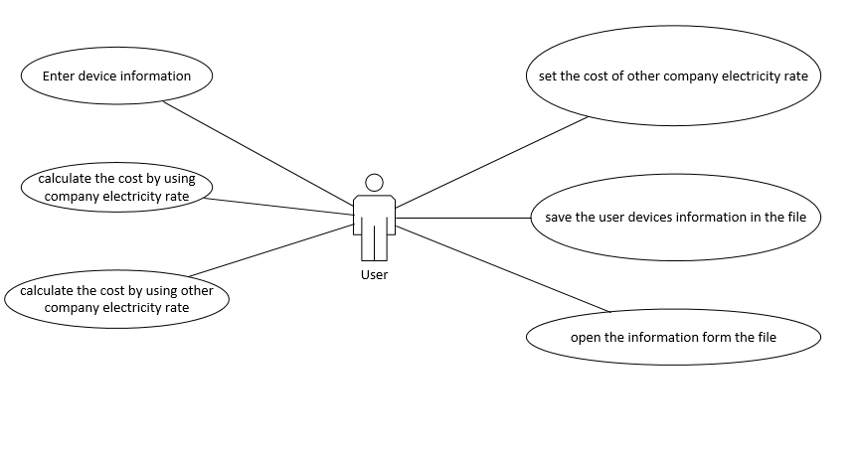

1. Enter device information

User will be adding they device information list in to the program, each device contain device name, device other name, device watts and hours of daily used.

1. Calculate the cost by using company electricity rate

User will be select three different electricity company in the program, eon, British Gas and npower to calculate the cost to the device which user input.

1. Calculate the cost by using other company electricity rate

User can input a rate from different company and the program will be calculate.

1. Save the user information in the file

User can save the device information to a file.

1. Open the information form the file

User can open the previous file and display in the program.

1. Set the cost of other company electricity rate

User can set the cost of other company electricity rate

## 3 Initial iteration Plan

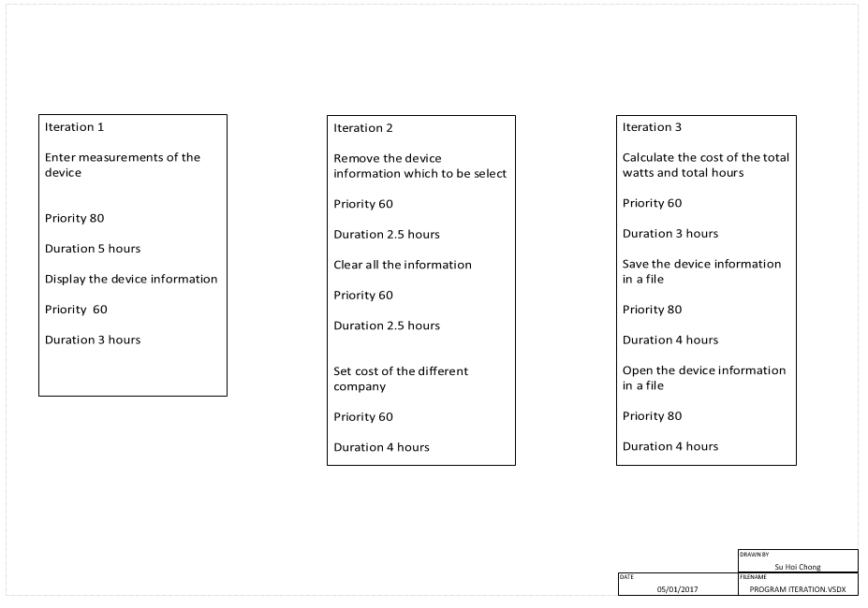

Form layout

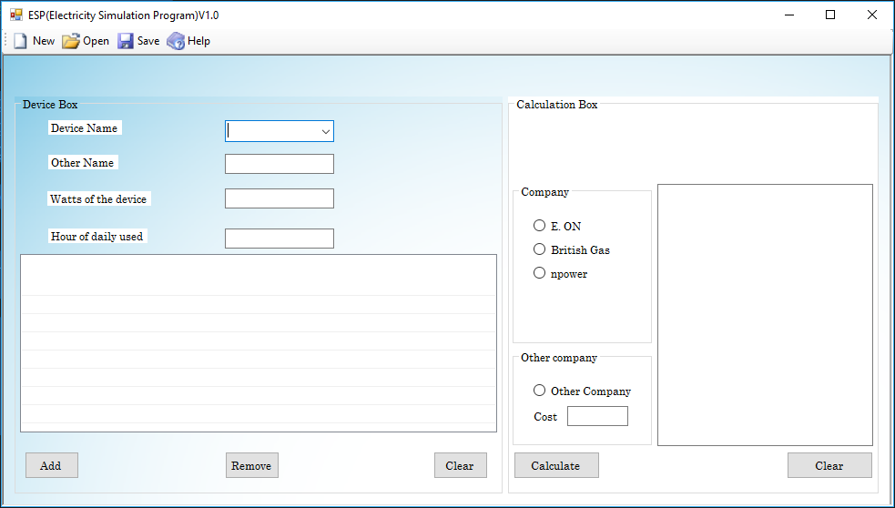

Remove button

addbutton

Cost textbox

Radio button - other

Radio button –company

listview

textboxhours

textboxwatts

textboxother

Combobox

## Business Layer Source Code

Calculate button

Clear button

Devices class

//File name: Devices.cs

//Author: Su Hoi Chong A94729

//Date: 04/01/2016

using System;

namespace ESP__Electricity_Simulation_Program_.Business

{

[Serializable]

public class Devices

{

//Data Fields

/// <summary>

/// To hold the device data in a different valueable,

/// String = text and number

/// double = number

/// </summary>

public string name;

public string othername;

public double watts;

public double hours;

//CONSTRUCTORS

/// <summary>

/// initializes a new instance of the device class

/// </summary>

/// <param name="name">The device name.</param>

/// <param name="othername">The device other name.</param>

/// <param name="watts">The watts of the device,measured in watts.</param>

/// <param name="hours">The hours used of the device. measured in hours.</param>

public Devices(string name, string othername, double watts, double hours)

{

if (name == "")

throw new System.FormatException("You must specify a value for the name of the device.");

this.name = name;

if (othername == "")

throw new System.FormatException("You must specify a value for the other name of the device.");

this.othername = othername;

if (watts <= 0)

throw new System.FormatException("You must enter a value for the watts of the Device.");

this.watts = watts;

if (hours <= 0|| hours > 24)

throw new System.FormatException("You must enter a value for the hours of daily used of the device.");

this.hours = hours;

}

/// <summary>

///

/// </summary>

/// <returns>

///

/// </returns>

public override string ToString()

{

return

"Device name: " + name +

", Other name:" + othername +

", Device watts(W)= " + watts + ", " +

"Hours used in a day =" + hours + "(h).";

}

}

}

## Presentation Layer Source Code

ESP Class

//File name: ESP.cs

//Author: Su Hoi Chong A94729

//Date: 03/01/2016

using ESP__Electricity_Simulation_Program_.Business;

using System;

using System.Collections.Generic;

using System.Windows.Forms;

namespace ESP__Electricity_Simulation_Program_

{

public partial class ESP : Form

{

//Data Field

Devices devices;

/// <summary>

/// valuable of each kWh cost of the company

/// </summary>

public double eon = 12.46214;

public double BG = 14.37;

public double npower = 17.367;

/// <summary>

/// get value to save and display the information form the file.

/// </summary>

///<value>

///get the value Lod

///</value>

public List<Devices> Lod

{

get

{

List<Devices> lod = new List<Devices>();

foreach (ListViewItem lv in devicelistView.Items)

{

lod.Add((Devices)lv.Tag);

}

return lod;

}

set

{

foreach (Devices d in value)

{

ListViewItem lv = new ListViewItem(d.ToString());

lv.Tag = d;

devicelistView.Items.Add(lv);

}

}

}

//PROPERTIES

/// <summary>

/// Get the name for the device

/// </summary>

/// <value>

/// The name of the device.

/// </value>

private string devicename

{

get

{

//if the comboboxDevice.Text = nothing, the error message will be display.

if (comboBoxDevice.Text == "")

{

//Error message

throw new FormatException("You must enter a value for the name of the device or you can select 'other' then on the other section type the name of your device.");

}

else

return comboBoxDevice.Text;

}

}

/// <summary>

/// Get the other name for the device.

/// </summary>

/// <value>

/// The other name for the device.

/// </value>

private string otherdevicename

{

get

{

//if the otherTextBox.Text = nothing and comboboxDevice.Text = other, the error message will be display.

if (otherTextBox.Text == "" && comboBoxDevice.Text == "other")

{

//Error message

throw new FormatException("You must enter a value for the other name of the Device.");

}

else

return otherTextBox.Text;

}

}

/// <summary>

/// Get the watts for the device.

/// </summary>

/// <value>

/// The watts for the device.

/// </value>

private double wattsdevice

{

get

{

//if the WattstextBox.Text = nothing, the error message will be display.

if (WattstextBox.Text == "")

{

//Error message

throw new FormatException("You must enter a value for the watts of the Device.");

}

else

return Convert.ToDouble(WattstextBox.Text);

}

}

/// <summary>

/// Get the hours used for the device.

/// </summary>

/// <value>

/// The hours used for the device.

/// </value>

private double hoursofdevice

{

get

{

//if the WattstextBox.Text = nothing, the error message will be display.

if (HourstextBox.Text == "")

{

//Error message

throw new FormatException("You must enter a value for the hours of daily used of the device.");

}

else

return Convert.ToDouble(HourstextBox.Text);

}

}

/// <summary>

/// Get the value form Devices class

/// </summary>

/// <value>

/// get value

/// </value>

public Devices value

{

get

{

return devices;

}

set

{

comboBoxDevice.Text = value.name.ToString();

otherTextBox.Text = value.othername.ToString();

WattstextBox.Text = value.watts.ToString();

HourstextBox.Text = value.hours.ToString();

}

}

//

/// <summary>

/// Add and display the informaiton devices to listview

/// </summary>

/// <param name="sender"></param>

/// <param name="e"></param>

private void addButton_Click(object sender, EventArgs e)

{

try

{

///devices = constructors in <see cref="Devices"/>.class

devices = new Devices(devicename, otherdevicename, wattsdevice, hoursofdevice);

///display the devices in listviewitem

ListViewItem lvitem = new ListViewItem(devices.ToString());

lvitem.Tag = devices;

devicelistView.Items.Add(lvitem);

}

catch (FormatException ex)

{

MessageBox.Show(ex.Message, "Warning", MessageBoxButtons.OK, MessageBoxIcon.Error);

}

}

//allow to remove a wrong data or information for the selected device.

/// <summary>

/// remove the selected item in the list

/// </summary>

/// <param name="sender"></param>

/// <param name="e"></param>

private void removeButton_Click(object sender, EventArgs e)

{

if (devicelistView.SelectedItems.Count > 0)

{

foreach (ListViewItem lvitem in devicelistView.SelectedItems)

{

devicelistView.Items.Remove(lvitem);

}

}

//if the items hasnt been selected, the error message will display.

else

{

Console.WriteLine("Error: You must select a device to remove."); ///Error message

MessageBox.Show("Error: You must select a device to remove.", "Error", MessageBoxButtons.OK, MessageBoxIcon.Error);

}

}

//CONSTRUCTORS

/// <summary>

/// Initializes a new instance of the <see cref="ESP"/> class.

/// </summary>

public ESP()

{

InitializeComponent();

//set the width of listview

foreach (ColumnHeader col in devicelistView.Columns)

col.Width = devicelistView.Width;

}

/// <summary>

/// To calculate the total hours and watts

/// </summary>

/// <param name="sender"></param>

/// <param name="e"></param>

/// <value>

/// get the string of watts and hours from the 'devices'.

/// </value>

private void CalculateButton_Click(object sender, EventArgs e)

{

double totalWatts = 0;

double totalHours = 0;

///convert string to double

double other;

if (OthercompanytextBox.Text == "")

other = 0;

else

other = Convert.ToDouble(OthercompanytextBox.Text);

///foreach loop to sum up the total device watts and hours used.

foreach (ListViewItem lvitem in devicelistView.Items)

{

Devices d = (Devices)lvitem.Tag;///get value

totalWatts = totalWatts + d.watts; ///sum up the total watts.

totalHours = totalHours + d.hours;///sum up the total hours.

}

///if the eon radio button is selected and click calculate button calculate and display the total watts, hours, the daily, monthy and year cost.

if (eonradioButton.Checked == true)

{

///Data Field

double energy = totalWatts * totalHours / 1000;

double eoncost = energy * eon / 100;

double eonmonthcost = eoncost / 24 * 30;

double eonyearcost = eoncost / 24 * 365;

resultTextBox.Text =

"You have select EON. " + Environment.NewLine +

"Total Watts of all the devices = " + totalWatts + "(W)." + Environment.NewLine +

"Total Hours used =" + totalHours + "(h)." + Environment.NewLine +

"Total daily cos £" + Math.Round(eoncost, 2) + "." + Environment.NewLine +

"Total monthly cost = £" + Math.Round(eonmonthcost, 2) + Environment.NewLine +

"Total year cost = £" + Math.Round(eonyearcost, 2) + ".";

}

///if the BG radio button is selected and click calculate button calculate and display the total watts, hours, the daily, monthy and year cost

if (BGradioButton.Checked == true)

{

double energy = totalWatts * totalHours / 1000;

double BGcost = energy * BG / 100;

double BGmonthcost = BGcost / 24 * 30;

double BGyearcost = BGcost / 24 * 365;

resultTextBox.Text =

"You have select British Gas. " + Environment.NewLine +

"Total Watts of all the devices = " + totalWatts + "(W)." + Environment.NewLine +

"Total Hours used =" + totalHours + "(h)." + Environment.NewLine +

"Total daily cos £" + Math.Round(BGcost, 2) + "." + Environment.NewLine +

"Total monthly cost = £" + Math.Round(BGmonthcost, 2) + Environment.NewLine +

"Total year cost = £" + Math.Round(BGyearcost, 2) + ".";

}

///if the npower radio button is selected and click calculate button calculate and display the total watts, hours, the daily, monthy and year cost

if (npowerradioButton.Checked == true)

{

double energy = totalWatts * totalHours / 1000;

double npowercost = energy * npower / 100;

double npowermonthcost = npowercost / 24 * 30;

double npoweryearcost = npowercost / 24 * 365;

resultTextBox.Text =

"You have select npower. " + Environment.NewLine +

"Total Watts of all the devices = " + totalWatts + "(W)." + Environment.NewLine +

"Total Hours used =" + totalHours + "(h)." + Environment.NewLine +

"Total daily cos £" + Math.Round(npowercost, 2) + "." + Environment.NewLine +

"Total monthly cost = £" + Math.Round(npowermonthcost, 2) + Environment.NewLine +

"Total year cost = £" + Math.Round(npoweryearcost, 2) + ".";

}

///if the other radio button is selected and click calculate button calculate and display the total watts, hours, the daily, monthy and year cost

if (OtherradioButton.Checked == true)

{

double energy = totalWatts * totalHours / 1000;

double othercost = energy * other / 100;

double othermonthcost = othercost / 24 * 30;

double otheryearcost = othercost / 24 * 365;

resultTextBox.Text =

"You have select other company. " + Environment.NewLine +

"Total Watts of all the devices = " + totalWatts + "(W)." + Environment.NewLine +

"Total Hours used =" + totalHours + "(h)." + Environment.NewLine +

"Total daily cos £" + Math.Round(othercost, 2) + "." + Environment.NewLine +

"Total monthly cost = £" + Math.Round(othermonthcost, 2) + Environment.NewLine +

"Total year cost = £" + Math.Round(otheryearcost, 2) + ".";

}

//validation - if all the radionbutton hasn't been click, errow message will display.

else if (eonradioButton.Checked == false && BGradioButton.Checked == false && npowerradioButton.Checked == false && OtherradioButton.Checked == false)

{

///Error message

Console.WriteLine("Error: You must select a company to calculate the cost.");

MessageBox.Show("Error: You must select a company to calculate the cost.", "Error", MessageBoxButtons.OK, MessageBoxIcon.Error);

}

}

/// <summary>

/// clear the information in the resulttextbox

/// </summary>

/// <param name="sender"></param>

/// <param name="e"></param>

private void Clearbutton_Click(object sender, EventArgs e)

{

resultTextBox.Clear();

}

/// <summary>

/// clear the information in the devicelistview

/// </summary>

/// <param name="sender"></param>

/// <param name="e"></param>

private void Clearbutton1_Click(object sender, EventArgs e)

{

devicelistView.Items.Clear();

}

/// <summary>

/// when the OtherradioButton is clicked, other radiobutton cannot be click.

/// incloude(npowerradioButton,BGradioButton,eonradioButton)

/// </summary>

/// <param name="sender"></param>

/// <param name="e"></param>

private void OtherradioButton_CheckedChanged(object sender, EventArgs e)

{

npowerradioButton.Checked = false;

BGradioButton.Checked = false;

eonradioButton.Checked = false;

}

/// <summary>

/// when the BGradionButton is clicked, OtherradioButton cannot be click.

/// </summary>

/// <param name="sender"></param>

/// <param name="e"></param>

private void eonradioButton_CheckedChanged(object sender, EventArgs e)

{

OtherradioButton.Checked = false;

}

/// <summary>

/// when the BGradionButton is clicked, OtherradioButton cannot be click.

/// </summary>

/// <param name="sender"></param>

/// <param name="e"></param>

private void BGradioButton_CheckedChanged(object sender, EventArgs e)

{

OtherradioButton.Checked = false;

}

/// <summary>

/// when the BGradionButton is clicked, OtherradioButton cannot be click.

/// </summary>

/// <param name="sender"></param>

/// <param name="e"></param>

private void npowerradioButton_CheckedChanged(object sender, EventArgs e)

{

OtherradioButton.Checked = false;

}

}

}

MDIPreantFrom class

//File name: MDIParentFrom.cs

//Author: Su Hoi Chong A94729

//Date: 04/01/2016

using System;

using System.Windows.Forms;

using System.IO;

using System.Runtime.Serialization.Formatters.Binary;

using ESP__Electricity_Simulation_Program_.Business;

using System.Collections.Generic;

namespace ESP__Electricity_Simulation_Program_.Presentation

{

public partial class MDIParentFrom : Form

{

//CONSTRUCTORS

/// <summary>

/// Initializes a new instance of the <see cref="MDIParentFrom"/> class.

/// </summary>

public MDIParentFrom()

{

InitializeComponent();

}

/// <summary>

/// Display childFrom<ESP>

/// </summary>

/// <param name="sender"></param>

/// <param name="e"></param>

private void ShowNewForm(object sender, EventArgs e)

{

ESP childForm = new ESP();

childForm.MdiParent = this;

childForm.Text = "ESP(Electricity Simulation Program)";

childForm.Show();

}

/// <summary>

/// Open a file and display in childfrom<ESP> devicelistView

/// </summary>

/// <param name="sender"></param>

/// <param name="e"></param>

private void OpenFile(object sender, EventArgs e)

{

OpenFileDialog openFileDialog = new OpenFileDialog();

openFileDialog.InitialDirectory = Environment.GetFolderPath(Environment.SpecialFolder.Personal);

openFileDialog.Filter = "Text Files (*.txt)|*.txt|All Files (*.*)|*.*";

string FileName = openFileDialog.FileName;

if (openFileDialog.ShowDialog(this) == DialogResult.OK)

{

Stream s = File.Open(openFileDialog.FileName, FileMode.Open);

BinaryFormatter bf = new BinaryFormatter();

{

ESP currentForm = this.ActiveMdiChild as ESP;

currentForm.Lod=(List<Devices>)bf.Deserialize(s);

}

s.Close();

}

}

/// <summary>

/// Display the Help information page.

/// </summary>

/// <param name="sender"></param>

/// <param name="e"></param>

private void helpToolStripButton_Click(object sender, EventArgs e)

{

HelpPage helpinformation = new HelpPage();

helpinformation.Show();

}

/// <summary>

/// save the information form childfrom<ESP>devicelistView as binary file

/// </summary>

/// <param name="sender"></param>

/// <param name="e"></param>

private void saveToolStripButton_Click(object sender, EventArgs e)

{

SaveFileDialog saveFileDialog = new SaveFileDialog();

saveFileDialog.InitialDirectory = Environment.GetFolderPath(Environment.SpecialFolder.Personal);

saveFileDialog.Filter = "Text Files (*.txt)|*.txt|All Files (*.*)|*.*";

if (saveFileDialog.ShowDialog(this) == DialogResult.OK)

{

string FileName = saveFileDialog.FileName;

Stream s = File.Open(saveFileDialog.FileName, FileMode.Create);

BinaryFormatter bf = new BinaryFormatter();

{

ESP currentForm = this.ActiveMdiChild as ESP;

bf.Serialize(s,currentForm.Lod);

s.Close();

}

}

}

}

}

Helppage class

//File name: HelpPage.cs

//Author: Su Hoi Chong A94729

//Date: 03/01/2016

using System;

using System.Collections.Generic;

using System.Windows.Forms;

namespace ESP__Electricity_Simulation_Program_.Presentation

{

public partial class HelpPage : Form

{

public HelpPage()

{

InitializeComponent();

}

}

}

## Appendix

Reference

1.

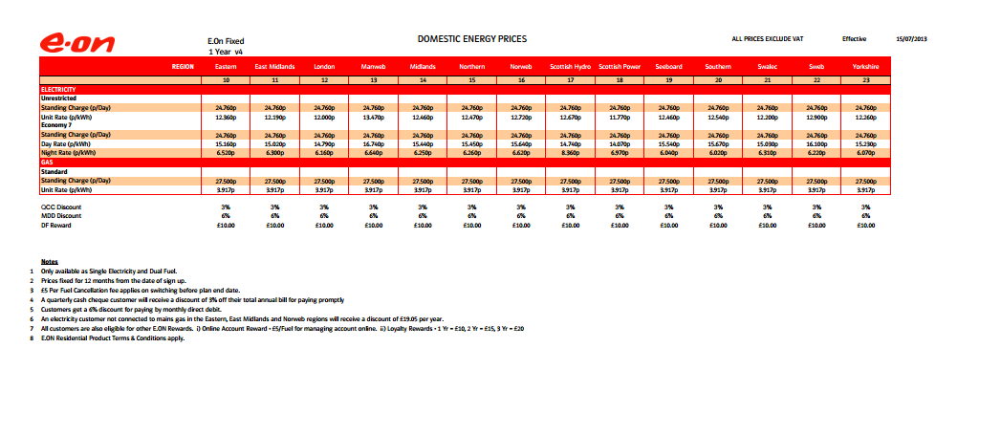

2. 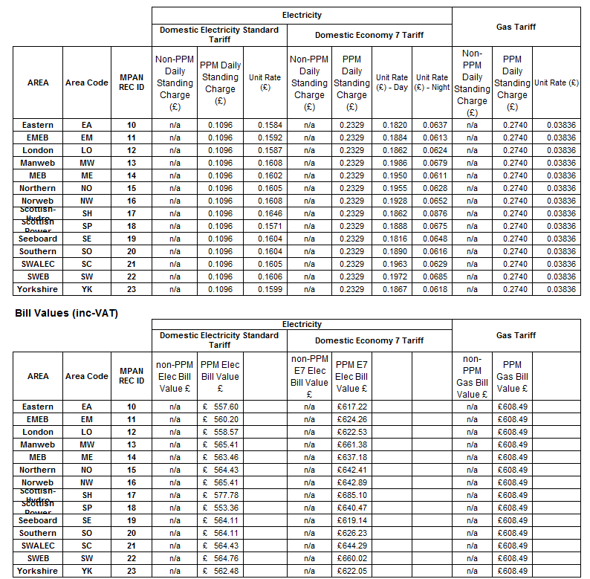

3.

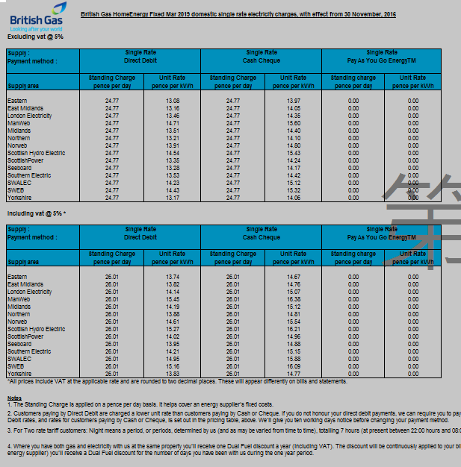

file, S. (n.d.). *Saving the items of a listbox to a text file*. [online] Stackoverflow.com. Available at: http://stackoverflow.com/questions/2293298/saving-the-items-of-a-listbox-to-a-text-file [Accessed 10 Jan. 2017].

integer?, H. (2017). *How to round up value C# to the nearest integer?*. [online] Stackoverflow.com. Available at: http://stackoverflow.com/questions/3920553/how-to-round-up-value-c-sharp-to-the-nearest-integer [Accessed 10 Jan. 2017].

be, M. (2017). *Manually telling my ListBox's scrollbar where to be*. [online] Stackoverflow.com. Available at: http://stackoverflow.com/questions/4489904/manually-telling-my-listboxs-scrollbar-where-to-be [Accessed 10 Jan. 2017].

horizontally, H. (2017). *How to make a listbox scroll horizontally*. [online] Stackoverflow.com. Available at: http://stackoverflow.com/questions/21453536/how-to-make-a-listbox-scroll-horizontally [Accessed 10 Jan. 2017].

Design

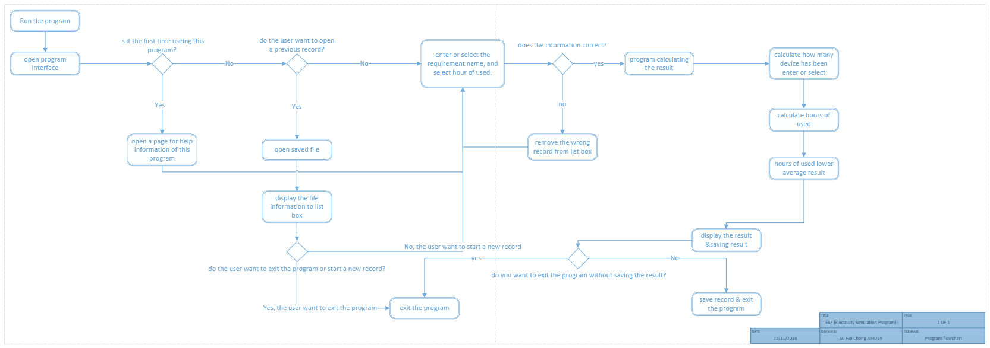

Test Plan

|  |  |  |  |  |  |  |
| --- | --- | --- | --- | --- | --- | --- |
| Program name: ESP(Electricity Simulation Program) | | | | | | |
| Tester Name: Su Hoi Chong A94729 | | | | | | |
| Programming Language: C# | | | | | | |
| Tested software: Visual studio 2015 | | | | | | |
| Tested Date: 08/01/2017 | | | | | | |
| Program Writer: Su Hoi Chong | | | | | | |
| Test No. | Test Purpose | Test Data | Expected Results | Actual Results | Actions need | Screen print | |
| 1 | Enter a device name in the combobox | insult combobox “Laptop” | Display “Device name Laptop” | Display “Laptop” | No | 1 | |
| 2 | Enter a device other name in the Othertextbox | insult othertext “Laptop2” | Display “other name:Laptop2” | Display “Laptop2” | No | 2 | |
| 3 | Enter a device watts in the textbox | Insult wattstextbox “100” | Display “device watts 100 ” | Display “device watts 100 ” | No | 3 | |
| 4 | Enter a device hours in the textbox | Insult hourstextbox “12” | Display “hours used 12” | Display “hours used 12” | No | 4 | |
| 5 | Add a value in to listView | insult combobox “Laptop”, othertextbox “null”, wattstextbox “100” hourstextbox “12” | Display “Device name: laptop, other name :null, device Watts(W) = 100, Hours used in a day = 12 (h). | Display “Device name: laptop, other name :null, device Watts(W) = 100, Hours used in a day = 12 (h). | No | 5 | |
| 6 | remove a value in to listView | insult combobox “Laptop”, othertextbox “null”, wattstextbox “100” hourstextbox “12” and insult combobox “Laptop”, othertextbox “null”, wattstextbox “100” hourstextbox “13”the click remove button | Expect remove the list with hours = 12 | remove the list with hours = 12 | No | 6,6.1 | |
| 7 | Clear all value in to listView | insult combobox “Laptop”, othertextbox “null”, wattstextbox “100” hourstextbox “12” and insult combobox “Laptop”, othertextbox “null”, wattstextbox “100” hourstextbox “13”then click clear button | Clear all the information in the listview | Clear all the information in the listview |  | 7,7.1 | |
| 8 | Error message for combobox | Witout insult any data in combobox and hasn’t select “other” in combobox | Error message appear “You must enter a value for the name of the device or you can select 'other' then on the other section type the name of your device." | Error message appear “You must enter a value for the name of the device or you can select 'other' then on the other section type the name of your device." | No | 8 | |
| 9 | Error message for othertextbox | Witout insult any data in othertextbox | Error message appear "You must enter a value for the other name of the Device." | Error message appear "You must enter a value for the other name of the Device." | No | 9 | |
| 10 | Error message for wattstextbox | Witout insult any data in wattstextbox | Error message appear "You must enter a value for the watts of the Device." | Error message appear "You must enter a value for the watts of the Device." | No | 10 | |
| 11 | Error message for hourstextbox | Witout insult any data in hourstextbox | Error message appear “You must enter a value for the hours of daily used of the device." | Error message appear “You must enter a value for the hours of daily used of the device." | No | 11 | |
| 12 | Check eon radio button allow to be click | Click eon radio button | Clicked radio radio button | Clicked radio radio button | no | 12 | |
| 13 | Check bg radio button allow to be click | Click bg radio button | Clicked bg radio button | Clicked bg radio button | No | 13 | |
| 14 | Check npower radio button allow to be click | Click npower radio button | Clicked npower radio button | Clicked npower radio button | No | 14 | |
| 15 | Check other radio button allow to be click | Click other radio button | Clicked other radio button | Clicked other radio button | no | 15 | |
| 16 | Check calculation on eon | insult combobox “Laptop”, othertextbox “null”, wattstextbox “100” hourstextbox “12”,then select eon radio button and press “calculate”button | Display result  “You have select EON.  Total Watts of all the devices = 100(W).  Total Hours used =12(h).  Total daily cos £0.15.  Total monthly cost = £0.19  Total year cost = £2.27.” | Display result  “You have select EON.  Total Watts of all the devices = 100(W).  Total Hours used =12(h).  Total daily cos £0.15.  Total monthly cost = £0.19  Total year cost = £2.27.” | No | 16 | |
| 17 | Check calculation on British Gas | insult combobox “Laptop”, othertextbox “null”, wattstextbox “100” hourstextbox “12”,then select bg radio button and press “calculate”button | Display result  You have select British Gas.  Total Watts of all the devices = 100(W).  Total Hours used =12(h).  Total daily cos £0.17.  Total monthly cost = £0.22  Total year cost = £2.62. | Display result  You have select British Gas.  Total Watts of all the devices = 100(W).  Total Hours used =12(h).  Total daily cos £0.17.  Total monthly cost = £0.22  Total year cost = £2.62. | No | 17 | |
| 18 | Check calculation on npower | insult combobox “Laptop”, othertextbox “null”, wattstextbox “100” hourstextbox “12”,then select npower radio button and press “calculate”button | Display result  You have select npower.  Total Watts of all the devices = 100(W).  Total Hours used =12(h).  Total daily cos £0.21.  Total monthly cost = £0.26  Total year cost = £3.17. | Display result  You have select npower.  Total Watts of all the devices = 100(W).  Total Hours used =12(h).  Total daily cos £0.21.  Total monthly cost = £0.26  Total year cost = £3.17. | No | 18 | |
| 19 | Check calculation on other company | insult combobox “Laptop”, othertextbox “null”, wattstextbox “100” hourstextbox “12”,then select npower radio button and insult “ 12 ” in costtextbox and press “calculate”button | Display result  You have select other company.  Total Watts of all the devices = 100(W).  Total Hours used =12(h).  Total daily cos £0.14.  Total monthly cost = £0.18  Total year cost = £2.19. | Display result  You have select other company.  Total Watts of all the devices = 100(W).  Total Hours used =12(h).  Total daily cos £0.14.  Total monthly cost = £0.18  Total year cost = £2.19. | no | 19 | |
| 20 | Clear all value in the textbox | Clear all the information which display in the text inside the calculation box | Clear  “You have select British Gas.  Total Watts of all the devices = 100(W).  Total Hours used =12(h).  Total daily cos £0.17.  Total monthly cost = £0.22  Total year cost = £2.62.” | Display nothing | no | 20,20.1 | |
| 21 | Error message in calculation box | Click the calculate button without any radio button has been clicked | Display error message “Error: Your must select a company to calculate the cost” | Display error message “Error: Your must select a company to calculate the cost” | No | 21 | |
| 22 | Error message in remove button | If the button has been click without select a item which is to be remove, it will display error message | Display error message “ Error : you must select a device to remove” | Display error message “ Error : you must select a device to remove” | No | 22 | |
| 23 | Test save button | Insult 4 value  1 Device name: TV,Other name: null, device watts 30, hours used = 12.  2 Device name: Desktop,Other name: null, device watts 600, hours used = 12.  3 Device name: PS4,Other name: null, device watts 90, hours used = 12.  4 Device name: freezer ,Other name: null, device watts 30, hours used = 24.  And save as test.txt | Save in a textfile as binary | Save in a textfile as binary | No | 23 | |
| 24 | Click help icon for help information | Click help icon | Display help information page | Display help information page | no | 25 | |
| 25 | Test open button | Open the “test.txt” file and display in devicelistview | Open the “test.txt” file and display in devicelistview | Open the “test.txt” file and display in devicelistview | no | 24 | |

1. 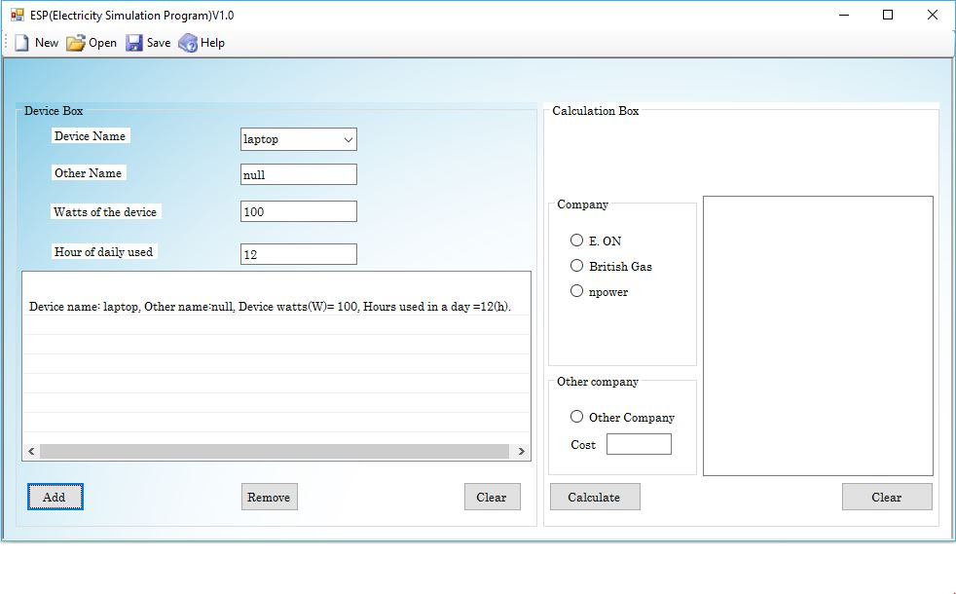
2. 
3. 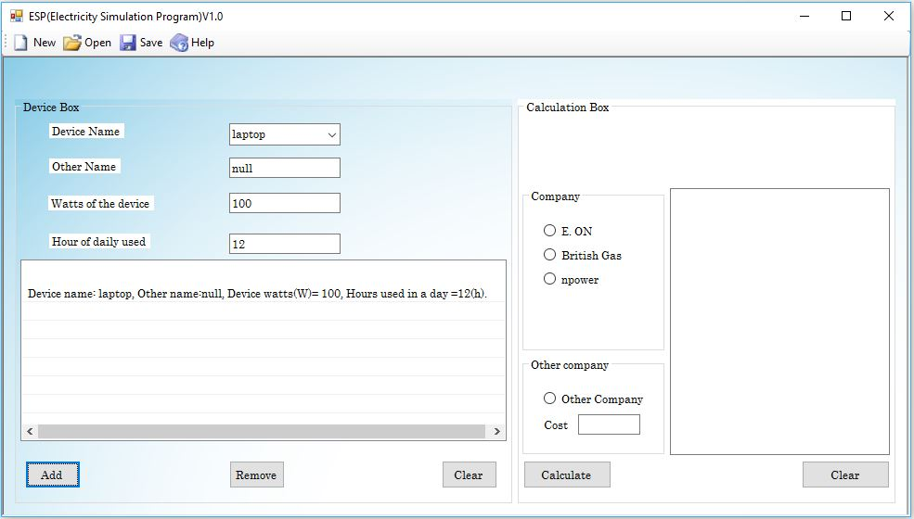
4. 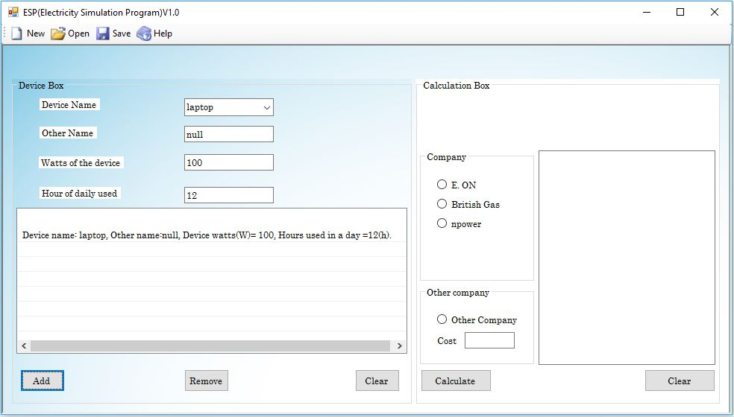
5. 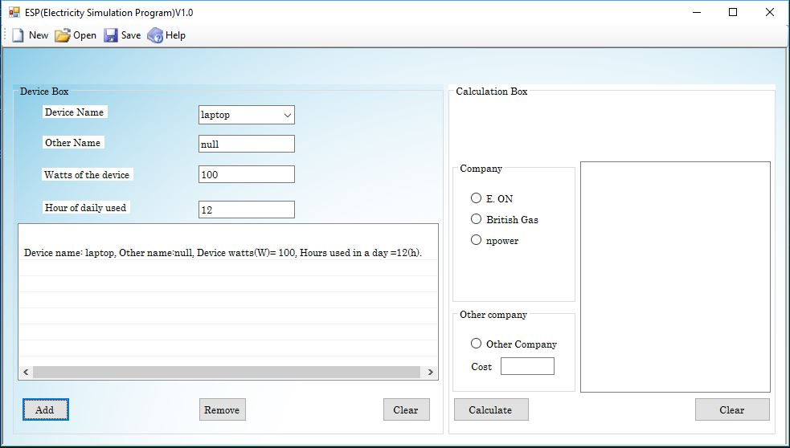
6. 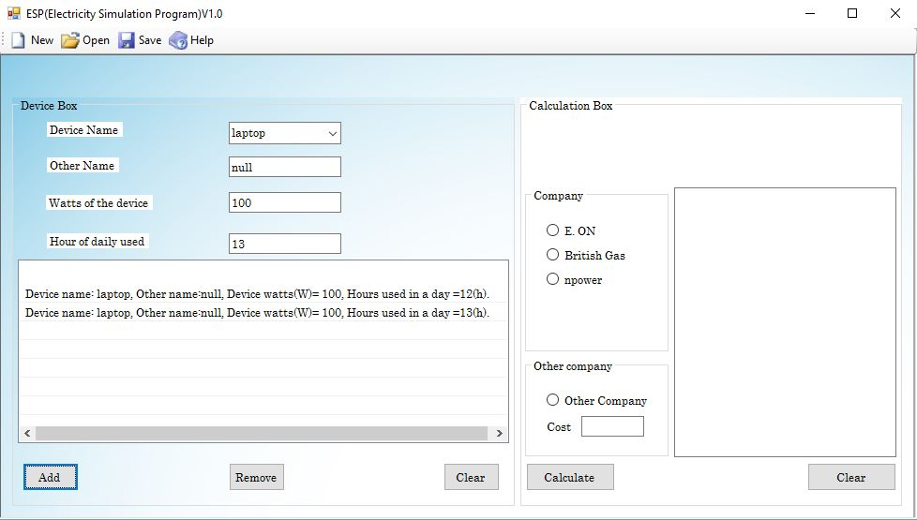

6.1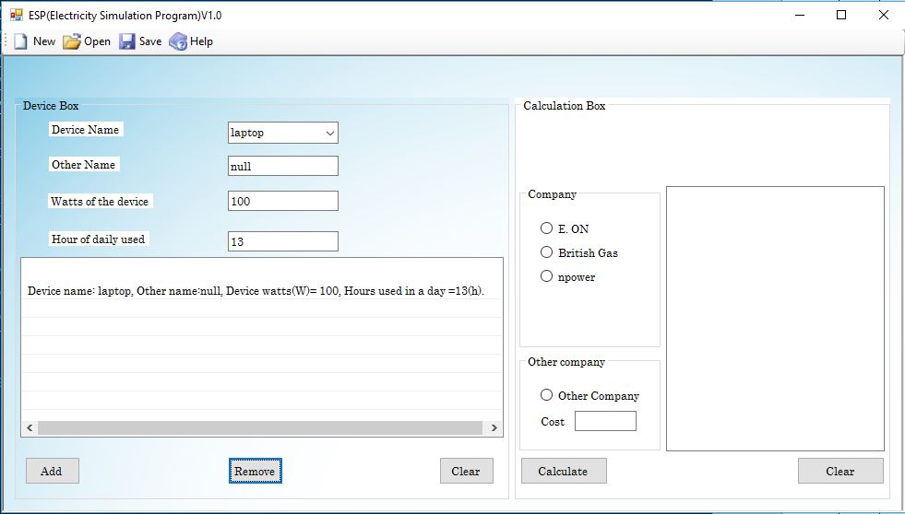

7. 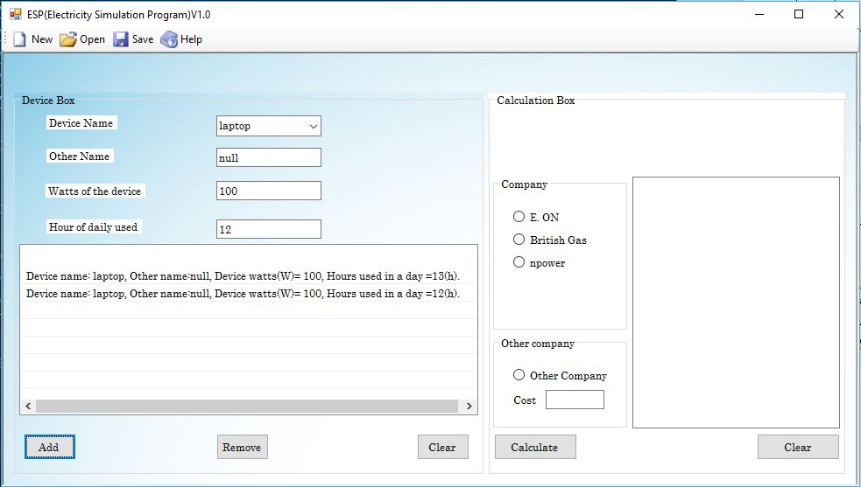

8. 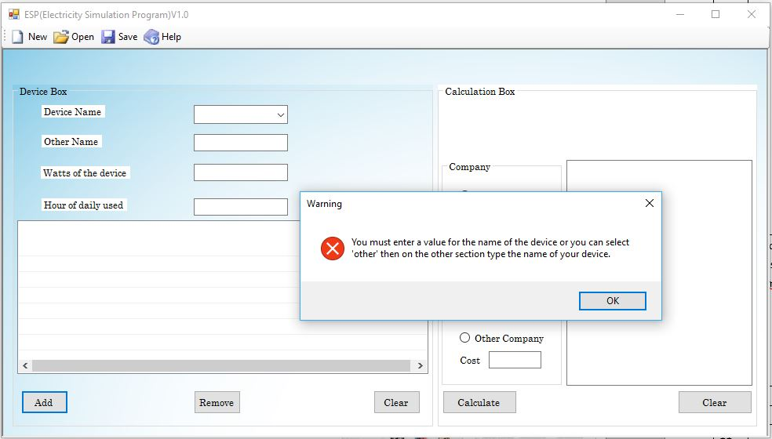

9. 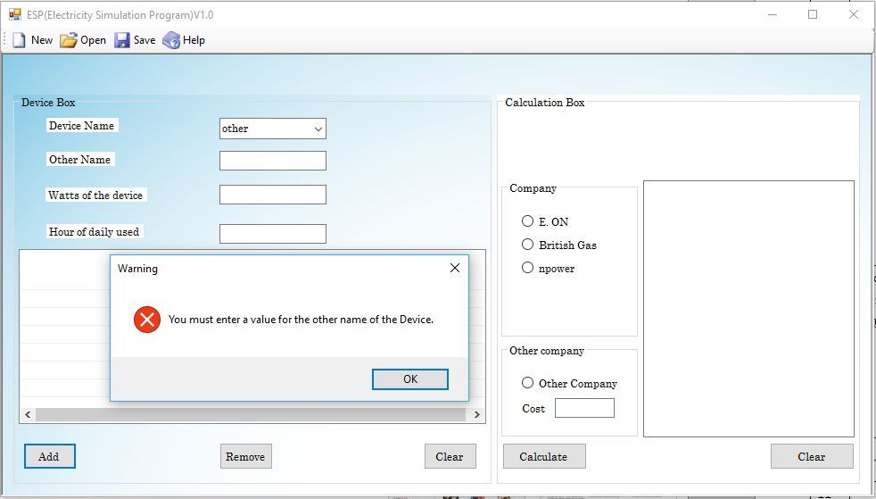

10. 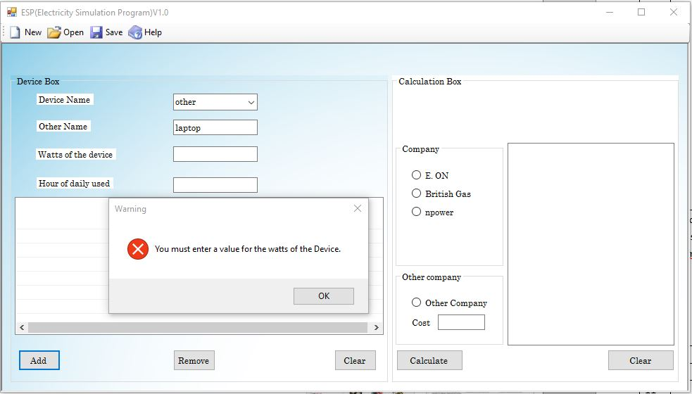

11.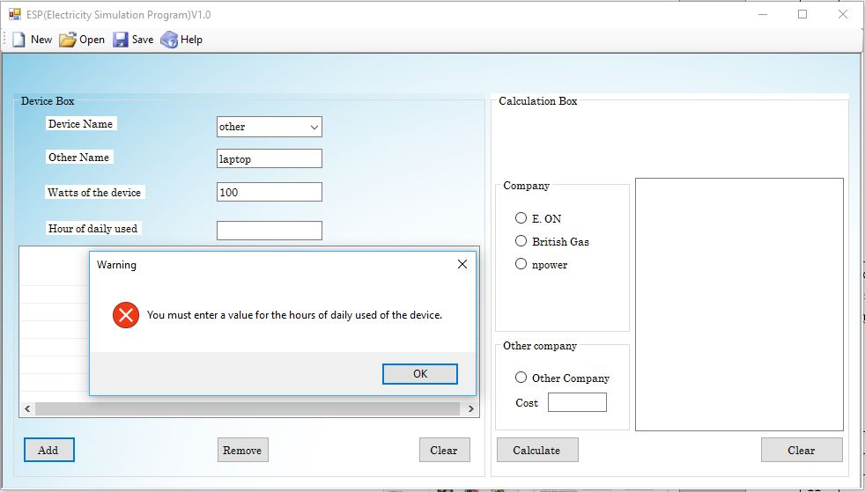

12. 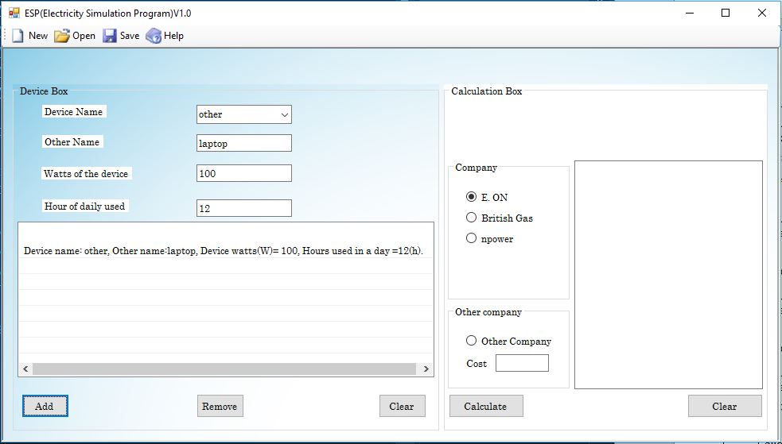

12.



13. 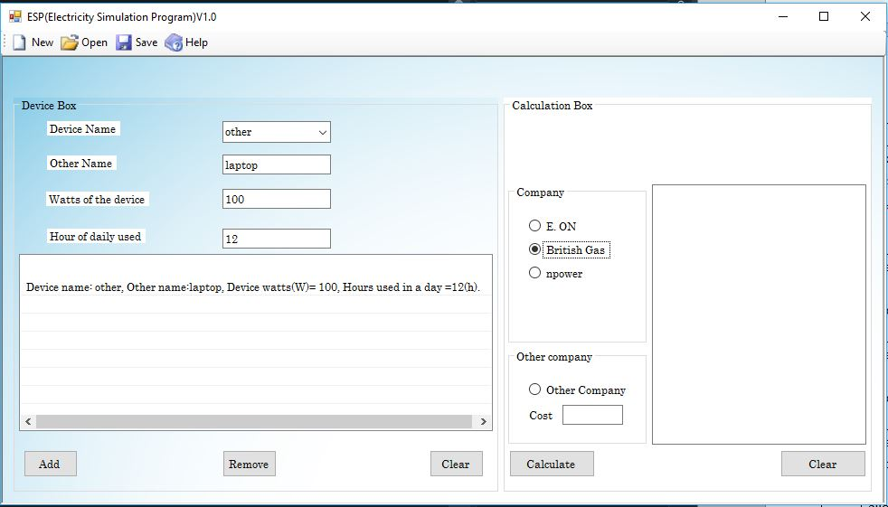

14. 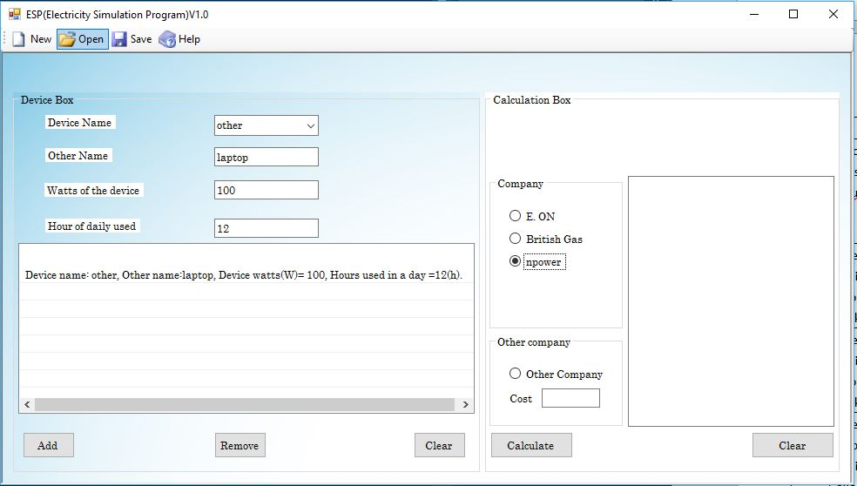

15. 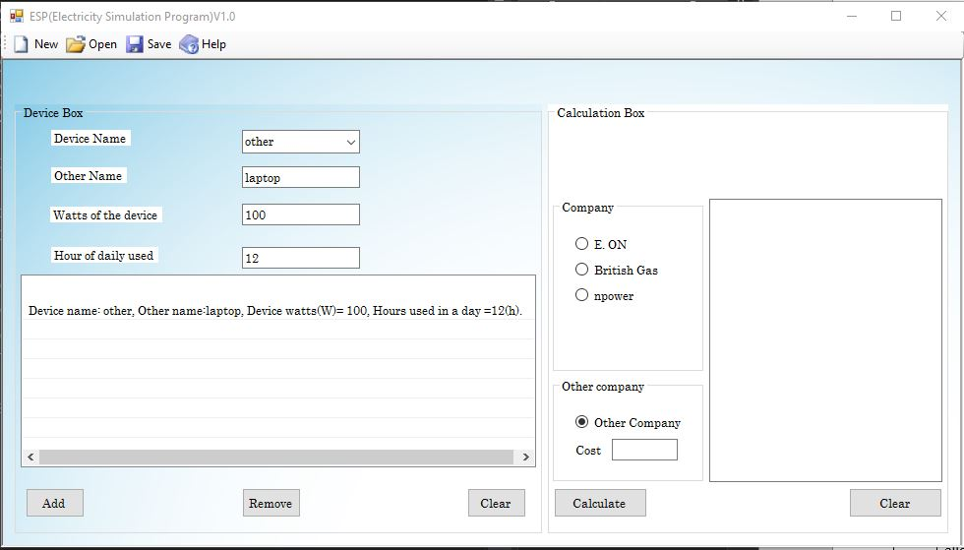

16. 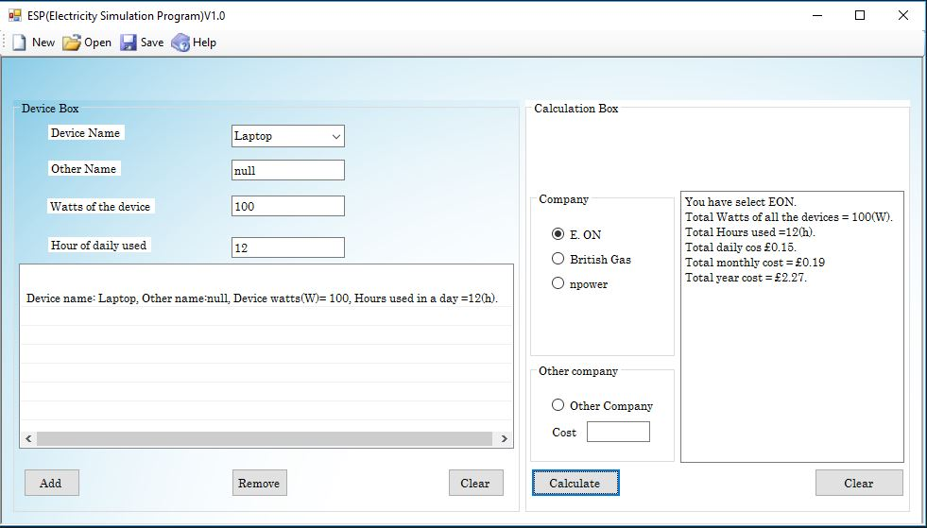

17. 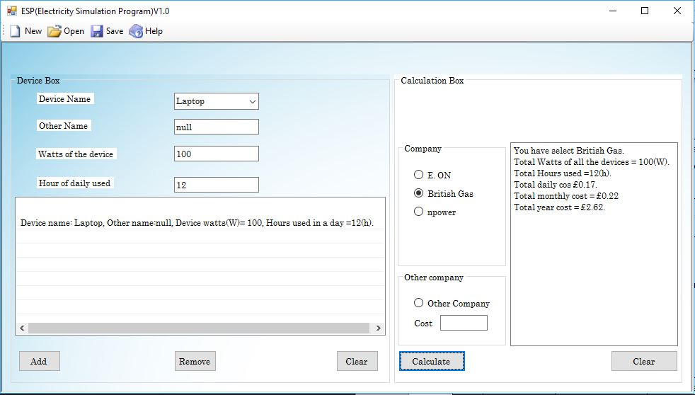

18. 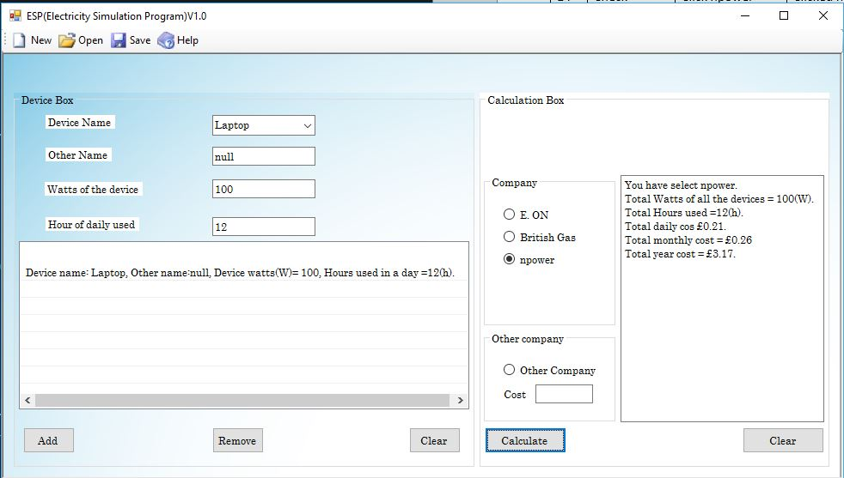

19. 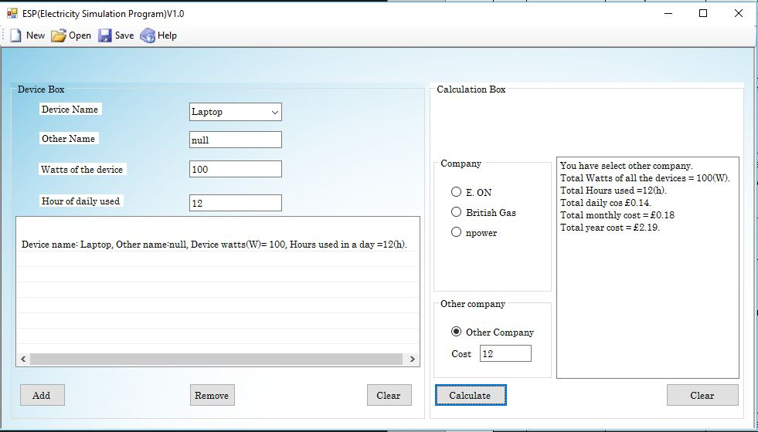

20. 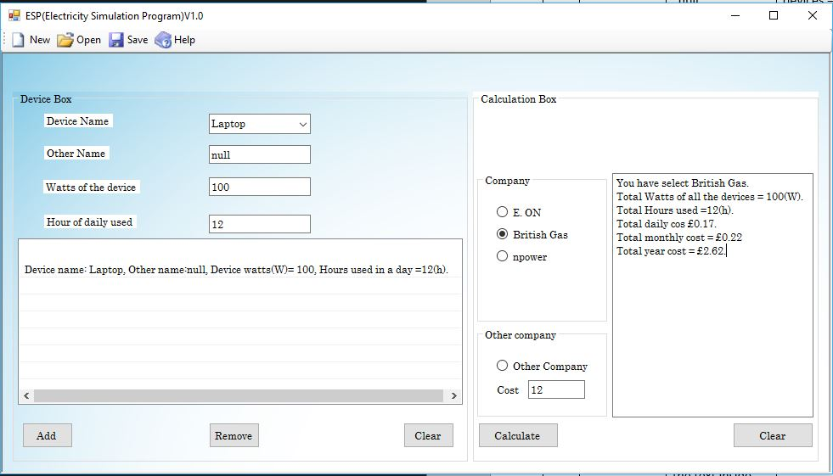

20.1. 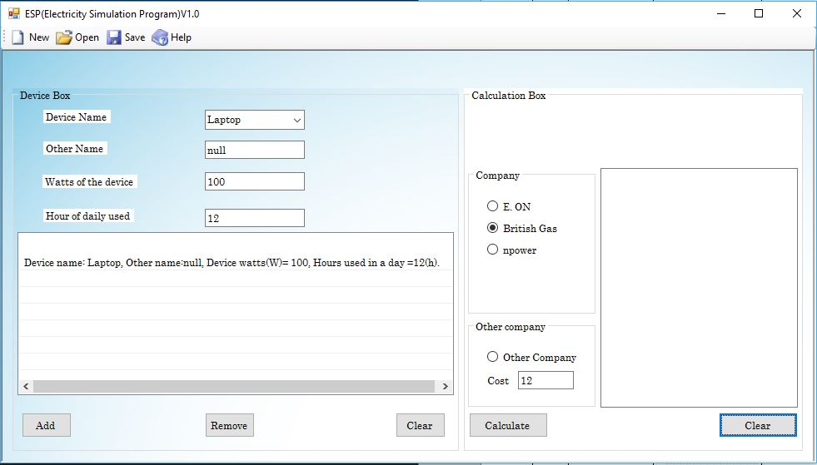

21. 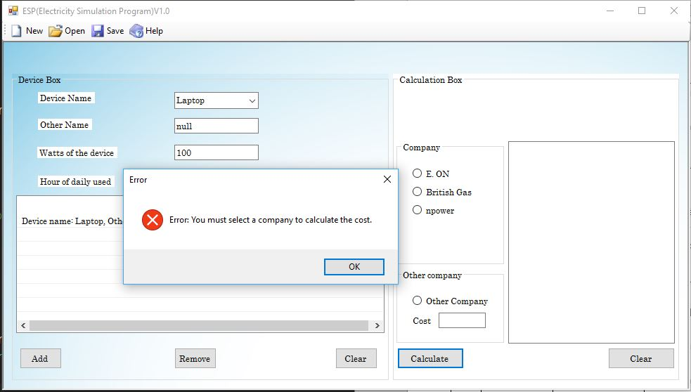

22. 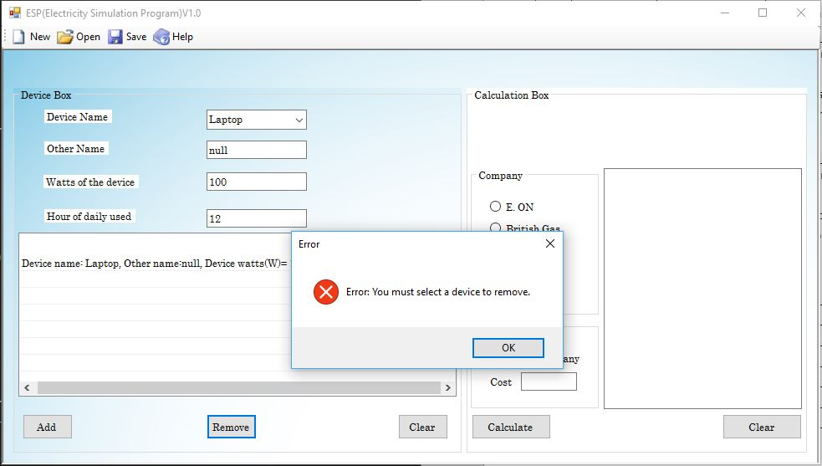

23. 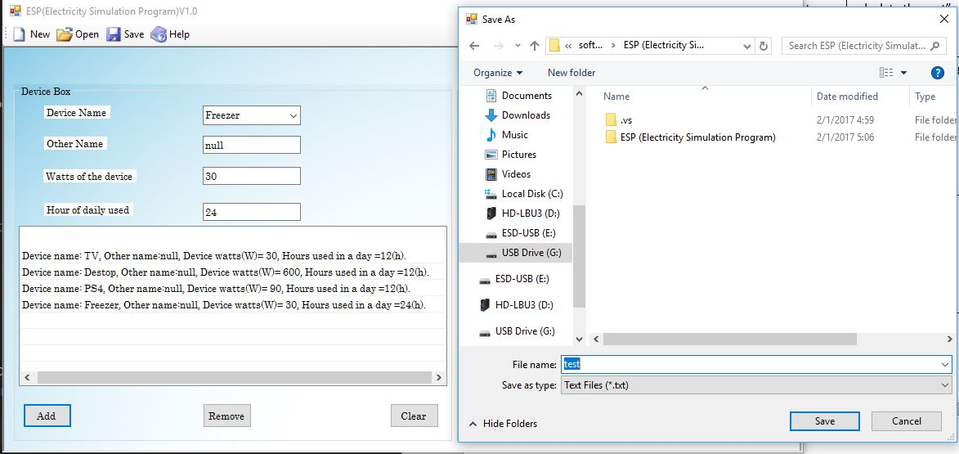

24. 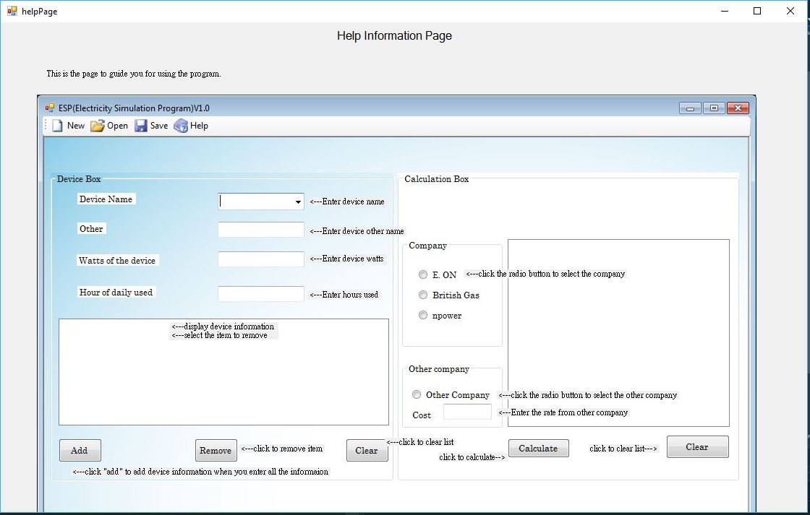

25. 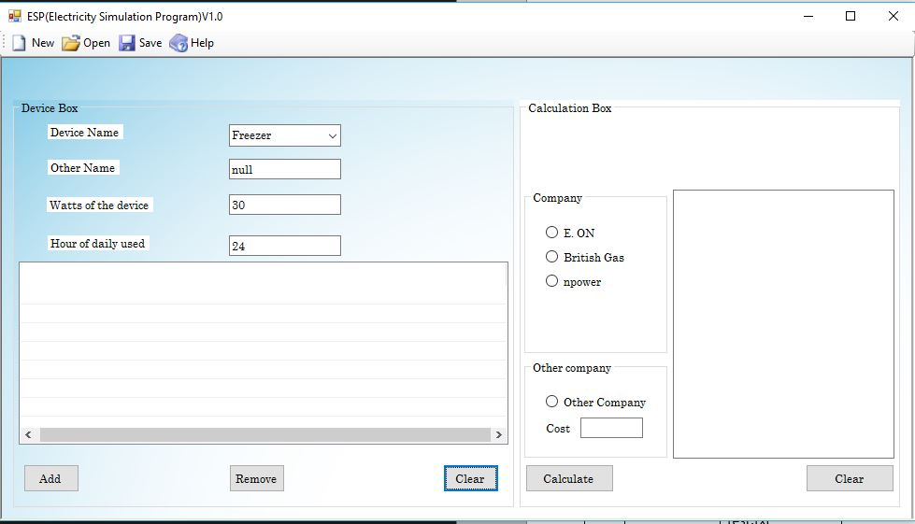

25.1. 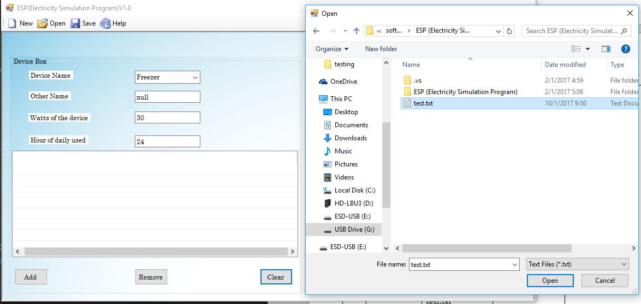

25.2.

