
MintTrack – Requirements Analysis Document (RAD)
- Introduction
  - Purpose of the system – The purpose of this system is to allow users to keep track of their income and expenses through an application on their Android powered cell phones. This application promotes making smart purchases and budgeting funds to make the most of money on hand and in the bank.
  - Scope of the system – This is a program for everybody looking to keep a detailed description of their personal spending habits. This includes high school students, college students, and even working professionals. Just about everybody can find a use for this tool.
  - Objectives and success criteria of the project –
The objectives of this program are as follows:
    - Create an application that allows users to quickly and easily record their income, expense, and transfer transactions
    - Make the application as user friendly and as informative as possible
    - Allow users to view their monetary information through both raw data and graphics
    - Allow users to personalize their categories of income and expenses as well as accounts for transfers and income
Success Criteria for this project includes:
- Completing the development of the application during the allotted time period
- Introducing an easy to use program to the public that allows users to conveniently keep track of their income and spending habits
  - Definitions, acronyms, and abbreviations
    - Account: A payment or funds storage type such as cash, credit card, debit card, savings account, or checking account.
    - Android: Google's mobile device operating system
    - API: Application Programming Interface – a way for the programmer to interact with the system hardware
    - APK: Stands for “Android Package.” The file format of Android applications.
    - Category: A reason for expense such as “food,” “car”, or a reason for income such as the name of a job, or other income such as “gift,” or “winnings.”
    - ChartDroid: An API for using graphing functionality in Android application development.
    - GUI: Graphical User Interface
    - Spinner: a drop-down menu in the Android OS
    - SQLite: A 'lite' version of database languages such as SQL and MySQL. SQLite database functionality is built into the Android operating system and consists of a single file that holds information and can be used much like a regular database.
    - YATC: Yet Another Tip Calculator
  - References
    - Jeff's personal Excel finance workbook
  - Overview
MintTrack is a personal budget tracking application designed for the Google Android operating system that allows people to track their income, expenses, and transfers over various accounts and payment methods. MintTrack will be developed using Java and the Android API to code interaction between the system and the user, ChartDroid to handle graphical analysis of data, XML to design layouts for the GUI, and a SQLite database to store all user information.
- Current System
  - Jeff's Financial Workbook -
This is a Microsoft Excel/OpenOffice Calc workbook that Jeff has been using for a little over a year now to keep track of his income and expenses. The workbook is broken up into two worksheets – one for expenses and one for income. Each worksheet is broken up into the twelve months of the year and various columns for date of transaction, amount spent/received, category of income/expense, and for the expense worksheet, payment type. There are no validation rules for entering data, and all data is entered through the keyboard. Additionally, there is no ability to graph, query, or sort transactions easily.
  - Budget Droid -
This is the closest program we have found relating to the type of program we are developing, and although it has some of the same features we are planning to incorporate into the application, it is definitely not the same. With this program, and in our program under development, users are able to enter and edit personal expenses and keep the balances of accounts handy and accurate. Additionally, the chart and exporting features are also used in this program. However, in this program users are not allowed to query transactions (aside from charting), and this program only tracks expenses, whereas ours will track income, expenses, and transfers. Another similarity between programs is the four-tab interface, however, this is common practice for organization in many Android applications. One thing this program does that MintTrack will not do is set weekly, bi-weekly, and monthly budgets.
- Proposed System
  - Overview
In MintTrack, users will be able to add, edit, and delete income, expense, and transfer transactions through the transaction menu, as well as query these transactions through the audit menu in the application. Users will also be able to view a grand total of how much money they have made or lost on the home menu, and use a handful of specialy designed tools in the tool menu; such as YATC (Yet Another Tip Calculator), export data, or view data as graphs. Through the preferences screen, users will be allowed to create, edit, and delete category names and account names. Default categories and accounts will be made available.
MintTrack will sport a custom 4-tab interface that will be highly descriptive and simplistic to use and completely navigatable even for the most novice user. Much of the program will be very self explanatory, however if a user were to get confused, or stuck somewhere, there will always be the help menu in the lower pop-up panel that will aid the user with whatever screen he or she is currently on. Additionally, there will be a help feature built into the product's website that the user will be able to access through the help menu in the application.
  - Functional requirement
3.2.1 Functionality for the Normal User – A normal user of the MintTrack application will be able to use all the basic functionality of the application in order to make good use of the program. The normal user will be able to enter, review, and edit income, expense, and transfer transactions. He or she will also be able to access the preferences and help menus from the bottom pop-up bar on the phone, and be able to export data and use the YATC in the tools menu. We hope that the normal user will not find it difficult to add, edit, and delete categories and accounts, and view their data in a graphical form.
3.2.2 Functionality for the Advanced User – The advanced user will enjoy all of the same functionality the “normal user,” as well as having the ability to create and edit accounts and categories of income and expenses. Additionally, the advanced user will find it easy to query transactions based off of a date range, category type or account type (or any/all of the above) to create an informative list of transactions or a nice, colorful, informative graph. However, we would like to assume that the normal user will find all of this functionality rather easy to accomplish as well.
  - Nonfunctional requirements
    - Usability
Users must be able to navigate through tabbed menus in order to add transactions, review data, and access tools.
    - Reliability
A force close in the application should not delete data entered by the user after that data is saved to the database.
When a force close happens, the user should be given the opportunity to restart the application.
    - Performance
While a user is entering or viewing data, there should be no lagging caused by the application.
When a user goes to query information in the database, the response time of the system should be minimal and preferably unnoticeable.
    - Supportability
As of right now we do not have a plan of issuing updates to users. If updates were to be offered, the application may have to be reinstalled in order for changes to the application to take effect.
If this were the case, the database should never be overwritten.
    - Implementation
Any user who installs the application to their mobile device running an Android operating system, version 1.5 or higher, should have complete access to it at all times in which the application will be completely functional.
    - Interface
The MintTrack application will run on Android operating systems, API 1.5 and higher. This is the general population of Android users.
    - Packaging
The application will be delivered through download directly to the mobile device as an APK file, where it will be installed.
  - System models
    - Scenarios
Name: addIncomeTransaction
Actors: User
Flow of Events:
  - User accesses transaction screen through transaction tab
  - User selects the income button; text fields and buttons appear for income transaction
  - User fills income transaction form (date, amount, account, notes)
  - Save button pressed; transaction added to database

Name: addExpenseTransaction
Actors: User
Flow of Events:
  - User accesses transaction screen through transaction tab
  - User selects the expense button; text fields and buttons appear for expense transaction
  - User fills expense transaction form (date, amount, account, category, notes)
  - Save button pressed; transaction added to database

Name: addTransferTransaction
Actors: User
Flow of Events:
  - User accesses transaction screen through transaction tab
  - User selects the transfer button; text fields and buttons appear for transfer transaction
  - User fills transfer transaction form (date, accountTo, accountFrom, amount, notes)
  - Save button pressed; transaction added to database

Name: deleteTransaction
Actors: User
Flow of Events:
  - User accesses the audit screen through the audit tab
  - User selects a transaction
  - Drop-down menu appears; user selects “Delete”
  - Transaction removed from database; total fields updated

Name: editTransaction
Actors: User
Flow of Events:
  - User accesses audit screen through audit tab
  - User selects a transaction
  - Drop-down menu appears; user selects “Edit”
  - User makes changes to form and presses Save button; updates made to database

Name: queryByDateRange
Actors: User
Flow of Events:
  - User accesses query screen through query tab
  - User uses date picker to choose starting date and ending date
  - Query button pressed; Data displayed

Name: queryByCategory
Actors: User
Flow of Events:
  - User accesses query screen through query tab
  - User chooses category(-ies) from spinner(s)
  - Query button pressed; Data displayed

Name: queryByAccount
Actors: User
Flow of Events:
  - User accesses query screen through query tab
  - User chooses account(s) from spinner(s)
  - Query button pressed; Data displayed

Name: useYATC
Actors: User
Flow of Events:
  - User accesses Tools screen through Tools tab
  - YATC button pressed; YATC is displayed and awaits user input
  - User inputs information and presses “Calculate” button

Name: exportData
Actors: User
Flow of Events:
  - User accesses query screen through query tab
  - User uses some query method to gather data
  - User opens pop-up menu from bottom of screen
  - User chooses Export to SD card button; data exported

Name: graphDataByDateRange
Actors: User
Flow of Events:
  - User accesses tools screen through tools tab
  - User presses Graph button
  - User selects date range with to and from date picker objects
  - User selects graph type and presses Submit button; graph displayed

Name: graphDataByCategory
Actors: User
Flow of Events:
  - User accesses tools screen through tools tab
  - User presses Graph button
  - User selects category(-ies) to graph
  - User selects graph type and presses Submit button; graph displayed

Name: graphDataByAccount
Actors: User
Flow of Events:
  - User accesses tools screen through tools tab
  - User presses Graph button
  - User selects account(s) to graph
  - User selects graph type and presses Submit button; graph displayed

Name: addAccount
Actors: User
Flow of Events:
  - User accesses preference menu through pop up menu at bottom of the screen
  - User chooses add account option
  - Text area is displayed; asks user for account name
  - A spinner is displayed; asks user for account type (cash, debit, credit, checking, savings)
    - If account type is checking or savings, the user is prompted to enter an initial value for the account
  - User presses Done button and account is added to the database

Name: deactivateAccount
Actors: User
Flow of Events:
  - User accesses preference menu through pop up menu at bottom of the screen
  - User chooses deactivate account option
  - Spinner is displayed with names of all accounts; user chooses account to deactivate
  - User prompted for confirmation of deactivation
  - Account listed as deactivated in the database

Name: renameAccount
Actors: User
Flow of Events:
  - User accesses preference menu through pop up menu at bottom of the screen
  - User chooses rename account option
  - Spinner is displayed with names of all accounts; user chooses account to rename
  - User prompted for confirmation of rename
  - Account name updated in the database

Name: addCategory
Actors: User
Flow of Events:
  - User accesses preference menu through pop up menu at bottom of the screen
  - User chooses add category option
  - Text area is displayed; asks user for category name
  - A spinner is displayed; asks user for category type (Income/expense)
  - User presses Done button and category is added to the database

Name: deleteCategory
Actors: User
Flow of Events:
  - User accesses preference menu through pop up menu at bottom of the screen
  - User chooses delete category option
  - Spinner is displayed with names of all categories; user chooses category to delete
  - User prompted for confirmation of deletion
  - Category removed from database and replaced with “miscellaneous” option

Name: renameCategory
Actors: User
Flow of Events:
  - User accesses preference menu through pop up menu at bottom of the screen
  - User chooses rename category option
  - Spinner is displayed with names of all categories; user chooses category to rename
  - User prompted for confirmation of rename
  - Category name updated in the database

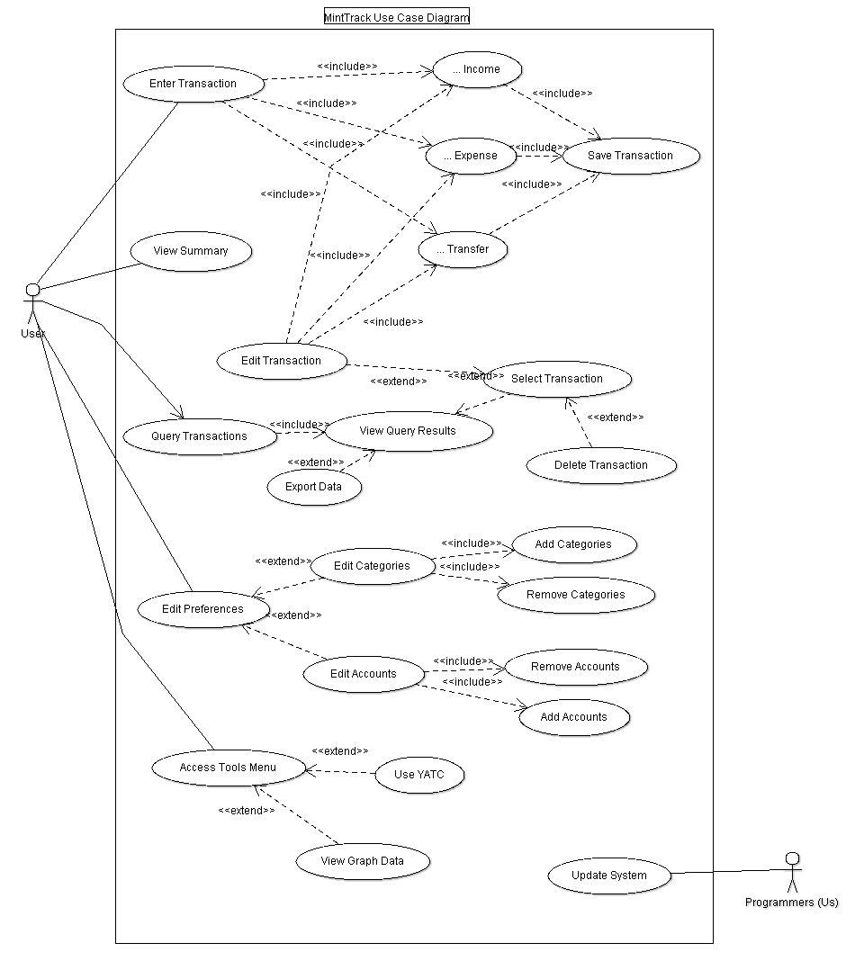
    - Use case model

Examples of Use Case Descriptions:
Use case name | EnterTransaction
Actors | User
Flow of Events | 1. User clicks on transaction tab  2. MintTrack loads transaction screen  3. User chooses transaction type  4. MintTrack loads screen associated with transaction type  5. User enters transaction information and presses save button  6. MintTrack updates database
Entry Condition(s) | - User selects transaction tab
Exit Condition(s) | - User presses save button  - User selects another tab

Use case name | EnterIncomeTransaction
Actors | User
Flow of Events | 1. User clicks on transaction tab  2. MintTrack loads transaction screen  3. User presses button for income transaction  4. MintTrack loads screen associated with income transaction  5. User presses date selector  6. MintTrack loads date picker object and displays it  7. User changes date with up/down buttons on date picker and presses the back button on the phone to return to the income transaction screen  8. MintTrack displays new date on the screen  9. User selects amount text area  10. MintTrack loads on-screen keyboard  11. User types in amount; presses back button to go back to income transaction screen  12. User presses category box  13. MintTrack loads spinner with all categories  14. User selects a category by pressing it  15. MintTrack updates category on display  16. User presses account text area  17. MintTrack loads a spinner with a list of all accounts  18. User selects an account by pressing it  19. MintTrack updates display with account name  20. User presses in note text area  21. MintTrack displays on-screen keyboard  22. User enters data for note; presses back button on phone to go back to income transaction screen  23. User presses save button  24. MintTrack updates the database with the new transaction
Entry Condition(s) | - User selects transaction tab
Exit Condition(s) | - User presses save button  - User selects another tab
*Other transactions will be similar to this one, but with the user entering both identical and different information.
    - Object model – Transaction Class with Inheritance and Class Diagram
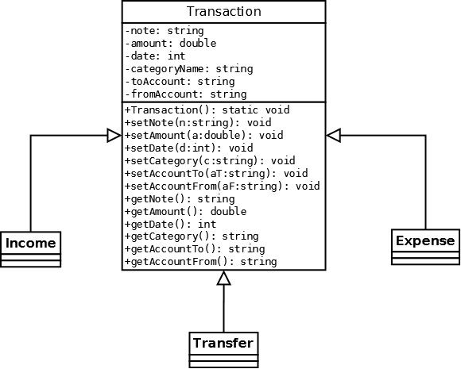
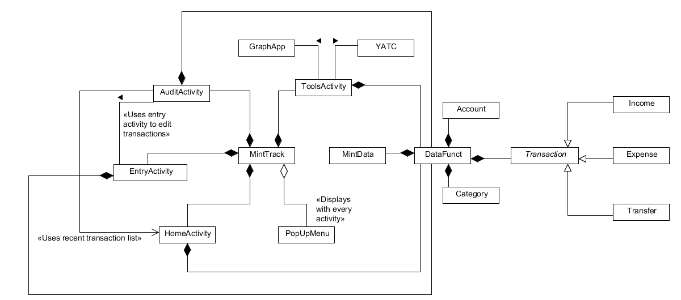
Boundary Objects:

YATCButton
GraphButton
ExportButton
EditButton
DeleteButton
PreferenceButton
InfoButton
SaveButton
IncomeButton
ExpenseButton
TransferButton
DatePicker
NoteTextField
CategorySpinner
AccountSpinner (2)
AmountTextField
IncomeTotalTextField
ExpenseTotalTextField
GrandTotalTextField
TransactionListView

    - Dynamic model – Audit/Transaction Interaction
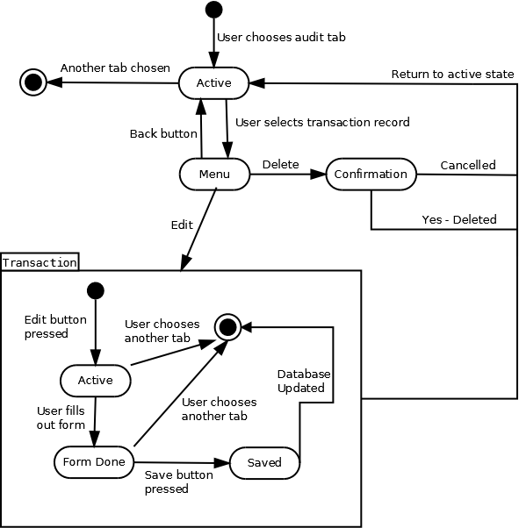

    - User Interface
