**Create an Objective**

After reaching the landing page for SET, Navigate to the sub-header titles “Dashboard View” and click the “New Objective” button to the right.

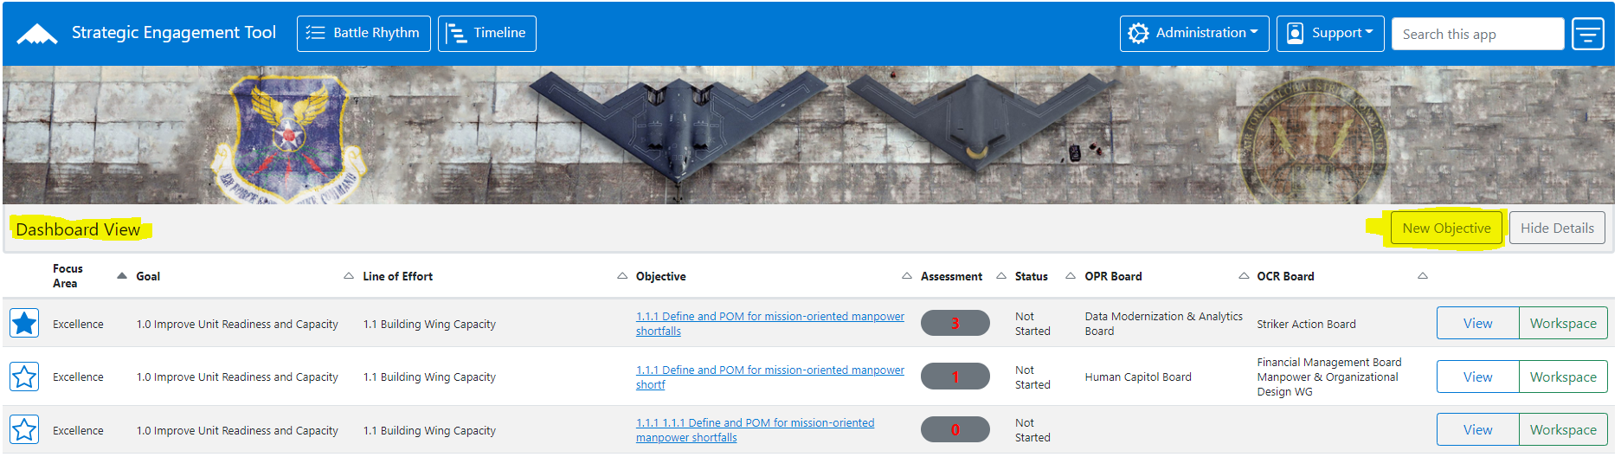

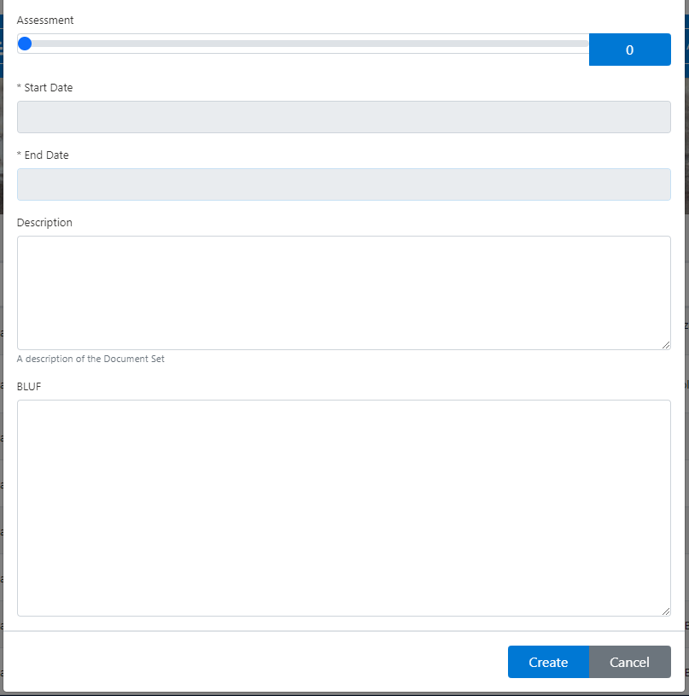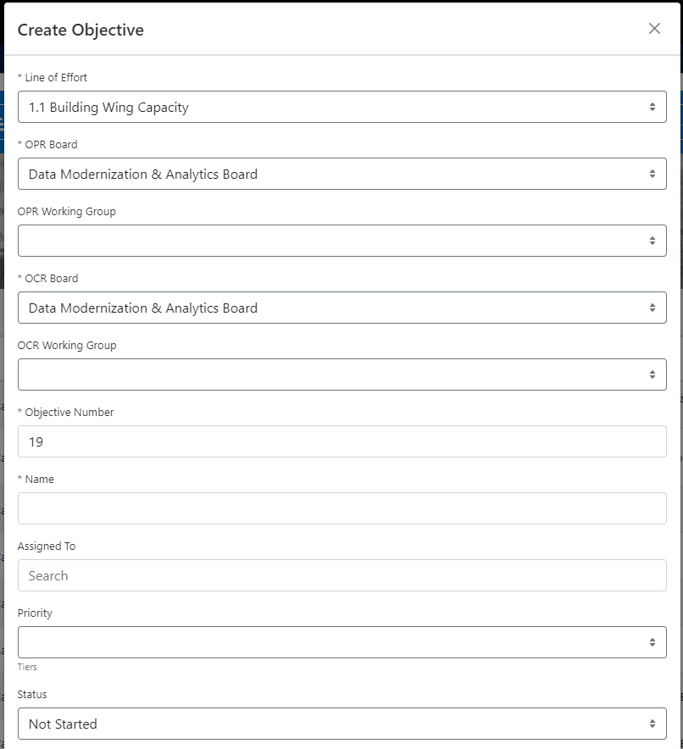After the “Create Objective” form loads, begin entering data. Required fields are marked with an asterisk. It is recommended to scroll from top to bottom and fill in as much data as possible for each label/section. I.E. Priority, BLUFF, etc.

Click the “Create” button at the bottom of the form. The objective will appear in the dashboard listed in order by its objective number.

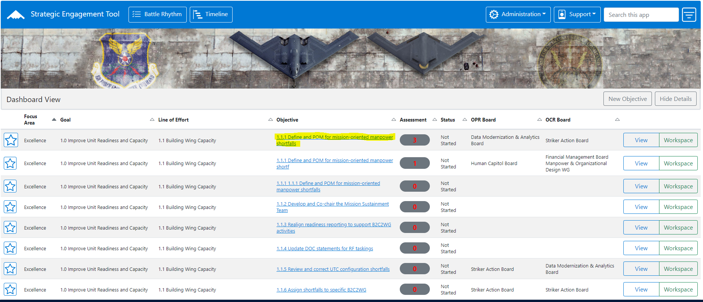

**Workspace**

The workspace is used to view specific details about a particular objective. Navigate to it by clicking the “Workspace” button on the far left on the objective’s row.



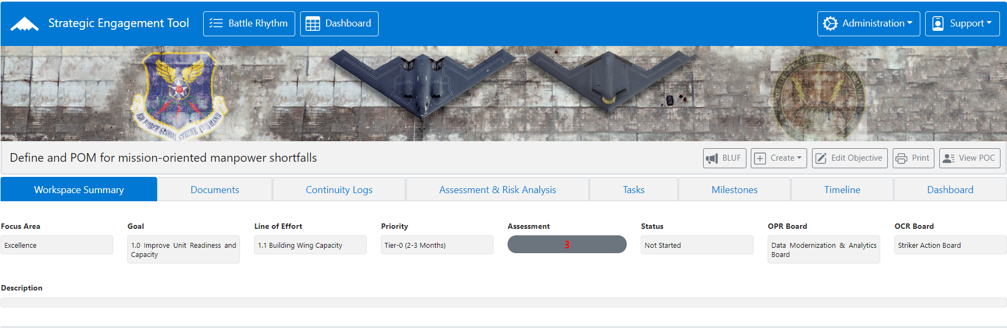

**Workspace main screen**

The navigation bar at the top of the page is the same as the navigation bar on the dashboard with the same look, layout, and buttons. The objective name appears on the sub navigation bar below the banner with the workspace specific buttons appearing on the right. The main screen is composed of the tabs for each of the workspace sections.

**Workspace Summary**

The “Workspace Summary” tab lists general information for an objective similar to the view form. The Assessment is to the center of the screen with a gray shape

**Documents**

Click the Documents tab to View, Edit, and Delete document templates

**Continuity Logs**

Click the Continuity Logs tab to view or add comments. Team Notes are to the left and are comments entered by action officers and other users. Senior Leadership Comments are to the right and are entered by high-ranking officials such as generals and officers only.

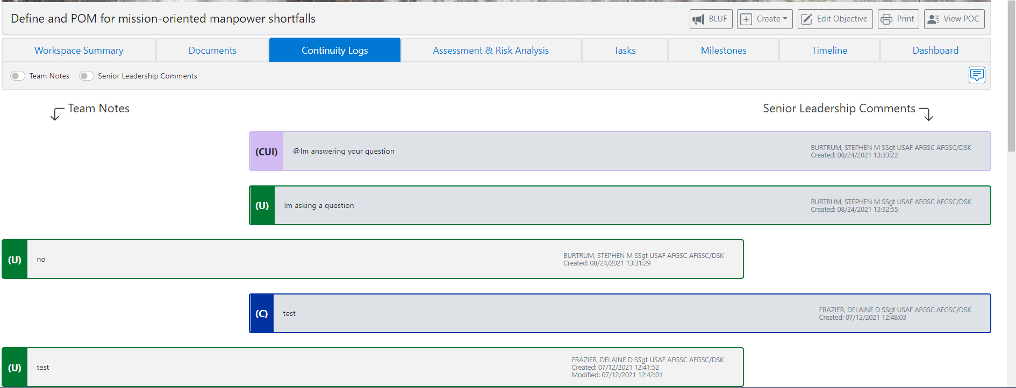

**Add a comment**

Click the New Log Entry icon and select the Comment Type, Classification, and then type in the comment. Click Create.



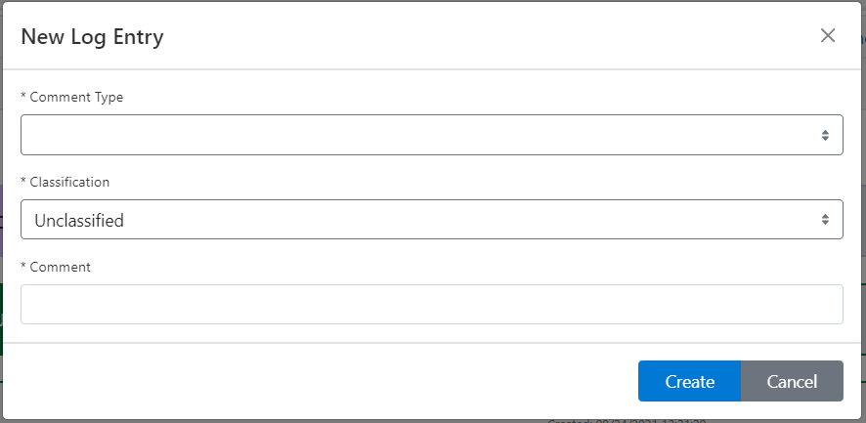

The toggle buttons can be used to view either the Team Notes or Senior Leadership Notes only.

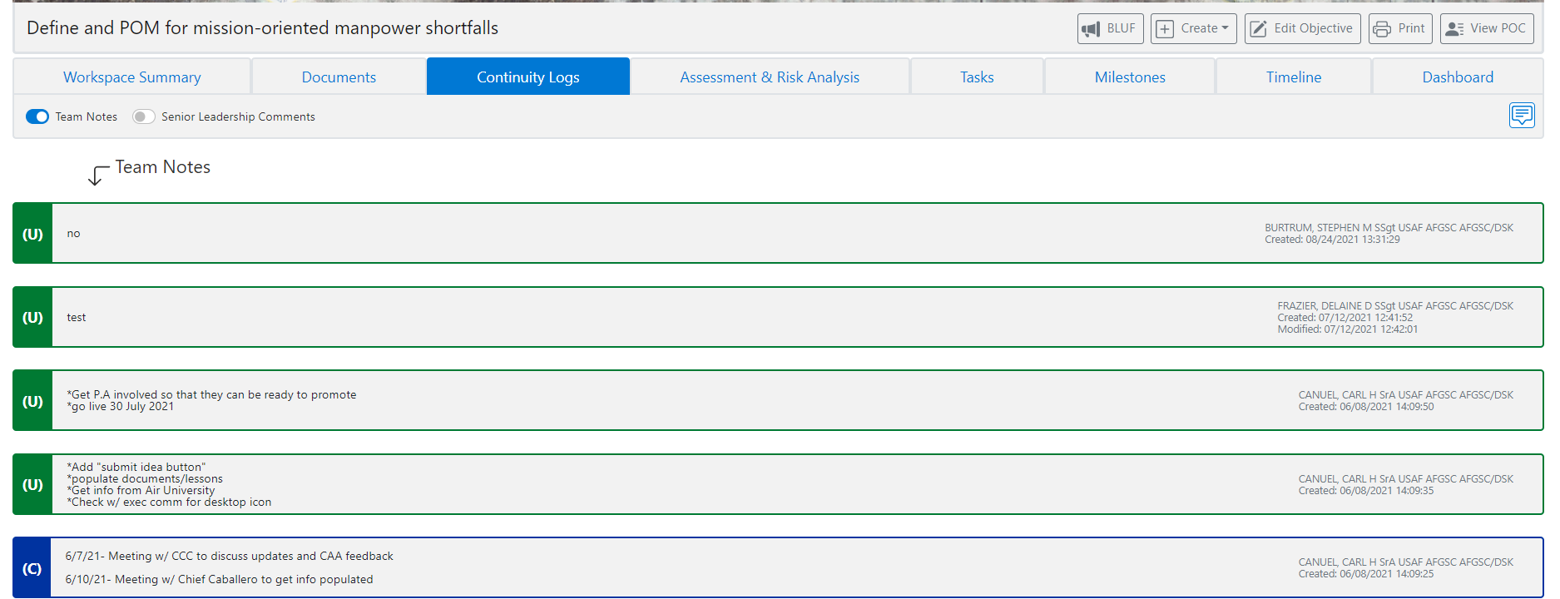

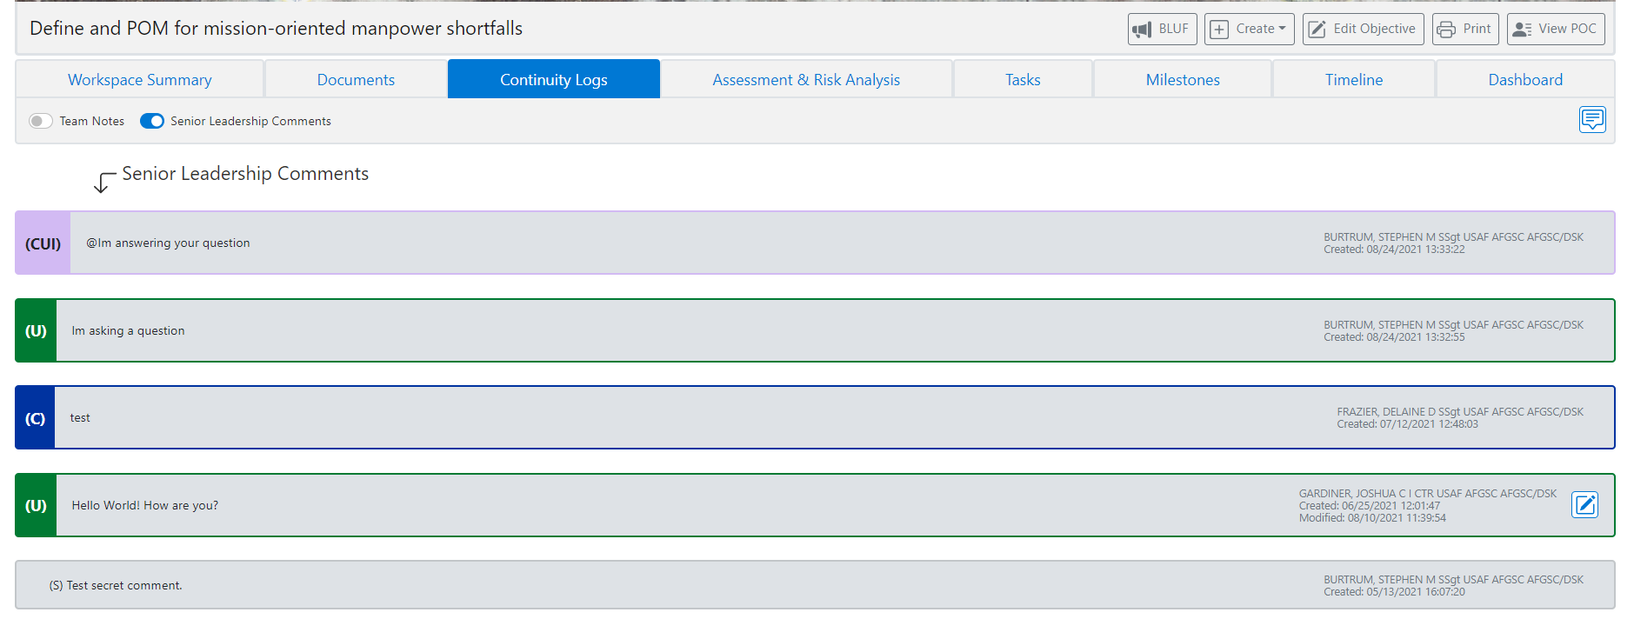

**Assessment & Risk Analysis**

Assessment data is composed for specific quantities of items associated with an objective and used as the Measure of Effectiveness (MOE) for an objective.

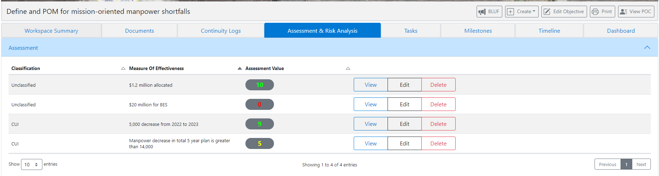

**Tasks**

Tasks are the basic steps needed to complete an objective. They have their own assessments, classifications, and criteria similar to an objective. They may or may not be associated with milestones.

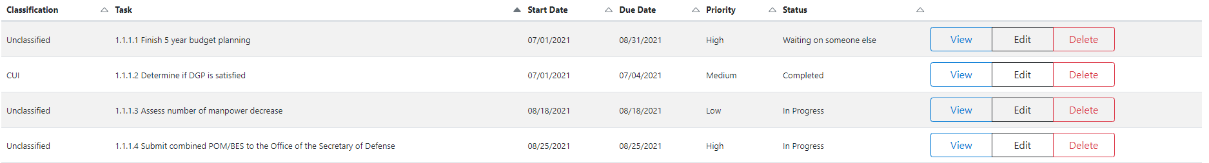

**Milestones**

A milestone is a particular highlight associated with an marking an important accomplishment for it. They have their own assessments, classifications, and criteria similar to an objective. They may or may not be associated with a task.

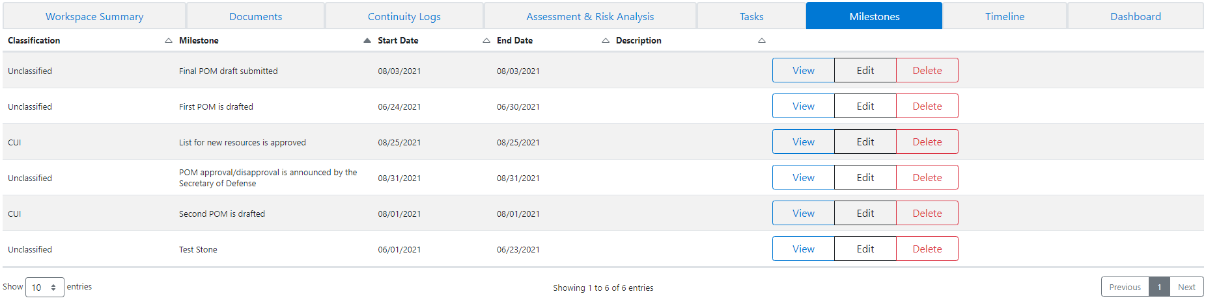

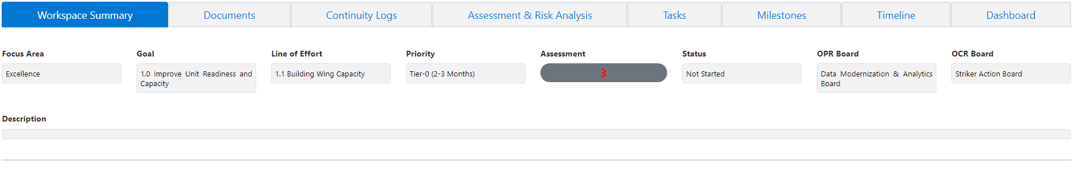

**Timeline**

The timeline for a specific objective lists the milestones and tasks in an interactive Gantt chart display. The milestones appear as golden diamond shapes and the tasks appear as box items that span their duration on the timeline.

The view can be adjusted by clicking on the Month-Year buttons located on the Timeline View sub-nav bar.

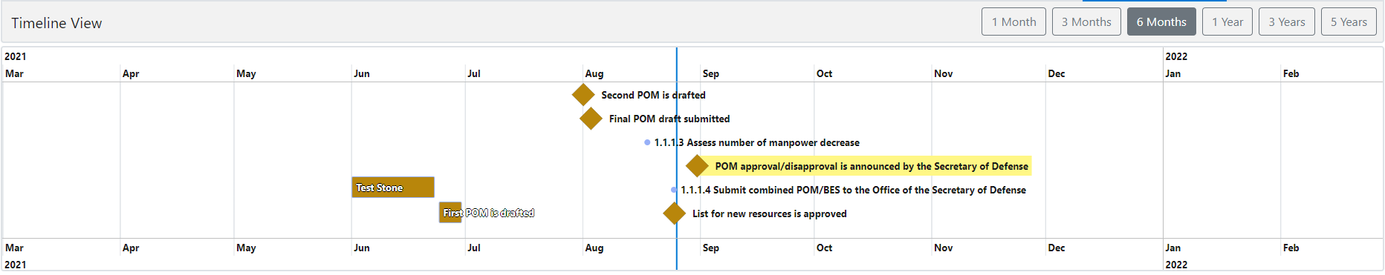

**Timeline**