Homework 2

1. (25%) Consider an application that transmits data at a steady rate (for example, the sender generates an N-bit unit of data every k time unit, where k is small and fixed). Also, when such an application starts, it will continue running for a relatively long period of time. Answer the following questions, briefly justifying your answer:
2. (15%) Would a packet-switched network or a circuit-switched network be more appropriate for this application? Why?

ANS. A circuit-switched network would be preferred because

* Since the transmission rate is already known, bandwidth requirement will be predictable, which means that the bandwidth can be reserved for each application session without much waste.
* Since the running period is relatively long, we don’t need to worry about the overhead costs of building circuit connection, which are amortized over the lengthy process of the application session.

1. (10%) Suppose that a packet-switched network is used and the only traffic in this network comes from such applications as described above. Furthermore, assume that the sum of the application data rates is less than the capacities of each and every link. Is some form of congestion control needed? Why?

ANS. Given the information, the capacity of each link is more than the sum of the application data rates. In the worst case, even though all the applications simultaneously transmit over one or more network links, the congestion problem won’t occur. So some form of congestion control is of no need.

2. (20%) Suppose users share a 3 Mbps link. Also suppose each user requires 150 kbps when transmitting, but each user transmits only 10 percent of the time. (See the discussion of statistical multiplexing in Section 1.3.)

1. (5%) When circuit switching is used, how many users can be supported?

ANS. 3000k / 150k =20 users can be supported.

1. (5%) For the remainder of this problem, suppose packet switching is used. Find the probability that a given user is transmitting.

ANS. The probability p that a given user is transmitting will be 0.1.

1. (5%) Suppose there are 120 users. Find the probability that at any given time, exactly n users are transmitting simultaneously. (Hint: Use the binomial distribution.)

ANS. $\left({120 \atop n}\right)p^{n}{(1-p)}^{120-n}$

1. (5%) Find the probability that there are 21 or more users transmitting simultaneously.

ANS. $1-\sum_{n=0}^{20}{\left({120 \atop n}\right)p^{n}{(1-p)}^{120-n}}$

According to the DeMoivre-Laplace theorem,

$$\sum_{n=0}^{20}{\left({120 \atop n}\right)p^{n}{\left(1-p\right)}^{120-n}}=p\left[\frac{0-12}{\sqrt{120*0.1*0.9}}< \frac{x-12}{\sqrt{120*0.1*0.9}}< \frac{20-12}{\sqrt{120*0.1*0.9}}\right]$$

$≈ ∅\left(2.43\right)-∅\left(-3.65\right)=0.9925-1+0.9998=0.9923$

所求 = 1 - 0.9923 $≈0.007$

1. (35%) This elementary problem begins to explore propagation delay and transmission delay, two central concepts in data networking. Consider two hosts, A and B, connected by a single link of rate R bps. Suppose that the two hosts are separated by m meters, and suppose the propagation speed along the link is s meters/sec. Host A is to send a packet of size L bits to Host B.
   1. (5%) Express the propagation delay, dprop, in terms of m and s.

ANS.

* 1. (5%) Determine the transmission time of the packet, dtrans, in terms of L and R.

ANS.

* 1. (5%) Ignoring processing and queuing delays, obtain an expression for the end-to-end delay.

ANS.

* 1. (5%) Suppose Host A begins to transmit the packet at time t = 0. At time t = dtrans, where is the last bit of the packet?

ANS. At time t = $d_{trans}$, the bit is just leaving Host A.

* 1. (5%) Suppose dprop is greater than dtrans. At time t = dtrans, where is the first bit of the packet?

ANS. When $d_{prop} > d_{trans}$, at time t = $d_{trans}$, the first bit is in the link and has not reached Host B.

* 1. (5%) Suppose dprop is less than dtrans. At time t = dtrans, where is the first bit of the packet?

ANS. When $d_{prop}< d_{trans}$, at time t = $d_{trans}$, the first bit has reached Host B.

* 1. (5%) Suppose s = 2.5·108, L = 120 bits, and R = 60 kbps. Find the distance m so that dprop equals dtrans.

ANS. $m=\frac{L}{R}s=\frac{120}{56k}(2.5*{10}^{8})$ = 536 km

1. (20%)
2. (5%) Which layers in the Internet protocol stack does a router process (just routing)?

ANS.

|  |
| --- |
| Application layer |
| Transport layer |
| Network layer |
| Link layer |
| Physical layer |

1. (5%) Which layers does a link-layer switch process?

ANS.

|  |
| --- |
| Application layer |
| Transport layer |
| Network layer |
| Link layer |
| Physical layer |

1. (5%) Which layers does a host process?

ANS.

|  |
| --- |
| Application layer |
| Transport layer |
| Network layer |
| Link layer |
| Physical layer |

1. (5%) Suppose a user wants to load a simple static HTML page into his/her browser. Also assume RTT is 5 seconds and the total needed time for the page to be transferred is 4 seconds. Calculate the time it takes from the initial request to the server until the user receives the file completely.

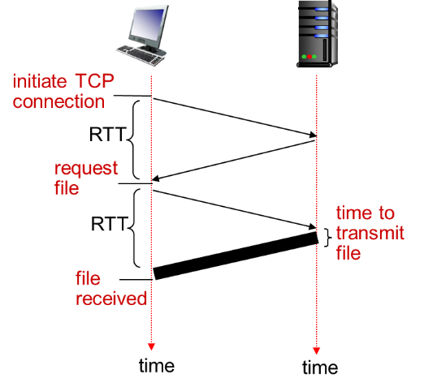ANS.

Total time = 2RTT+ file transmission time = 2*5 + 4 =14 (sec)