**Report**

**gray: worst when compared with others ; yellow: best when compared with others;**

|  |  |  |  |  |  |  |  |  |  |
| --- | --- | --- | --- | --- | --- | --- | --- | --- | --- |
| Command | Array | | | Double linked list | | | Binary search tree | | |
| **Period Time (sec)** | **Total Time (Sec)** | **Memory (MB)** | **Period Time (sec)** | **Total Time (Sec)** | **Memory (MB)** | **Period Time (sec)** | **Total Time (Sec)** | **Memory (MB)** |
| Case 1 (common use) | | | | | | | | | |
| adta –r 5000 | 0 | 0 | 0.9883 | 0 | 0 | 0.668 | 0 | 0 | 0.793 |
| adtp | 0 | 0 | 0.9883 | 0 | 0 | 0.688 | 0 | 0 | 0.793 |
| adtp –r | 0.01 | 0.01 | 0.9883 | 0 | 0 | 0.688 | 0.01 | 0.01 | 0.793 |
| adts | 0 | 0.01 | 0.9883 | 0.62 | 0.62 | 0.688 | 0 | 0.01 | 0.793 |
| adtp | 0.01 | 0.02 | 0.9883 | 0 | 0.62 | 0.688 | 0.01 | 0.02 | 0.793 |
| adta –r 50000 | 0.03 | 0.05 | 3.73 | 0.01 | 0.63 | 3.676 | 0.08 | 0.10 | 3.746 |
| adtd –r 10000 | 4.41 | 4.46 | 3.73 | 2.13 | 2.76 | 3.691 | 12.12 | 12.22 | 3.762 |
| adts | 0.04 | 4.50 | 3.73 | 35.39 | 38.15 | 3.691 | 0 | 12.22 | 3.762 |
| adtd –r 10000 | 3.68 | 8.18 | 3.73 | 2.29 | 40.44 | 3.691 | 13.98 | 26.20 | 3.762 |
| adts | 0.01 | 8.19 | 3.73 | 15.61 | 56.05 | 3.691 | 0 | 26.20 | 3.762 |
| adtd –b 10000 | 0 | 8.19 | 3.73 | 0.01 | 56.06 | 3.691 | 0.01 | 26.21 | 3.762 |
| Case 2 (delete random) | | | | | | | | | |
| adta –r 50000 | 0.02 | 0.02 | 3.492 | 0.01 | 0.01 | 3.57 | 0.08 | 0.08 | 3.668 |
| adtd –r 10000 | 5.31 | 5.33 | 3.492 | 2.46 | 2.47 | 3.641 | 28.83 | 28.91 | 3.867 |
| adtd –r 10000 | 4.9 | 10.23 | 3.492 | 2.07 | 4.54 | 3.703 | 18.94 | 41.07 | 3.867 |
| adtd –r 10000 | 3.54 | 13.77 | 3.492 | 1.88 | 6.42 | 3.703 | 12.16 | 60.01 | 3.867 |
| adtd –r 10000 | 2.21 | 15.98 | 3.492 | 1.61 | 8.03 | 3.703 | 4.99 | 65 | 3.867 |
| adtd –r 10000 | 0.77 | 16.75 | 3.492 | 0.53 | 8.56 | 3.703 | 1.28 | 66.28 | 3.867 |
| Case 3 (sort) | | | | | | | | | |
| adta –r 50000  adts | 0.04 | 0.09 | 3.598 | 49.94 | 49.95 | 3.5/  3.625 | 0 |  |  |
| adta –r 40000  adts | 0.04 | 0.06 | 3.426 | 30.23 | 30.24 | 2.852/  3.203 | 0 |  |  |
| adta –r 30000  adts | 0.02 | 0.03 | 1.895 | 20.09 | 20.09 | 2.336/  2.598 | 0 |  |  |
| adta –r 20000  adts | 0.02 | 0.03 | 1.895 | 7.48 | 7.48 | 1.508/  1.676 | 0 |  |  |
| adta –r 10000  adts | 0.01 | 0.01 | 1.203 | 1.86 | 1.86 | 0.9297/  1.188 | 0 |  |  |
| adta –r 5000  adts | 0 | 0 | 0.9414 | 0.56 | 0.56 | 0.6641/  0.6641 | 0 |  |  |
|  |  |  |  |  |  |  |  |  |  |

Observation.

1. When we add objects randomly, if the total number of objects is small, the difference of execution time among the three data structure is very small to detect by human, but the memory used of array is larger than the other two. With the number of objects increases, we can observe the execution time and the required memory of double linked list will be the most efficient, while binary search tree requires most time and memory space.
2. The command of deleting front, deleting back, printing forward and backward won’t take much time.
3. With the number of objects increases, the execution time of deleting randomly increases and we can find that the double linked list takes least time while the binary search tree takes most time.

The graph of deleting time v.s. number of object:

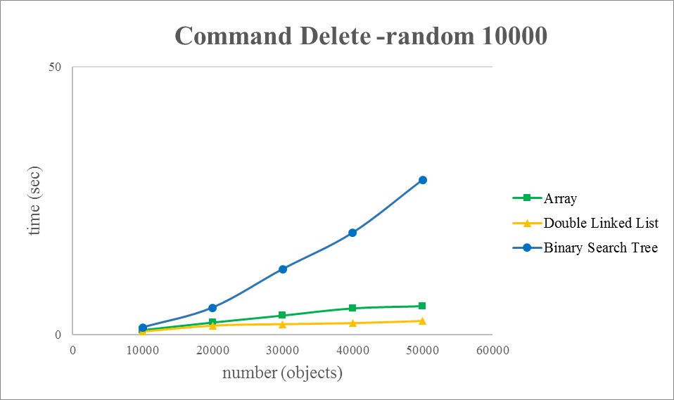

1. With the number of objects increases, the execution time of sorting objects increases and we can find that the double linked list takes more time when compared to array.

(We don’t take binary search tree into consideration because the structure is designed to be sorted already.)

The graph of sorting time v.s. number of object:

