|  |
| --- |
| B03901156 電機三 黃于瑄 |

**105-2 CA with Embedded DSD Homework 1 Report**

1. **8-bit arithmetic logic unit(ALU)**

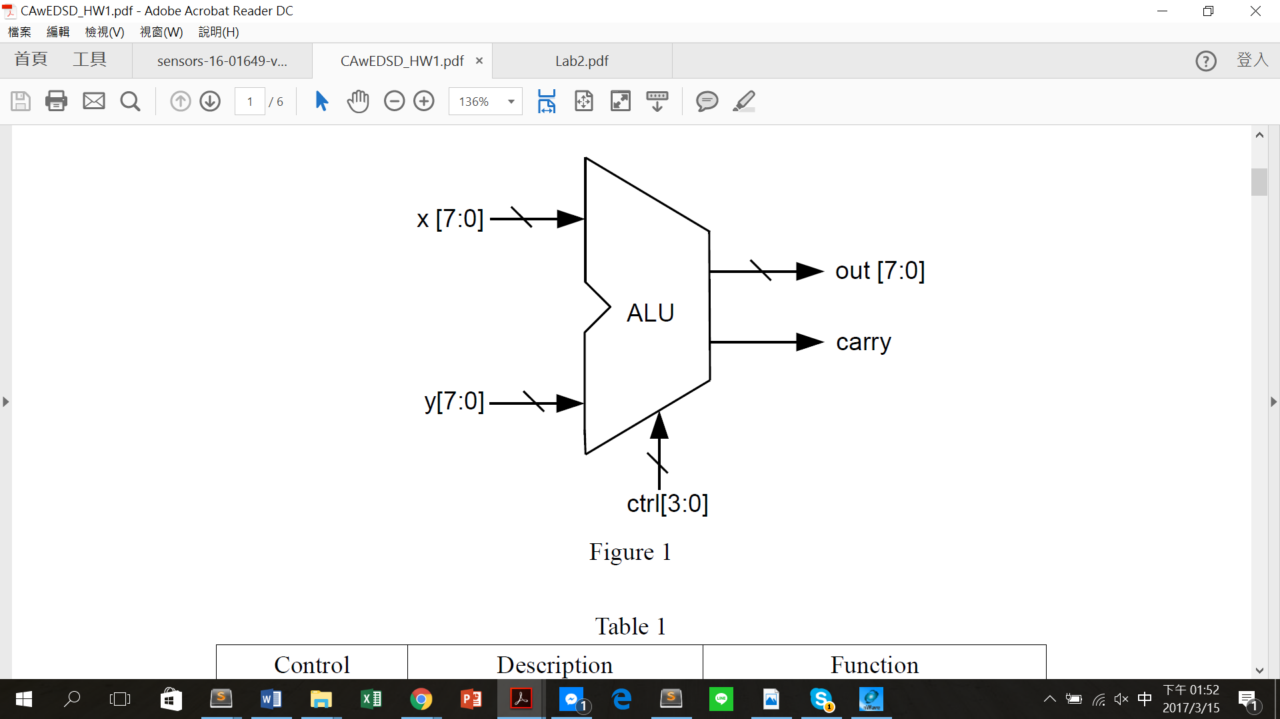

**The implementation of alu_rtl_tb2.v and alu_tb2.v :**

參考 Lab2 中 Lab2_test_alu.v 的寫法，對於每個operation皆考慮x及y所有可能的組合情形，並在console上印出test通過或失敗的訊息；以Addition的test pattern 為例:

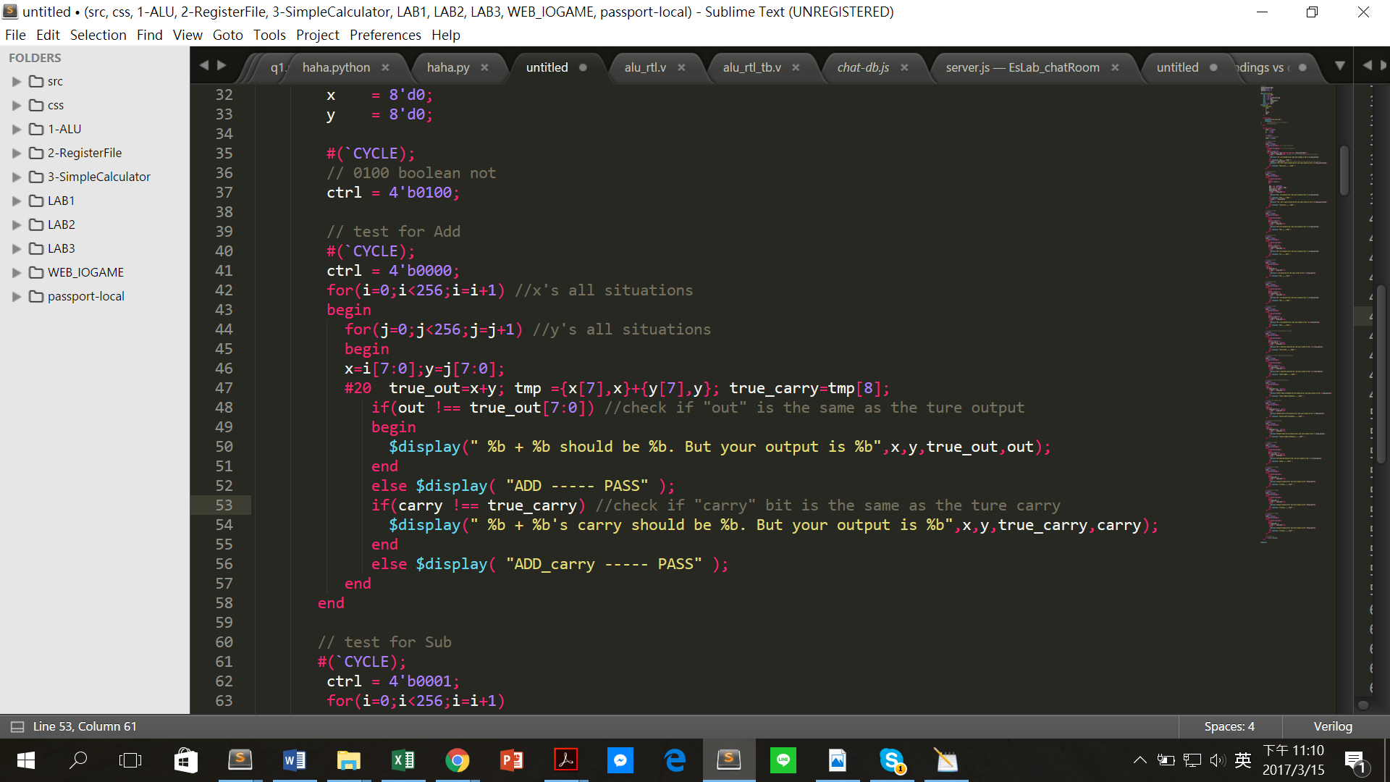

而每個operation所得波形圖如下所示: (case ctrl)

1. (ctrl == **4'b0000**) 🡪 out = x **+** y ;

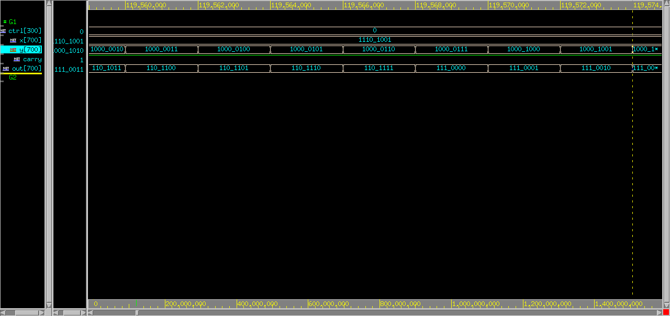

1. (ctrl == **4'b0001**) 🡪 out = x - y ;

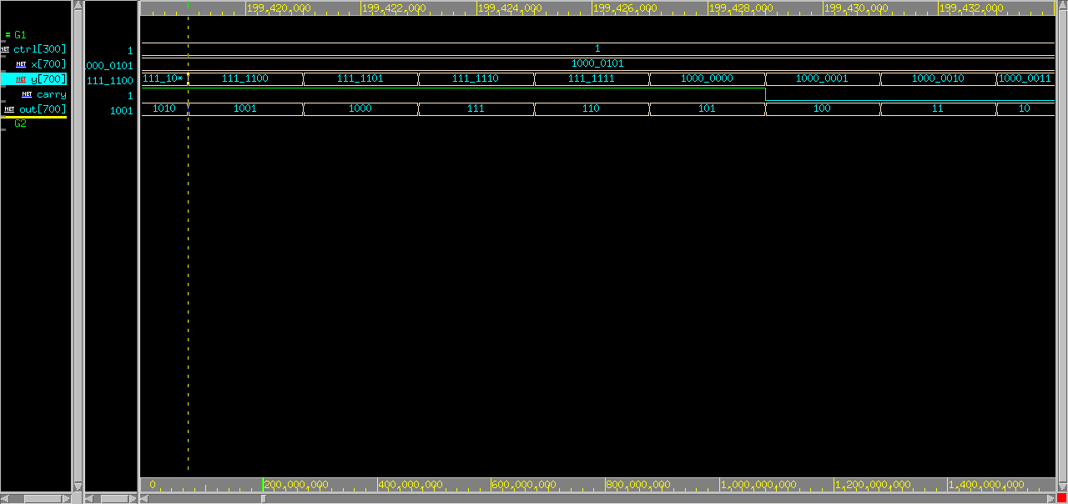

1. (ctrl == **4'b0010**) 🡪 out = x **&** y ;
2. 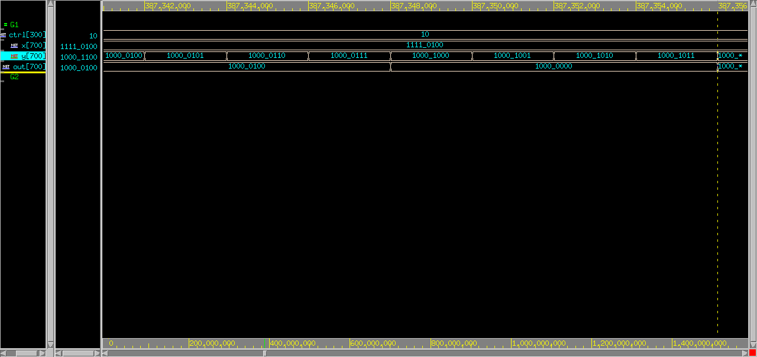
3. (ctrl == **4'b0011**) 🡪 out = x **|** y ;

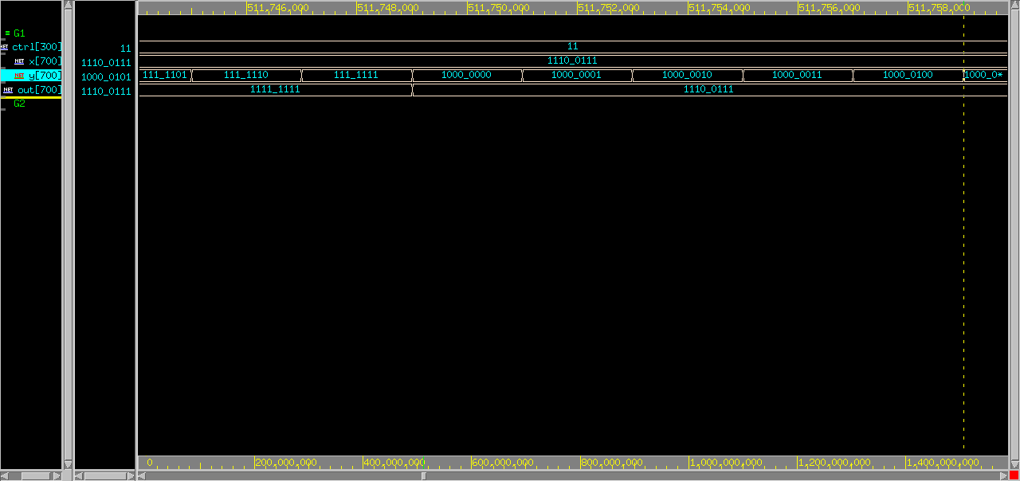

1. (ctrl == **4'b0100**) 🡪 out = **~** x ;

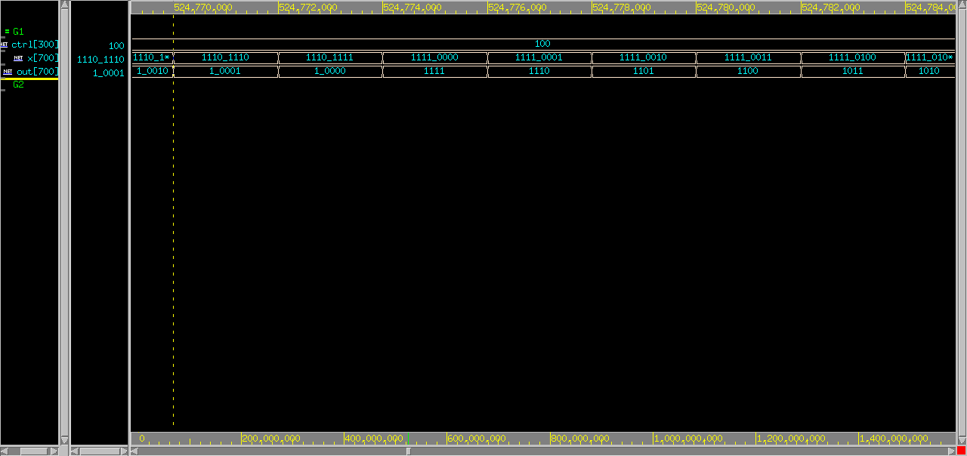

1. 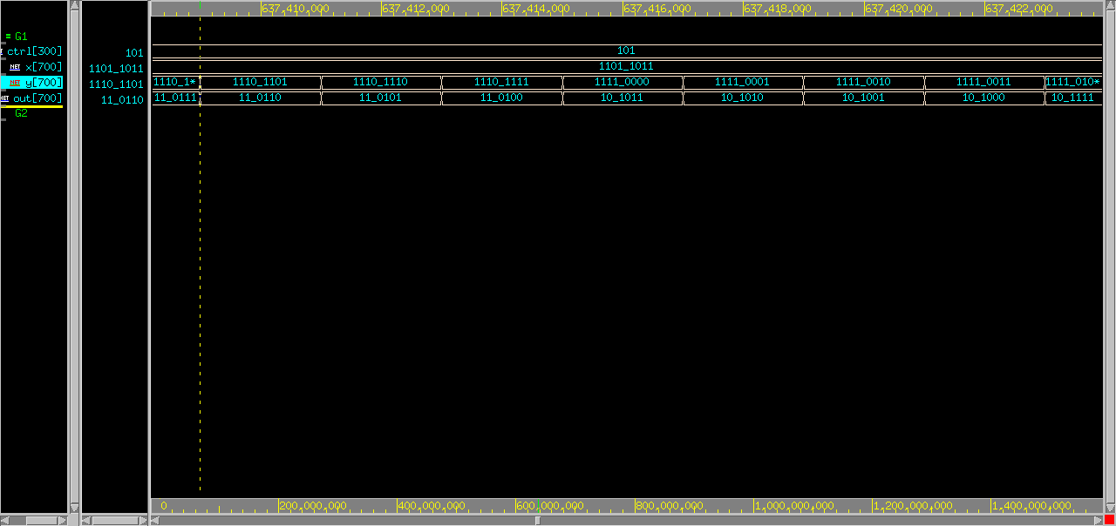(ctrl == **4'b0101**) 🡪 out = x **^** y ;
2. (ctrl == **4'b0110**) 🡪 out = **~**x **&** **~**y ;

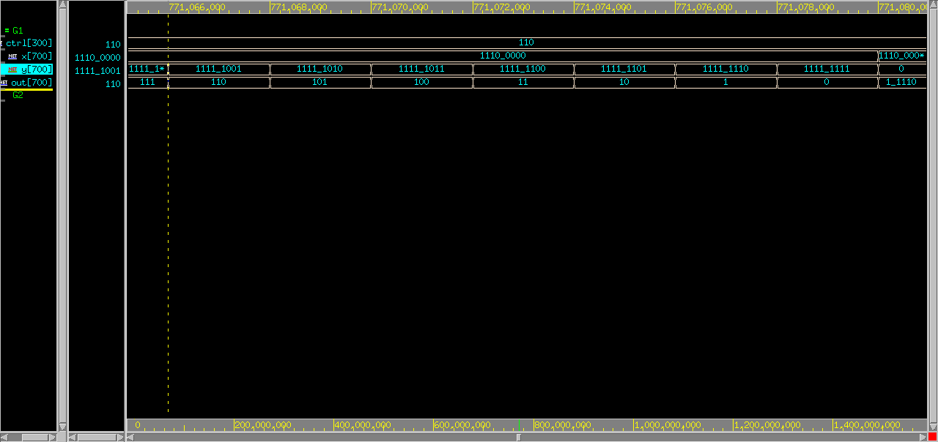

1. (ctrl == **4'b0111**) 🡪 out = **y << x[2:0]** ;

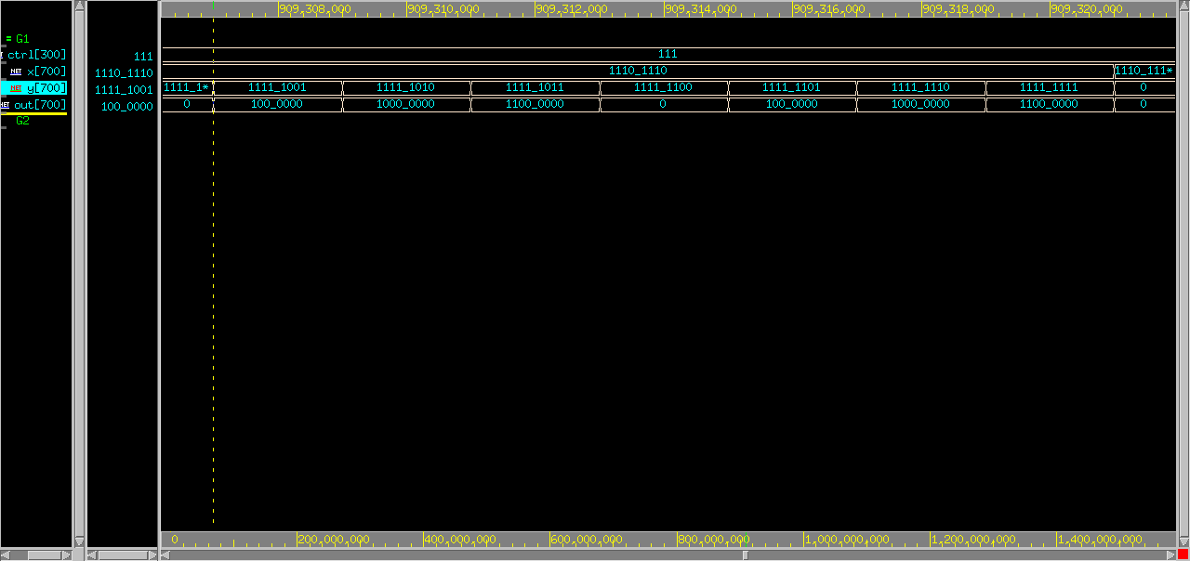

1. 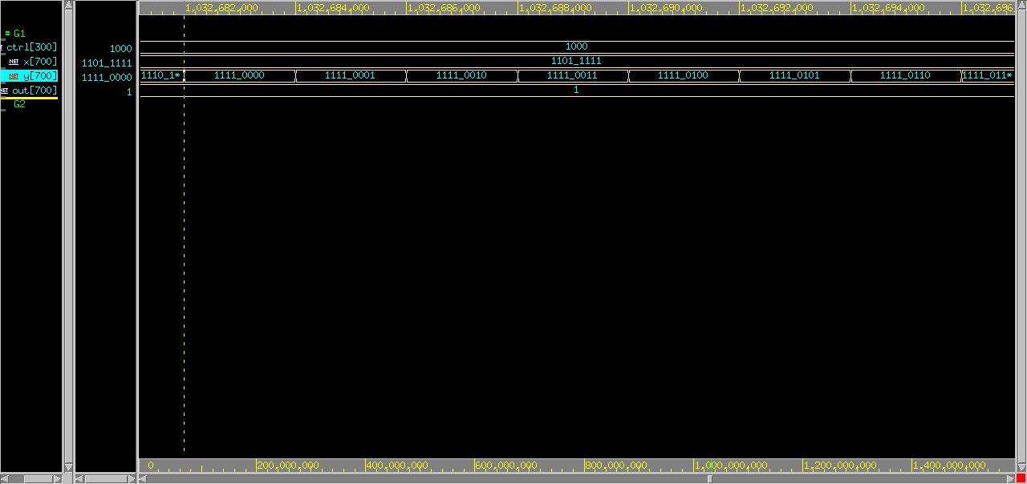(ctrl == **4'b1000**) 🡪 out = **y >> x[2:0]** ;
2. (ctrl == **4'b1001**) 🡪 out **= {x[7],x[7:1]}** ;

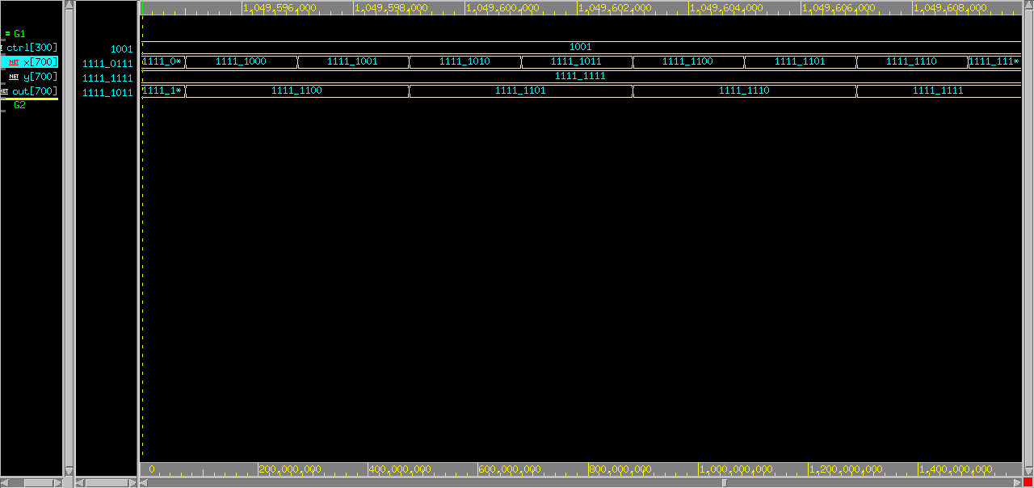

1. (ctrl == **4'b1010**) 🡪 out **= {x[6:0] , x[7]}** ;

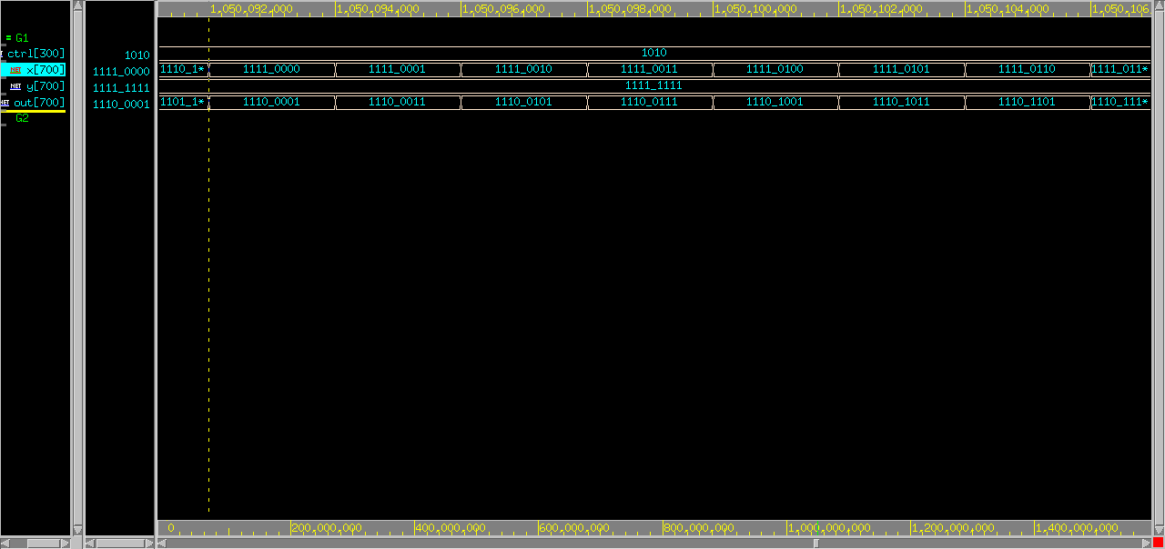

1. (ctrl == **4'b1011**) 🡪 out **= {x[0] , x[7:1]}** ;

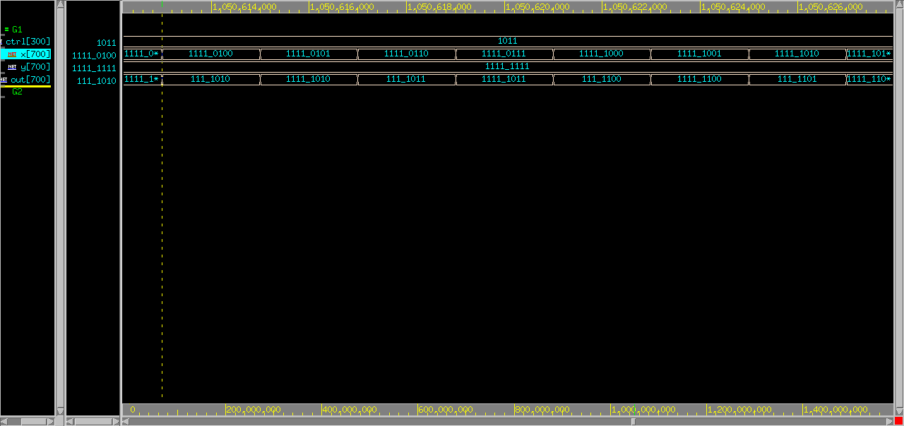

1. (ctrl == **4'b1100**) 🡪 out **= (x==y) ? 1 : 0** ;

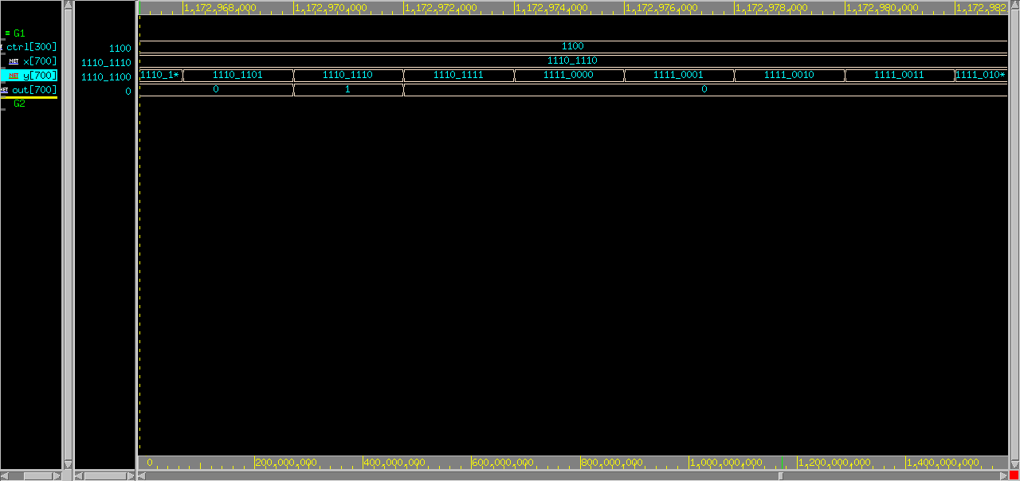

1. (ctrl == **4'b1101** or **4'b1110** or **4'b1111**) 🡪 out **= 0** ;

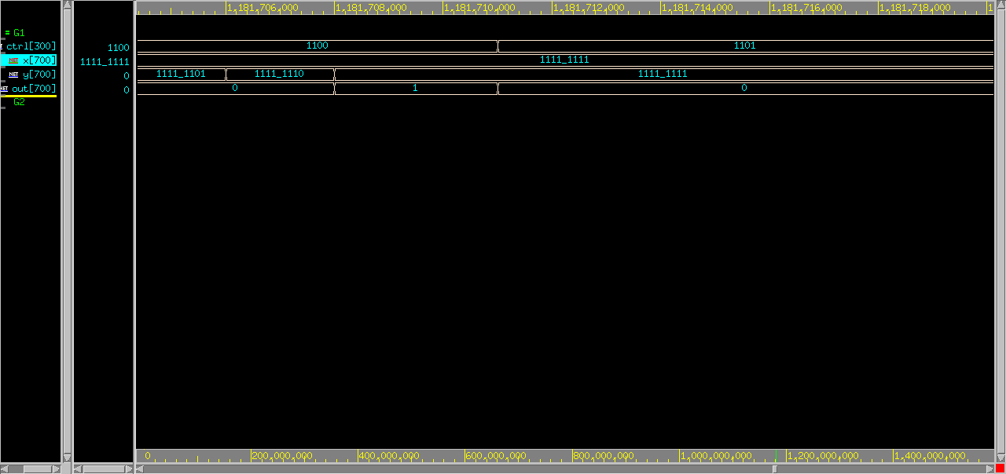

1. **8x8 Register File**

關於 $r0 = constant zero :

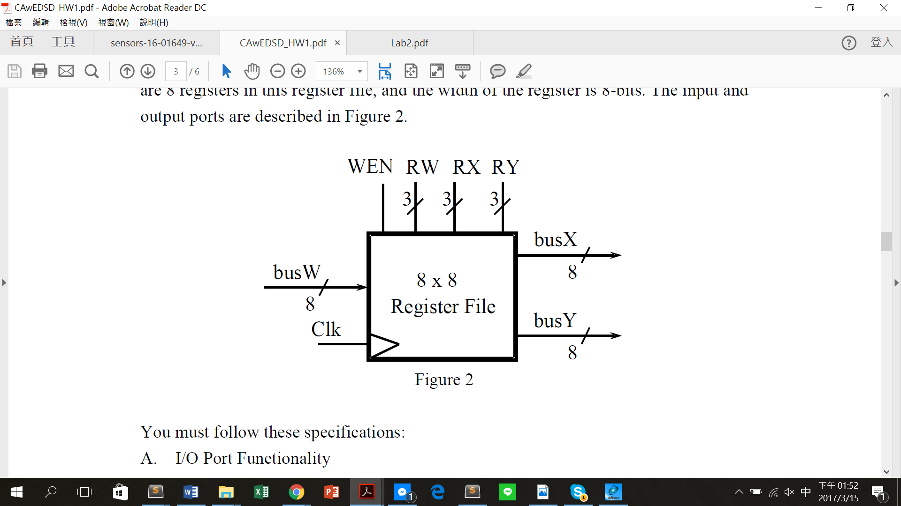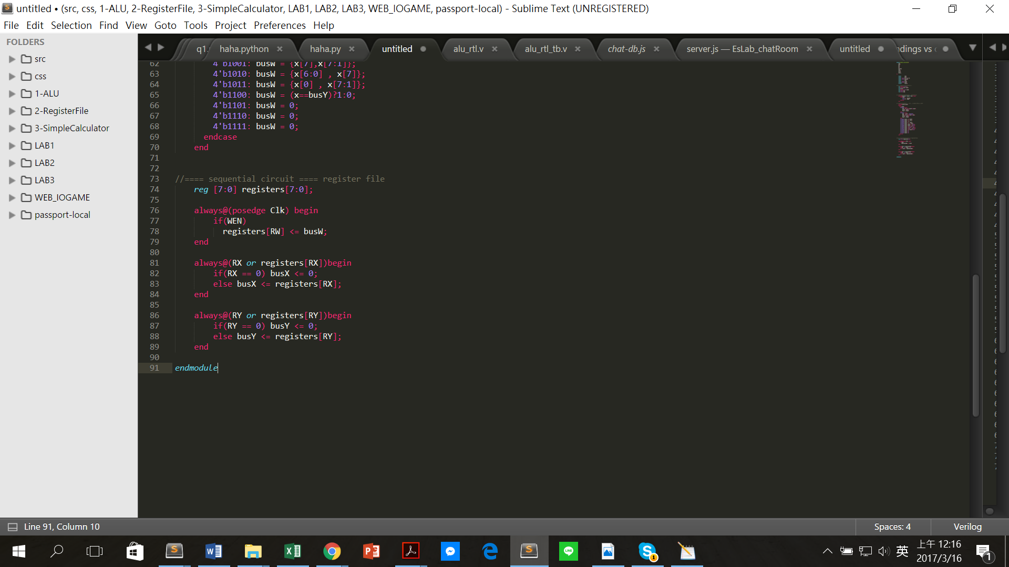

**3. Simple Calculator**

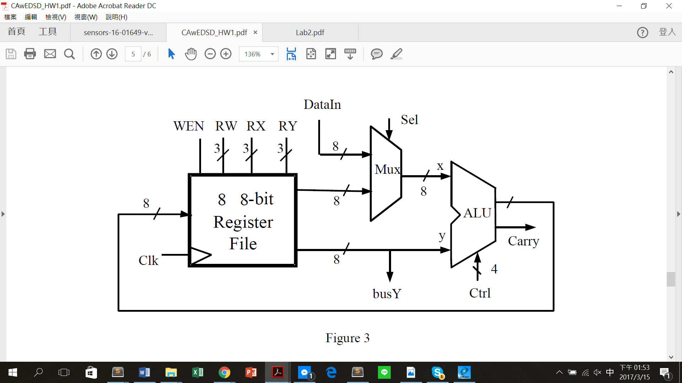

Design:

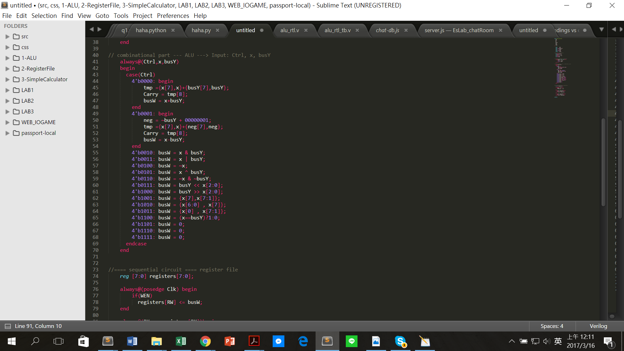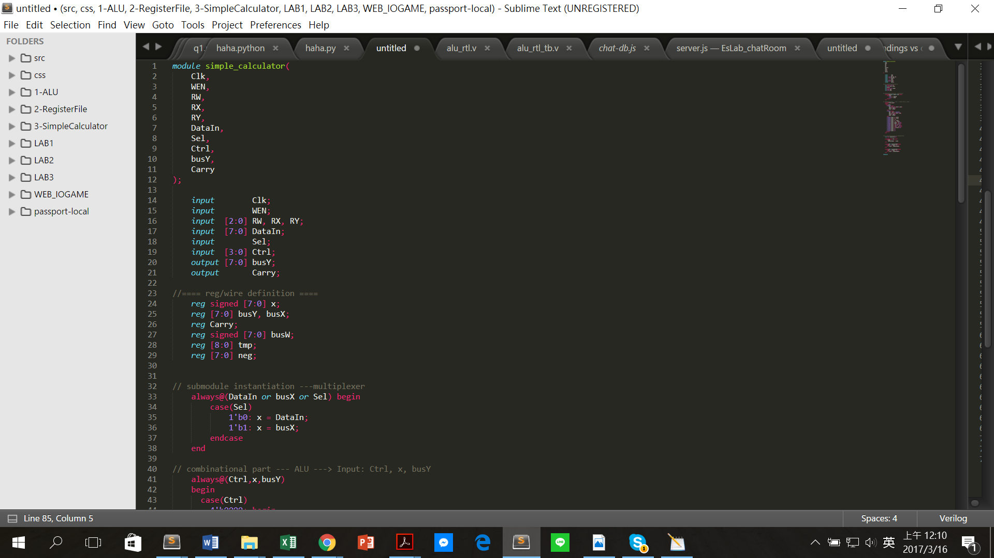



波形圖:

