**105-2 CA with Embedded DSD Homework 3 Report**

*Hardware Implementation of Single Cycle MIPS*

|  |
| --- |
| B03901156 電機三 黃于瑄 |

1. **RTL simulation**

**The implementation of module SingleCycle_MIPS :**

According to the datapath on the below, I implemented several sub modules at the first, and then utilize them in module SingleCycle_MIPS.

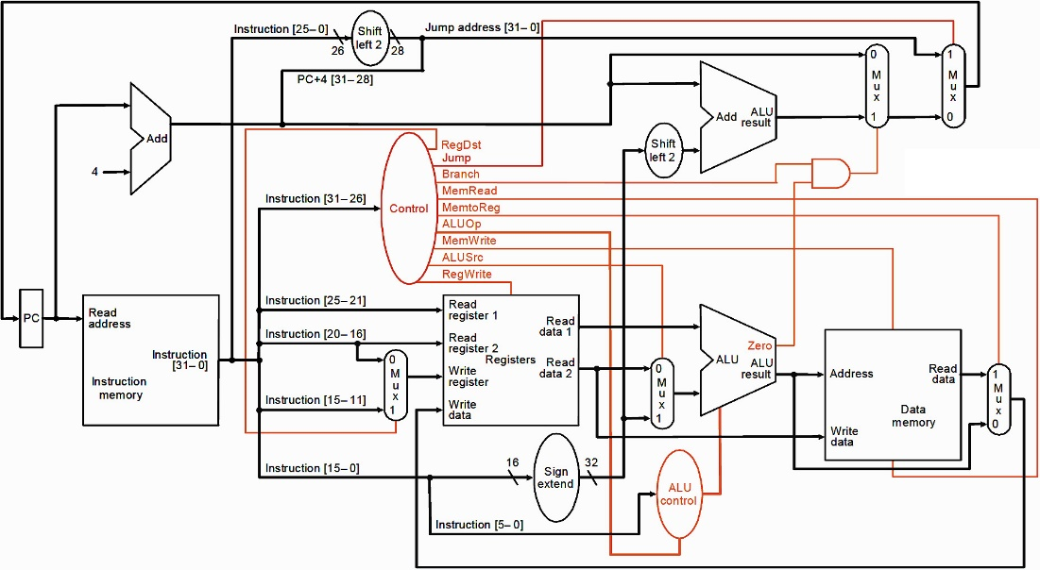

**Sub modules:**

1. PC (Program Counter)
2. Add_ALU
3. register_file
4. mainControl
5. ALU
6. ALUControl
7. signExtend
8. Mux

**In module SingleCycle_MIPS:**

Cell Reference

_PC PC

_mainControl mainControl

_ALU ALU

_ALUControl ALUControl

_signExtend signExtend

_regFile register_file

MUXX_RegDST Mux_WIDTH5_0

MUXX_Src Mux_WIDTH32_0

MUXX_MemToReg Mux_WIDTH32_5

PC_adder Add_ALU_0

branch_adder Add_ALU_1

MUXX_Branch Mux_WIDTH32_4

MUXX_JumpRegister Mux_WIDTH32_2

MUXX_Jump Mux_WIDTH32_3

MUXX_JumpAndLink_1 Mux_WIDTH5_1

MUXX_JumpAndLink_2 Mux_WIDTH32_1

而每個cell所得波形圖如下所示:

1. _PC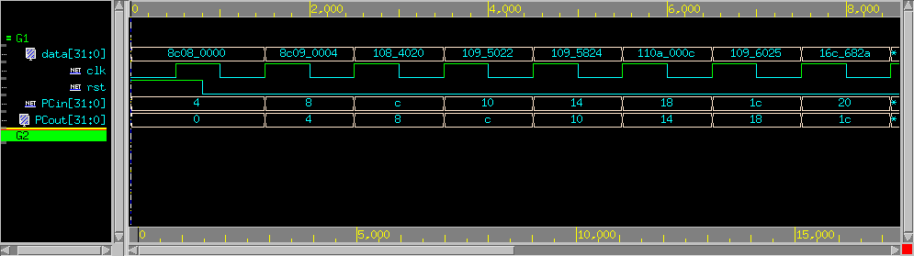
2. _mainControl

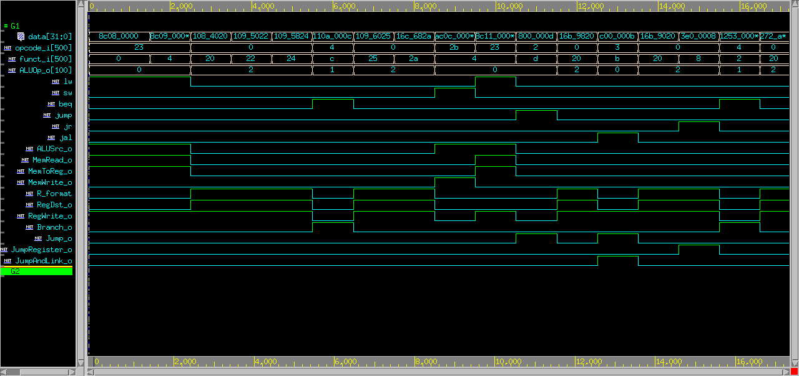

1. _ALU

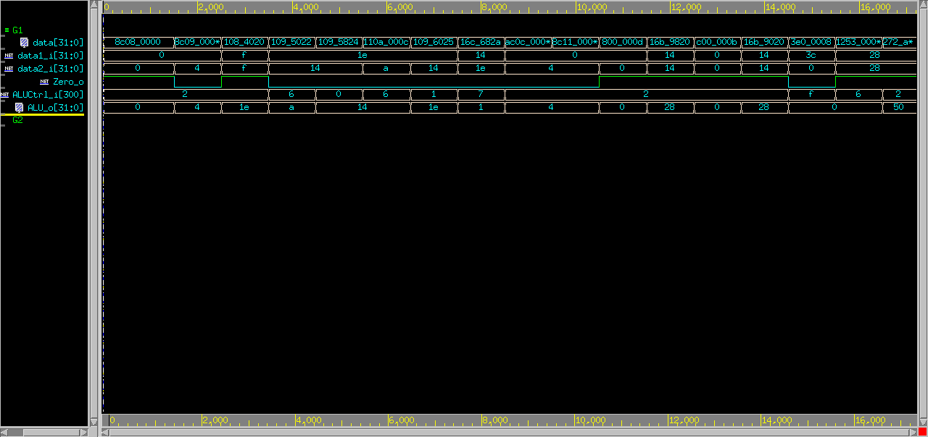

1. _ALUControl

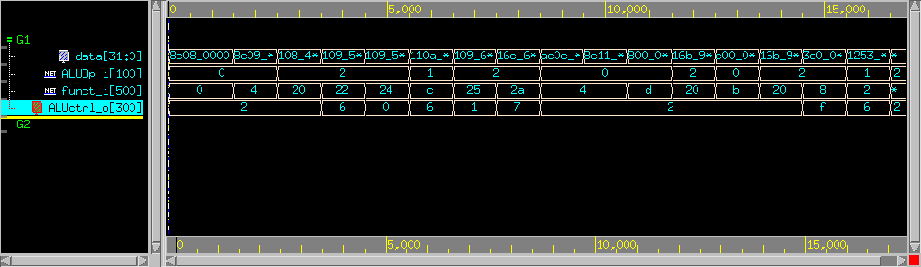

1. _regFile

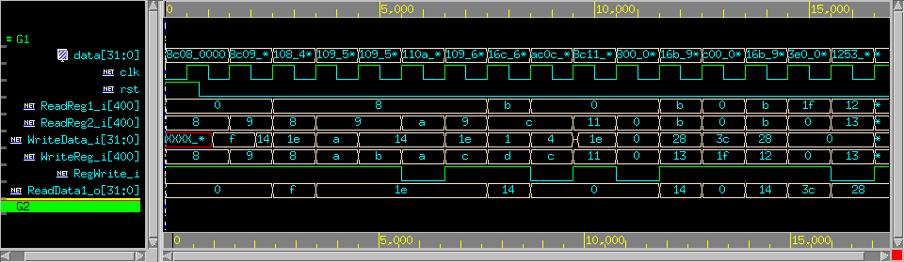

1. MUXX_RegDST

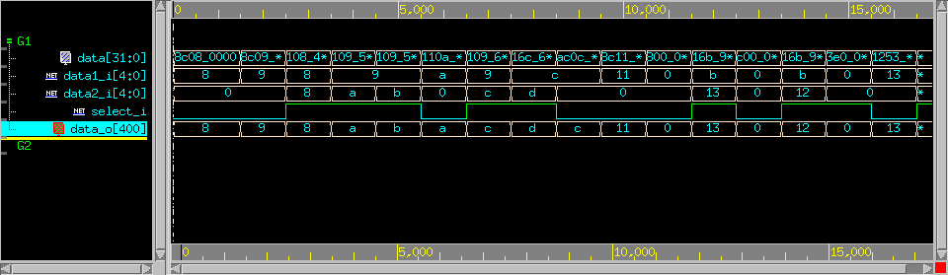

1. MUXX_Src

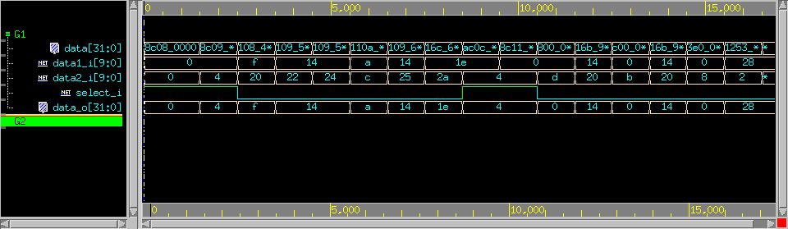

1. MUXX_MemToReg

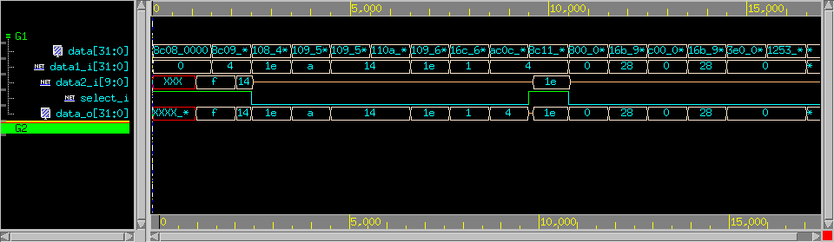

1. PC_adder

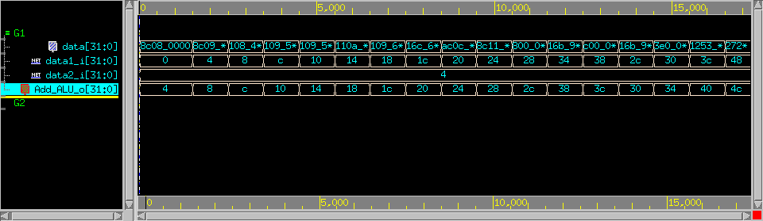

1. branch_adder

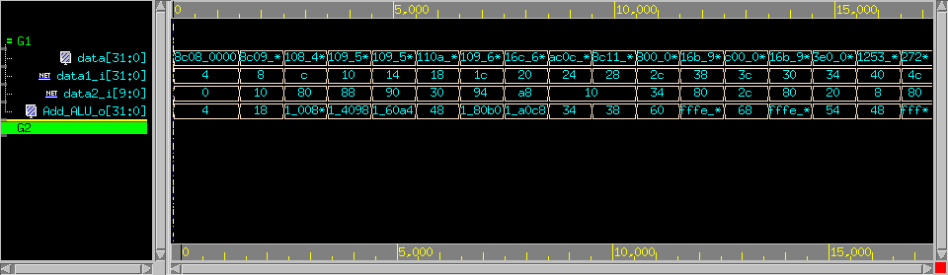

1. MUXX_Branch

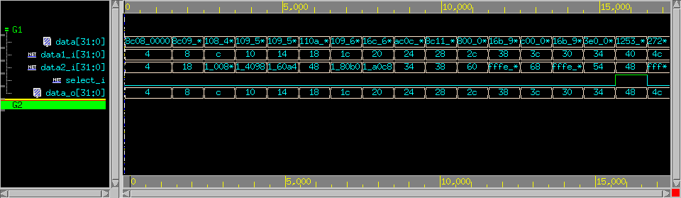

1. MUXX_JumpRegister

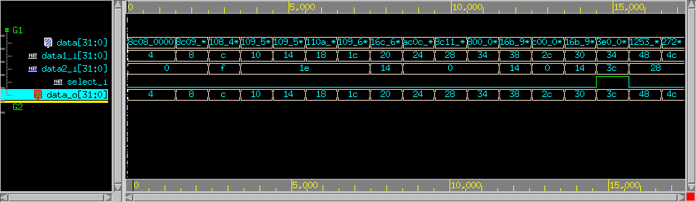

1. MUXX_Jump

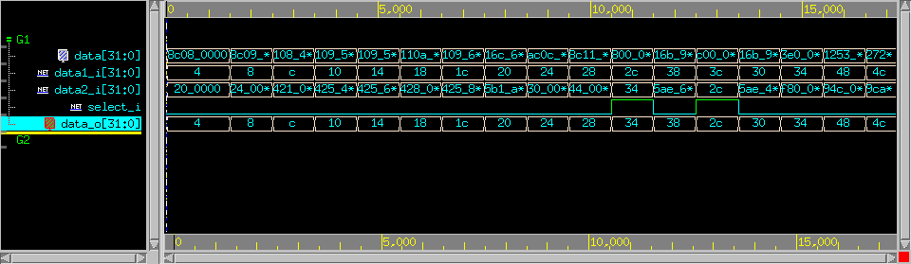

1. MUXX_JumpAndLink_1

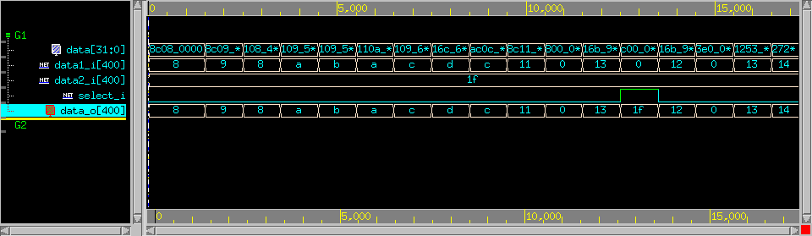

1. MUXX_JumpAndLink_2

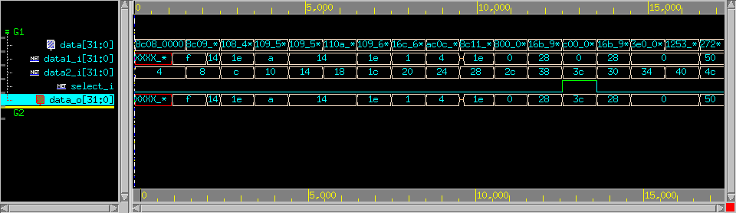

1. **Synthesis**

**Area Report:**

****************************************

Report : area

Design : SingleCycle_MIPS

Version: G-2012.06

Date : Thu Apr 20 03:26:55 2017

****************************************

Library(s) Used:

typical (File: /home/raid7_2/course/cvsd/CBDK_IC_Contest/CIC/SynopsysDC/db/typical.db)

Number of ports: 172

Number of nets: 533

Number of cells: 38

Number of combinational cells: 22

Number of sequential cells: 0

Number of macros: 0

Number of buf/inv: 20

Number of references: 21

Combinational area: 45503.898122

Noncombinational area: 34056.632446

Net Interconnect area: undefined (No wire load specified)

Total cell area: **79560.530569**

Total area: undefined

**Timing Path Report:**

****************************************

Report : timing

-path full

-delay max

-max_paths 1

-sort_by group

Design : SingleCycle_MIPS

Version: G-2012.06

Date : Thu Apr 20 03:28:45 2017

****************************************

# A fanout number of 1000 was used for high fanout net computations.

Operating Conditions: slow Library: slow

Wire Load Model Mode: top

Startpoint: _regFile/register_reg[31][1]

(rising edge-triggered flip-flop clocked by CLK)

Endpoint: A[6] (output port clocked by CLK)

Path Group: CLK

Path Type: max

Point Incr Path

----------------------------------------------------------------------------------------------------------

clock CLK (rise edge) 0.00 0.00

clock network delay (ideal) 0.50 0.50

_regFile/register_reg[31][1]/CK (DFFRX1) 0.00 # 0.50 r

_regFile/register_reg[31][1]/Q (DFFRX1) 0.26 0.76 r

_regFile/U732/Y (MXI4X1) 0.20 0.96 f

_regFile/U676/Y (MX4X1) 0.16 1.12 f

_regFile/U674/Y (MXI2X1) 0.07 1.20 r

_regFile/ReadData2_o[1] (register_file) 0.00 1.20 r

MUXX_Src/data1_i[1] (Mux_WIDTH32_0) 0.00 1.20 r

MUXX_Src/U14/Y (AO22X1) 0.19 1.39 r

MUXX_Src/data_o[1] (Mux_WIDTH32_0) 0.00 1.39 r

_ALU/data2_i[1] (ALU) 0.00 1.39 r

_ALU/sub_371/B[1] (ALU_DW01_sub_0) 0.00 1.39 r

_ALU/sub_371/U4/Y (CLKINVX1) 0.04 1.43 f

_ALU/sub_371/U2_1/CO (ADDFXL) 0.38 1.81 f

_ALU/sub_371/U2_2/CO (ADDFXL) 0.22 2.04 f

_ALU/sub_371/U2_3/CO (ADDFXL) 0.22 2.26 f

_ALU/sub_371/U2_4/CO (ADDFXL) 0.22 2.48 f

_ALU/sub_371/U2_5/CO (ADDFXL) 0.22 2.71 f

_ALU/sub_371/U2_6/CO (ADDFXL) 0.22 2.93 f

_ALU/sub_371/U2_7/CO (ADDFXL) 0.22 3.16 f

_ALU/sub_371/U2_8/S (ADDFXL) 0.14 3.30 f

_ALU/sub_371/DIFF[8] (ALU_DW01_sub_0) 0.00 3.30 f

_ALU/U20/Y (AOI221XL) 0.19 3.49 r

_ALU/U18/Y (OAI211X1) 0.07 3.56 f

_ALU/ALU_o[8] (ALU) 0.00 3.56 f

A[6] (out) 0.00 3.56 f

data arrival time 3.56

clock CLK (rise edge) 10.00 10.00

clock network delay (ideal) 0.50 10.50

clock uncertainty -0.10 10.40

output external delay -6.00 4.40

data required time 4.40

----------------------------------------------------------------------------------------------------------

data required time 4.40

data arrival time -3.56

----------------------------------------------------------------------------------------------------------

slack (MET) 0.84

1. **Gate-level simulation**

**Simulated timing (ns) : 10ns**