Installation guide

For this project we used PyCharm, only think is left for the user is to install the dependencies

For this open PyCharm

1.open project

2.a window will appear:

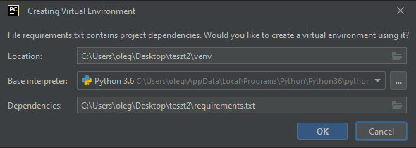

3.choose location for the environment file (recommended same location as the project)

4.interpreter should be python 3.6

5. dependencies should be the requirements.txt that came with the project

6.press ok and wait for the package to install

7.if error happens, you will need to manually install each lib

7.1 go to File->settings->project: “name”-> python interpreter

7.2 press + and search for your version

8. then simply run the “GUI_Control.py