**VASANTHAM HEALTH CENTRE (P) Ltd.**

**Dennison road, Nagercoil-629001, Ph.222526, 222626**

**Email: vasanthamhealthcentre@gmail.com**

**Fax no: 04652-233877**

**VASANTHAM HEALTH CENTRE (P) Ltd.**

**OUR VISION :**

To provide the highest quality tertiary (super specialty) medical care exceptional service and best value to all its local and global patrons through dedicated highly skilled and compassionate doctors and staff using state of the art technology.

**OUR MISSION:**

We are committed to the growth development and welfare of our people and creation of value for our stakeholders upon whom we rely to make the mission to our patient happen.

**OUR GOALS:**

* Increased in patient admission by 20% every year.
* Increased the surgeries by 20% over the previous year.
* Reduction in infection rates to 015from the present 0.5%.

**VASANTHAM HEALTH CENTRE (P) Ltd.**

**OUR SERVICES**

**Obstetrics & Gynaecology.**

**Emergency unit**

**Urology.**

**Cath lab**

**Dermatology.**

**Coronary care unit.**

**ENT.**

**Gastroenterology.**

**Paediatrics.**

**Neonatology.**

**Radiology.**

**Neurology.**

**Oncology .**

**Pulmonology.**

**Ophthalmology.**

**Vascular surgery**

**Rheumatology.**

**Psychology.**

**General surgery**

**Orthopaedics**

**Nephrology**

**General medicine**

**Diabetology**

**Plastic surgery**

**Dental care**

**Dialysis laparoscopic surgery**

**OUR FACILITIES**

* **ICU**
* **CCU**
* **ECHO**
* **STRESS ECHO**
* **FETAL ECHO**
* **STRAIN IMAGING**
* **HOLTER MONITORING**
* **CATH LAB**
* **ENDOSCOPY**
* **CAROTID DOPPLER**
* **C-ARM**
* **EEG**
* **ECG**
* **SPIROMETRY**
* **X-RAY**
* **USG**
* **CORDIO THORACIC UNIT**

**CORDIO THORACIC SURGICAL UNIT**

* **Coronary artery bypass surgery (CABS)**
* **Beating heart surgery(OPCAB)**
* **Valve replacement surgery**
* **Repair of congenital cardiac defects**

**VASANTHAM HEALTH CENTRE (P) Ltd**

**SPECIALIST DOCTORS LIST**

|  |  |
| --- | --- |
| NAME OF THE DOCTOR | QUALIFICATION |
| Dr. Ajitha Sekar - MD | MD(OBG) |
| Dr. N.B.Venkataraman - MD, DM | MD,DM(CARDIO) |
| Dr. Venkatesh - MD, DCH(CARDIO) | MD,DCH(CARDIO) |
| Dr. B.V Selvan - MD | MD(DERMATOLOGY) |
| Dr. Vijayaraj - DLO | DLO(E.N.T) |
| Dr. Sivarajan - MS, M.ch | MS,M.ch( GEN.SURGEON) |
| Dr.SETHURAM - DM | DM(NEUROLOGY) |
| Dr.ABRAHAM MUTHURANGAM - MS,Mch | MS,Mch(UROLOGIST0 |
| Dr.VALLUVAN - MBBS,MD | MBBS,D.ORTHO |
| Dr.B.NAGARAJAN - DNB | DNB(PSYCHIATRIC) |
| Dr.T.MUTHURETNAM - M.ch | M.ch(NEURO SURG) |
| Dr.JERRYL MACLEAN - DTCD,FCCP,DNB | DTCD,FCCP,DNB(PULMONOLOGIST) |
| Dr. Vijayaraj - DLO | MBBS,DMRD(RADIOLOGIST) |
| Dr.M.S.KISHORE - MBBS,DMRD | DM(GASTRO ENTEROLOGY) |
| Dr.J.ANTONY JOE - DM | MS,Mch (VASCULAR SURGEON) |
| Dr.RAJESH - MS,Mch | MD(ANAESTHESIOLOGIST) |
| Dr.SIVA KUMAR - MD | MD,DNB,DM (NEPHROLOGIST) |

|  |  |
| --- | --- |
| NAME OF THE DOCTOR | QUALIFICATION |
| Dr. V.V.Sujith | MBBS |
| Dr. Sivakami | MBBS |
| Dr.Subashini | MBBS |
| Dr.S.Ratheesh | MBBS |
| Dr.Fredilia | MBBS |

**RMO DOCTORS LIST**

**CATH LAB**

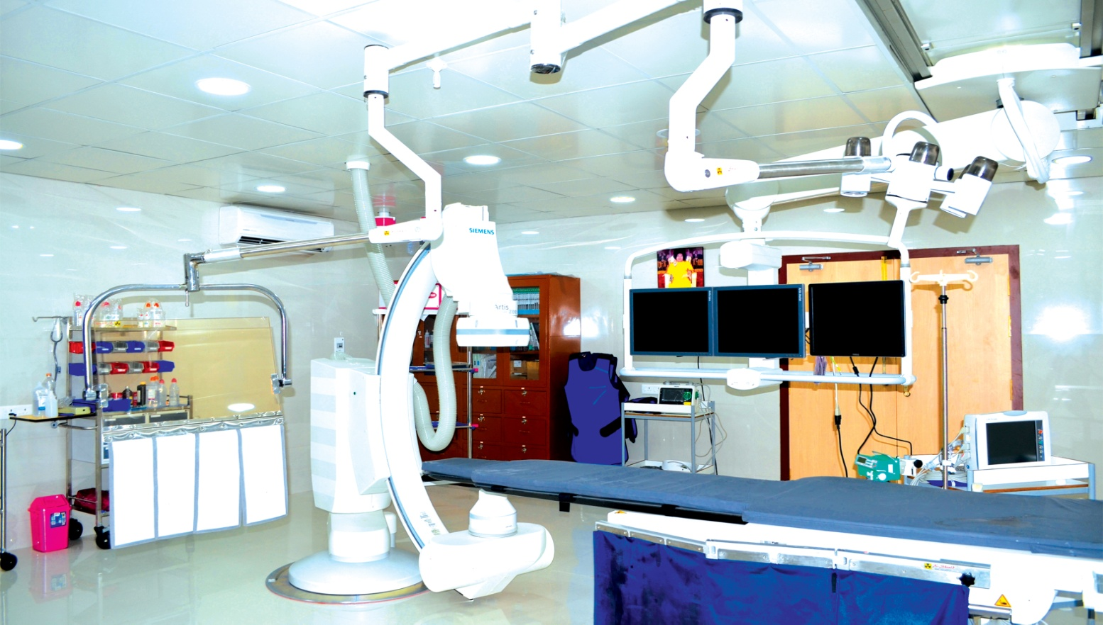

**CORONARY CARE UNIT**

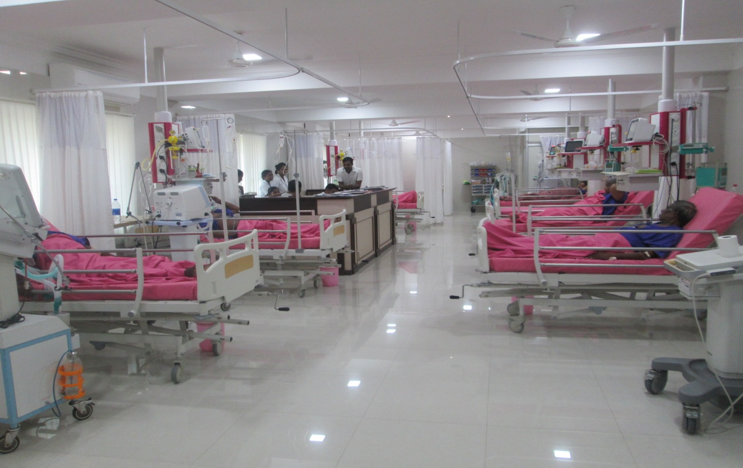

**CAMP PHOTOS**



