**TREE**

Trees: these are hiearical data structures which are used to store and retrieve data efficiently

**TERMS / PROPERTIES OF TREES:**

1. **size:** total number of nodes present in the tree
2. **Child nodes:** a node which is derived from a node above it is called child node
3. **Parent node:**  a node which have a child node I called parent of that child nodes
4. **Siblings :** each parent node can have multiple child nodes and each child is a sibling of other child node of same parent .
5. **Edge :** it is a connection between 2 nodes it is for presentation a relation.
6. **Leaf nodes:** these nodes are ends of tree they does not have further child node or can say they have 0 children
7. **Height:** a height of a node is the maximum number of edges between that node till leaf nodes
8. **Level:** the level is the at what level the node is each time a node have a child it increase 1 level root is at 0 level and with every time we goes to a child node from parent it increase the level by 1 formula : height of root - height of node of which we want the level of
9. **Ancestor :** these are the parent and grand parent node of a node in other words all node which leads to these node
10. **Descendants :** these are the child or grand child node of the parents in other words every node the current node can reach directly or indirectly

**Types of Binary Tree**

1. **Complete Binary Tree :** these are the type of tree where each level are full means contains 2 nodes at each level except for the last level the last level can have any number of node but the node should be filled in left to right way
2. **Full Binary Tree / Strict Binary Tree:** this binary tree each node have either 2 or 0 children
3. **Perfect Binary Tree:** this binary tree each level is full and all leafs node are at the same level
4. **Height Balanced Binary Tree:** here each and every node height difference of left and right subtree is either -1 , 0 , 1
5. **Skewered Binary Tree:**  these tree each node have only a single child (looks like linked list )
6. **Order Binary Tree:** Follow a specific property along each node like Binary Search Tree
7. **Degree Of Tree:** this is the max number of child a node have

**PROPERTIES**

1. **Perfect BST:**  total number of nodes : **2(h-1)+1**
2. **Perfect BST:** total number of leaf nodes**: 2h**
3. If we have n leaves then how many LEVELs we will have

We can have at least log n+1 level

1. **Strict Binary Tree :** if we have n leaf nodes then internal nodes = n-1 not including leaf nodes;

**Traversals**

1. **Pre Order :**

Sequence : (root,left,right)

Used for evaluating Maths Expressions, Serialization ,Copy Tree

1. **In Order :**

Sequence : (left,root,right)

BST inorder traversal give sorted sequence of elements

1. **Post Order :**

Sequence : (left,right,root)

It is used to delete a node from the binary tree

When use bottom up calculation then also we use post order

1. **Breadth First Traversal :** this is where we traver tree in level order means each node at a current level will be process before going to next level
2. **Depth First Traversal :**

**Disadvantages of Binary Search Trees:**

When we use a BST and all the values comes in a increasing or decreasing order it becomes skewed towards left or right dues to this they becomes like a linkedlist and all operations cost O(n) time   
  
so in order to prevent it we use a self balancing binary Trees to maintain its balance to make the insertion , deletion, searching in Log(n) time

**AVL Tree (Adleson velski and landis)**

**AVL tree is a self balancing binary tree :**

**Algorithm :**

1. **First insert normally insert the value it suppose to be**
2. **Now from inserted Node go up and find the unbalance node**
3. **Use any one of 4 rules and rotate the sub Tree**

**To make is balance we can rotate it to Left Hand Side or right Hand Side**

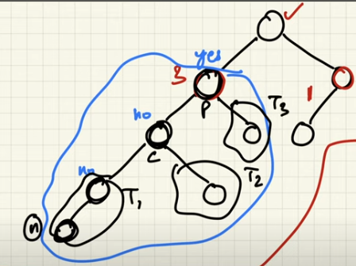

**Rotate Right :**

**Now we can see below**

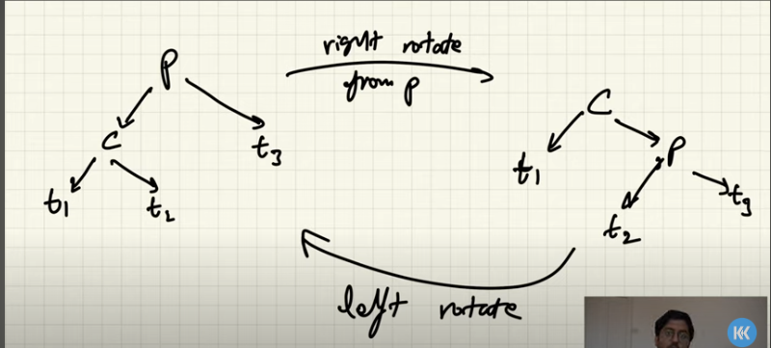

**Example:**

**Before Rotation:**

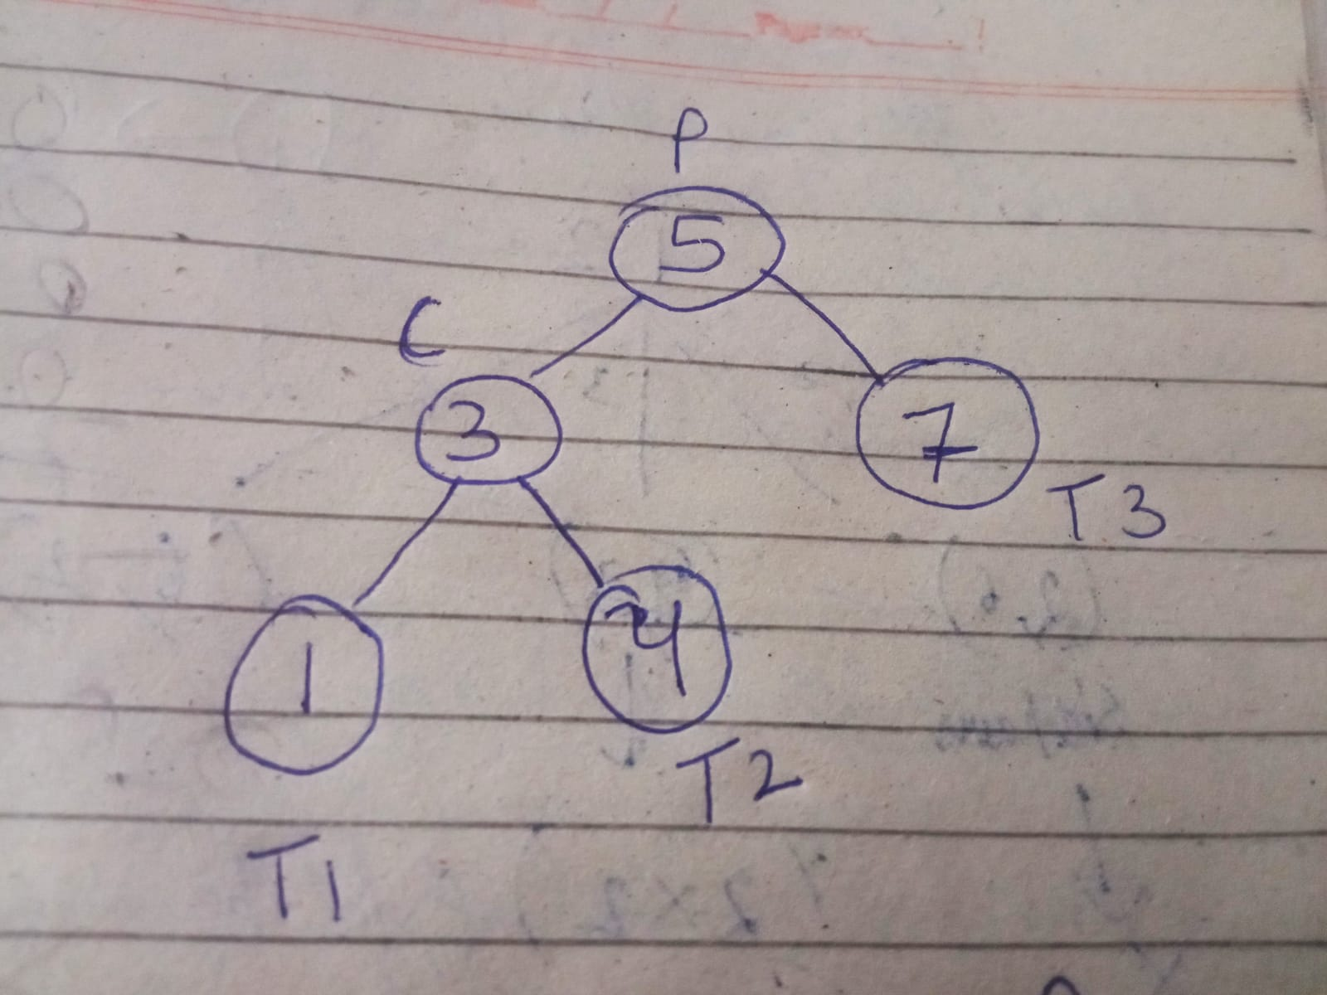

**After rotation :**

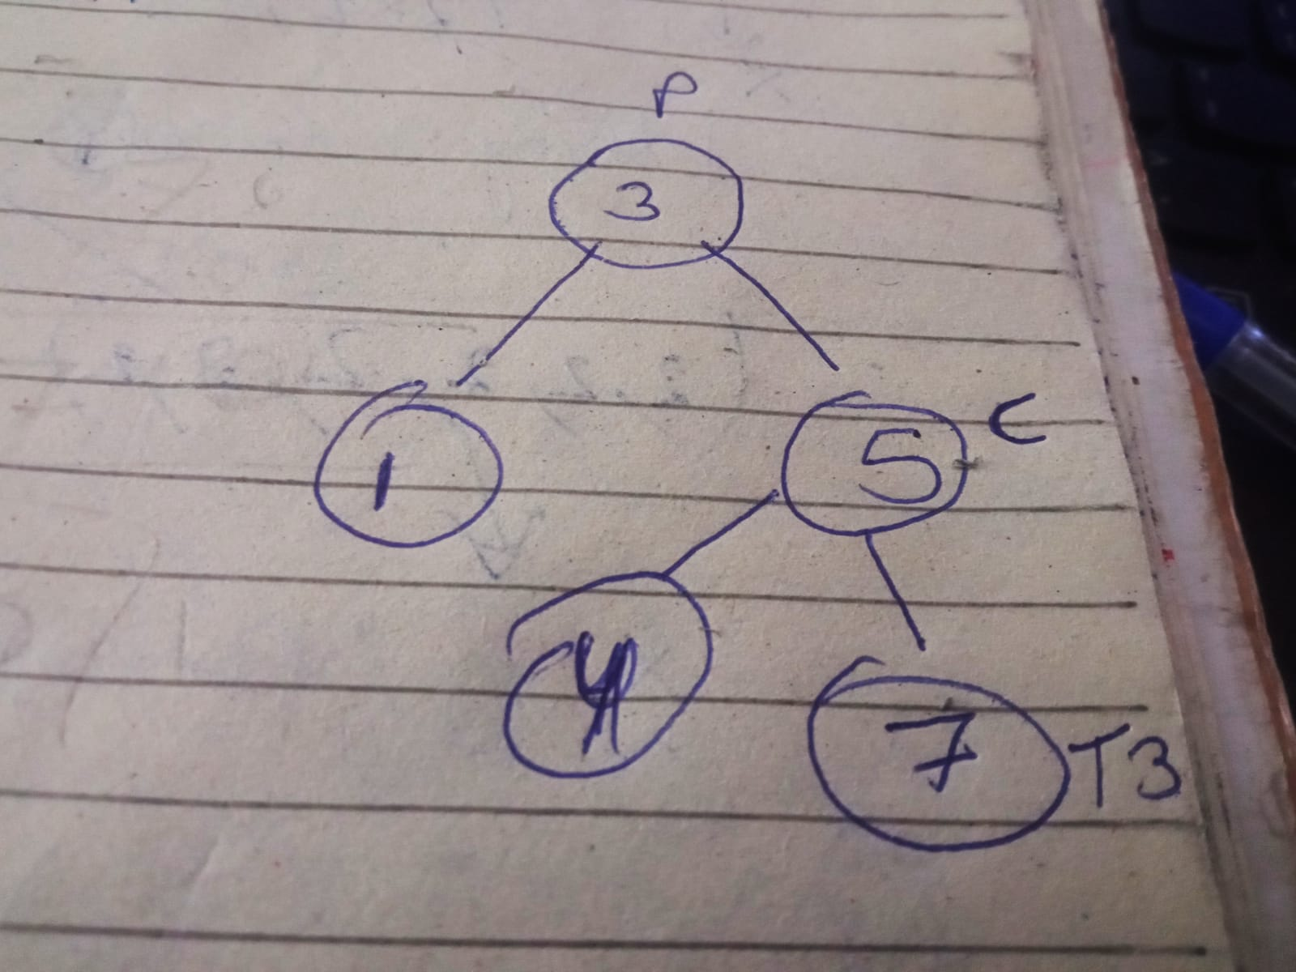

**If we want to rotate right its just opposite to what we just did**

**Before Rotation:**



**After rotation :**



**4 Rules of AVL Tree**

**Rule 1: Left -Left case**

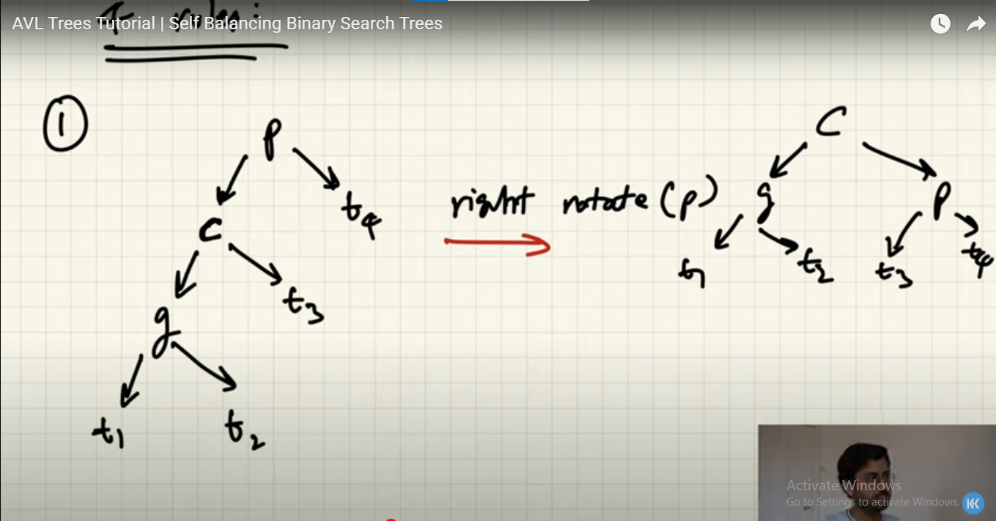

**Rule 2 : Left - Right**

**Here we first Left rotate at C node making it same as Left Left rule**

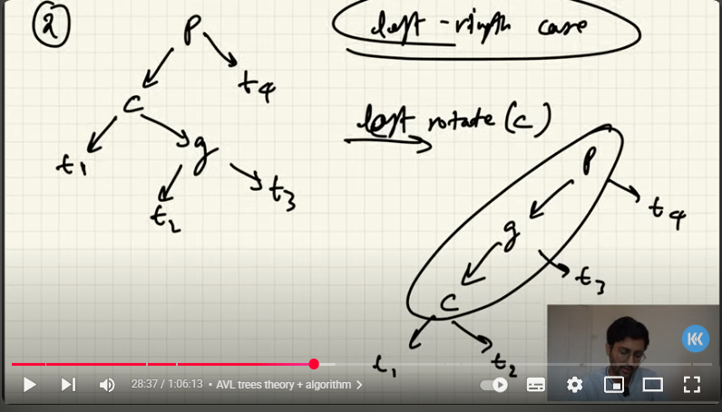

**Then again rotate it to right with parent node same as 1**



**Rule 3 : Right - Right**

**Here we Rotate just Left one time at P node**

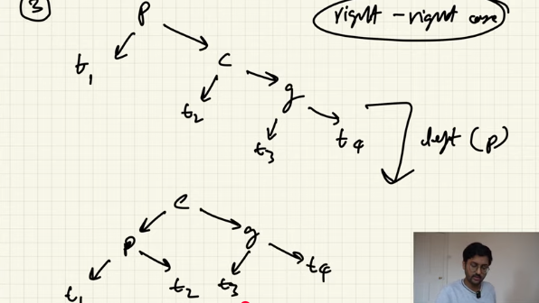

**Rule 4 : Right - Left:**

**First we rotate right form c making is same as Right - Right Rule**

**Then apply left rotation at p to make it balance**

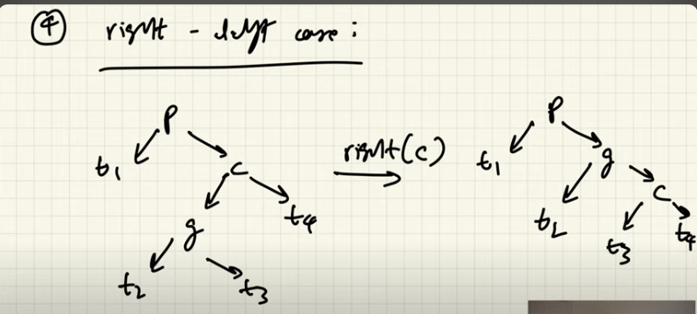

**Left rotation on new p**

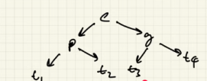

**Link for reference : <https://www.youtube.com/watch?v=CVA85JuJEn0>**

**SEGMENT TREES**

Segement Trees Are use to apply a function in a range like sum of number in a range or find max number , min number between a range

And it allows us to perform it in O(log n) time

Updating time is also :Log(n)

Segment Tree Structure is similar to a simple full binary Tree the only difference Is node at each node the Segement tree stores the range upperbound , lower bound and the function result of that range

Example of a Segement Tree to find Sum of values in a Range in Array :

Array = [3,8,7,6,-2,-8,4,9]

We want to find the sum of : element in range[2,6]

7+6-2-8+4=7

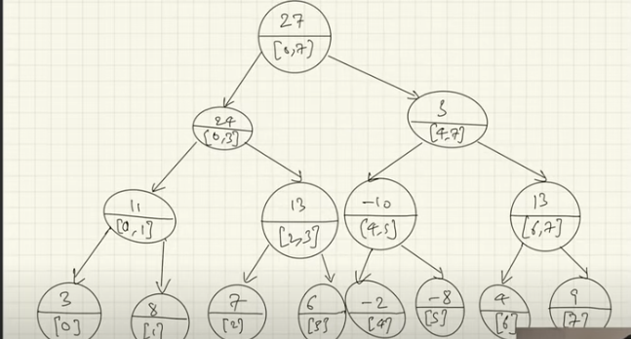

Now to perform an operation we will have 3 cases :

1. Node range is completely inside our Query range:

then we will just return the current node answer cause it a part of our answer like node range =[4,5] is in range of query range = [2,6]

1. The Query range is overlapping the Node range :

So in this case we will check its left node and node same Question the range of query exists in that node and this will continue untill we reach the leaf node

1. The Query range is completely out of the Node range like :

we want [2,6] range and the node have range [0,1] or [7,8] Then we will just return the default value in our case it will be 0 cause we does not want to include this sum in our answer

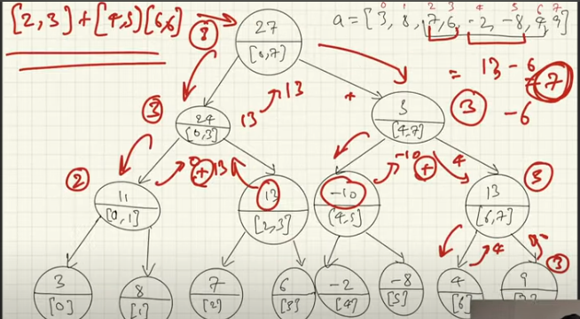

Update The Array And Segment Tree :

Approch here we just look at node and check weather that node exists in that range if yes we will go in child node if not we will just return the default values

By doing this we will reach the end or leaf node and we will update the value and return new value this will get update by recursion. By default

1. Check node weather its in range
2. If yes check child nodes If not return the value at node values
3. At the end we will reach at the leaf where we update leaf and recursion will update the tree

When to Use BFS :

1. Mostly BFS get use when the answer lies near root node
2. Where we wana process the tree level wise