
PROJECTS
- MUSIC RECOMMENDATION SYSTEM : This project was using machine learning and data analysis we utilize a data set form spotify to develop a music recommendation algorithm using cosine similarity using the lyrics of song to recommend user similar songs.

- Note Providing System for College Students: This project was created by using HTML,CSS for front end and PHP in the back end with this project we developed a web site which allow the student to share notes and study material with each other.
EDUCATION
Bachelor of Engineering
at LNCT Group of Colleges Bhopal M.P. India
Course : Artificial Intelligence & Data Science

Diploma In C.S.E.
at S.V. Polytechnique College Bhopal M.P. India
Course: Computer Science Engineering.
SKILLS

Programming Languages : Java,Python,HTML,CSS.
DataBase : SQL
Operating System: Windows
CERTIFICATES
- Data Science & Machine learning (2023): Teachnook
- Programming in Java (2021): CRISP
- Front-end Web Development (2024): IBM Skill Build
- DBMS (2023): Infosys
- Data Structures and Algorithms (2023): Infosys
- SIS Tech innovation Hackathon (participation 2023): SIS Tech
- Data Dive Hackathon (2nd Prize 2023): JNCT
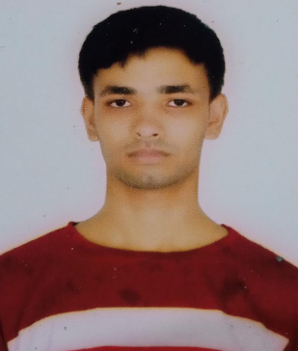
7223988268
Abdulsaboor8166@gmail.com
Bhopal, M.P.

PROFILE
Enthusiastic and dedicated student pursuing a B.Tech degree in Artificial Intelligence and Data Science at JNCT College, Bhopal. I have a strong passion for Artificial Intelligence and I am committed to building a career in this exciting field. With a solid foundation from my diploma in Computer Science Engineering (CSE), I am continuously expanding my skills in data handling and analysis. At 22 years old, I am eager to apply my knowledge and contribute to innovative projects, looking for opportunities to grow and excel in the software industry.

ABDUL SABOOR

