Goals:
- our landing page should gathers info about the customer
also should suggest a good value to the customer
# e.g: best critics can interact with the actors
e.g: get best critics about movies freely



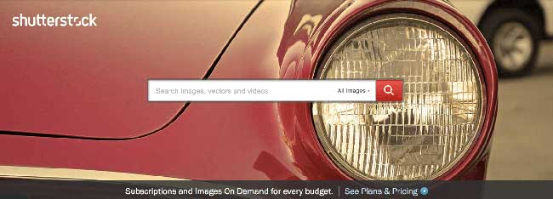



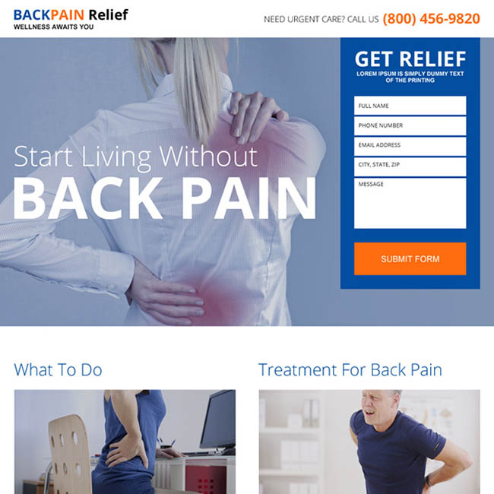

next step:

- implementing project backend
- implementing project frontend

our site features:

- admin/user/loging/signup/ user home page
- movies classification(showing overview(genre, director, ...))
- movies page(basic info about the movie and related critics)
- following critics
- like and comment on ciritics(critic page(movie and the critic opinion about it))
- best movies based on rate
- best critics of month
- best critics about a movie
- followings new post
- site home page(5 best movies, 5 best critics, best critic of the month)
- searchbar
- admin should be able to delete and add movies, genre, etc etc

database:
user(role: admin / critic)
movie()
critics()



https://www.hulu.com/static/hitch/s3/attachments/ckbvd0gyz00xg19mlsu9nayv7-homepage-masthead-test-desktop-3200x1320-v4c-6-16-20.jpg

https://www.hulu.com/welcome

https://www.mailerlite.com/

https://shamsi.co/creating-a-landing-page-in-less-than-10-minutes

