Task 1: Website Research Report
Theme: Personal Branding and Digital Portfolios
Student Name: | Tarek Ahmed Umar
Unit Title: | Website Design
Unit Code: | WNI534
Assessor Name: | Billy Madlela
Due Date: | 22 May 2026
Table of Contents
Section A: Compare and Contrast 2
1. brittanychiang.com 2
Ease of Use 3
Information Content 4
2. mattfarley.ca 6
Ease of Use 6
Information Content 7
3. adhamdannaway.com 10
Ease of Use 10
Information Content 11
4. Comparison 12
Section B: HCI Features 13
1. brittanychiang.com 13
Feature 1: Fixed Sidebar Navigation 13
Feature 2: Skill Tags 13
Feature 3: Project Cards 13
2. mattfarley.ca 13
Feature 1: Role Cards in the Hero Section 13
Feature 2: Portfolio Grid 13
Feature 3: Testimonials and CTA Button 13
3. adhamdannaway.com 14
Feature 1: Interactive Split-Screen Hero 14
Feature 2: Top Navigation Bar 14
Feature 3: Project Card Grid 14
References 15

Section A: Compare and Contrast
This report researches and compares three personal portfolio websites as part of an investigation into the theme of personal branding in web design. The three sites are brittanychiang.com (a software engineer), mattfarley.ca (a designer and developer), and adhamdannaway.com (a designer and coder). Each site is compared in terms of ease of use and information content.

1. brittanychiang.com
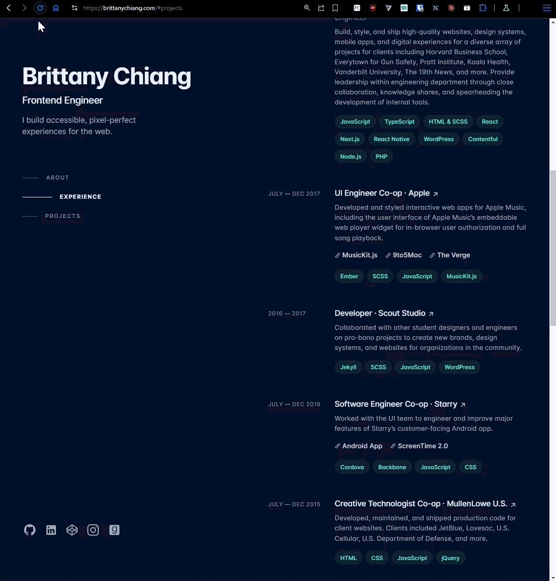

Ease of Use
This website has a fixed sidebar, which occupies the left part of the browser window. It does not move as you scroll down, and you will always have navigation options available: About, Experience and Projects. Navigation is easy on this website since you do not lose your way while moving through the pages. Dark navy background and white letters make reading easier. There are no pop-ups and distracting effects, so everything looks clear and tidy.
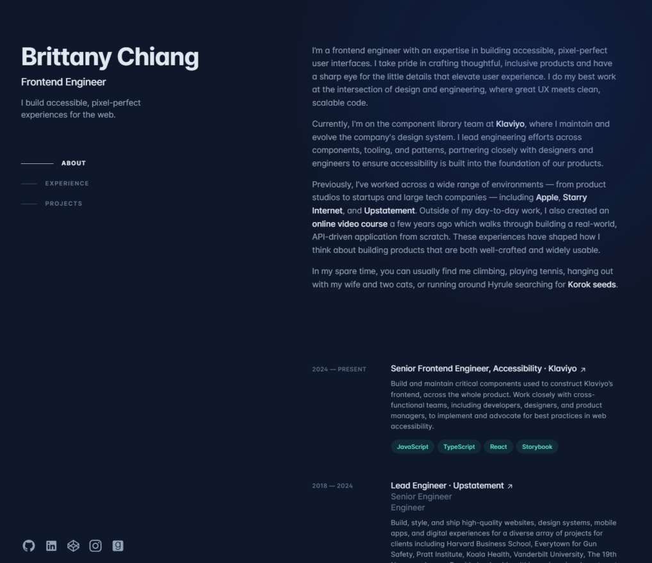
Professional career experience with role, tech stack and job description.
About me content
3 fixed sidebar navigation links. They stay fixed when moving
Figure 1 Fixed sidebar navigation on brittanychiang.com, her about me and professional experiences

Information Content
Brittany Chiang's identity and skills are stated very well on her website. Her About section contains a small personal statement. Her Experience section features detailed information about all her jobs, including dates of employment, companies' names and relevant technologies such as JavaScript and React. Her Projects are described on a separate page and contain pictures and clickable links to code and demonstrations of products. Her CV can be viewed from a separate page as well. The information is logically structured, making it easier for a recruiter to look for necessary details.
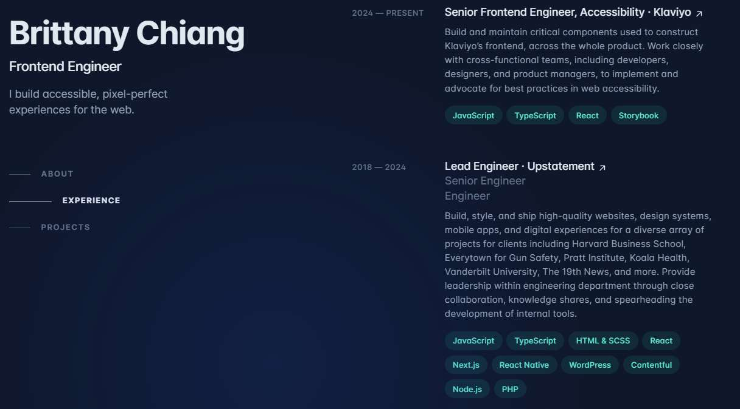
Quick-reference skills for recruiters
Figure 2 Technology skill tags in the Experience section
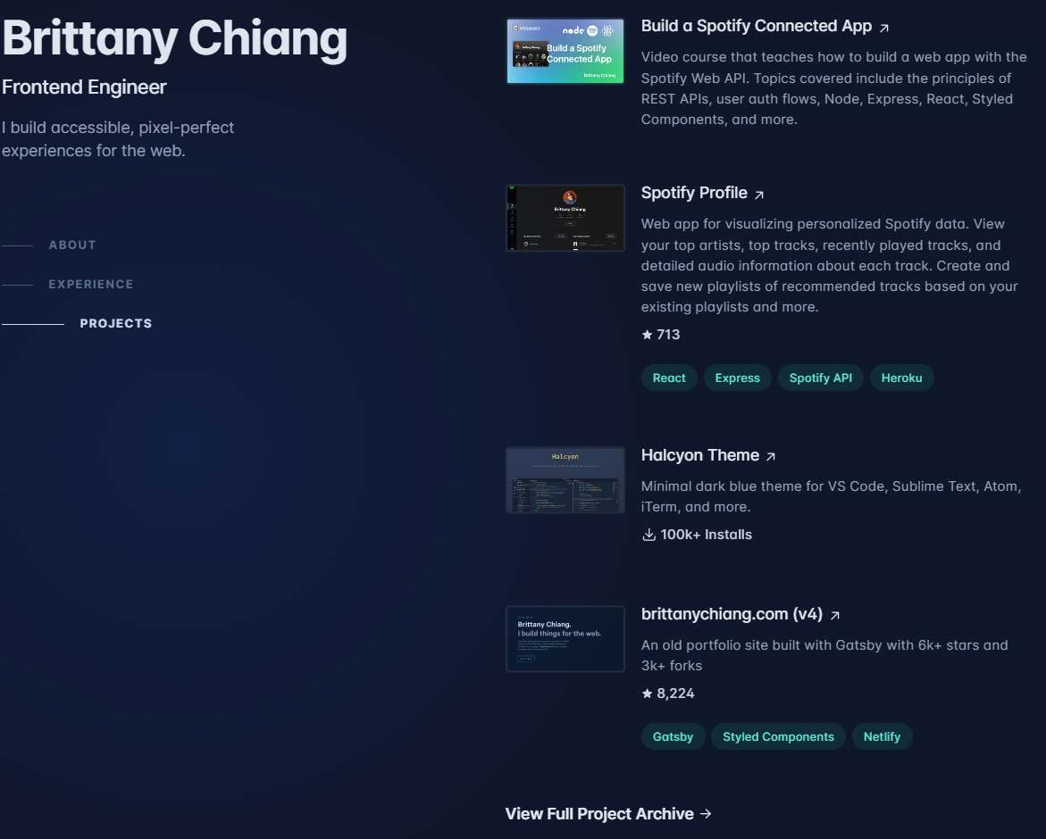
Link to view all projects.
Each card links to a live demo or GitHub. Contains description and usage information, along with the tech stack used to create the project.
Figure 3 Project cards in the Projects section

2. mattfarley.ca
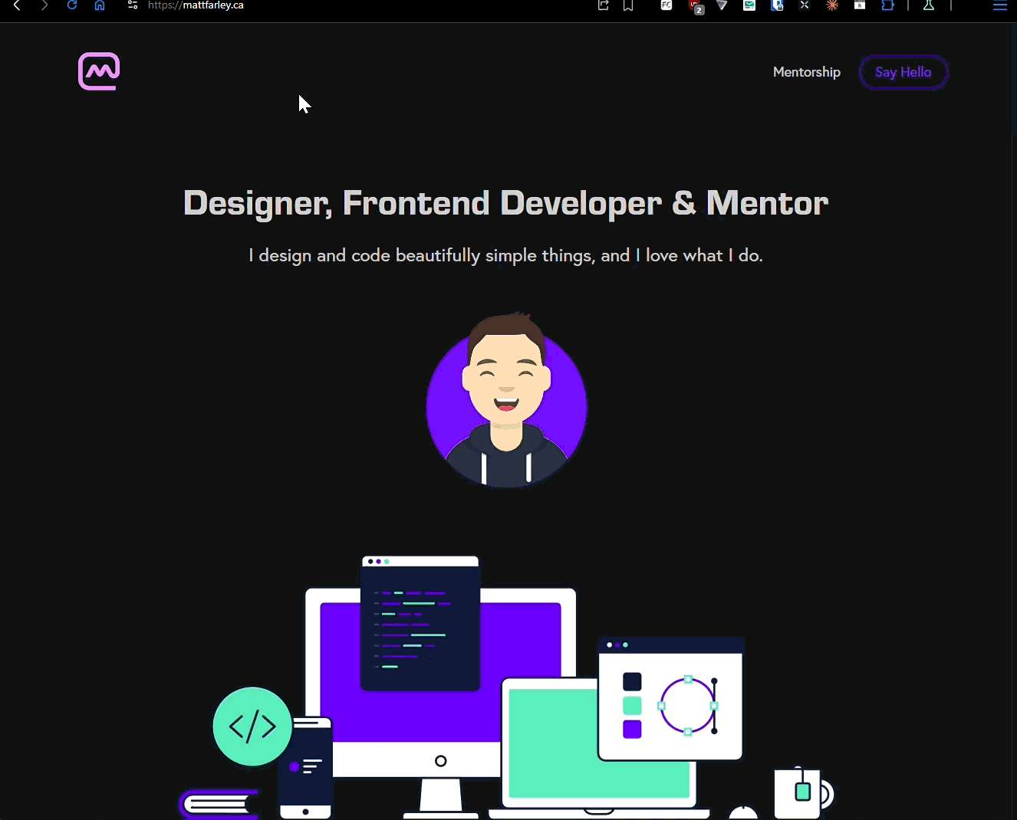

Ease of Use
Matt Farley has a plain top menu with only two elements – Mentorship tab and "Say Hello" button. All content of the page is located on one scrolling page with two alternating backgrounds: dark and purple. Thus, you can understand where a new section starts easily. At the beginning of the page, Matt presents himself using three cards – Designer, Frontend Developer and Mentor. This layout helps to understand who he is instantly. It proceeds with the information about his services and portfolio, testimonials and a button that allows contacting Matt.
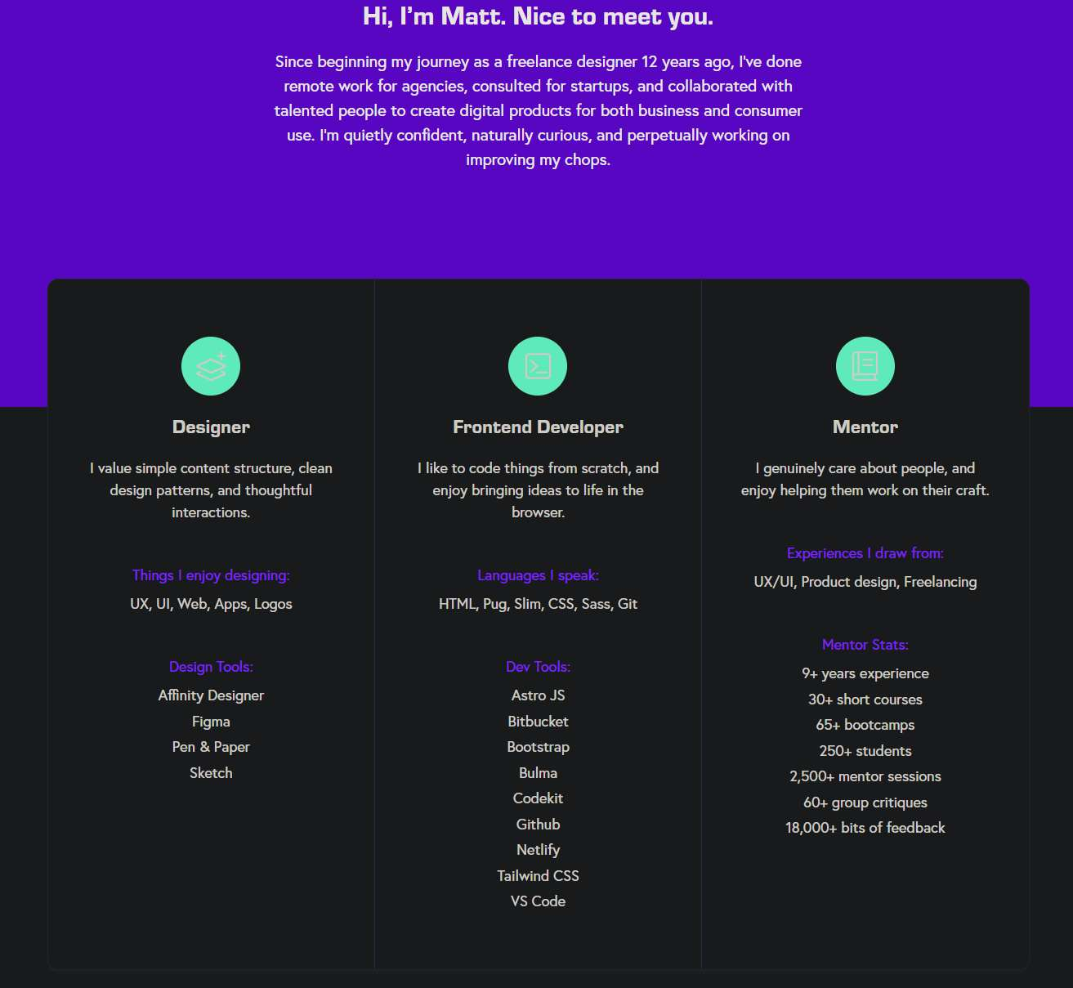
Quick and simple about me.
3 role cards instantly communicates what skills Matt has and what roles specializes in.
Figure 4 Hero section with role cards on mattfarley.ca

Information Content
Matt Farley provides enough useful information about his experience and skills on the website. He states design tools he uses, coding languages he is proficient in and some mentor statistics (such as 2,500+ mentor sessions). This makes his experience sound even more authentic. His portfolio of design and front-end works consists of tiles representing clients' brands and his startup projects, respectively. At the end of the page, you can see some testimonials provided by his clients with their names and photos.
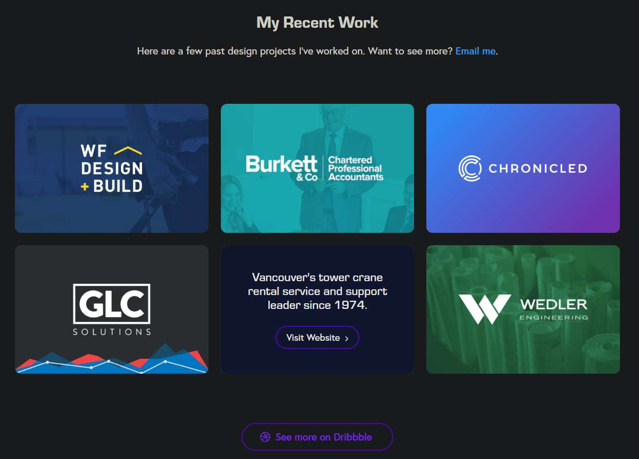
Link to see more of his projects that he worked on.
Hovering over the tiles give quick description of the company
Tiles shows clients he worked for
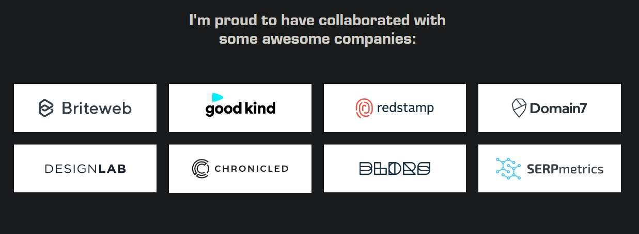
Showcasing more collaboration work with companies. Together showing real client experience at a glance.

Figure 5 Portfolio grid showing client brand tiles and previous projects worked on
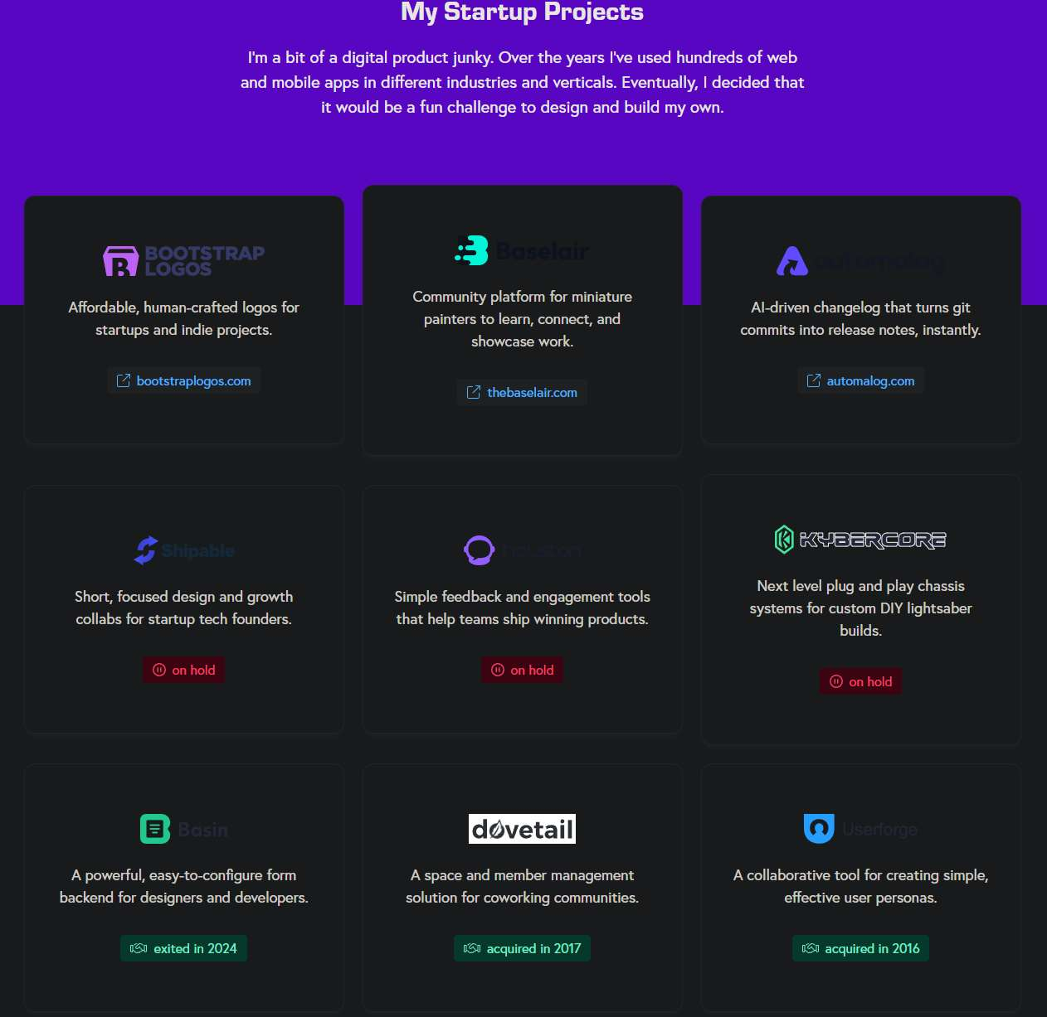

Showing status of the project and its success of being acquired. This shows Matt can build and deploy projects that companies are willing to buy.

Links to the project to view it. Allows recruiters to see Matts variety of skills.
Multiple startup project cards with name, logo, and description.

Figure 6 Personal startup projects and their status
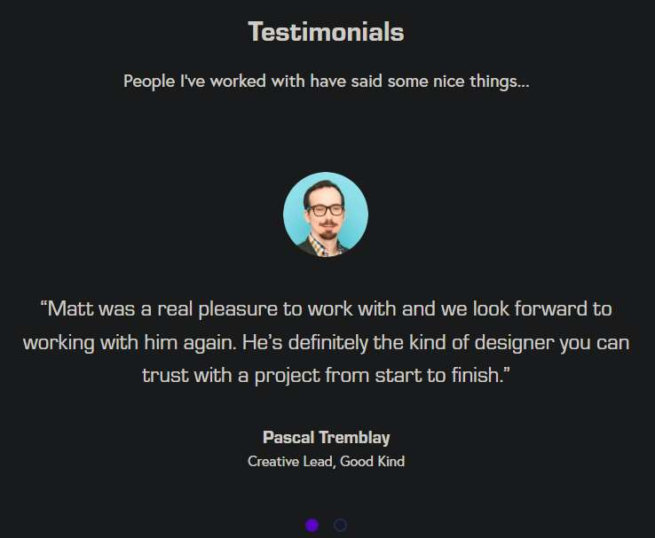
Real testimonials with photo, name, role and quote, shows client trust.

Figure 7 Testimonials section with client quotes
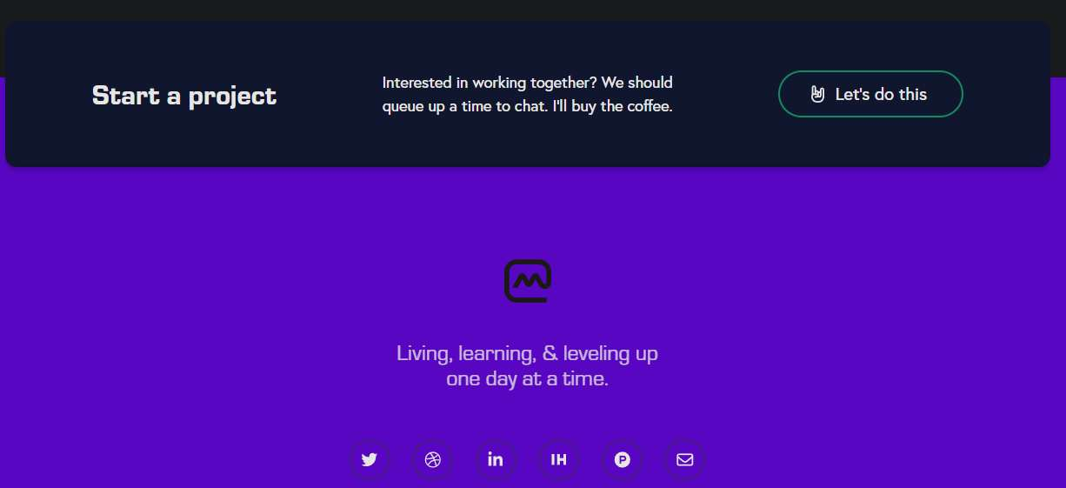
Easy contact route for potential clients

Figure 8 Start a project" call-to-action bar and different connection methods

3. adhamdannaway.com

Ease of Use
The Adham Dannaway web site features a dual-sided hero page where the left side states 'designer' while the right side states '<coder>'. As one hovers over either side of the page, that particular side expands and becomes more visible. It is a very imaginative presentation of his skills. The menu above contains five navigational items including About, Learn, Portfolio, Blog, and Contact which make for a very intuitive and user-friendly navigation menu.
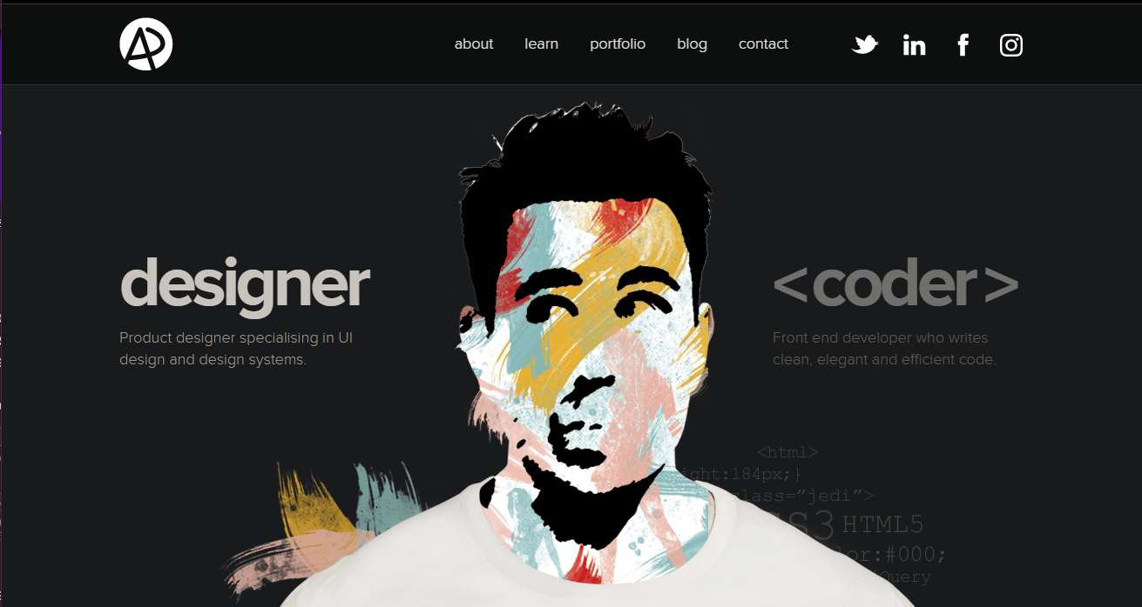
Designer identity: left side expands to show designer identity when hovered.

Figure 9 Split hero - designer side activated
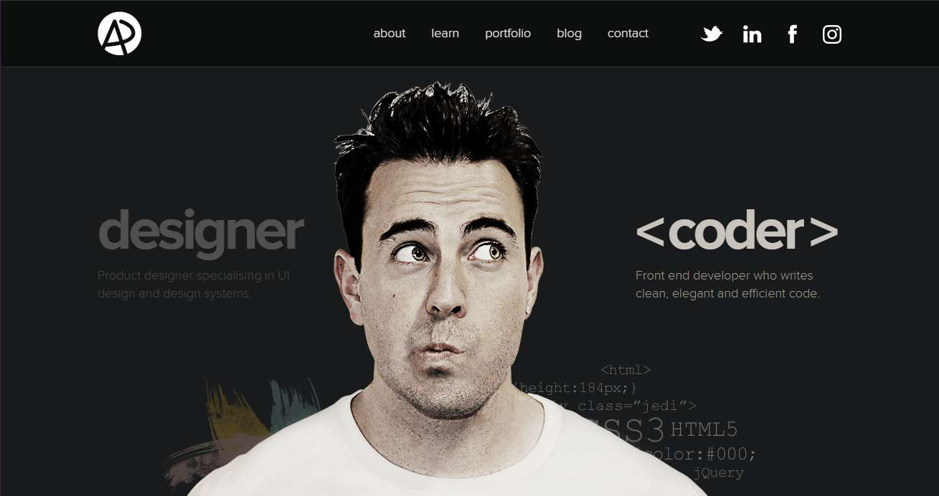

Coder identity: right side expands to show the coder identity when hovered.
Figure 10 Split hero - coder side activated

Information Content
The homepage shows some of the latest works selected in the form of 3 project cards, each having its own title and category listed. If one visits the Portfolio page then a greater number of projects are visible there. Blog and Learn pages also feature on the website, proving that Adham not only displays his work on his website but also shares knowledge through it. AD logo features prominently on every page of the website, thus ensuring consistency with the personal brand of Adham. The amount of text detail here is slightly lesser than the other two websites.
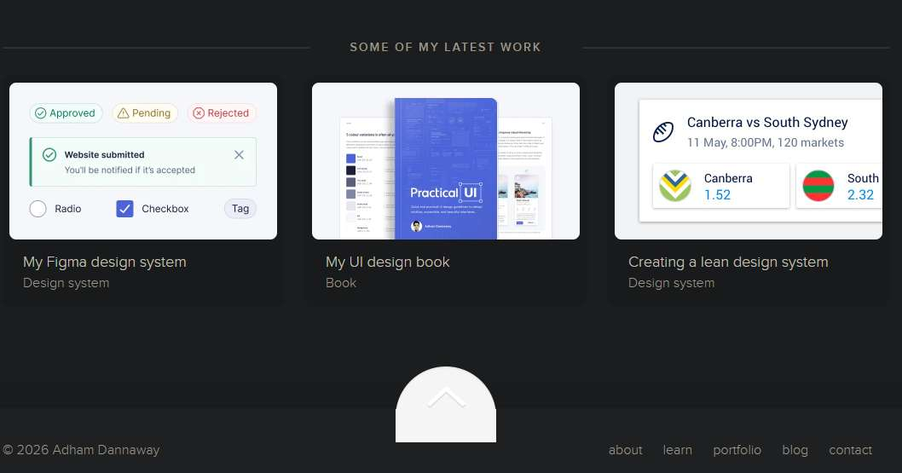
Recent project card shows thumbnail, title and type of project

Figure 11 Recent projects showcase
Logo appears in every page: consistent branding
Social links in the nav bar to give quick connection access

Figure 12 Top navigation bar and AD monogram logo
Nav bar with access to all the pages containing, about me, learning materials, portfolio, blogs and contact via email.
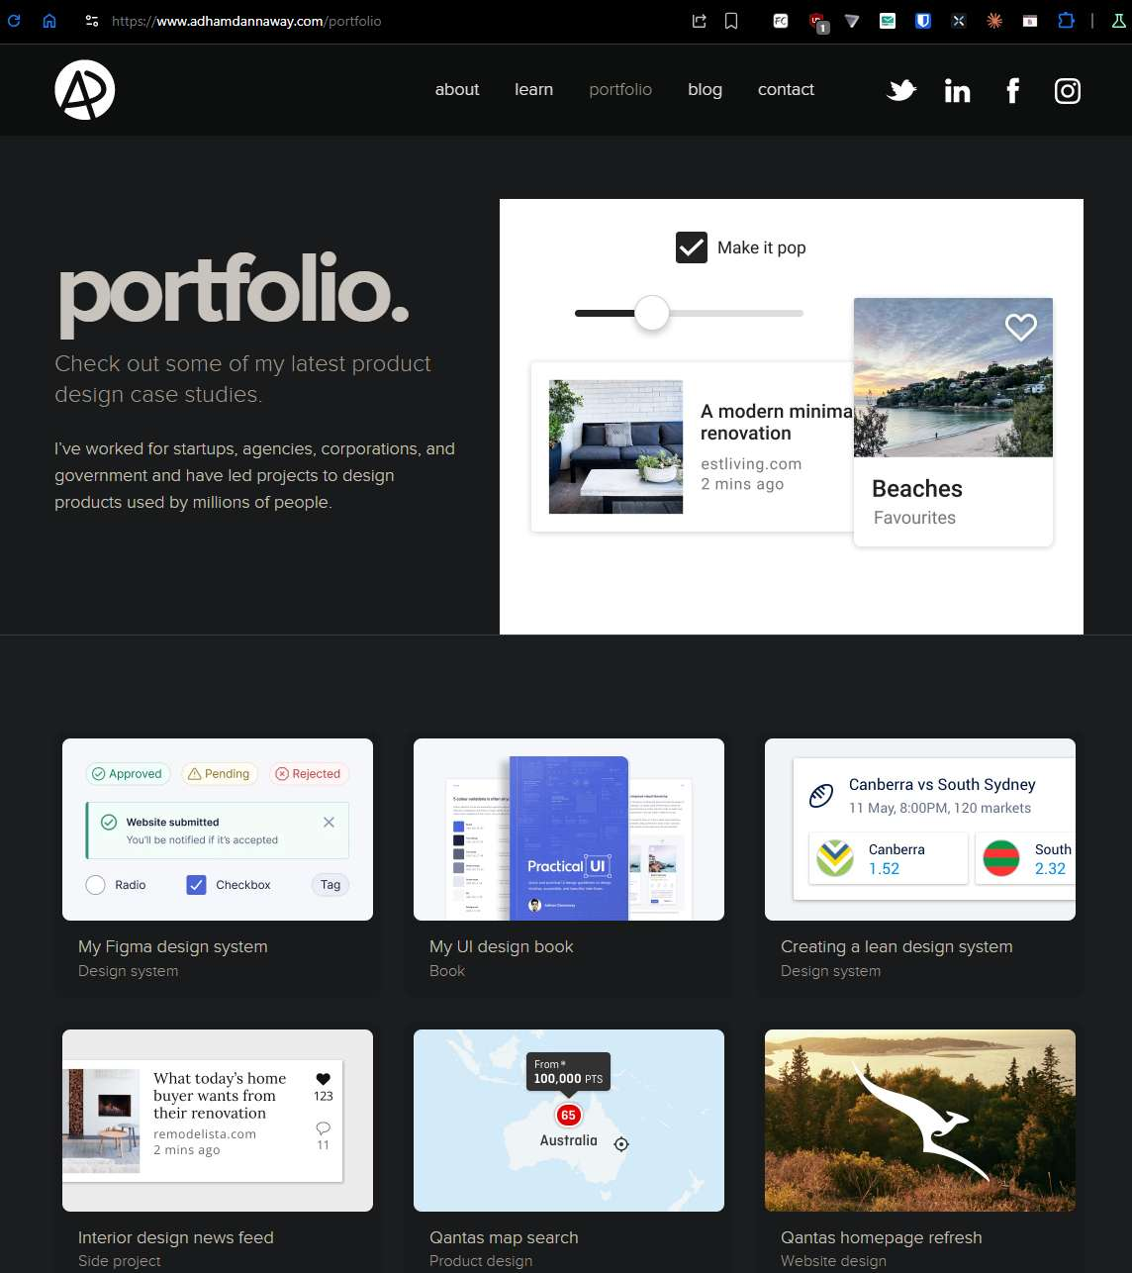
Category which the project falls under. Easy to understand their expertise in different development environments

Project information with thumbnail showcasing the projects UI they worked on.

Quick showcase of their UI/UX skills

Portfolio page with what kind of projects and clients they have worked on and its impact

Figure 13 Portfolio page project grids

4. Comparison
All sites are user-friendly, yet they have distinct approaches in presentation of information. Brittany Chiang's website is structured in a most organized way and is perfect for scanning through extensive career information. Matt Farley's site is a good option to consider, especially for those who are interested in numbers – his website is the one with the strongest elements of persuasive language usage (numerous testimonials). Adham Dannaway's site can be regarded as the most eye-catching and unforgettable of all the above websites, but not too informative one.
As for content information provided by the authors, then Brittany Chiang's site provides more detail, Matt Farley's website features more convincing language use, whereas Adham Dannaway's site presents much information visually. However, all the above sites succeed in promoting personal brand to an audience.
The changes which could be implemented are numerous: the first is to provide a search tool to Chiang's website, because there is much content and recruiters may need to check her skill faster. The next idea is to create a separate portfolio page on Matt Farley's site, because it requires to scroll down the whole page to find a certain project. Finally, it is necessary to make Adham Dannaway's site available in mobile version – its split-screen hero works excellently only when opened on the computer. In general, the choice of the most efficient personal branding website will depend on audience: Chiang addresses technical recruiters, Farley – freelancers, and Dannaway – employers in creative industries.

Section B: HCI Features
This section identifies and evaluates three HCI (Human-Computer Interaction) features on each website. The screenshots above have shown each of these features with annotations.

1. brittanychiang.com

Feature 1: Fixed Sidebar Navigation
Navigation bar remains fixed on scrolling, thus, it is visible all the time and a user can instantly click any of the sections on the webpage. It corresponds to the recommendation of Nielsen (1994) regarding the need to keep the location of a user on a website clear and give free navigation opportunities. Thus, implementing the above recommendation allows providing better experience to both new visitors of the page and returning ones.
Without such functionality, users would need to constantly scroll to the top of a webpage in order to find necessary links and navigate to other sections, which could be rather uncomfortable.

Feature 2: Skill Tags
Under each position, there is a line of colored tags that contain information about software skills (e.g., Java Script, React etc.). They are convenient to scan as grouping of data into clusters based on proximity is recommended by Interaction Design Foundation (2023) and allows grouping relevant data. Such visualisation is extremely useful for recruiters who may instantly see whether the candidate possesses necessary skills.

Feature 3: Project Cards
Each project is shown as a card that contains an image, project name, brief information and affordance in a form of clickable link icon. Hover effects allow showing that elements are clickable. Therefroe, users do not need instructions to understand what is going on.

2. mattfarley.ca

Feature 1: Role Cards in the Hero Section
The role cards (Designer, Frontend Developer, and Mentor) are displayed at the very top of the site. They inform the visitor about what the website is going to be about, setting expectations for further navigation and reading. This creates good user experience, as the visitor will immediately understand if the site interests him, saving valuable time for further use of the site.

Feature 2: Portfolio Grid
The portfolio is presented in the form of an equally-sized grid with brand logos displayed on every tile. This design feature shows the viewer that all works are equally important and valuable to Matt. This approach relies on the Gestalt principle of similarity (Interaction Design Foundation, 2023): items that look alike belong together.

Feature 3: Testimonials and CTA Button
The testimonials about Matt are located immediately before the "Start a project" button. Positive opinions about Matt's skills and attitude encourage the visitor to start working with him. In order to make the most of positive feedback, Matt places the "Start a project" button directly under it so that a client acts when his opinion is favourable to it.
Such design feature is often used in professional sites as it encourages immediate actions after building trust to the website owner.

3. adhamdannaway.com

Feature 1: Interactive Split-Screen Hero
The user's left-right movement on the hero section makes one side of the screen expand and light up and leaves the other fading out. This is a case of direct manipulation where the user's actions lead to a direct visible reaction (CareerFoundry, 2023). The effect helps highlight the duality of being a designer and a programmer in a memorable and engaging way. However, the feature only works properly in a desktop version because it utilizes hover interactions. ss

Feature 2: Top Navigation Bar
The navigation menu of the page features a regular layout where the logo is placed on the left and the links are displayed on the right. The layout is consistent with regular web standards and most users understand how they work (Interaction Design Foundation, 2023). The active page link differs from other links, enabling the user to be sure where he/she currently is. Thus, the site remains easy to navigate for new visitors.

Feature 3: Project Card Grid
A grid of cards is used to present various projects with preview images, titles, and tags. Thanks to the layout and spacing between projects, users can easily scan the content of the page. Moreover, thanks to the good preview images, the user gets an immediate impression about the level of design in the project.
This format is superior to the list because the image conveys design quality immediately.

References
Interaction Design Foundation (2023) Gestalt Principles of Design. Available at: https://www.interaction-design.org/literature/topics/gestalt-principles (Accessed: 4 May 2026).
Nielsen, J. (1994) 10 Usability Heuristics for User Interface Design. Nielsen Norman Group. Available at: https://www.nngroup.com/articles/ten-usability-heuristics/ (Accessed: 4 May 2026).
Nielsen Norman Group (2022) Affordances: Making Features Discoverable. Available at: https://www.nngroup.com/articles/affordances/ (Accessed: 4 May 2026).
CareerFoundry (2023) What is Direct Manipulation in UX Design? Available at: https://careerfoundry.com/en/blog/ux-design/what-is-direct-manipulation/ (Accessed: 4 May 2026).
Nielsen Norman Group (2014) Chunking in UX Design. Available at: https://www.nngroup.com/articles/chunking/ (Accessed: 4 May 2026).

