Task 4: Security Techniques and Operating System Utilities
Student Name: | Tarek Ahmed Umar
Unit Code: | WNI499
Unit Title: | Computer Systems
Assessor: | Shafaat Shah
Submission Date: | 21 November 2025
Diploma: | Access to HE Diploma (Computer Science)
Table of Contents
Introduction 3
4.1 Security Techniques - Names, Purposes, and Characteristics 4
Antivirus Software 4
Firewall Protection 4
Encryption Software 4
4.2 Justification for Security Techniques 6
Scenario 1: Protecting Business Data - Antivirus Software 6
Scenario 2: Securing Home Network - Firewall Protection 6
Scenario 3: Safeguarding Confidential Data - Encryption 6
4.3 Installation of Security Techniques 8
4.3.1 Installing Malwarebytes Antivirus 8
4.3.2 Modifying Windows Defender Firewall 10
4.3.3 Installing 7-Zip Encryption Software 11
4.3.4 Setting Up Two-Factor Authentication (2FA) - Microsoft Account 14
4.4 Configuration of Security Techniques 16
4.4.1 Antivirus Configuration - Avast 16
Configuring Scans: 16
Managing Real-time Protection: 17
Exclusions: 18
4.4.2 Firewall Configuration 19
Custom Rules 19
Application Rules 21
Network Profiles 24
4.4.3 Encryption Configuration - 7-Zip 26
4.5 Updating Security Techniques 29
Antivirus Updates 29
Updating virus definitions manually: 29
Automatically Updating Virus Definitions: 30
Firewall Updates 31
Encryption Software Updates 32
4.6 Operating System Utilities - Purposes and Characteristics 33
4.6.1 Disk Cleanup Utility 33
4.6.2 Task Manager 33
4.6.3 System Configuration (MSConfig) 34
4.6.4 DirectX Diagnostic Tool (DxDiag) 35
4.6.5 System Restore 36
4.7 Using Operating System Utilities 37
4.7.1 Using Disk Cleanup 37
4.7.2 Using Task Manager 39
4.7.3 Using MSConfig 44
4.7.4 Using DxDiag 46
Conclusion 48
References 49

Introduction
Computer security and system maintenance remain essential aspects of proper IT management within the modern world of technology. This report analyses the application of three major security methods together with the cornerstones of operating system management. The practical application discussed below takes place on real-life versions of Windows 10 operating systems.
This multi-layered security solution helps shield computers from malware attacks, unauthorized network access, and hackers. The step- by-step instructions of the report come with the aid of screenshots. Also discussed are the OS utilities that encompass Disk Cleanup, Task Manager, MSConfig, DxDiag, and System Restore functions that are critical to the process of system management and optimization.

4.1 Security Techniques - Names, Purposes, and Characteristics

Antivirus Software
Antivirus software forms the foundation of endpoint protection and functions as the first line of defence against the continuously morphing world of cyber threats. Various methods of detection are used together by these software tools to spot malicious code falling under different types of threats.
Purpose: This scans, quarantines, and cleans viruses, Trojans, ransomware, and other forms of malware. Its purpose is to offer real-time protection.
Key Characteristics:
- Real-time Protection: System activity and file operations are monitored continuously
- Signature-based Detection: Very extensive malware signatures’ database updated frequently
- Heuristic Analysis: Behavioural Analysis of Unknown Threats
- Scheduled Scanning: Scans performed automatically at set times
- Low System Impact: Optimized Resource Utilization

Firewall Protection
Firewall technology serves as an essential perimeter security layer that implements stateful packet inspection together with deep packet inspection that analyses various layers of network communication.
Purpose: To create a security boundary between trusted internal networks and untrusted external networks, checking and controlling the network traffic according to security policies.
Key Characteristics:
- Inbound/Outbound Filtering: Handling inbound and outbound filter requests
- Rule-based Control: customizable rules on IP addresses, ports, and protocols
- Application-level Filtering: program-level network access control
- Network Profile Management: Various policies regarding Domain, Private, and Public Networks
- Stateful Inspection: Legitimate communications are tracked through their state

Encryption Software
Encryption symbolizes the final protection system that makes given information mathematically unbreakable without the right cryptographic keys. AES -256 offers computational security that requires more than a billion years of calculation power using today’s computers.
Purpose: Takes readable information and encrypts it so that only with the proper decoding key can the information be accessed.
Key Characteristics:
- AES-256 Encryption: Military-grade encryption with 256-bit key length
- Password Protection: User defined authentication for archive access
- Compression Integration: Simultaneous compression and encryption ( LZMA2)
- File Header Encryption: Optional metadata encryption
- Cross-platform Compatibility: Archives are accessible on Windows, Linux, macOS

4.2 Justification for Security Techniques

Scenario 1: Protecting Business Data - Antivirus Software
A small business dealing with customer databases and financial matters should have automated security protection without the need for IT personnel. The financial implications of malware attacks may prove disastrous. A banking Trojan may compromise financial details, while an email virus may hamper business operations. Ransomware may encrypt valuable information.
Antivirus software offers complete first line of defence through real-time scans that protect the system by intercepting the execution of malicious code even before the data is compromised. The solution caters to the vulnerable nature of small businesses that lack expertise on the part of the users who could introduce the threats.
Advantages: the ability to operate automatically with minimal training required, the availability of cost-free versions of the tool that offer great savings on costs, the capability to ensure regulatory compliance (GDPR, PCI-DSS), and prevents business-disrupting downtime.

Scenario 2: Securing Home Network - Firewall Protection
A home network with various devices like computers and smartphones involves fine control over the network. As the Internet-connected devices increase, the attack surface broadens. A compromised IoT network can act as a pivot point that may target valuable resources.
Firewall protection offers security at the device layer with application-filtering capabilities that conventional router firewalls cannot offer. Personalization of rules enables the user to block certain applications that may access the network. Network profiles manage security settings when connecting with the Internet.
Advantages: Security profiles based on the type of network being secured, application-specific control that denies unauthorized communication, protection against zero-day attacks by implicit deny, and the enhancement of privacy by blocking telemetry.

Scenario 3: Safeguarding Confidential Data - Encryption
A freelancer dealing with confidentiality of client documents must be secured against hardware theft and unauthorized access to cloud services. Mobile workers experience special difficulties accessing secured data at different geographical points. A laptop stolen from a car compromises client confidentiality of cloud services.
Encryption makes the data completely unreadable independently of how the data may have been obtained. This solution caters to the needs of professionals who cannot physically secure their equipment. Encryption of archives with passwords prevents access even if the system may have been compromised.
Advantages: End-to-end security over the entire lifecycle of the data, platform independence that enables security even if the data is stored on different platforms; the system meets GDPR and HIPAA regulatory requirements; there is no complex infrastructure of keys required.

4.3 Installation of Security Techniques

4.3.1 Installing Malwarebytes Antivirus
Step 1: Download the installer from https://www.malwarebytes.com/mwb-download/thankyou using the “Free Download” button.
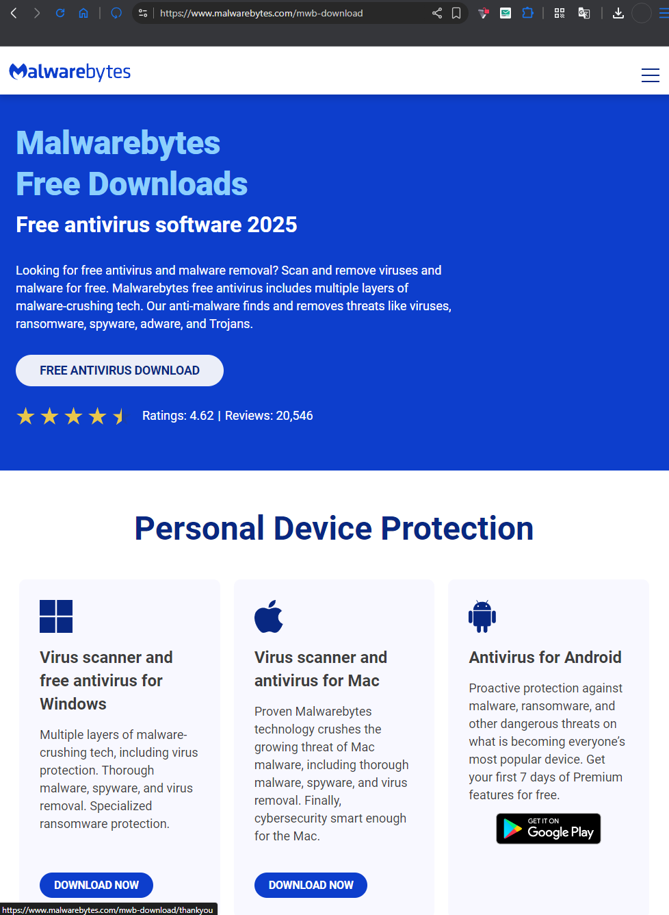
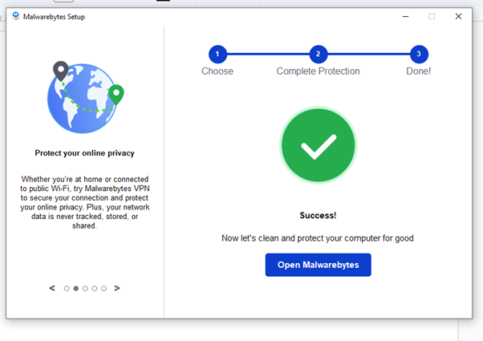
Figure 1 : Malwarebytes download page showing free download button and then downloaded software running and setup.
Step 2: Execute the installer with administrative privileges. Accept license agreement and choose recommended settings. The installer extracts files, registers components, and configures initial settings automatically.
Step 3: Upon completion, Malwarebytes launches and downloads latest threat definitions. Perform initial 'Threat Scan' to establish security baseline.
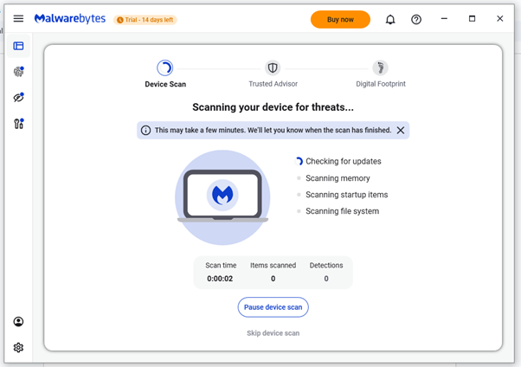
Figure 2 Malwarebytes performing comprehensive full system scan

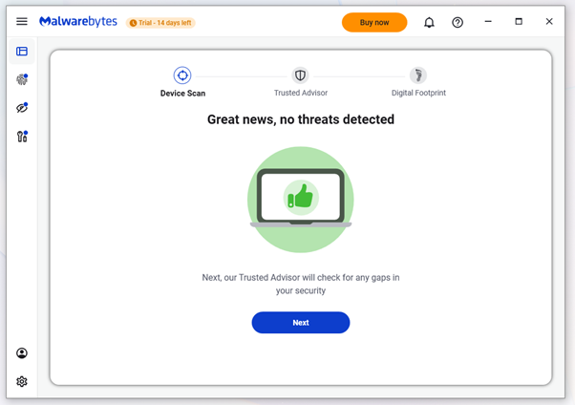
Figure 3 Scan results showing system is clean with no threats detected

4.3.2 Modifying Windows Defender Firewall
Step 1: Access Windows Security Centre via Control Panel System and Security Windows Defender Firewall.
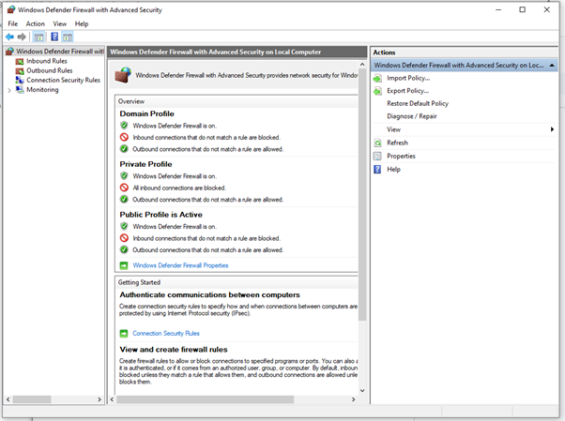
Figure 4: Windows Defender Firewall main interface showing status
Step 2: Click “inbound Rules” to add a new rule
Step 3: Configure application permissions via “Allow an app or feature through Windows Defender Firewall”. Then Locate required applications and check appropriate network types.
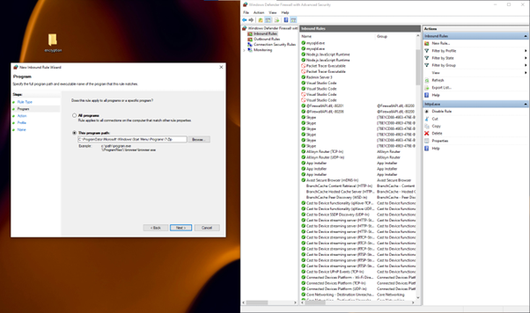
Figure 5 Configuring inbound firewall rules to allow 7-Zip application

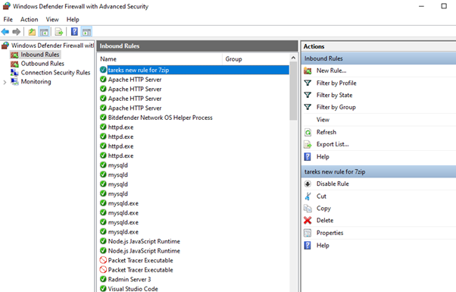
Figure 6 Confirmation of newly added firewall rule in allowed applications list

4.3.3 Installing 7-Zip Encryption Software
Step 1: Download 7- Zip from https://www.7-zip.org (64-bit).
Step 2: Run installer with administrative privileges. Accept default installation location and complete setup. 7- Zip integrates into Windows context menu.
Step 3: Verify installation by right-clicking any file, “7-Zip” submenu should appear. Test encryption by creating a password-protected archive.
Step 4: To test it out, create a folder with whatever contents to encrypt it. open the location of that folder in 7-zip

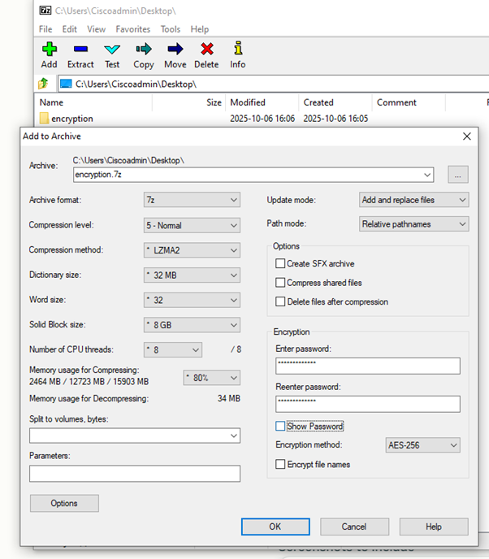
Figure 7 7-Zip encryption setup showing file selection to encrypt a folder

Step 5: Right click on the folder and press “Add to archive”. And choose an encryption level and a password to encrypt the folder.
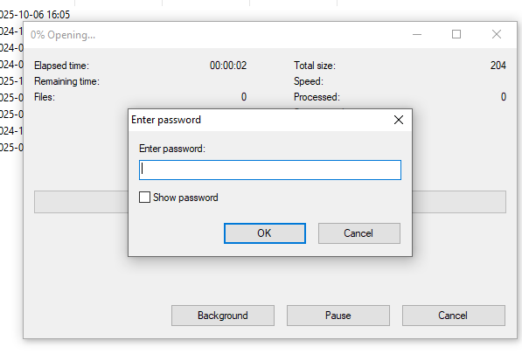
Figure 8 Confirmation that 7-Zip encryption is functioning correctly
Step 6: When clicked on the archive file and it prompts to enter a password it suggests the encryption of that folder has succeeded.
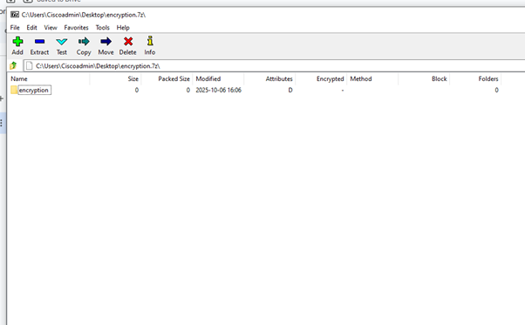
Figure 9 Testing decryption - password prompt appears when accessing archive
Common Installation Issues:
- Malwarebytes Error 1603: Disable other antivirus software temporarily, run as administrator
- Firewall Error 0x80070422: Ensure Windows Firewall service is running via services.msc
- 7-Zip context menu missing: Reinstall with administrator rights, check shell extension conflicts

4.3.4 Setting Up Two-Factor Authentication (2FA) - Microsoft Account
Two-Factor Authentication, or 2FA, adds an extra layer of security to your Microsoft Account. It means you have to verify your login with TWO types of verification: your password, plus approval from an authenticator app on your smartphone. Below are the steps to setup and use the 2fa feature:
Step 1: Go to your Microsoft account security settings page at https://account.microsoft.com/security. Click on "Security info" in the left menu. On this page, you can view all security options set for your Microsoft account, such as phone-based verification, recovery via emails, or authenticator applications.
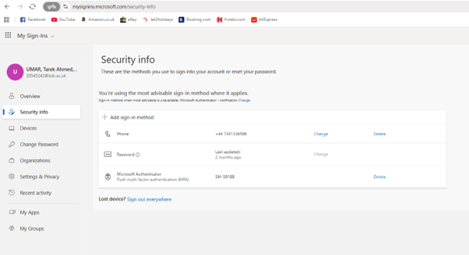
Figure 10 Microsoft Account Security Info page showing 2FA option
Step 2: Add Authenticator App Click "Add sign in method" on Security info page. Then, choose "Authenticator app." Download Microsoft Authenticator from your app store if not yet installed.
Open Microsoft Authenticator, then scan the QR code from your Microsoft account page. Microsoft’s authenticator app will provide you with a 6-digit code, which changes every 30 seconds to produce one-of-a-kind verification codes for logging into your account.
Step 3: The authenticator app offers support for two modes of 2FA:
- Push Notifications: This notifies you on your phone to approve/reject login request
- Verification Codes: Manual entry of 6-digit verification codes (less convenient, works offline)
When login in to your Microsoft Account with a new computer, you'll be required to authenticate your login through your Authenticator App. It shows you where you are attempting to log in to your Microsoft Account. This is show below:
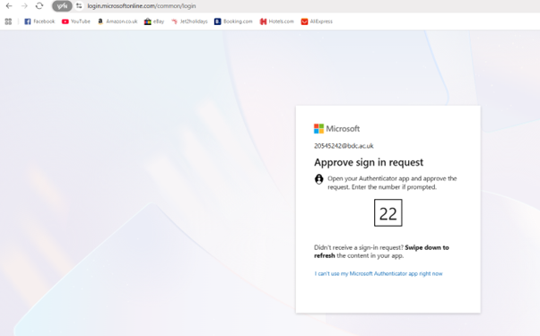
Figure 11 Login site sending a request to mobile Microsoft authenticator to accept the login request.
Step 4: You will get notification in Microsoft Authenticator app, Approve the login attempt from your phone, and you will be granted access to your account, but failure to approve or deny will block the login attempt.
Why 2fa is important for security:
- Protects from unauthorized access, even in case password is hacked via phishing or data breaches
- Protecting sensitive information, financial data, and work-related information
- Microsoft requires 2FA for accounts with sensitive activity or from unknown devices
- Recovery options are available (phone, emails) no matter what method has failed
Common issue and their resolution:
Issue: Notifications not appearing in Authenticator app Resolution:
Make sure app permissions are allowed (go to Settings Notifications on iOS, or Settings Apps Microsoft Authenticator Notifications on Android). Verify push notifications are allowed in settings for Microsoft Authenticator app.

4.4 Configuration of Security Techniques

4.4.1 Antivirus Configuration - Avast
Configuring Scans: Open Avast Menu Settings Protection Smart Scan. Select “Auto Continue smart scan”. Configure frequency (Daily/Weekly) , start time, and enable “Run missed scans as soon as possible”.
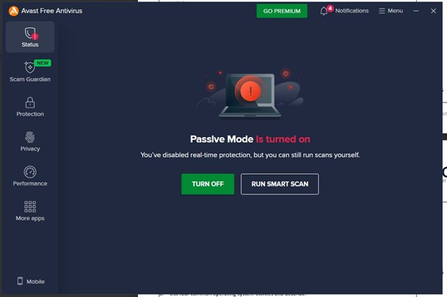
Figure 12 Avast main interface showing protection status
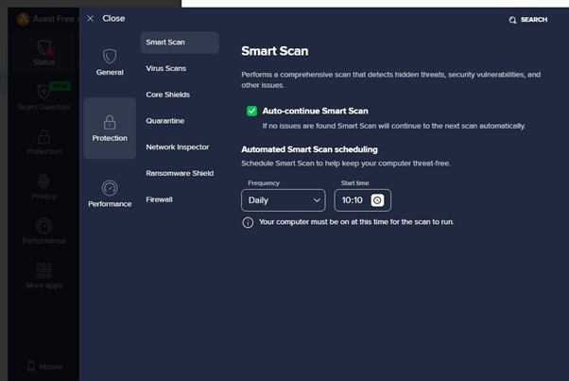
Figure 13 Configuring automated scan schedule in Avast with frequency and start time.

Managing Real-time Protection: Navigate to Settings Protection Core Shields. File, Web, Mail, and Behaviour Shields should remain active. Temporarily disable via system tray icon if necessary for legitimate software installation.

Figure 14 Real-time protection temporarily disabled for troubleshooting

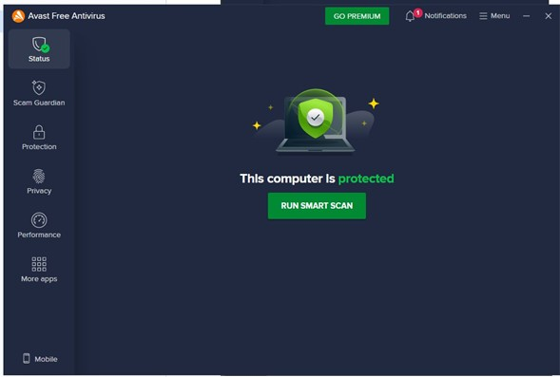
Figure 15 Real-time protection re-enabled confirming active monitoring
Exclusions: Settings General Exclusions. Add trusted file paths, folders, or URLs to reduce false positives and system overhead. However use caution and only exclude verified safe locations.
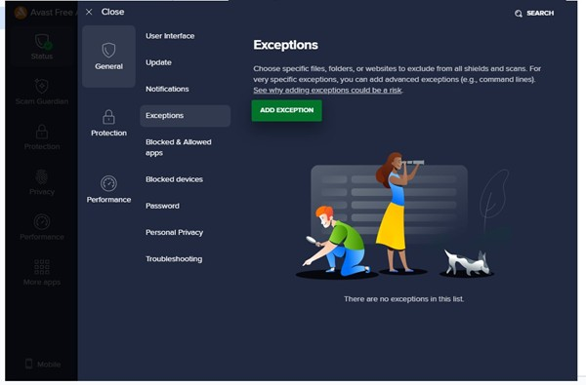
Figure 16 Adding exclusion rules for trusted development directories
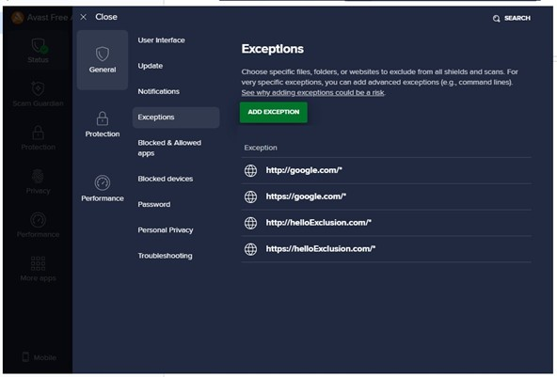
Figure 17 Examples of configured exclusions showing file paths

4.4.2 Firewall Configuration
Custom Rules: Open Windows Defender Firewall with Advanced Security (wf.msc). Select “Inbound Rules” “New Rule”. Choose rule type as “Custom”, configure protocol and ports, define action as “Allow”.
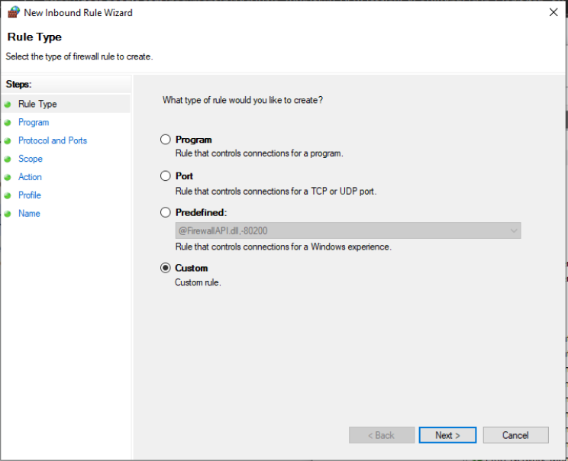
Figure 18 Custom rule creation wizard showing rule type selected as custom
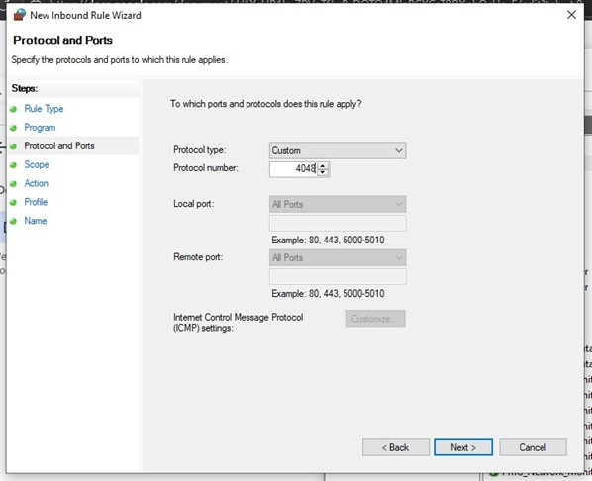
Figure 19 Configuring custom protocol number 4048 for traffic control
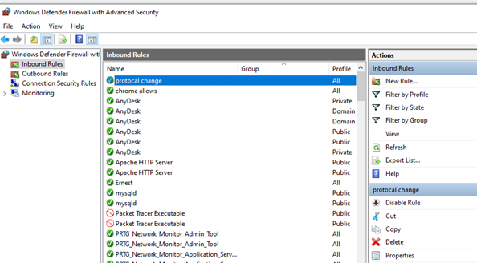
Figure 20 : Verification of custom rule in inbound rules list
Application Rules: Create program-specific rules via “Program'” rule type. Browse to executable, choose allow/ block, select network profiles, and provide descriptive name.

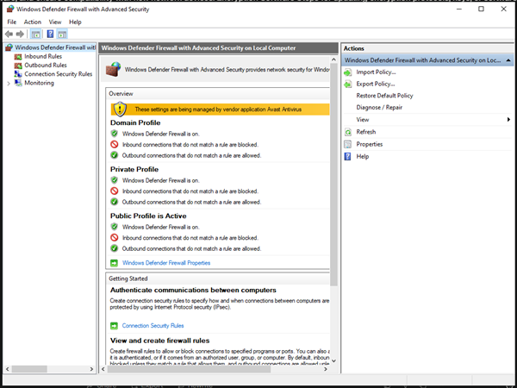
Figure 21 Accessing advanced firewall settings for application rules

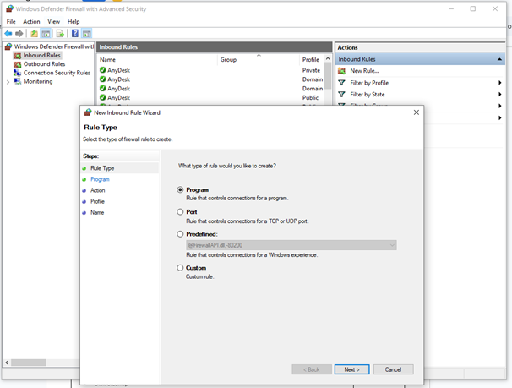
Figure 22 New Inbound Rule Wizard for program selection

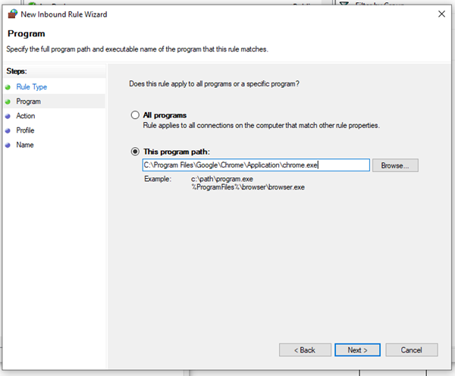
Figure 23 Configuring firewall rule for Chrome browser
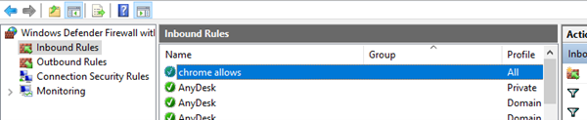
Figure 24 Confirmation of Chrome rule successfully added

Network Profiles: Configure profile-specific settings in firewall properties. Public networks require strict rules blocking incoming connections, while Private networks allow file sharing.
Public Profile Configuration: Open Windows Defender Firewall with Advanced Security (wf.msc) and select the Public Profile tab. public networks implement strictest settings: Firewall State “On (recommended)”, Inbound connections “Block (default)” preventing unauthorized access, and Outbound connections “Allow (default)” enabling legitimate applications.
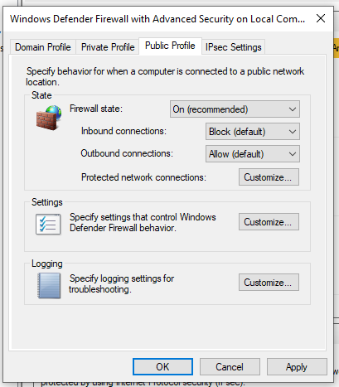
Figure 25 Public network profile with firewall enabled
Modifying Public Profile Settings: Click “Customize” button to modify profile settings. To temporarily disable firewall for troubleshooting, change Firewall State from “On (recommended )” to “Off”. This can be done only to troubleshoot issues in a trusted Wi-Fi/network. Always re-enable firewall immediately after troubleshooting on public networks due to increased security risks.
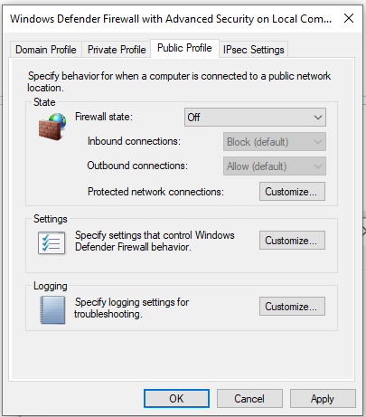
Figure 26 Modifying firewall settings to turn off public firewall settings.#
Private Profile Differences: Private networks allow file sharing, network discovery, and printer sharing while maintaining baseline firewall protection. Enable these features only on trusted home or office networks.

4.4.3 Encryption Configuration - 7-Zip
Creating Encrypted Archives: Right click files 7-Zip Add to archive. Select “.7z” format (required for AES-256), enter strong password, select “AES-256” encryption method.
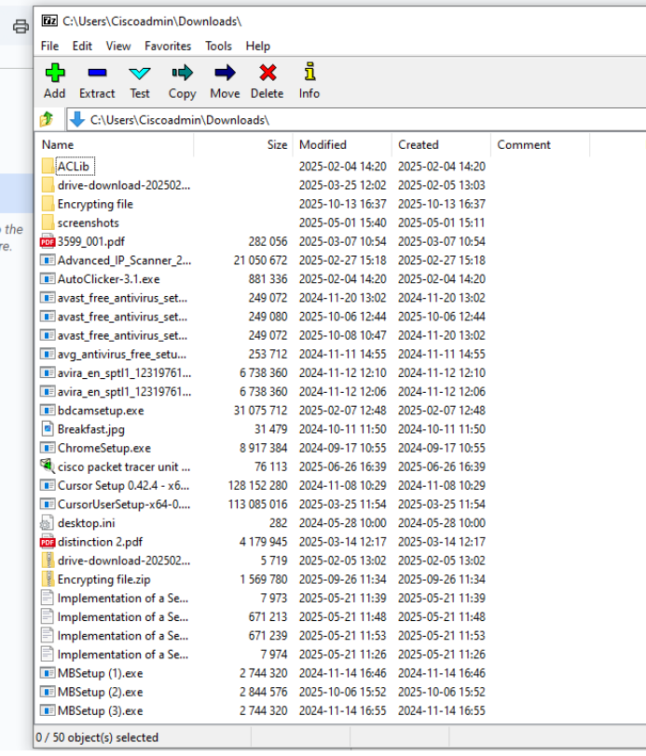
Figure 27 7-Zip file manager showing file selection for encryption

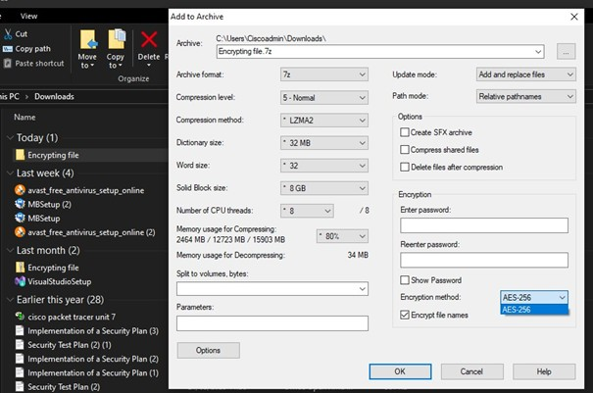
Figure 28 Add to Archive dialog displaying AES-256 configuration
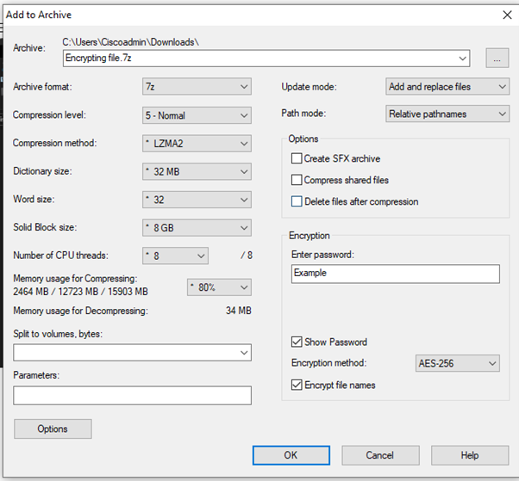
Figure 29 Detailed encryption settings with password and file name encryption

Enable “Encrypt file names” to protect metadata of the file. Set compression to LZMA2 for optimal balance. Higher dictionary sizes provide better compression but requires more memory.

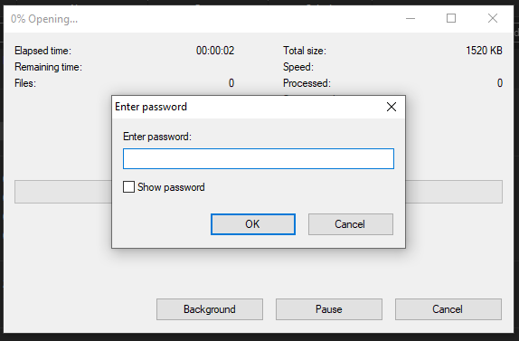
Figure 30 Encrypted archive created - password prompt appears on access
Decryption: Double click encrypted archive and enter the password. Incorrect passwords result in “Wrong password” errors which prevents unauthorized access.
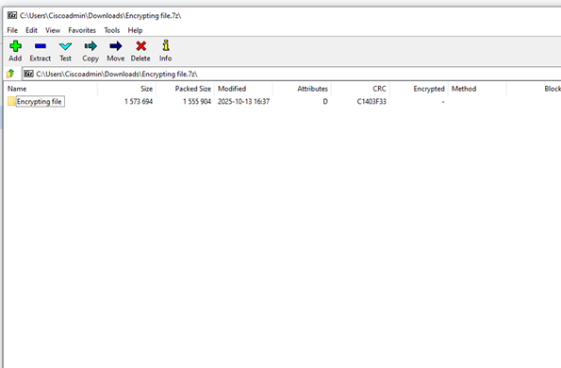
Figure 31 Successfully decrypted archive showing the files inside

4.5 Updating Security Techniques

Antivirus Updates

Updating virus definitions manually:
Manual virus definition updates enable you to have instant control over when updates to antivirus threat databases occur. Manual updates guarantee you have the opportunity to force updates before major operations or after automated updates have not yet occurred.
Accessing Manual Update Interface: Open Avast antivirus interface. Go to Menu Settings General Update. On the Update page, you will see your latest definition version information, definition version history, definition version release date, and definition update options.
Initiating Manual Update Check: To manually check for updates from Avast servers, click on “CHECK FOR UPDATES”. It checks for updates on Avast’s servers to see if there are new definition updates are available.
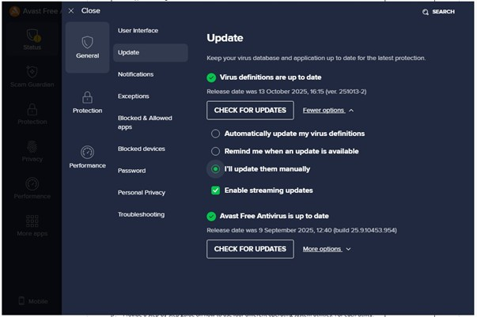
Figure 32 Avast Virus definition is selected to be updated manually.
Verification and Confirmation: On clicking on the update button, status messages regarding the availability and process of updates from Avast are displayed. If there are updates available, they begin downloading and installing themselves, with indicators illustrating their percentage level completion. On success, a green tick sign with “Status: Updated” is displayed.

Automatically Updating Virus Definitions:
Automatic definition updates guarantee your antivirus is updated to its latest version. It does not require you to manually update it. It updates at regular intervals to provide constant safety from new viruses.
Configuring Automatic Update Settings: Navigate to Menu Settings General Update. It is in this settings section where all the updates related to viruses or applications are controlled. Making sure to enable updates to keep your threat protection updated by Avast.
Enabling Automatic Updates: Check the "Automatically update my virus definitions" checkbox to enable automatic updates to virus definition databases periodically.
Configure the following options:
- “Automatically update my virus definitions”
- “Remind me when an update is available”
- “I'll update them manually”
After choosing “Automatically update my virus definitions”:
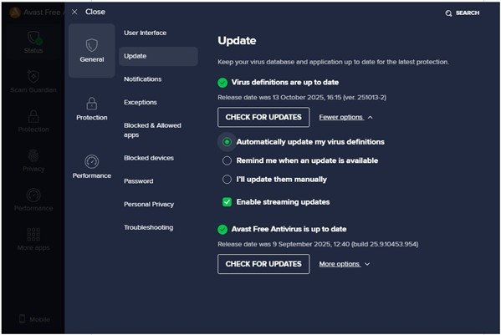
Figure 33 Avast virus definition is set to automatic.

Firewall Updates
Windows Firewall updates via Windows Update. Navigate Settings → Update & Security → Windows Update. Click 'Check for updates'. Firewall improvements deploy through cumulative updates and feature releases.
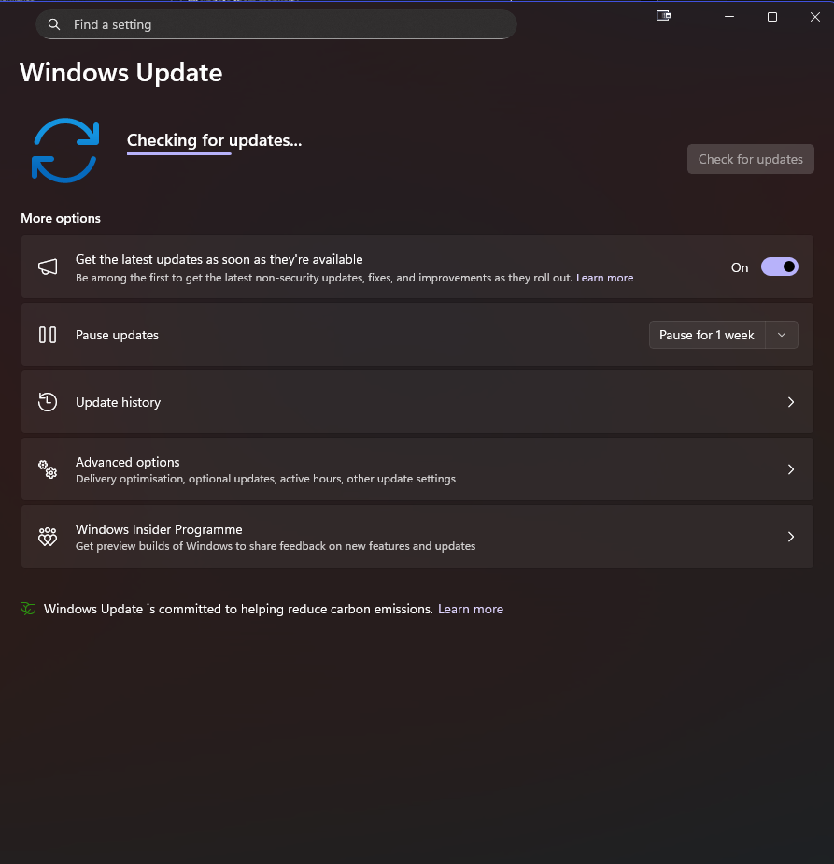
Figure 34 Windows checking for updates which check for windows firewall software updates

Encryption Software Updates
Check https://www.7-zip.org/download.html for latest version. Download and execute installer - it performs in-place upgrade preserving settings. No uninstallation required. Verify functionality post-update by creating test encrypted archive.
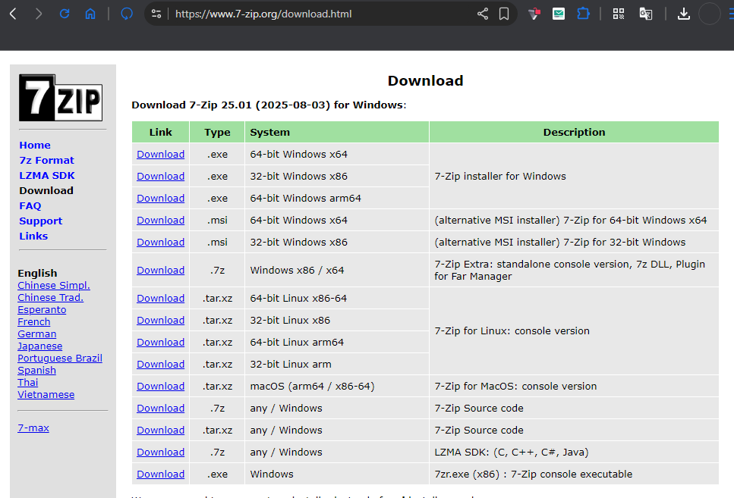
Figure 35 7 Zip site to check if new updates are available via update release date

4.6 Operating System Utilities - Purposes and Characteristics
The operating system utilities are necessary for functions such as maintaining, optimizing, and repairing computers. Below is an analysis of five core utilities in Windows operating systems, highlighting their functions and attributes, which make these tools necessary for managing computers.

4.6.1 Disk Cleanup Utility
Purpose: Disk Cleanup performs its functions by eliminating unnecessary files generated in the course of normal computer operation, thereby creating additional storage space. It works on temporary system files, system cache files, downloaded program installation files, Thumb cache files, recycle bin contents, and Windows scan cache files. It is most helpful in scenarios involving computers with restricted storage capacity, computers with solid-state drives, or in scenarios requiring large disk space for major version updates.
Key Characteristics:
- Selective Deletion: Enables deletable files to be identified, with opportunities for users to view choices for deleting particular types of files.
- Space Calculation: Shows what space could be recovered for each type before deleting, to enable proper decision making.
- System File Cleanup: Advanced mode views additional types, such as Windows Update System Cleanup logs, and previous Windows installation folders
- Safe Operation: t removes only those files on the computer, which Microsoft identifies are safe to delete. These files are not critical for the system and does not affect the user.
- Scheduling Capability: It can be automated with Task Scheduler for automatic maintenance purposes
- Low System Impact: Lightweight utility with low CPU and memory utilization while running
- Multiple Drive Support: Works with any type of storage device including external drives, not just the system drive.

4.6.2 Task Manager
Purpose: Task Manager, with its executable process named taskmgr.exe, is a full-featured system monitor for Windows operating systems. Task Manager’s functions include real-time system resource analysis for processor, RAM, disk, and network utilization, managing applications and tasks, such as killing frozen applications, running applications with administrative privileges, managing programs running on start-up for optimal booting, and in-depth analysis of resource utilization. Task Manager is used by system administrators, tech-savvy computer users, and computer support specialists for analysing computer performance problems, aiding in finding resource-hungry applications, and managing computer services.
Key Characteristics:
- Multi-tab Interface: Organized tabs (Processes, Performance, App History, Startup, Users, Details, Services) to segregate different functionality areas
- Real-Time Monitoring: Real-time updates of performance data, multiple updates per second, to provide instant visibility into system status
- Process Hierarchy: It shows the parent-child process relationship in which some applications have launched sub-processes, with their resource allocation
- Resource Attribution: It identifies those consuming resources with percentage-based measurements, aiming for optimization that can be targeted based on resource usage
- Administrative Actions: Capabilities to stop unresponsive tasks, modify process priority levels, generate memory dumps for diagnostic purposes
- Startup Management: It manages programs running during start-ups in Windows, thereby affecting its start-up time and resource availability
- Network Monitoring: Tracking network utilization by applications to detect applications consuming high network bandwidth
- Service Control: Access and control Windows services without having to launch services.msc console from the Services tabs
- User Session View: Shows all logged-in users with their resource usages on multiple-user systems

4.6.3 System Configuration (MSConfig)
Purpose: The System Configuration utility, commonly known as msconfig.exe, offers in-depth booting and start-up customization settings, which are crucial for optimizing computer systems. MSConfig’s core functions consist of booting problems resolution through Safe Boot modes, start-up settings management (Normal, Diagnostic, Selective start-up mode management), management for boot settings (timeout value, processor number, restrictions on RAM allocation), start-up applications management, and management for Windows services start settings. MSConfig is an extremely efficient tool in identifying system stability problems for optimizing booting, identifying problematic drivers/services, managing multiple operating systems during start-ups, and multiple other functions.
Key Characteristics:
- Boot Configuration: Total control over booting options, such as Safe Mode variations (Minimal, Alternate shell, Network), booting timer, and choosing the default operating system in multiple-boot setup systems
- Advanced Boot Options: Set restrictions on processor core numbers, maximum memory allowed, kernel debug parameters, and graphics output options
- Startup Selection Modes: Option to choose Normal Startup ( startup with all services/programs ), Diagnostic Startup (startup with basic services only), or Selective Startup ( custom settings)
- Service Management: Enables/Disables Windows services selectively with “Hide all Microsoft services” option, isolating third-party services for conflict analysis
- Tools Launcher: Easily launch common administrative tools in Windows from a centralized interface such as Event Viewer, System Information, and Registry Editor
- Persistent Changes: Modifications will apply for multiple reboots until manually undone, creating consistent environments for troubleshooting.
- Safe Mode Access: Simplified way to set up booting in Safe Mode, instead of having to press F8 during boot up.

4.6.4 DirectX Diagnostic Tool (DxDiag)
Purpose: DirectX Diagnostic Tool, or DxDiag, with its executable by running dxdiag.exe, offers in-depth information with regard to DirectX components, graphics, sound, and input hardware. It is utilized for: DirectX installation integrity validation, validation for graphics and audio hardware specifications, DirectX functionality testing via its in-built diagnostic tests, DirectX driver problems related to digital signatures, and overall generation of system reports for support purposes. DirectX DxDiag reports are commonly sought after by game developers, multimedia professionals, or support personnel for graphics, audio, or compatibility-related rendering problems in computer games.
Key Characteristics:
- System Overview: Detailed information regarding operating system version, processor information, RAM installed, DirectX version, BIOS information, and information about its manufacturer
- Display Diagnostics: Information about graphics cards, such as GPU type, driver version, VRAM, monitor model, displayed resolution, and DirectX support level.
- Sound Device Testing: Audio device enumeration with driver information, hardware acceleration options, and basic audio output testing functionality
- Input Device Detection: It displays information about input devices such as keyboards, mice, gaming controllers, hardware IDs, vendor, and driver version
- Driver Verification: Validates driver digital signatures for authenticity as well as certification with Windows Hardware Quality Labs (WHQL )
- Report Generation: Enables the generation of text-based reports on the system, which can be saved or sending to tech support for assistance
- DirectX Feature Testing: Validates DirectDraw, Direct3D, or DirectSound support, identifies problems with rendering pipelines
- Non-intrusive Operation: Read-only diagnostic tool, does not change system configurations which guarantees safe diagnostic process.

4.6.5 System Restore
Purpose: System Restore, with the executable being rstrui.exe, it aids in recovering from problems through the restoration of Windows system files, applications, registry, and system settings by reverting to previously recorded restore points. Some of its uses are to resolve issues with applications, reverse changes in the system for causing instability, reverse changes in drivers due to compatibility problems, and to reverse changes after removal of malware. It is a non-destructive process without affecting user private data, such as files like documents, pictures, and other private information are not affected while carrying out restoration tasks.
Key Characteristics:
- Automatic Restore Points: These are restore points generated by Windows whenever there are major changes to the system such as during Windows Updates, driver installation, or applications being installed
- Manual Restore Point Creation: Users create restore points manually in scenarios before making intentional system modifications providing known-good restoration targets
- Selective Restoration: Offers multiple restore points ranging across several dates, thereby permitting restoration
- Impact Preview: Provides information on programs, drivers, or other affected items to enable decision-making regarding their restoration
- Personal File Protection: Does not affect user files like pictures, movies, videos, or other files stored in user profile folders
- Reversible Operations: Restore operations themselves can be reversed in case the restoration itself does not resolve problems or causes new issues
- Disk Space Management: It manages disk space for storing restore points, consuming usually 1-5% disk space, with automatic cleanups for oldest restore points
- Safe Mode Accessibility: Accessible from Safe Mode or from Windows Recovery Environment, if normal booting is not possible.

4.7 Using Operating System Utilities

4.7.1 Using Disk Cleanup
Step 1: Launch Disk Cleanup (cleanmgr.exe). Select drive to clean. Utility calculates potential space recovery.
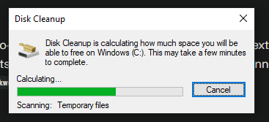
Figure 36 Disk Cleanup initial calculation phase scanning for files

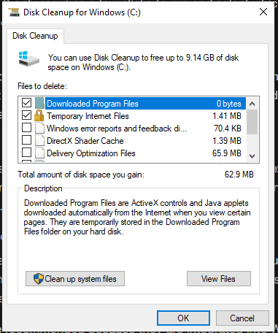
Figure 37 Disk Cleanup ready state showing 1.40 MB cleanable space
Step 2: Select file categories for deletion. Review descriptions to understand what will be removed. Check desired categories.
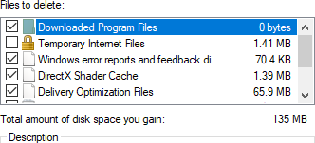
Figure 38 Disk Cleanup displaying 135MB selected for deletion
Step 3: Click OK and confirm deletion. Utility removes selected files displaying progress.
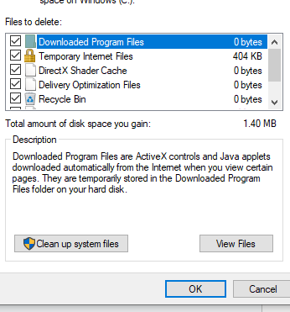
Figure 39 Minimal remaining data (1.40 MB) after successful cleanup

4.7.2 Using Task Manager
Step 1: Launch Task Manager (Ctrl+Shift+Esc ). Click “More details” for full interface.
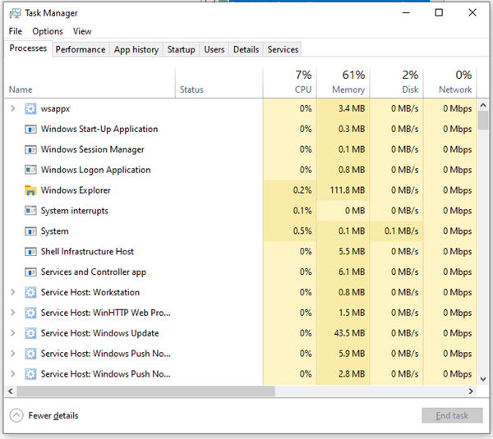
Figure 40 Task Manager Processes tab showing resource utilization (CPU 7%, Memory 61%)
Step 2: Monitor performance via Processes tab. Sort by resource consumption to identify top consumers.
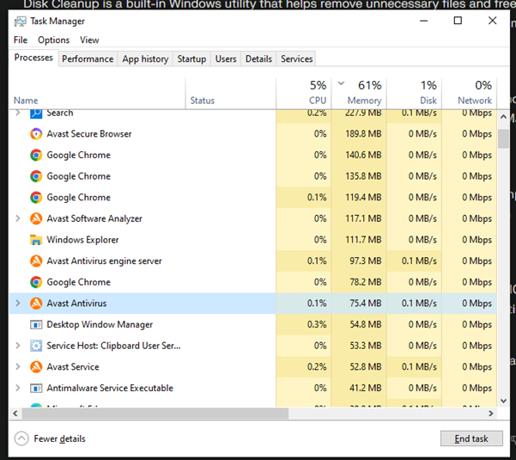
Figure 41 Task Manager showing Avast antivirus running normally
Step 3: Launch programs via File Run new task. Enter program name and check “administrative privileges” if needed.
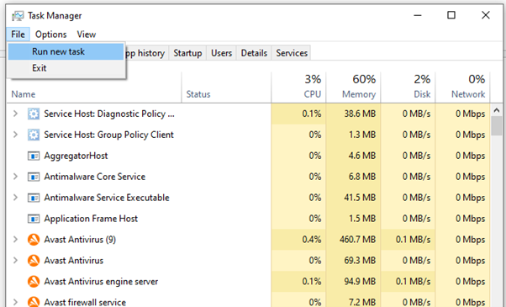
Figure 42 Task Manager File menu showing 'Run new task' option
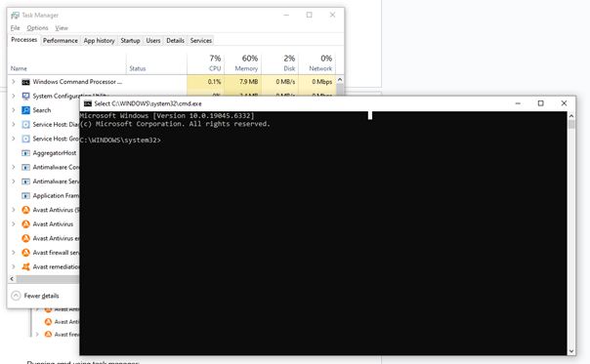
Figure 43 Command Prompt launched via Task Manager

Step 4: End unresponsive processes by right-clicking and selecting “End task”.
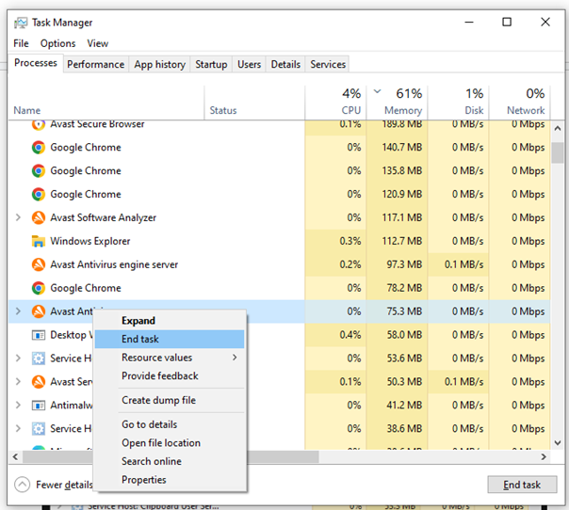
Figure 44 Right-click context menu showing 'End task' option
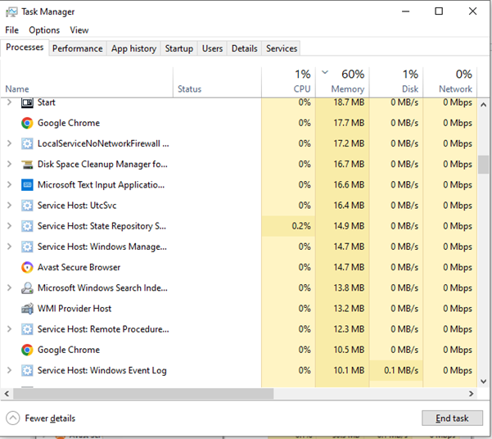
Figure 45 Process list after ending Avast - no longer running

4.7.3 Using MSConfig
Step 1: Run msconfig with administrative privileges. Interface displays five configuration tabs.
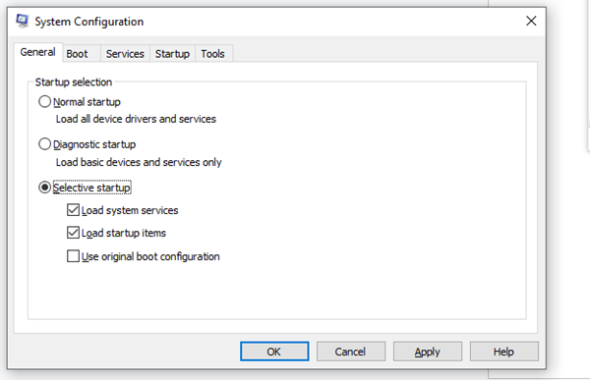
Figure 46 MSConfig Boot tab with selective startup configuration
Step 2: Configure boot options in Boot tab. Set timeout duration and Safe Boot options if that is needed.
Step 3: Access Advanced options to configure processor count and memory limits for troubleshooting by navigating from “boot” “Advanced Options”.
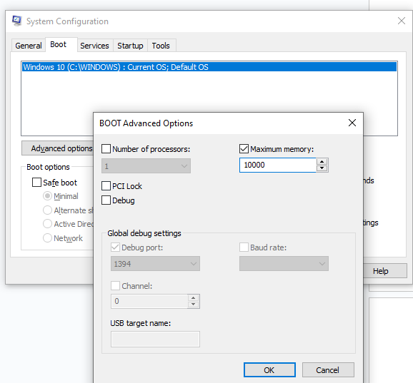
Figure 47 Advanced Boot Options with 10GB maximum memory restrictio
Step 4: Apply changes and restart. MSConfig notification confirms changes were applied.

4.7.4 Using DxDiag
Step 1: Run dxdiag. Click “sYes” to verify driver digital signatures.
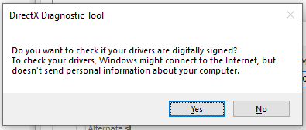
Figure 48 RUNNIGN DxDiage which gives digital signature verification prompt
Step 2: Click yes and go to the review System tab for comprehensive computer information including OS, processor, RAM, and DirectX version.
Step 3: Check Input tab for connected devices. Direct input Devices section lists keyboards, mice, and controllers. This is useful for verification of input devices if they are working or not. 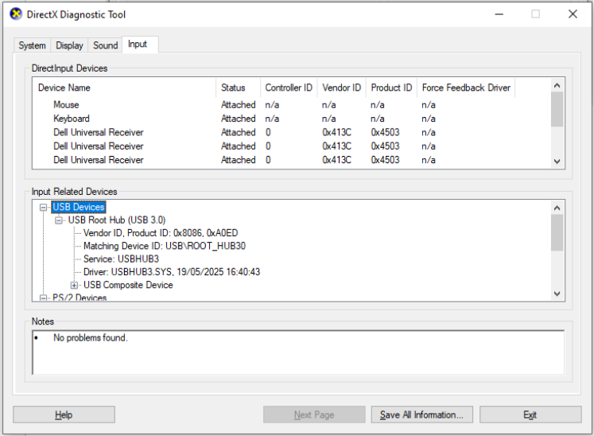
Figure 49 DxDiag Input tab showing detected input devices and USB tree

Step 4: Examine Sound tab for audio hardware. “No sound card was found” indicates absent or disabled audio.
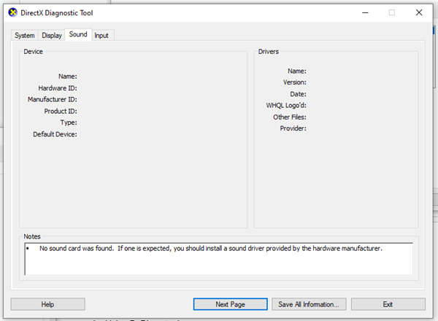
Figure 50 DxDiag Sound tab showing no sound card detected
Step 5: Generate diagnostic reports via “Save All Information” for technical support submission.

Conclusion
This report demonstrates that these necessary security methods and operating system tools have been successfully applied in real-life scenarios for their demonstration. Such an overall security mechanism with layers like anti-virus screening, firewalls, and encryption protects from different types of attacks. Every security method discussed has its own applications.
Functions performed by operating system utilities include managing system performance in an active maintenance process. Disk Cleanup optimizes disc space, Task Manager offers real-time management, MSConfig assists in carrying out diagnostic starts, DxDiag offers in depth hardware details, while System Restore functionality aids in recovery. These utilities worl together with security, creating a complete management of the windows operating system.
Regular updates and reviews of security settings enable it to remain effective in face of new threats. Security professionals must stay updated with new vulnerabilities, which require immediate updates. Various steps outlined in this report provide necessary information for creating secure settings for systems while having efficiency in their operation.

References
- Avast Software. (2025). Avast Free Antivirus Documentation and User Manual. Available at: https://www.avast.com/en-gb/index (Accessed: 19 November 2025)
- Center for Internet Security (CIS). (2024). CIS Microsoft Windows 10 Enterprise Benchmark. Available at: https://www.cisecurity.org/ (Accessed: 19 November 2025)
- European Union. (2018). General Data Protection Regulation (GDPR). Regulation (EU) 2016/679.
- Igor Pavlov. (2024). 7-Zip File Archiver Official Documentation. Available at: https://www.7-zip.org/ (Accessed: 19 November 2025)
- Malwarebytes Corporation. (2025). Malwarebytes Free Antivirus User Guide. Available at: https://www.malwarebytes.com/ (Accessed: 19 November 2025)
- Microsoft Corporation. (2025). DirectX Diagnostic Tool (DxDiag) - Hardware Diagnostics. Available at: https://docs.microsoft.com/en-us/previous-versions/windows/desktop/dxdiag/dx-diag-tool (Accessed: 19 November 2025)
- Microsoft Corporation. (2025). Disk Cleanup Utility - Storage Management. Available at: https://docs.microsoft.com/en-us/windows/client-management/ (Accessed: 19 November 2025)
- Microsoft Corporation. (2025). Firewall Profile Configuration and Management. Available at: https://docs.microsoft.com/en-us/windows/security/ (Accessed: 19 November 2025)
- Microsoft Corporation. (2025). Security Best Practices for Microsoft Accounts. Available at: https://docs.microsoft.com/en-us/microsoft-365/ (Accessed: 19 November 2025)
- Microsoft Corporation. (2025). System Configuration (MSConfig) - Boot and Service Configuration. Available at: https://docs.microsoft.com/en-us/windows/win32/services/ (Accessed: 19 November 2025)
- Microsoft Corporation. (2025). System Restore - System Recovery and Backup Utilities. Available at: https://docs.microsoft.com/en-us/windows/win32/backup/ (Accessed: 19 November 2025)
- Microsoft Corporation. (2025). Task Manager - System Monitoring and Process Management. Available at: https://docs.microsoft.com/en-us/windows/win32/taskschd/task-scheduler-start-page (Accessed: 19 November 2025)
- Microsoft Corporation. (2025). Microsoft Authenticator App - Two-Factor Authentication. Available at: https://account.microsoft.com/security (Accessed: 19 November 2025)
- Microsoft Corporation. (2025). Windows Defender Antivirus Overview. Available at: https://docs.microsoft.com/en-us/windows/security/threat-protection/windows-defender-antivirus/ (Accessed: 19 November 2025)
- Microsoft Corporation. (2025). Windows Defender Firewall with Advanced Security. Available at: https://docs.microsoft.com/en-us/windows/security/threat-protection/windows-firewall/ (Accessed: 19 November 2025)
- National Cyber Security Centre (NCSC). (2024). Cyber Security Guidance and Best Practices. Available at: https://www.ncsc.gov.uk/ (Accessed: 19 November 2025)
- National Institute of Standards and Technology (NIST). (2019). Recommendations for Key Management. NIST Special Publication 800-57 Part 1. Available at: https://nvlpubs.nist.gov/nistpubs/Legacy/SP/nistspecialpublication800-57p1r4.pdf (Accessed: 19 November 2025)
- PCI Security Standards Council. (2024). Payment Card Industry Data Security Standard (PCI-DSS). Available at: https://www.pcisecuritystandards.org/ (Accessed: 19 November 2025)
- Pavlov, I. (2024) 'AES-256 Encryption Implementation in 7-Zip', 7-Zip Archiver Release Notes, Version 24.00. SANS Institute. (2023). Windows Security Best Practices and Hardening Guidelines. Available at: https://www.sans.org/ (Accessed: 19 November 2025)

