Task 1: How an Operating System Can Be Viewed as an Event-Driven Application
Unit: | Event Driven Programming (WN1507)
Assessor: | Billy Madlela
Student: | Tarek Ahmed Umar
Date: | November 2025

Table of Contents
1. Introduction 2
Definition 2
Importance of event-driven programs and why 2
2. Operating Systems 3
Operating Systems and their purpose 3
Operating systems in managing hardware & software resources 3
3. Events in Operating Systems 3
Definition within the context of OS 3
Synchronous vs. Asynchronous Events 3
4. Event Handling Mechanisms 3
How the OS handles and detects Events 3
Interrupts in event handling 3
Priority Inversion: A Critical Challenge in Event-Driven Systems 3
5. Queues and Dispatchers in Events 3
Event-driven OS components 3
Event loops, listeners, and handlers 4
Below is an event-driven architecture with event loops, listeners, and handlers made by me in https://app.diagrams.net/: 5
6. Examples of Events in OS 6
The systems start-up and shutdown 6
System service installation, setting changes, scheduled tasks 6
7. Multithreading and Concurrency 6
Concurrent events handling 6
Functions of threads in dealing with multiple events 6
Event-Driven vs Procedural Approaches to Event Handling Comparison table: 7
8. The challenges in event-driven operating systems 8
Difficulty in managing state and transitions 8
Event Prioritization and Handling Concerns 8
Event Handler Re-entrancy and Mutual Exclusion 8
9. Real-world Application 9
Example of event-driven OS in a corporate setting 9
Event-Driven vs Thread-Per- Connection Performance Comparison table: 9
Importance of event-driven OS in system performance 10
10. Conclusion 10
Summary of event-driven OS 10
The Future trends occurring in OS design 10
References 11

1. Introduction

Definition
An event-driven program is a computer application/software whose control flow is based on external events instead of predetermined programs. Examples of such events include activities performed by users, hardware interruptions, or system notifications. An event-driven system responds to occurrences by executing corresponding event handler programs. These programs do not involve linear programming concepts. An event-driven technique is basic to operating systems, yet this reactive model is fundamental to modern operating systems.
[11][13]

Importance of event-driven programs and why
An event-driven architecture is critical for current and for future computing. It allows for real-time responsiveness to user interactions, prevents inefficient polling, and allows stellar scalability, supporting thousands of simultaneous operations. The event-driven architecture is necessary for operating systems with unpredictably asynchronous demands for hardware and applications. An event-driven architecture is critical for providing power efficiencies required by mobile devices.
[11][13][16][19]

2. Operating Systems

Operating Systems and their purpose
An operating system can be regarded as a system software, which performs a role of intermediary between hardware and application programs. An operating system is intended to conceal the complexities arising from hardware components. An operating system manages resources such as memory. These resources are managed by means of interfaces, all while providing security.
[24]

Operating systems in managing hardware & software resources
Operating systems manage both hardware and applications by allocating resources. However, hardware events such as keyboards sending input, packets for networks, or completion of operations on hard disks require resource allocation on the part of OS. Thus, detection of these events and directing such events to their corresponding event listeners is necessary. This makes event-driven architecture essential, without it the OS cannot predict when the hardware events will happen.
[18][24]

3. Events in Operating Systems

Definition within the context of OS
An event is any significant activity that demands OS attention. They are known to be the fundamental means for communication between hardware and software components. Every event contains attributes: source (device, timer, application), type (interrupt, signal, system call), priority (level of urgency), and data. These events are detected by the OS and delivered to their corresponding handlers.
[14][24]

Synchronous vs. Asynchronous Events
Synchronous events happen based on specific application requests. System calls facilitate these requests. The application determines when these events happen. Asynchronous events happen without application control. These events rely on external circumstances. An example of asynchronous events is hardware interrupts. Disk completion triggers these interrupts without any involvement by the application that made the request. Operating systems deal with many unpredictable asynchronous events.
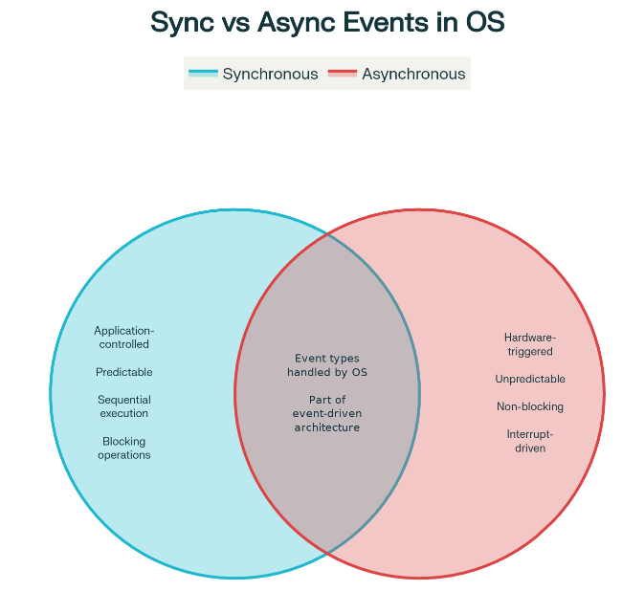
[22][24]

4. Event Handling Mechanisms

How the OS handles and detects Events
Operating systems have multiple event detection capabilities. Synchronous events occur when a request for processing is made by an application through system calls. Asynchronous events occur due to hardware notifications that are detected by interrupt lines managed by operating systems. The CPU is constantly vigilant for notifications. Upon reception, it triggers processing. Operating systems have and maintain event queues pending that are checked by the kernel event loop.
[24]

Interrupts in event handling
Interrupts are the fundamentals for event-driven OS functioning. An interrupt is a hardware-generated signal pointing toward asynchronous events. On detecting a need for service, devices use interrupt signals via specific processor lines. As soon as the processor recognizes an interrupt request, it saves the processing execution state, switches to kernel mode, and jumps to the ISR. The ISR performs critical actions involving interrupt acknowledgement, data processing, and maintenance operations on kernel structures. Finally, it resumes executing the interrupted process.

Priority Inversion: A Critical Challenge in Event-Driven Systems
Priority inversion is a paradoxical situation found in event-processing systems where high-priority events are pushed back because low-priority event processing is holding a resource lock. Here is a scenario: a high-priority keyboard interrupt is waiting for a low-priority disk I/O event to free a resource lock on a shared data structure. During this low-priority processing, a high-priority event, usually immediately serviced, is held waiting. This leads to lower system responsiveness. Operating systems mitigate this by implementing priority inheritance, which temporarily gives the low-priority process the same priority as the waiting high-priority event. Real-time operating systems mitigate priority inversion with bounded priority inversion strategies that guarantee wait times, which is especially important for safety-critical systems such as healthcare and aviation.
[22][24][27]

5. Queues and Dispatchers in Events

Event-driven OS components
An event-driven operating system relies on several components working in harmony. These components include event sources (timers, hardware, and apps ), event queues (to hold events until acted on), event dispatchers (to monitor for waiting events), event listeners (to express interest in particular types), and event handlers ( to execute event response logic). These components work together through continuous cycles of detection, queuing, selection, and handling.
[11][13][14]

Event loops, listeners, and handlers
An event loop is a representation of a heartbeat in event-driven systems that is constantly engaged with: scanning for waiting events, finding events with highest priority, dispatching to event listeners, executing event listeners. If there are no events waiting, then it will engage in low-power idle processing. An event listener is interested in particular event types. An event listener is code that responds to events. In Linux, they have interrupt descriptor tables for interrupt-handling code, system call tables for system call-handling code.

Below is an event-driven architecture with event loops, listeners, and handlers made by me in https://app.diagrams.net/:
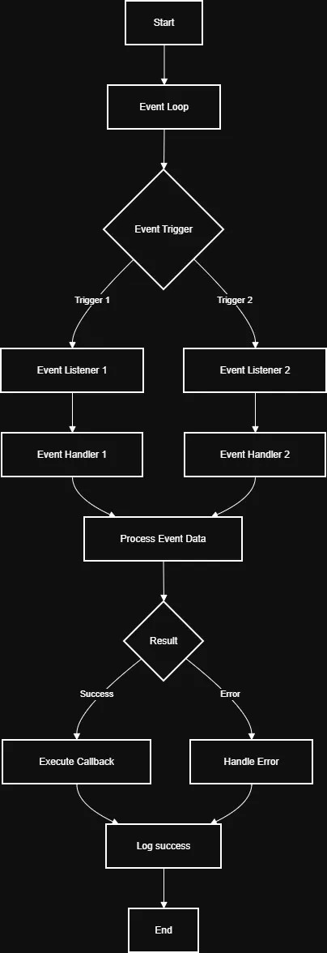
[24][30]

6. Examples of Events in OS

The systems start-up and shutdown
Operating systems have critical events in their life cycle. System booting is initiated by the start-up of hardware devices. The BIOS/UEFI performs initialisation of hardware components and loading of the OS kernel. The OS kernel then performs activities such as initialisation of kernel structures, interrupt controllers, identification of devices, and drivers. System shutting down is initiated by users or due to critical situations. The OS notifies programs, performs state saving, waits for process completion, and stops operations.
[24]

System service installation, setting changes, scheduled tasks
During normal operations, there are several events for which systems respond. Configuration events occur due to change operations. These include display events that happen when a change is made to screen brightness and audio events which happen because of volume adjustments. System events happen due to the installation of a service. Maintenance events happen due to operations such as memory releases by OS and garbage collection.
[24]

7. Multithreading and Concurrency

Concurrent events handling
Contemporary systems deal with many events simultaneously coming from multiple sources. Event-driven systems face these situations by using several techniques: interrupt-handling routines run atomically with respect to code that is interrupted, event queuing deals with multiple events asynchronously, interrupt priority levels enable high-priority events to interrupt low-priority interrupt-handling code, and critical regions temporarily disable interrupts during access to shared resources.
[18][30]

Functions of threads in dealing with multiple events
Multithreading is event-driven synchronization extended for application use. Threads are light-weight processing environments that have their own separate memory space but share process memory. Each process can wait independently for I/O completions after that a process can continue executing while another process is waiting for I/O completion. These concepts work in conjunction with each other. The kernel deals with hardware events, deciding which process will run.

Event-Driven vs Procedural Approaches to Event Handling Comparison table:
Aspect | Event-Driven | Procedural/Sequential | Blocking Model
Execution Model | Reactive: responds to external events | Proactive: checks for conditions continuously | Blocking: waits for conditions
CPU Utilization | 2-5% (mostly idle) | 40- 60% (constant polling) | 50-80% (blocked on I/O)
Response Latency | 1-10ms | 100-500ms | 100-1000ms
Concurrent Connections | 10,000+ | 500-1,000 | 100 -500
Memory Footprint | Minimal per connection | 2-4 MB per connection | 5-10 MB per connection
Scalability | Linear improvement | Performance cliff at ~1,000 connections | Degrades rapidly
Developer Complexity | Higher (async patterns) | Lower ( familiar patterns) | Lowest (simple loops)
Real-World Example | Nginx, Node.js , Redis | Apache (traditional), Python Flask | Legacy systems, batch processing
Best Use Case | High concurrency systems | Moderate load, simple logic | Single-threaded batch jobs
Typical Throughput | 10,000-100,000 req/sec | 100-1,000 req/ sec | 10-100 req/sec
This comprehensive table shows the fundamental architectural differences between event-driven, procedural, and blocking approaches.
[30][33][36]

8. The challenges in event-driven operating systems

Difficulty in managing state and transitions
Event-driven systems increase system complexity because system behaviour is now a function of current system state and event occurrences. The same event will result in different behaviours based on system states. These issues with managing states in event processing programs are created because critical operations can occur while processing events. Critical regions have to be identified, interrupts turned off, and event-handling functions differentiated based on accessed data.
[14][18][24]

Event Prioritization and Handling Concerns
When multiple events are pending, it is necessary for OS to have event prioritization for processing. Higher priority interrupts require immediate attention, while lower-priority ones need to finally be executed. Lack of priority causes event starvation. Challenges that occur in interrupt nesting involve re-entrancy for interrupt handler functions if interrupted by higher priority interrupts. Priority inversion problems happen when higher priority events wait for lower priority event handler functions. Modern operating systems address these through careful design, and event-driven benefits outweigh its complexity.

Event Handler Re-entrancy and Mutual Exclusion
Systems operating on events have to ensure that code operating on these events is written in such a way that it behaves properly even if interrupted by events with higher priority. Re-entrant code is properly behaving code even if it is called while it is already executing. Non-re-entrant code involving global data structures can be detrimental to these structures if interrupted during execution. Consider a situation where code is executing to update a particular list involving linked structures. If it is interrupted by another code executing for updating this list, it will be detrimental to data structures. Programmers can ensure re-entrancy by designing careful code or by temporarily avoiding interrupts. Its effect will, however, result in reduced responsiveness for overall system functionality because high priority events like hardware interrupt requests will have to wait until completion of code execution. Complex systems involve use of lock free data structures with atomic operations that minimize times for inhibiting interrupts.

[14][22][24][27]

9. Real-world Application

Example of event-driven OS in a corporate setting
Knowledge about event-driven OS concepts applies immediately and utterly to enterprise environments. Each enterprise-class OS handles thousands of requests concurrently, all asynchronous packets coming over the network. Synchronous processing is hopelessly inefficient: waiting for I/O on a single-threaded app is effectively wasting all but a small amount of time. The event-driven OS design revolutionizes this by registering apps for pending I/O requests and then switching between apps when requests for disk reads are made. Once completed, interrupts notify the OS to send completion notifications to corresponding apps.

Event-Driven vs Thread-Per- Connection Performance Comparison table:
Metric | Thread-Per-Connection | Event-Driven | Advantage
Concurrent Connections | 500-1,000 | 10,000-50,000 | 10-50x higher
Memory per Connection | 2-4 MB | <100 KB | 99% reduction
Total Memory (10K clients) | 20-40 GB | <1 GB | 95% reduction
Context Switches/sec | 10,000+ | ~100 | 99% reduction
CPU Usage (idle) | 40-60% | 2-5% | 90% reduction
Response Time | 100-500ms | 1-10ms | 10-100x faster
Request Throughput | 500-1K req/sec | 10K-100K req/sec | 10-100x higher
Scalability | Poor (linear degrades) | Excellent (linear improves) | Near-linear scaling
Real Example | Apache (traditional) | Nginx | 10-20x better

[18][30][31][34]

Importance of event-driven OS in system performance
An event-driven architecture is imperative in OS design for improved performance. Without this technique, enterprise apps would have to have one thread for every connected client. If servers have 10,000 clients, then 10,000 threads would have to run. Each thread would consume megabytes of memory. An event-driven architecture is efficient. Servers run with event-driven multiplexing, with one application thread dealing with thousands of connections. This will consume little memory. Such apps will deal with much more clients on similar hardware.
[13][31][34]

10. Real-world Vocational Application
Banking and Financial Transactions System
One such practical vocation application area in which event-driven operating system behaviour is crucial is banking and financial transaction processing systems. The banking sector must handle transactions from ATMs, Internet banking, and all PoS terminals, which amount to millions, all at once and unpredictably.
Under traditional procedural systems, it would be necessary for the system repeatedly to poll each transaction source with inquiries concerning whether a new transaction had arrived. This would be wasteful of CPU cycles, with resultant increased latencies and poor responsiveness. The scenario is, however, entirely different under event -driven OS designs.
As soon as a customer enters his/her card into an ATM, the resultant hardware event causes an immediate interrupt. The event loop in the Operating System recognizes this interrupt and deals with it by calling its handler, which is an ATM transaction processor. Another event is created by a banking client making a transfer online, and this event takes place concurrently without interrupting either of these transactions.
The urgency of event-driven behaviours is made clear by examining financial transactions and time sensitivity. Every financial transaction must be handled with absolute priority processing and responsiveness. This means high-priority fraud notification messages may be delayed behind lower-priority, regular financial transactions if the operating system was designed with blocking and polling approaches.
Additionally, at peak banking times when lunch and end-of-month transactions occur, thousands of transactions are submitted by ATMs and online users at the same time. The event-driven architecture design enables one instance of the operating system to handle all these events concurrently with fewer threads and memory, whereas, with thread-for-connection, one would need thousands of threads, each consuming 2-4 MB of memory. This amounts to a memory reduction of 95% at 10,000 transactions by the bank with event-driven architecture.
The event-driven method makes sure that notifications regarding the end of each transaction interrupt the Operating System instantly so that transactions can be credited or debited without any delay, and this focuses upon why event-driven Operating System performance is not only advantageous but crucial in vocational financial systems.

Flow chart illustrating this event driven process:
Also viewable via this link

11. Conclusion

Summary of event-driven OS
Operating systems are, at their root, event-processing applications reacting to external stimuli by dispatching event handlers, managing resource allocation by processing events instead of traditional scheduling algorithms, or controlling environments by means of event loops. This model directly covers all OS-related needs: efficiency by processing only when necessary, responsiveness by allowing for a quick response to important events, scalability by processing multiple events simultaneously, and energy efficiency by providing opportunities for idle periods. Viewing operating systems in terms of event processing reveals insight for system design.
[11][13][16][24]

The Future trends occurring in OS design
The role of event-driven architecture will continue to be prominent in OS design because it helps address underlying issues associated with computer computations. The process of implementation is constantly improving. Due to multicore processors, event processing now needs to be distributed across multiple cores. Real time systems use strict event processing architectures with predictable latency. IoT systems will demonstrate appropriate architectures that can scale well in resource-limited environments. Those involving ML will investigate dynamic event prioritization.
[35]

References
- [11] Stack.convex (2024) 'Event Driven Programming: A Definitive Guide', Available at: https://stack.convex.dev/ (Accessed: 10 November 2025)
- [13] Quix.io (2023) 'The what, why and how of event-driven programming', Available at: https://quix.io/ (Accessed: 10 November 2025)
- [14] Wikipedia (2006) 'Event-driven architecture', Available at: https://en.wikipedia.org/wiki/Event-driven-architecture (Accessed: 10 November 2025)
- [16] RisingWave (2024) 'Understanding Event-Driven Programming', Available at: https://risingwave.com/ (Accessed: 10 November 2025)
- [18] Stackoverflow (2020) 'interrupt-driven vs event-driven in the context of operating systems', Available at: https://stackoverflow.com/ (Accessed: 10 November 2025)
- [19] Lenovo (2025) 'Dive into Event-Driven Programming: Your Next Big Leap!', Available at: https://lenovo.com/ (Accessed: 10 November 2025)
- [22] Embedded.com (2013) 'Embedded device driver design: Interrupt handling', Available at: https://embedded.com/ (Accessed: 10 November 2025)
- [24] Linux Kernel Labs (2014) 'Interrupts — The Linux Kernel documentation', Available at: https://linux-kernel-labs.github.io/ (Accessed: 10 November 2025)
- [27] Docs.Oracle (2009) 'Chapter 7 Interrupt Handlers (Writing Device Drivers)', Available at: https://docs.oracle.com/ (Accessed: 10 November 2025)
- [30] Stackoverflow (2010) 'How does event driven I/O allow multiprocessing?', Available at: https://stackoverflow.com/ (Accessed: 10 November 2025)
- [31] PubNub (2024) 'The Benefits of Event-Driven Architecture', Available at: https://pubnub.com/ (Accessed: 10 November 2025)
- [33] Stanford (2007) 'Multiprocessor Support for Event-Driven Programs', Available at: https://scs.stanford.edu/ (Accessed: 10 November 2025)
- [34] Adaptiv (2025) 'The Advantages of Event-Driven Architecture - Adaptiv', Available at: https://adaptiv.nz/ (Accessed: 10 November 2025)
- [35] Ubuntu (2025) 'Real-time OS examples: use cases across industries', Available at: https://ubuntu.com/ (Accessed: 10 November 2025)
- [36] ScienceDirect (2025) 'Multitasking - an overview | ScienceDirect Topics', Available at: https://sciencedirect.com/ (Accessed: 10 November 2025)

