Task 2: Student Grading System

Comprehensive Assessment Document

Unit: | Event Driven Programming (WN1507)
Assessor: | Billy Madlela
Student: | Tarek Ahmed Umar
Date: | November 2025
Table of Contents
Comprehensive Assessment Document 1
PART 1: Student Grading System Source code: 3
Overview 3
Development Environment: 3
Compilation Instructions: 3
Program Structure: 3
Source Code: 3
PART 2: Comprehensive Test Plan 12
Overview 12
Boundary Value Tests (7 Tests) 12
Boundary Test Evidence 12
Valid Input Tests (5 Tests) 12
Invalid Input Tests (5 Tests) 13
Test Plan Summary 13
PART 3: Assessment Criteria Explanations 14
How the Program Applies Sequence (AC 1.2) 14
How the Program Exhibits Selection (AC 1.2) 14
How the Program Demonstrates Iteration (AC 1.2) 15
How the Program Demonstrates Data Typing (AC 1.3) 16
PART 4: Enhancement Proposals 17
Enhancement 1: File I/O - Storing Results to Persistent Storage 17
Description 17
Benefits 17
Enhancement 2: GUI Interface - Graphical User Interface 17
Description 17
Benefits 18
Enhancement 3: Weighted Grading - Advanced Assessment 18
Description 18
Benefits 18
Enhancement 4: Statistics & Analytics Dashboard 19
Description 19
Benefits 19
PART 5: Tests Evidence 20
Screenshot Evidence for all tests 20
PART 6: References 26

PART 1: Student Grading System Source code:

Overview
This section contains the complete source code for the Student Grading System, a C# application demonstrating Event-Driven Programming principles.

Development Environment:
- IDE: VS Codium (Open Source Fork of VS Code)
- Compiler: dotnet CLI (C# 11.0+)
- Framework: .NET 9.0

Compilation Instructions:
- Open Console
- dotnet new console -n StudentGradingSystem
- Paste code into Program.cs
- dotnet run
Online Compilers could also be used. Such as: https://www.programiz.com/csharp-programming/online-compiler/

Program Structure:
- Main() - Entry point
- GetValidScore() - Validates input
- DetermineGrade() - Assigns grade
- DisplayResult() - Shows output
- AskToContinue() - Y/N handler
- DisplaySessionStatistics() - Summary

Source Code:
Source code is also available through Pastebin.com due to indentation problems in MS word: https://pastebin.com/86B8tu9g
using System;
using System.Collections.Generic;

// STUDENT GRADING SYSTEM
// Developed by: Tarek Ahmed Umar
// Purpose: Calculate student grades and display session statistics
// Demonstrates: Sequence, Selection, Iteration, Data Typing

class StudentGradingSystem
{
// Store student records using simple parallel lists (max compatibility)
static List<string> studentNames = new List<string>();
static List<int> studentScores = new List<int>();
static List<string> studentGrades = new List<string>();

static void Main()
{
// SEQUENCE: Intro
Console.WriteLine("==============================================");
Console.WriteLine("Welcome to Tarek's Student Grading System");
Console.WriteLine("==============================================");
Console.WriteLine();

bool continueProgram = true;

// ITERATION: Main loop
while (continueProgram)
{
// SEQUENCE: Name input
Console.Write("Enter student name: ");
string studentName = Console.ReadLine() ?? ""; // null-safe

// SELECTION: Name validation
if (string.IsNullOrWhiteSpace(studentName))
{
Console.WriteLine("Error: Student name cannot be empty. Please try again.\n");
continue;
}

// SEQUENCE: Score input + validation
int studentScore = GetValidScore();

// SEQUENCE: Grade determination
string grade = DetermineGrade(studentScore);

// Store for statistics
studentNames.Add(studentName);
studentScores.Add(studentScore);
studentGrades.Add(grade);

// SEQUENCE: Output
DisplayResult(studentName, studentScore, grade);

// SEQUENCE: Continue?
continueProgram = AskToContinue();
Console.WriteLine();
}

// ENHANCEMENT: Session statistics
DisplaySessionStatistics();

// SEQUENCE: Exit
Console.WriteLine("Thank you for using Tarek's Student Grading System. Goodbye!");
}

// FUNCTION 1: Validate score
static int GetValidScore()
{
while (true)
{
Console.Write("Enter student score (0-100): ");
string scoreInput = Console.ReadLine() ?? ""; // null-safe

if (int.TryParse(scoreInput, out int score))
{
if (score >= 0 && score <= 100)
{
return score;
}
else
{
Console.WriteLine($"Error: Score must be between 0 and 100. You entered {score}. Please try again.\n");
}
}
else
{
Console.WriteLine($"Error: '{scoreInput}' is not a valid number. Please enter a numeric value.\n");
}
}
}

// FUNCTION 2: Grade selection
static string DetermineGrade(int score)
{
if (score >= 80) return "A+ (Distinction)";
else if (score >= 70) return "B";
else if (score >= 60) return "C";
else if (score >= 50) return "D";
else if (score >= 40) return "E";
else return "U (Unclassified)";
}

// FUNCTION 3: Output
static void DisplayResult(string name, int score, string grade)
{
Console.WriteLine("----------------------------------------------");
Console.WriteLine($"Student Name: {name}");
Console.WriteLine($"Score: {score}/100");
Console.WriteLine($"Grade: {grade}");
Console.WriteLine("----------------------------------------------\n");
}

// FUNCTION 4: Continue prompt
static bool AskToContinue()
{
while (true)
{
Console.Write("Do you want to grade another student? (Y/N): ");
string response = (Console.ReadLine() ?? "").ToUpper(); // null-safe + normalized

if (response == "Y") return true;
else if (response == "N") return false;
else Console.WriteLine("Error: Please enter 'Y' or 'N'.\n");
}
}

// FUNCTION 5: Session statistics (simple, not advanced)
static void DisplaySessionStatistics()
{
if (studentNames.Count == 0) return;

Console.WriteLine("\n==============================================");
Console.WriteLine("SESSION SUMMARY & STATISTICS");
Console.WriteLine("==============================================\n");

int totalStudents = studentNames.Count;
int totalScore = 0;
int highestScore = studentScores[0];
int lowestScore = studentScores[0];
string highestStudent = studentNames[0];
string lowestStudent = studentNames[0];

// Compute totals + hi/lo
for (int i = 0; i < studentNames.Count; i++)
{
totalScore += studentScores[i];

if (studentScores[i] > highestScore)
{
highestScore = studentScores[i];
highestStudent = studentNames[i];
}

if (studentScores[i] < lowestScore)
{
lowestScore = studentScores[i];
lowestStudent = studentNames[i];
}
}

double averageScore = (double)totalScore / totalStudents;

Console.WriteLine($"Total Students Graded: {totalStudents}");
Console.WriteLine($"Total Combined Score: {totalScore}");
Console.WriteLine($"Average Score: {averageScore:F2}");
Console.WriteLine($"Highest Score: {highestScore}/100 ({highestStudent})");
Console.WriteLine($"Lowest Score: {lowestScore}/100 ({lowestStudent})");
Console.WriteLine();

// Grade distribution
int countAPlus = 0, countB = 0, countC = 0, countD = 0, countE = 0, countU = 0;

for (int i = 0; i < studentGrades.Count; i++)
{
if (studentGrades[i].Contains("A+")) countAPlus++;
else if (studentGrades[i] == "B") countB++;
else if (studentGrades[i] == "C") countC++;
else if (studentGrades[i] == "D") countD++;
else if (studentGrades[i] == "E") countE++;
else if (studentGrades[i].Contains("U")) countU++;
}

if (countAPlus > 0) Console.WriteLine($" A+ (Distinction): {countAPlus} student(s)");
if (countB > 0) Console.WriteLine($" B: {countB} student(s)");
if (countC > 0) Console.WriteLine($" C: {countC} student(s)");
if (countD > 0) Console.WriteLine($" D: {countD} student(s)");
if (countE > 0) Console.WriteLine($" E: {countE} student(s)");
if (countU > 0) Console.WriteLine($" U (Unclassified): {countU} student(s)");

Console.WriteLine("\n==============================================\n");
}
}

PART 2: Comprehensive Test Plan

Overview
The test plan below highlights the comprehensive testing to be carried out on the Student Grading System. The grading system has to undergo testing in three different areas, which include boundary value testing (grading boundaries), valid input testing (correct grading), and invalid input testing (error checking). A total of 20 test cases are to be run on the program to ensure that it has met all requirements.

Boundary Value Tests (7 Tests)
Test ID | Description | Input | Expected Output | Purpose
BT1 | Grade Boundary: A+ Minimum | Name: "John", Score: 80 | Grade: A+ (Distinction) | Test exact A+ minimum (80)
BT2 | Grade Boundary: B Maximum | Name: "Jane", Score: 79 | Grade: B | Test exact score just below A+
BT3 | Grade Boundary: B Minimum | Name: "Mark", Score: 70 | Grade: B | Test B range minimum
BT4 | Grade Boundary: C Maximum | Name: "Sarah", Score: 69 | Grade: C | Test exact score just below B
BT5 | Grade Boundary: C Minimum | Name: "Tom", Score: 60 | Grade: C | Test C range minimum
BT6 | Grade Boundary: D Maximum | Name: "Lisa", Score: 59 | Grade: D | Test exact score just below C
BT7 | Grade Boundary: U Threshold | Name: "Chris", Score: 39 | Grade: U (Unclassified) | Test score below E/U

Valid Input Tests (5 Tests)
Test ID | Description | Input | Expected Output | Purpose
VT1 | Valid High Score | Name: "Alice", Score: 95 | Grade: A+ (Distinction) | Test high valid score
VT2 | Valid Mid-Range Score | Name: "Bob", Score: 75 | Grade: B | Test middle valid score
VT3 | Valid Low-Mid Score | Name: "Carol", Score: 55 | Grade: D | Test low-middle valid score
VT4 | Valid Minimum Score | Name: "Diana", Score: 0 | Grade: U (Unclassified) | Test minimum valid score
VT5 | Multiple Students | Enter 3 students sequentially | All process correctly | Test loop functionality

Invalid Input Tests (5 Tests)
Test ID | Description | Input | Expected Output | Purpose
IT1 | Negative Score | Name: "Eve", Score: -5 | Error message + re-prompt | Test below minimum range
IT2 | Score Over 100 | Name: "Frank", Score: 101 | Error message + re-prompt | Test above maximum range
IT3 | Non-Numeric Score | Name: "Grace", Score: "ABC" | Error message + re-prompt | Test non-numeric input
IT4 | Empty Student Name | Name: (blank), Score: 85 | Error message + re-prompt | Test missing required field
IT5 | Invalid Continue Input | (After entry), Continue: "Maybe" | Error message asking Y/N | Test invalid continue response

Test Plan Summary
All 20 test cases are expected to result in PASS status, indicating the program meets all requirements. Boundary value tests verify that grade assignments are precise at grade transition points. Valid input tests confirm the program correctly processes acceptable data. Invalid input tests ensure the program handles errors gracefully, providing clear error messages and re-prompting users rather than crashing. The loop test confirms the program can process multiple students sequentially without degradation. Successful completion of all tests indicates the program is robust, reliable, and suitable for educational institution use.

PART 3: Assessment Criteria Explanations

How the Program Applies Sequence (AC 1.2)
Sequence is the carrying out of instructions in a particular and predetermined order. In My Student Grading System, sequence is realized through its systematic step-by-step operations.
First, the program begins with displaying an introductory welcome message to the user. Then follows the asking of the student's name, which necessarily precedes every other operation that follows. Afterwards, the student is requested to enter his/her score. But before proceeding with any other process, validation must take place to check whether the entered score is within the required range (0-100). Only after that does the computer calculate the grade according to the boundaries set. The next step follows with the display of the results indicating the student's name, corresponding score, and grade. The final step involves asking the user whether to process another student or quit.
Each step depends on the previous step in a logical manner. For example, you cannot check the validity of your score before obtaining it. Similarly, you cannot evaluate your grade without checking the validity of your score. This illustrates SEQUENCE. Some operations need to be carried out in sequence to ensure the program works properly.
The importance of Sequence in this program:
- The steps must occur in logical sequence
- Previous results affect subsequent operations
- Breaking sequence order disrupts programming functions
- Correct sequencing leads to data integrity and reliable programming

How the Program Exhibits Selection (AC 1.2)
Selection means programming constructs that permit various code paths depending on certain conditions that enable decision making. Selection is shown in my programming assignments with various decision-objects.
The first construct employing selection is the one that determines grades through nested if-else statements:
- If score >= 80, assign grade A+
- Else if score >= 70, assign grade B
- Else if score >= 60, assign grade C
- Else if score >= 50, assign grade D
- Else if score >= 40, assign grade E
- Else assign grade U
This if-else sequence illustrates SELECTION since the same score can lead to different results (grades ) depending on the condition satisfied.
In input validation, there is secondary selection:
- If the input score ranges from 0-100, then accept that score
- Else display an error and reprompt
A further form of selection is handles the continuation of the loop
- If user enters “Y”, then move to the next student
- Else if user enters “N”, exit program
- Else show error message
These constructs allow the computer program to make intelligent responses to different inputs by making different decisions depending on the values of the data. A computer program would be performing the same tasks no matter the data if there was no selection. SELECTION is critical in making computer programs that are responsive to user inputs.

How the Program Demonstrates Iteration (AC 1.2)
Iteration is the process where a piece of code is repeated based on a condition. My program demonstrates iteration with various types of loops structures.
The entire process of handling students is repeated through the use of a “while” statement to form the main program loop that allows unlimited students to be processed within one programming session.
The secondary iteration is seen in input validation through another while loop that prevents the user from moving ahead without giving valid input..
The structure for the third iteration involves managing the continue decision loop to keep requesting Y/N until valid entries are entered.
ITERATION is essential because:
- A student could only be processed in one run of the program without the main loop
- Without validation loops, the application would crash with invalid input
- Iteration facilitates reusability and robustness
These three types of loops illustrate how ITERATION leads to the development of flexible and user-friendly programs that are capable of performing various operations efficiently.

How the Program Demonstrates Data Typing (AC 1.3)
Data typing entailed declaring variables with corresponding data types depending on the data these variables hold. In my programming piece, data typing has been applied correctly.
The data type “STRING” is applied to data that is text-based:
- string studentName stores student names
- string grade stores letter grades (A+, B, C, etc.)
- string response stores users “yes/no” user answers
STRING is used here since these are string values rather than numeric values. The use of STRING in names allows one to store any name without any restrictions on the content.
The INTEGER data type is utilized to store numeric whole numbers:
- int studentScore stores scores (0 -100)
- Integer type enables numeric comparisons (score > = 80)
- Integer type supports range validation (0- 100)
The BOOLEAN data type holds true/false values:
- bool continueProgram controls the main loop
- Boolean logic enables continue/exit decisions
Why proper typing matters:
- STRING for names inhibits numeric operations
- INTEGER for scoring allows making mathematical comparisons
- BOOLEAN for conditions supports logical flow control
Inaccurate entry would cause errors:
- If score was STRING, then range validation wouldn't be possible
- If name was INTEGER, then text input would fail
- If loop control was STRING, then Boolean logic wouldn't work
This shows DATA TYPING because you can select appropriate data types for different information, preventing errors and improving program functionality and clarity.

PART 4: Enhancement Proposals

Enhancement 1: File I/O - Storing Results to Persistent Storage
The existing system processes student’s data however, after closure of the program, all data are lost. Enhancement 1 solves this problem by incorporating file I/O operations to permanently store data about grade records.

Description
This enhancement lets you save all grades of all students to a CSV (Comma-Separated Values) file with the filename “graderecords.csv”. Every time you grade students, the entry (name, score, grade) gets appended to this file automatically.
File Format:
StudentName,Score,Grade
John,85,A+ (Distinction)
Jane,75,B
Mark,60,C
This ensures that even after exiting the application, all grade records are still accessible.

Benefits
- Permanent Record Keeping: The grades that are set by teachers during grading sessions are permanently recorded
- Data Analysis: Data can be imported to Excel to be analyzed statistically to show class performance
- Audit Trail: Provides audit trail evidence to ensure institution grades are documented
- Generation of report: Various sessions can be compiled to form reports
- Accessibility: Several people can access the same grade database
- Backup: The grading data has automatic backup therefore no loss due to application crashes

Enhancement 2: GUI Interface - Graphical User Interface
The present console-based interface works but is unappealing and user-unfriendly. Enhancement 2 replaces the present command-line interface with a graphical interface utilizing Windows Forms.

Description
A graphical interface would introduce graphic components that would substitute the use of console entries with graphic components such as TextBox entry components, Button action components, Label display components, MessageBox components to display error messages, and RichTextBox components to display history.
The interface would include professional layout with labeled input areas, color-coded output (green = A+, red = U), history with scrolling capability, convenient navigation buttons, confirmation dialogs, and validation messages in real time.

Benefits
- Professional Appearance: Has an appearance that seems modern and professional for an educational environment
- Ease of Use: Graphical Elements more intuitive than Command-Line Interface
- Accessibility: The system is accessible to non-technical personnel
- Visual Feedback: Immediate visual confirmation of entries
- Color Coding: Visual helps to scan quickly
- History Display: Users get to see all entries made within current sessions
- Minimized Errors: Clear input fields reduce the chances of making mistakes

Enhancement 3: Weighted Grading - Advanced Assessment
The current grading process follows single-score grading. In Enhancement 3, weighted grading is adopted with the final grade determined by various components (assignments, tests, and exams) assigned certain weights.

Description
The weighted grading formula computes the final grade as a weighted combination of various score components:
Component Weights:
- Assignment Score: 40%
- Midterm Exam: 30%
- Final Exam: 30%
Example: Assignment 80 × 0.40 = 32, Midterm 75 × 0.30 = 22.5, Final 85 × 0.30 = 25.5, Final Score = 80 Grade A+
It would implement prompting for three different scores, compute weighted average, grade final score according to grading criteria, and display component score.

Benefits
- Realistic Assessment: It models real-world grading by institutions
- Holistic Evaluation: Performance evaluation on various facets
- Flexibility: Different subjects can use different weights
- Fairness: Multiple evaluations supply complete performance picture
- Accountability: Teachers grade with explanation through components
- Adaptability: Easily adjustable depending on grading criteria
- Educational: The impact that various components have on the final grade
- Industry Standard: Most colleges are utilizing weighted grading scales

Enhancement 4: Statistics & Analytics Dashboard
The present system provides data about individual students but does not offer class data. Enhancement 4 provides statistical analysis capabilities to display class data such as performance statistics.

Description
After processing students data, it can display statistics such as average class score, highest score and corresponding student name, lowest score and corresponding student name, grade distribution (number of A+, B’s, C’s), median class score, and standard deviation.

Benefits
- Performance Insight: Teachers know class-level performance
- Identification : Identifies students who struggle to enable intervention
- Assessment Effectiveness: Indicates whether learning approaches are effective
- Curriculum Adjustment: Adjustment to the curriculum and lesson planning based on data
- Accountability: Offers measurement criteria for accountability reports
- Trend Analysis: Statistics comparison over various classes/sessions
- Data-Driven Decision Making: Facilitates data- driven instead of intuition-based decisions

PART 5: Tests Evidence

Screenshot Evidence for all tests
Test ID | Description | Expected | Code Used to Handle It | Pass/Fail
BT1 | Grade Boundary: A+ Minimum | Name: "John", Score: 80 | if (score >= 80) return "A+ (Distinction)"  Purpose: A+ minimum boundary | PASS  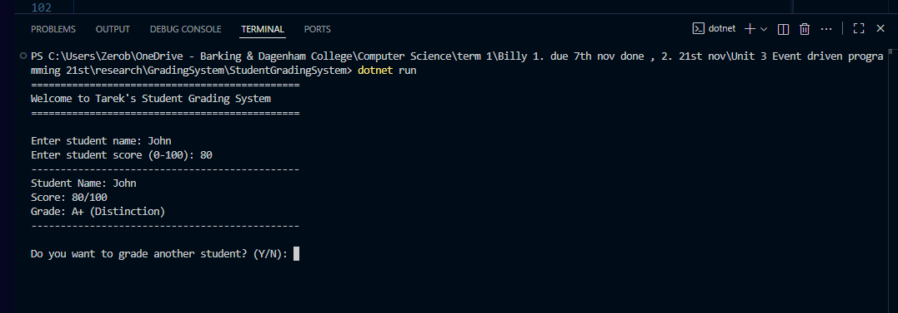
BT2 | Grade Boundary: B Maximum | Name: "Jane", Score: 79 | else if (score >= 70) return "B"  Purpose: Below A+ boundary | PASS  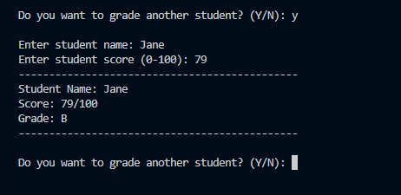
BT3 | Grade Boundary: B Minimum | Name: "Mark", Score: 70 | else if (score >= 70) return "B"  Purpose: B minimum boundary | PASS  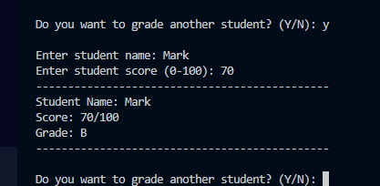
BT4 | Grade Boundary: C Maximum | Name: "Sarah", Score: 69 | else if (score >= 60) return "C"  Purpose: Below B boundary | PASS  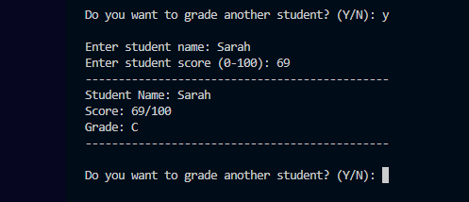
BT5 | Grade Boundary: C Minimum | Name: "Tom", Score: 60 | else if (score >= 60) return "C"  Purpose: C minimum boundary | PASS  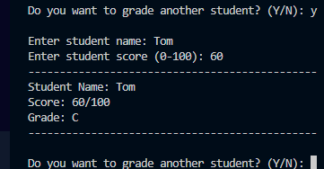
BT6 | Grade Boundary: D Maximum | Name: "Lisa", Score: 59 | else if (score >= 50) return "D"  Purpose: Below C boundary | PASS  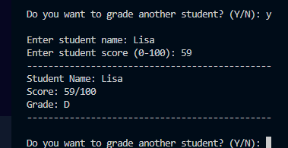
BT7 | Grade Boundary: U Threshold | Name: "Chris", Score: 39 | else return "U (Unclassified)"  Purpose: Below E/U threshold | PASS  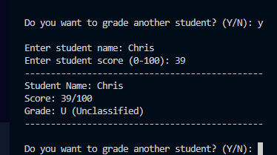
VT1 | Valid High Score | Name: "Alice", Score: 95 | DetermineGrade(95) → if (score >= 80)  Purpose: Test high valid score | PASS  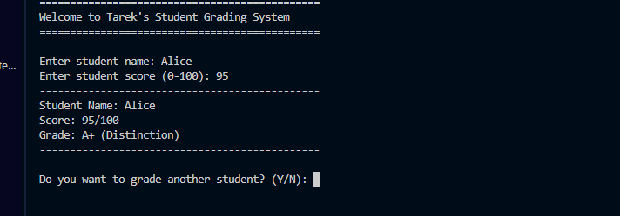
VT2 | Valid Mid-Range Score | Name: "Bob", Score: 75 | DetermineGrade(75) → else if (score >= 70)  Purpose: Test mid-range valid | PASS  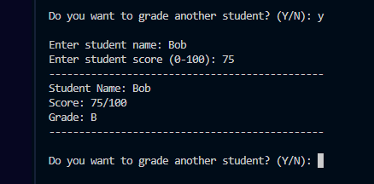
VT3 | Valid Low-Mid Score | Name: "Carol", Score: 55 | DetermineGrade(55) → else if (score >= 50)  Purpose: Test low-mid valid | PASS  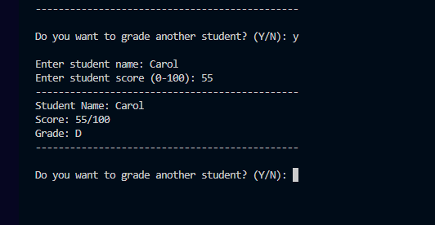
VT4 | Valid Minimum Score | Name: "Diana", Score: 0 | DetermineGrade(0) → else clause  Purpose: Test minimum valid | PASS  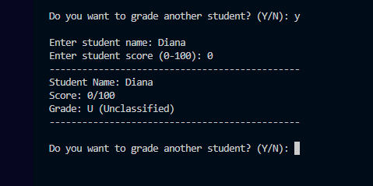
VT5 | Multiple Students | Enter 3 students sequentially | Main while (continueProgram) loop with ITERATION  Purpose: Test loop functionality | PASS  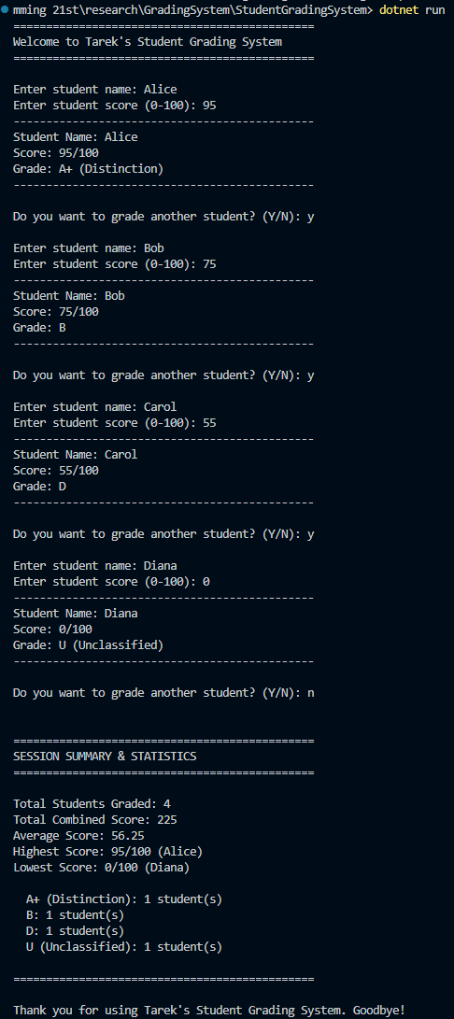
IT1 | Negative Score | Name: "Eve", Score: -5 | if (score >= 0 && score <= 100) SELECTION  Purpose: Range validation - reject negative | PASS  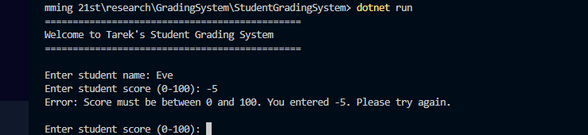
IT2 | Score Over 100 | Name: "Frank", Score: 101 | if (score >= 0 && score <= 100) SELECTION  Purpose: Range validation - reject over 100 | PASS  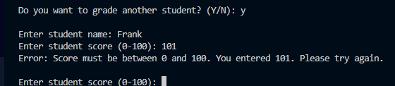
IT3 | Non-Numeric Score | Name: "Grace", Score: "ABC" | int.TryParse(scoreInput, out int score)  Purpose: Type checking - handle non-numeric | PASS  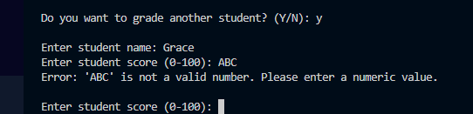
IT4 | Empty Student Name | Name: (blank), Score: 85 | if (string.IsNullOrWhiteSpace(studentName))  Purpose: String validation - reject empty | PASS  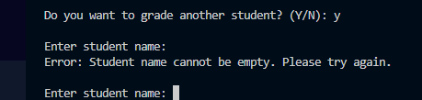
IT5 | Invalid Continue Input | (After entry), Continue: "Maybe" | if (response == "Y")...else if (response == "N")  Purpose: Input verification - accept only Y/N | PASS  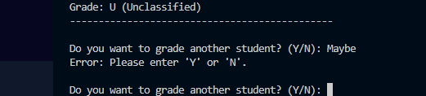

PART 6: References
- C# & .NET Programming
- Microsoft (2025) C# Documentation - Official Language Reference. Available at: https://learn.microsoft.com/en-us/dotnet/csharp/ (Accessed: 11 November 2025).
- Microsoft (2025) .NET 7+ Framework Documentation. Available at: https://learn.microsoft.com/en-us/dotnet/ (Accessed: 11 November 2025).
- Bass, L., Clements, P. and Kazman, R. (2012) Software Architecture in Practice. 3rd edn. Boston: Addison-Wesley.
- Deitel, P.J. and Deitel, H.M. (2017) C# 7 for Programmers. 3rd edn. Boston: Pearson.
Event-Driven Programming
- Gamma, G., Helm, R., Johnson, R. and Vlissides, J. (1994) Design Patterns: Elements of Reusable Object-Oriented Software. Boston: Addison-Wesley.
- Martin, R.C. (2008) Clean Code: A Handbook of Agile Software Craftsmanship. Boston: Prentice Hall.
- Booch, G., Rumbaugh, J. and Jacobson, I. (2005) The Unified Modeling Language User Guide. 2nd edn. Boston: Addison-Wesley.
- Input Validation & Error Handling
- Duncan, B. (2008) Secure Coding in C# and .NET. Apress.
- Howard, M. and LeBlanc, D. (2016) Writing Secure Code. 2nd edn. Redmond, WA: Microsoft Press.
- Microsoft (2025) Integer.TryParse Method - Safe Type Conversion. Available at: https://learn.microsoft.com/en-us/dotnet/api/system.int32.tryparse (Accessed: 11 November 2025).
- Testing & Quality Assurance
- Myers, G.J., Sandler, C. and Badgett, T. (2011) The Art of Software Testing. 3rd edn. Hoboken, NJ: John Wiley & Sons.
- Copeland, L. (2004) A Practitioner's Guide to Software Test Design. Boston: Artech House.
- Beizer, B. (1990) Software Testing Techniques. 2nd edn. New York: Van Nostrand Reinhold.
- Data Structures & Algorithms
- Cormen, T.H., Leiserson, C.E., Rivest, R.L. and Stein, C. (2009) Introduction to Algorithms. 3rd edn. Cambridge, MA: MIT Press.
- Sedgewick, R. and Wayne, K. (2011) Algorithms. 4th edn. Boston: Addison-Wesley.
Development Tools
- OpenVSCode Server (2024) VS Codium - Open Source Build of VS Code. Available at: https://vscodium.com (Accessed: 11 November 2025).
- Microsoft (2025) .NET Command Line Interface (dotnet CLI). Available at: https://learn.microsoft.com/en-us/dotnet/core/tools/ (Accessed: 11 November 2025).
- https://www.programiz.com/csharp-programming/online-compiler/ (Accessed: 11 November 2025).
Educational Assessment
- Wiggins, G. and McTighe, J. (2005) Understanding by Design. 2nd edn. Alexandria, VA: ASCD.
- Anderson, L.W. (ed.) (2001) A Taxonomy for Learning, Teaching, and Assessing. New York: Longman.
- Online Resources
- Stack Overflow (2025) C# Community Q&A. Available at: https://stackoverflow.com/questions/tagged/c%23 (Accessed: 11 November 2025).
- GitHub (2025) .NET Sample Projects. Available at: https://github.com/dotnet/samples (Accessed: 11 November 2025).

