Access To HE Diploma – Trigonometry Answer Sheet
TRIGONOMETRY TASK TEMPLATES – Task 5
Student Name | Tarek Ahmed Umar
Student Number | 20545242
Unit Title | Trigonometry
Unit Code | WNI488
Assignment Title | Trigonometry
Submission Date | 13th February 2026

NB. Please use this answer sheet to submit your work for the Trigonometry assignment – task 5. You can write your solutions to task 5 questions here or copy and paste the photographic evidence of your task 5 solutions here, thanks.
Learning Outcome 5: Be able to solve equations | Assessment Criteria  5.1
Task 5: Solve Trigonometry Equations

- Solve equations like $sin⁡(ax+b)=c$to determine angles for ramps, slopes or object trajectories within given intervals.
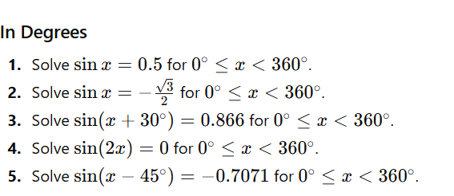
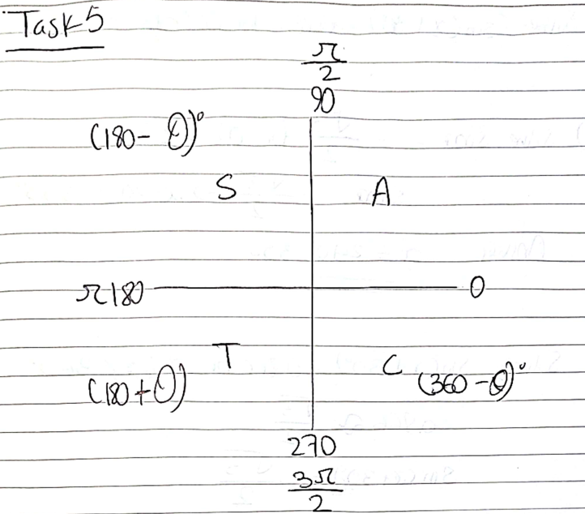

1.
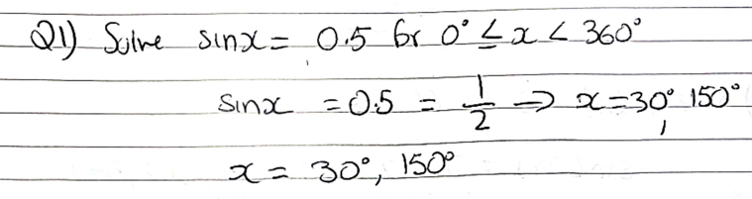
2.
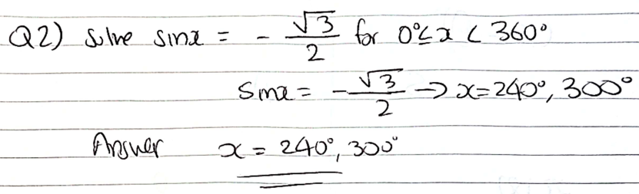
3.
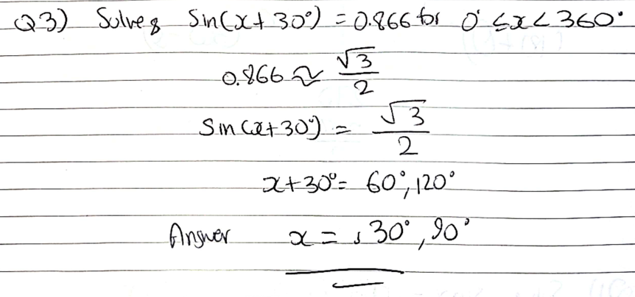
4.
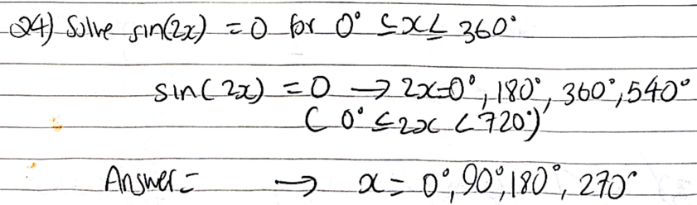

5.
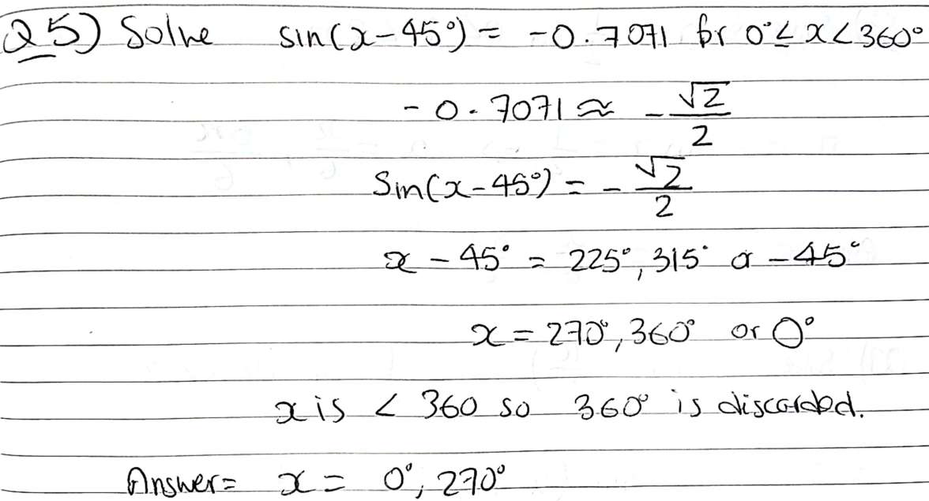

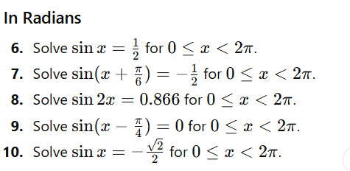
6.
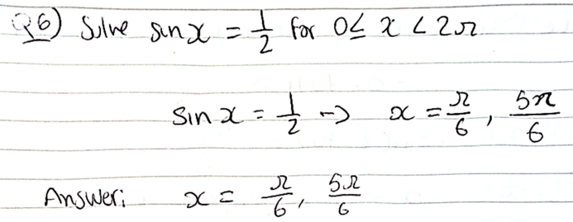
7.
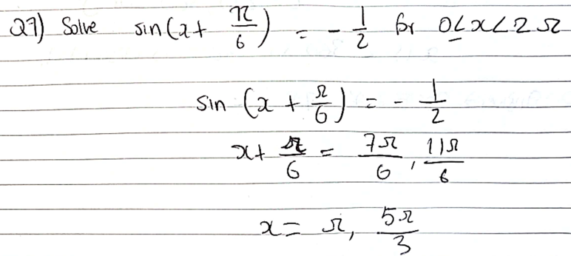

8.
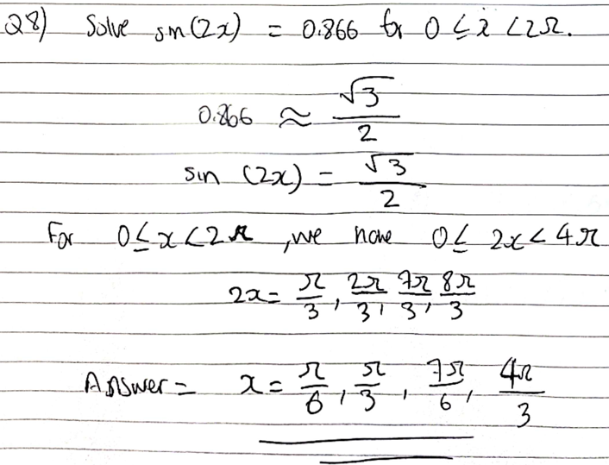
9.
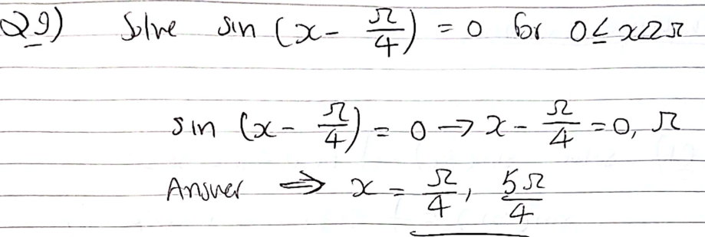

10.
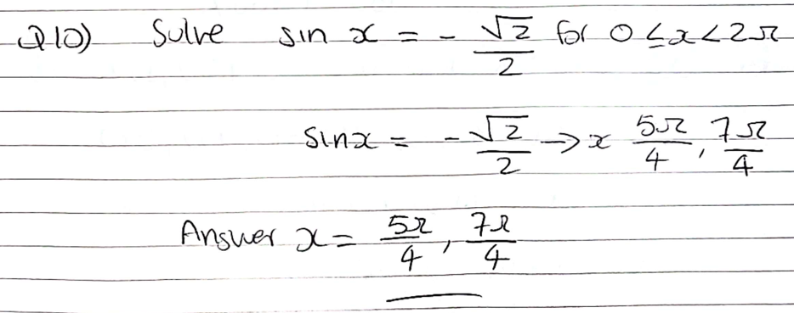

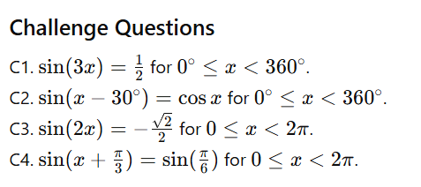

C1.
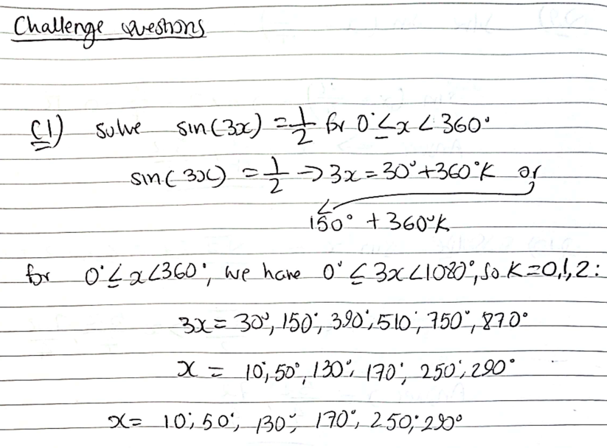

C2.
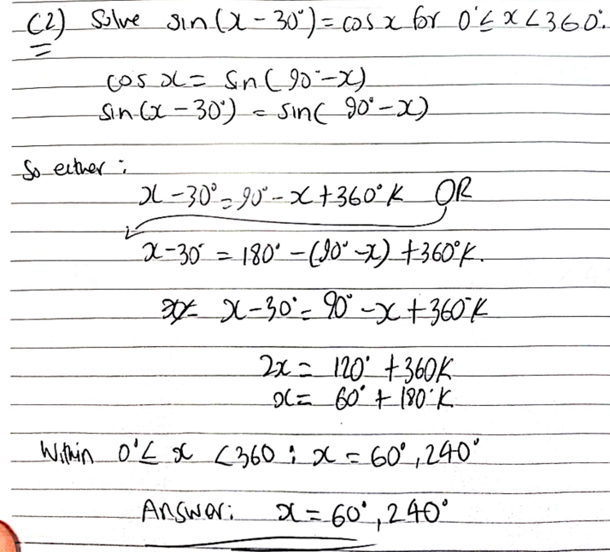

C3.
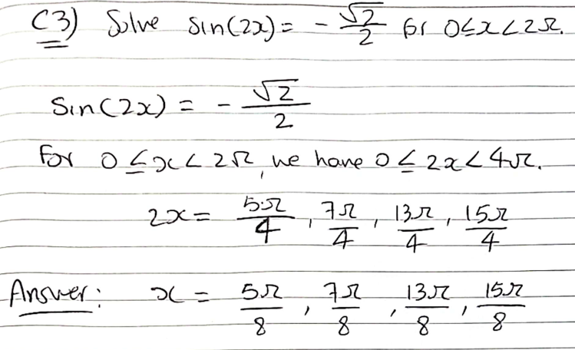

C4.
