Big Data Assignment

Part 1: Understanding Big Data Concepts

Student Name: | Tarek Ahmed Umar
Unit Title: | Big Data
Unit Code: | WNI495
Assessment Criteria: | 1.1, 1.2, 1.3, 1.4
Due Date: | 27/02/2026

Table of Contents
Part 1: Understanding Big Data Concepts 1
Learning Outcome 1: Understanding Big Data Concepts 2
1.1 Defining Big Data 2
1.2 The 5 Vs Framework: Collection Challenges 2
1.3 Distinguishing Big Data, Data Mining and Data Analytics 3
1.4 The Fifth V: Value 4
Conclusion 4
References 5

Learning Outcome 1: Understanding Big Data Concepts

1.1 Defining Big Data
Big Data refers to data that is too large, complex, and created too quickly to be handled adequately using traditional processing approaches (IBM, 2024). The “3 Vs” concept of Big Data, such as : Volume, Velocity, and Variety, was first introduced by Doug Laney, a Gartner analyst, in 2001 (Laney, 2001). Data sources include IoT devices, social media, and financial transactions, among others (European Commission, 2025). Data volume worldwide is expected to reach 463 zettabytes in 2025, up from 181 zettabytes in 2024 (PowerDrill, 2026 ). Big Data helps organisations identify trends, thereby aiding strategic decision-making processes (Syracuse University, 2025).

1.2 The 5 Vs Framework: Collection Challenges
Volume refers to huge volumes of data, with businesses processing twice as many petabytes in 2024 as in 2020, hence the need to use distributed storage tools like Hadoop (PowerDrill, 2026). The rate at which Big Data is being generated is known as velocity, with Google receiving 63,000 requests every second, hence the need to use stream processing tools like Apache Kafka (ServerMania, 2024). Variety includes semi-structured data like JSON/XML, structured data like relational databases, and unstructured data like pictures and videos, with 80-90% of Big Data being unstructured (ServerMania, 2024). The issue of quality is addressed by veracity, with missing, duplicate, or inconsistent data affecting accuracy, hence impacting fraud detection, medical diagnostics, among other areas, hence the need to implement processes to validate data quality (Presentation, 2026 ).
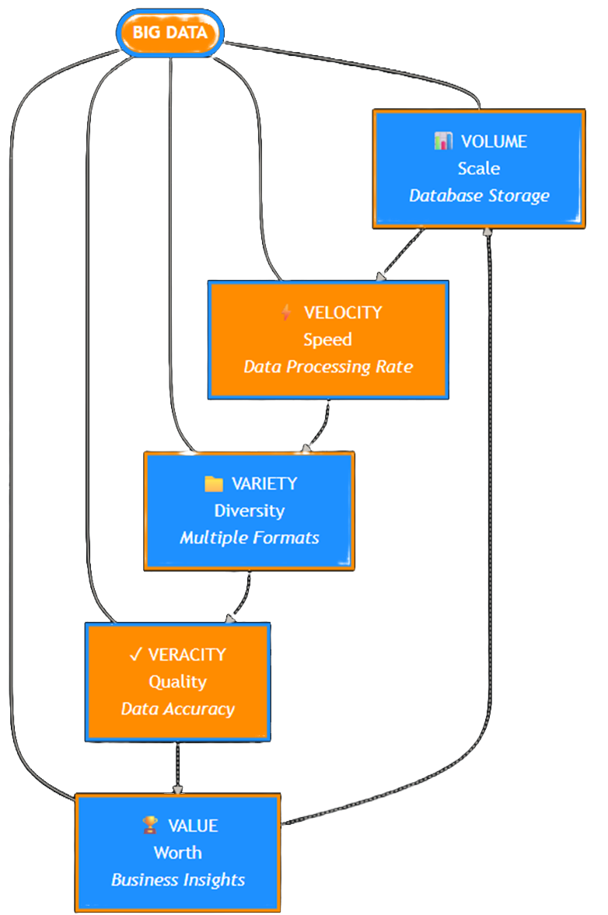
Figure 1 The 5 Vs of Big Data Framework

1.3 Distinguishing Big Data, Data Mining and Data Analytics
Big Data refers to huge infrastructure and databases (Whizlabs , 2021). Data mining involves using algorithms to discover patterns, according to Syracuse University (2025). Data analytics involves analyzing data to arrive at answers to specific business-related questions, as defined by Ethans (2024).
Aspect | Big Data | Data Mining | Data Analytics
Purpose | Store datasets | Discover patterns | Answer questions
Approach | Infrastructure | Algorithm-driven | Goal-oriented
Example | IoT storage | Fraud detection | Sales forecasting
Tools | Hadoop, Spark | Clustering, ML | Tableau, Power BI.

Table 1: Comparison of Big Data, Data Mining and Data Analytics
These three concepts are interrelated, with Big Data being the raw material, data mining being the patterns, and data analytics being the business insights, as defined by Syracuse University (2025).

1.4 The Fifth V: Value
Value: Business benefits provided by Big Data are referred to as value. No use is seen in acquiring data if it is not being used to create value (Presentation, 2026). An example of value generation is that of Netflix, which makes $1 billion annually from customer retention using their recommendation engine, which powers 80% of the content viewed (Systems Plus, 2022). Others include retailers who optimize their supply networks, healthcare organizations that use predictive diagnostics for value extraction, among many examples. Value realization also involves strategies, tools, and data scientists who can ask the right questions. It is not possible for organizations to create reliable value if they lack Volume, Velocity, Variety, and Veracity. Successful strategies involve using value extraction before data collection as a way of transforming information into competitive advantage.

Conclusion
Big Data needs more specialized infrastructure compared to conventional data management approaches. Big Data aspects and challenges are described using the 5 Vs model. Data mining is used for pattern recognition, data analytics for knowledge production, while big data provides the infrastructure. Successful organizations focus on acquiring valuable data rather than mere statistics.

References
Ethans (2024) 'Data analysis vs. data mining vs. data science vs. machine learning vs. big data', Ethans.co.in, 11 August. Available at: https://ethans.co.in/blogs/data-analysis-vs-data-mining-vs-data-science-vs-machine-learning-vs-big-data/ (Accessed: 10 February 2026).
European Commission (2025) 'Big data', Shaping Europe's Digital Future, 8 October. Available at: https://digital-strategy.ec.europa.eu/en/policies/big-data (Accessed: 10 February 2026).
GeeksforGeeks (2024) '6V's of big data', GeeksforGeeks, 9 January. Available at: https://www.geeksforgeeks.org/data-science/5-vs-of-big-data/ (Accessed: 10 February 2026).
IBM (2024) 'What is big data?', IBM Think Topics, 17 November. Available at: https://www.ibm.com/think/topics/big-data (Accessed: 10 February 2026).
Laney, D. (2001) '3-D data management: Controlling data volume, velocity and variety', META Group Research Note, 6 February.
Plutus Education (2025) '5 Vs of big data: Meaning, examples, applications & importance', PlutusEducation.com, 28 March. Available at: https://plutuseducation.com/blog/5-vs-of-big-data/ (Accessed: 10 February 2026).
PowerDrill (2026) 'What is big data? A comprehensive guide in 2025', PowerDrill.ai Blog, 14 January. Available at: https://powerdrill.ai/blog/what-is-big-data-a-comprehensive-guide (Accessed: 10 February 2026).
Presentation: Big Data Veracity and Value (2026) 'Exploring data dimensions: Big data veracity and value', Class presentation by Marius, Roberto, Tarek, Farddin and Justas, January 2026.
ServerMania (2024) 'The 5 V's of big data: Velocity, volume, value, variety, and veracity', ServerMania Knowledge Base, 16 July. Available at: https://www.servermania.com/kb/articles/vs-of-big-data (Accessed: 10 February 2026).
SMOWL (2025) 'The 5 Vs in big data: What they are and how to apply them', SMOWL Blog, 21 October. Available at: https://smowl.net/en/blog/big-data-5v/ (Accessed: 10 February 2026).
Syracuse University (2025) 'Data mining vs. data analytics: Key differences explained', iSchool Syracuse, 27 October. Available at: https://ischool.syracuse.edu/data-mining-vs-data-analytics/ (Accessed: 10 February 2026).
Systems Plus (2022) '8 case studies and real world examples of how Big Data has helped keep on top of competition', Systems Plus, 15 February. Available at: https://systems-plus.com/8-case-studies-and-real-world-examples-of-how-big-data-has-helped-keep-on-top-of-competition/ (Accessed: 10 February 2026).
Whizlabs (2021) 'Data mining vs big data - Find out the best differences', Whizlabs Blog, 17 November. Available at: https://www.whizlabs.com/blog/data-mining-vs-big-data/ (Accessed: 10 February 2026).

