Big Data Assignment

Part 2: Processing Big Data

Student Name: | Tarek Ahmed Umar
Unit Title: | Big Data
Unit Code: | WNI495
Assessment Criteria: | 2.1, 2.2
Due Date: | 27/02/2026

Table of Contents
Part 2: Processing Big Data 1
Learning Outcome 2: Understanding the Impacts of Processing Big Data 2
2.1 Processing Time and Security Impacts on Big Data 2
Processing Time Impacts 2
Security Impacts 2
2.2 Hardware and Software Requirements Analysis 2
Data Collection and Integration 2
Hardware Requirements 2
Infrastructure Deployment 3
Processing Frameworks 4
Visualization Tools 4
Conclusion 5
References 7

Learning Outcome 2: Understanding the Impacts of Processing Big Data

2.1 Processing Time and Security Impacts on Big Data

Processing Time Impacts
In time-sensitive applications, processing time has a significant impact on Big Data efficacy. Traditional datasets without distributed computing require 10-100× times as long as petabyte-scale queries (AtScale, 2025). Since 5 ms delays result in millions of missed chances, financial trading demands sub-millisecond latency (Templeton Recruitment, 2024). Systems that detect fraud must examine transactions in 100–300 milliseconds. Businesses employ edge computing, stream processing (Apache Flink, Storm), and in-memory systems like Spark, which provide 100× quicker processing by caching data in RAM (AtScale, 2025).

Security Impacts
Security adds quantifiable costs. According to Venn (2025), AES-256 encryption increases computational costs by 15–30%, whereas homomorphic encryption results in 10,000× penalties (GoldComet, 2025). RBAC increases query latency by 50–100 ms (Venn, 2025). Media sites use less encryption to maximise speed, whereas financial institutions prioritise security despite costs. The best balance is achieved by hybrid techniques that only encrypt sensitive information..

2.2 Hardware and Software Requirements Analysis

Data Collection and Integration
Big data is gathered by batch ingestion (Sqoop, Flume for planned transfers) or streaming (Apache Kafka for real-time events). By combining structured and unstructured sources into data lakes, ETL pipelines resolve schema conflicts and quality concerns; data preparation accounts for 30–40% of project work (Acceldata, 2024). ELT methods import raw data initially, then transform it as needed.

Hardware Requirements
Parallel processing is optimised by specialised hardware: GPUs with 900 GB/s bandwidth speed up machine learning training; 24-64 core CPUs manage many threads for MapReduce tasks (Varidata, 2025); 25-100 Gbps networks avoid transfer bottlenecks; NVMe SSDs (7 GB/s) store hot data while HDDs archive cold data; and 1TB+ RAM allows Spark in-memory caching, which delivers 100× speedups (NovoServe, 2025).
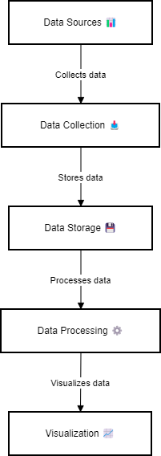
Figure 1 Big Data Processing Pipeline: showing the five core stages from data sources through visualization

Infrastructure Deployment
Criterion | Cloud | On-Premise
Cost | OpEx, pay-as-you-go | CapEx, high upfront
Scalability | Elastic, petabyte-scale | Hardware-limited
Performance | Variable latency | Low latency
Control | Shared responsibility | Full control
Maintenance | Provider-managed | Self-managed

Table 1: Cloud vs On-Premise (Teradata, 2022; Hypersense, 2025)
Analysis: Cloud is good for varying workloads, but it costs three to five times as much over time (Teradata, 2022). Consistent processing with data sovereignty requirements is a benefit of on-premise. Both are optimised using hybrid models. Take into account TCO with egress fees ($0.12/GB).

Processing Frameworks
Feature | Hadoop | Spark
Speed | Disk-based, slower | In-memory, 100× faster
Use Cases | Batch ETL, archival | Real-time, ML
Fault Tolerance | HDFS replication | RDD lineage
Ease | MapReduce (Java) | Python, R APIs

Table 2: Hadoop vs Spark (Acceldata, 2024; TechTarget, 2025)
Analysis: With sub-second latency, Spark outperforms Hadoop in real-time fraud detection, although it requires 5–10 times more RAM (TechTarget, 2025). Hadoop is ideal for batch processing that is economical. Both are used by organisations: Spark for interactive searches and Hadoop for archive.

Visualization Tools
Aspect | Tableau | Power BI
Audience | Advanced analysts | Business users
Performance | Billions of rows | <10M rows optimized
Pricing | $70/user/month | $10/user/month
Integration | AWS, GCP, Hadoop | Azure, Office 365

Table 3: Tableau vs Power BI (Tableau, 2025; TechnologyAdvice, 2025)
Analysis: Tableau effectively manages datasets with billions of rows (Johnson Matthey: 3,000 users). Power BI works well with Microsoft stacks and is less expensive, although it has trouble with more than 10 million records. Choose according to platform alignment, user skill, and data volume.
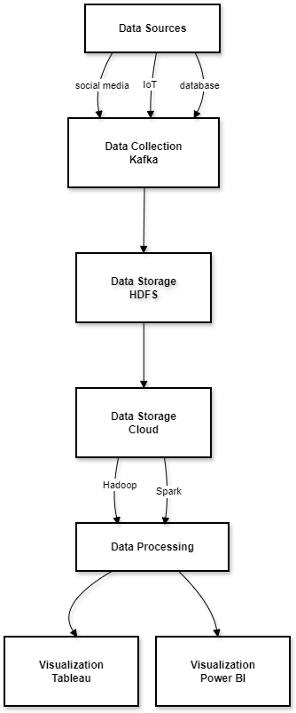
Figure 2 Big Data Technology Stack Architecture: illustrating specific technologies at each processing stage, including Apache Kafka for collection, HDFS and cloud storage, Hadoop/ Spark processing frameworks, and Tableau/Power BI visualization tools

Conclusion
Cost, security, and performance must all be balanced while processing big data. While batch analytics may withstand overnight windows, financial systems require sub-millisecond delay through stream processing. Because of the security overhead (15–30% for AES-256), sensitive data must be applied selectively. Workloads must be supported by hardware, such as multi-core CPUs for parallel processing, GPUs for machine learning, and tiered storage for cost reduction. On-premises processing is consistent, cloud offers elastic scalability but is 3–5 times more expensive over time; hybrid approaches maximise both. Compared to Hadoop's batch processing, Spark offers real-time performance but requires 5–10× more RAM. Organisations should not seek universal answers but rather weigh trade-offs against requirements.

References
Acceldata (2024) 'Choosing between Hadoop vs. Spark: Key differences explained', Acceldata.io, 22 May. Available at: https://www.acceldata.io/blog/hadoop-vs-spark-how-to-choose (Accessed: 16 February 2026).
AtScale (2025) 'Current challenges in big data: Problems & solutions', AtScale Blog, 13 October. Available at: https://www.atscale.com/blog/big-data-challenges-problems-solutions/ (Accessed: 16 February 2026).
GoldComet (2025) 'Data encryption trends for enhanced enterprise security in 2025', GoldComet, 14 January. Available at: https://www.goldcomet.com/post/data-encryption-trends-for-enhanced-enterprise-security-in-2025 (Accessed: 16 February 2026).
Hypersense (2025) 'Cloud vs. on-premise infrastructure: Comparison guide for IT leaders', Hypersense Software, 30 July. Available at: https://hypersense-software.com/blog/2025/07/31/cloud-vs-on-premise-infrastructure-guide/ (Accessed: 16 February 2026).
NovoServe (2025) 'What server configurations are ideal for big data analytics clusters', NovoServe Blog, 3 March. Available at: https://novoserve.com/blog/what-server-configurations-are-ideal-for-big-data-analytics-clusters (Accessed: 16 February 2026).
Tableau (2025) 'Tableau vs. Microsoft Power BI', Tableau.com, 31 January. Available at: https://www.tableau.com/compare/tableau-vs-power-bi (Accessed: 16 February 2026).
TechTarget (2025) 'Hadoop vs. Spark for modern data pipelines', TechTarget, 5 August. Available at: https://www.techtarget.com/searchdatamanagement/feature/Hadoop-vs-Spark-Comparing-the-two-big-data-frameworks (Accessed: 16 February 2026).
TechnologyAdvice (2025) 'Power BI vs Tableau: Data analytics duel', TechnologyAdvice, 18 March. Available at: https://technologyadvice.com/blog/information-technology/power-bi-vs-tableau/ (Accessed: 16 February 2026).
Templeton Recruitment (2024) 'Surprising data trends and challenges for 2024', Templeton Recruitment, 2 January. Available at: https://www.templeton-recruitment.com/tech-news/surprising-data-trends-and-challenges-for-2023 (Accessed: 16 February 2026).
Teradata (2022) 'Cloud use cases: On-premises vs. cloud', Teradata Insights, 24 March. Available at: https://www.teradata.com/insights/data-architecture/on-premises-vs-cloud (Accessed: 16 February 2026).
Varidata (2025) 'Core server requirements for AI industry big data processing', Varidata, 20 October. Available at: https://www.varidata.com/knowledge-en/core-server-requirements-for-ai-industry-big-data-processing/ (Accessed: 16 February 2026).
Venn (2025) 'Data encryption in 2025: Algorithms, use cases & challenges', Venn, 16 October. Available at: https://www.venn.com/learn/data-security/data-encryption/ (Accessed: 16 February 2026).

