Big Data Assignment

Part 3: Big Data Applications and Compliance

Student Name: | Tarek Ahmed Umar
Unit Title: | Big Data
Unit Code: | WNI495
Assessment Criteria: | 3.1, 3.2

Table of Contents
Part 3: Big Data Applications and Compliance 1
Learning Outcome 3: Understanding the Uses and Compliance of Big Data 2
3.1 Real-World Applications of Big Data: Case Study Analysis 2
Case Study 1: Netflix – Personalised Content Recommendations 2
Case Study 2: Johnson Matthey – Inventory Management with Tableau 3
Case Study 3: Walmart – Supply Chain and Customer Experience 3
Comparative Analysis 3
3.2 UK Legislation Governing Big Data: GDPR and Data Protection Act 2018 3
UK General Data Protection Regulation (UK GDPR) 4
Data Protection Act 2018 5
Enforcement and Penalties 6
Conclusion 7
References 7

Learning Outcome 3: Understanding the Uses and Compliance of Big Data

3.1 Real-World Applications of Big Data: Case Study Analysis
Big Data helps organisations turn information into business advantages. In this section, three case studies from the entertainment, manufacturing, and retail industries will be discussed to show the business value of Big Data.

Case Study 1: Netflix – Personalised Content Recommendation
Big Data is used by Netflix, which has more than 148 million users, to better analyse viewer behaviour and provide personalised experiences (Systems Plus, 2022 ). Netflix gathers a variety of information from its users, like as the videos they have viewed, the search terms they have used, the times of day, the devices they are using, and the points at which they pause and rewind videos ( TechVidvan, 2026).
Implementation: Machine learning algorithms process these data points to create detailed viewer profiles and make recommendations on the home page. In fact, about 80% of viewing is driven by these algorithm-driven recommendations rather than users actively searching for videos ( Systems Plus, 2022).
Business impact : Netflix believes that its recommendation engine generates about $1 billion in revenue from reduced churn and better customer retention (Systems Plus, 2022 ). Recommendation systems also allow Netflix to target new shows to specific audiences, saving on advertising spend and differentiating it from competitors.

Case Study 2: Johnson Matthey – Inventory Management with Tableau
Johnson Matthey is a 200-year-old manufacturer and global leader in sustainable technologies. It has multiple manufacturing plants across Europe and the USA, but it faced a problem of disparate legacy systems, which could not provide a single, trusted view of inventory (Tableau, 2022)
Solution: Johnson Matthey chose Tableau as its enterprise analytics platform, integrating data from its production, logistics, and finance systems. It now has 3,000 users, growing from 50 initial users, with 1,200 employees logging into Tableau every month (Tableau , 2022) . It is now able to show inventory levels, losses, raw material age, and finished goods across all its sites in near real -time.
Business impact: Managers can now quickly identify inventory levels, losses, and raw material age, and make purchasing decisions accordingly, which will not only save the company money but will also contribute to its sustainability goals by avoiding unnecessary production and storage ( Tableau, 2022). The intuitive nature of Tableau will enable the company to quickly train its users, who will be able to make data-driven decisions on the factory floor.

Case Study 3: Walmart – Supply Chain and Customer Experience
Walmart, the largest retailer globally, is leveraging Big Data to analyse data from its distribution centres, stores, and pharmacies in real-time (TechVidvan, 2026). For instance, data from its point-of-sale systems, loyalty cards, and online activities are fed into its central analytics systems.
Applications: Big Data analytics tools are used to analyse data and provide insights that can be used to optimize routes and schedules of its delivery systems, set prices based on demand and competitor activity, and personalize promotions based on customers’ purchase history. Big Data is also used to improve checkout speeds by analysing busy times and adjusting staffing accordingly (TechVidvan, 2026 ).
Business impact: Big Data has improved Walmart’s business in terms of reduced costs, better stocking of products that are locally relevant, and improved customer experience. In a low-margin business such as retail, these are crucial factors that provide competitive advantage.

Comparative Analysis
Organization | Industry | Big Data Application | Key Outcome
Netflix | Entertainment | Personalised recommendations | Higher retention, lower marketing cost
Johnson Matthey | Manufacturing | Inventory analytics | Reduced waste, better stock control
Walmart | Retail | Supply chain & CX optimisation | Lower logistics cost, improved experience

Table 1: Summary of Big Data case studies ( Sources: Systems Plus, 2022; Tableau, 2022; TechVidvan, 2026)

Overall, Big Data has provided value to all these organizations based on its ability to integrate large volumes of data, analyse it, and provide insights that can be used by business organizations. Netflix is leveraging Big Data to improve customer retention, Johnson Matthey is leveraging Big Data to improve its business operations, while Walmart is leveraging Big Data to improve its supply chain and pricing strategies.

3.2 UK Legislation Governing Big Data: GDPR and Data Protection Act 2018
Big Data projects in the UK must comply with UK GDPR and the Data Protection Act 2018, which together define how organisations collect, store and analyse personal data. These frameworks apply even when processing occurs in large, distributed data lakes or cloud platforms.

UK General Data Protection Regulation (UK GDPR)
UK GDPR sets out the fundamental rules for the processing of personal data in the UK. The post-Brexit changes, introduced through the Data (Use and Access) Act 2025 , maintain most of the EU GDPR provisions but also enable the UK government to adapt certain requirements (GOV.UK, 2025; Connaught Law, 2025).
Seven core principles: UKGDPR sets out seven principles, and organisations are obliged to adhere to these principles. The principles of lawfulness, fairness, and transparency require organisations to ensure a lawful basis and privacy statements. The principles of purpose limitation and data minimization restrict the accumulation of Big Data sets to only what is necessary and for a specific purpose. The principles of accuracy and storage limitation require organisations to ensure the accuracy of the data and store it for a limited period. The principles of integrity, confidentiality, and accountability require organisations to ensure the security of the data and produce evidence of compliance.
Implications for Big Data: The UKGDPR principles will require organisations using Big Data analytics systems to implement certain requirements, such as a centralised system of consent management, privacy-by-design approaches to data management, and effective anonymization or pseudonymization of the data sets (GDPR Local, 2026). The UKGDPR provisions of the Data (Use and Access) Act 2025 enable more automation of decision-making processes, but a level of human intervention is necessary when the decision impacts the individual (Privacy World , 2025 ).
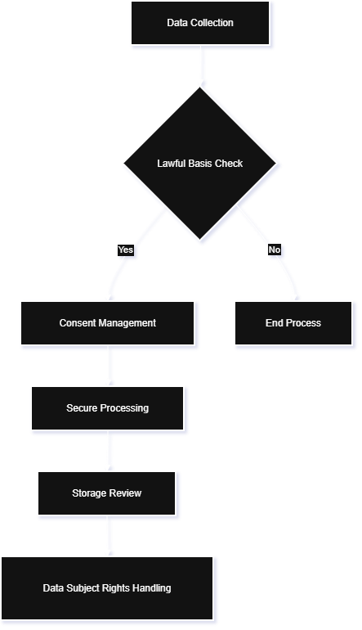
Figure 1 UK GDPR compliance process for Big Data operations

Data Protection Act 2018
The Data Protection Act 2018 (DPA 2018 ) is an additional law to UK GDPR and provides specific UK legislation and data protection provisions, including law enforcement and national security. This law applies to data protection in the UK. (Legislation.gov.uk, 2026 ).
Key provisions: DPA 2018 provides definitions for special categories of data, which include data about health, biometric data, and ethnic data. These require explicit consent or strong legal justification to process. There is also a need to provide privacy information to data subjects about data collection, lawful bases, storage periods, and data transfer outside the UK, as well as information about data subject rights.

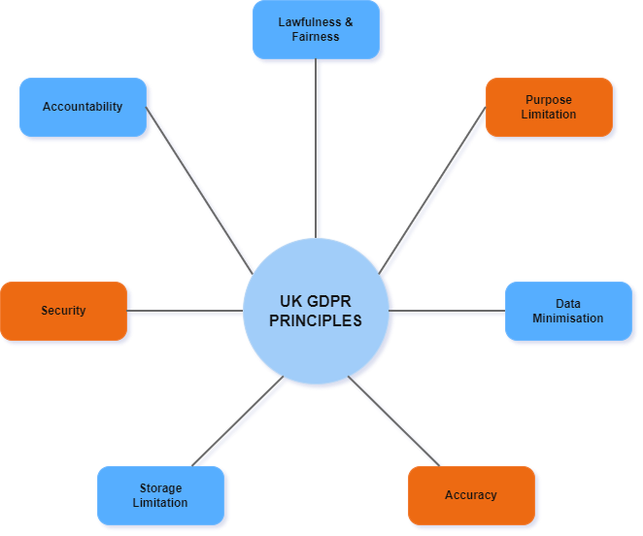
Figure 2 Seven core principles of UK data protection

Enforcement and Penalties

Enforcement and Penalties
The Information Commissioner’s Office (ICO) enforces UK GDPR and DPA 2018. It can issue fines of up to £17.5 million or 4% of global annual turnover, whichever is higher (DPO Consulting, 2025). Recent cases include a £14 million penalty against Capita for inadequate security controls and a £3.07 million fine against Advanced Computer Software Group after a ransomware incident affecting NHS 111 services (Connaught Law, 2025 ). In 2024 alone, ICO fines totalled around £65 million, underlining the financial risk of poor governance in Big Data environments.

Conclusion

The above case studies have highlighted the way different organisations within different industries have sought to leverage the capabilities of Big Data to improve their competitive advantage, be it retaining customers, managing inventory, or improving supply chains. However , it is important to note that UK GDPR and the Data Protection Act 2018 have emphasized the need for organizations to ensure that, when leveraging the capabilities of Big Data, they have appropriate privacy and security controls in place.

References
Connaught Law (2025) 'UK data protection 2025: GDPR compliance guide', Connaught Law, 6 December. Available at: https://connaughtlaw.com/uk-data-protection-gdpr-compliance-guide/ (Accessed: 10 February 2026).
DPO Consulting (2025) 'UK Data Protection Act 2018 explained: Scope, principles and compliance', DPO Consulting, 30 September. Available at: https://www.dpo-consulting.com/blog/uk-data-protection-act-explained (Accessed: 10 February 2026).
GDPR Local (2026) 'Responsible big data practices: Guidance for GDPR compliance', GDPR Local, 12 January. Available at: https://gdprlocal.com/gdpr-for-big-data/ (Accessed: 10 February 2026).
GOV.UK (2025) 'Data (Use and Access) Act 2025: Data protection and privacy changes', GOV.UK, 26 June. Available at: https://www.gov.uk/guidance/data-use-and-access-act-2025-data-protection-and-privacy-changes (Accessed: 10 February 2026).
GOV.UK (2025) 'The UK's data protection legislation', GOV.UK, 21 January. Available at: https://www.gov.uk/data-protection (Accessed: 10 February 2026).
Legislation.gov.uk (2026) 'Data Protection Act 2018', Legislation.gov.uk, 5 February. Available at: https://www.legislation.gov.uk/ukpga/2018/12/contents (Accessed: 10 February 2026).
Privacy World (2025) 'The Data (Use and Access) Act 2025: A new chapter in the UK's data protection framework', Privacy World Blog, 3 August. Available at: https://www.privacyworld.blog/2025/07/the-data-use-and-access-act-2025-a-new-chapter-in-the-uks-data-protection-framework/ (Accessed: 10 February 2026).
Systems Plus (2022) '8 case studies and real world examples of how Big Data has helped keep on top of competition', Systems Plus, 15 February. Available at: https://systems-plus.com/8-case-studies-and-real-world-examples-of-how-big-data-has-helped-keep-on-top-of-competition/ (Accessed: 10 February 2026).
Tableau (2022) 'Johnson Matthey uses Tableau to optimise inventory management', Tableau Blog, 26 October. Available at: https://www.tableau.com/en-gb/blog/johnson-matthey-uses-tableau-optimise-inventory-management (Accessed: 10 February 2026).
TechVidvan (2026) 'Top 10 big data case studies that you should know', TechVidvan Tutorials. Available at: https://techvidvan.com/tutorials/top-10-big-data-case-studies/ (Accessed: 10 February 2026).

