Independent Research Assignment

Task 2: Collecting Research Material
Student Name: | Tarek Ahmed Umar
Unit Title: | Independent Research
Unit Code: | WNI860
Assessment Criteria: | 2.1, 2.2, 2.3
Assessor Name: | Muryum Bhayat
Due Date: | 27th February 2026

Table of Contents
Task 2: Collecting Research Material 1
2.1 Gathering data from credible sources 2
2.2 Research scope, parameters and objectives 3
2.3 Methodology and theoretical frameworks 4
References 6

2.1 Gathering data from credible sources
Research will be gathered from four sources to examine “The Impact of Artificial Intelligence on Employment: Job Losses vs. New Opportunities in 2025- 2030”: case studies, industry reports, official government statistics, and scholarly literature. It is crucial to triangulate across all four since news media frequently sensationalise, industry reports may contain commercial bias, and academic sources may not keep up with the rate of change. These dangers are decreased and a more convincing argument is produced when several source types are used in tandem.
Peer- reviewed databases (Google Scholar, Scopus) will be used to find academic literature, with a focus on research on task-level automation, labour market displacement, and skills mismatch that were published between 2022 and 2026. These are especially helpful for methodologically transparent idea definition and causal mechanism establishment.

Current information on AI adoption rates, workforce reorganisation, and emerging role demand will be provided by industry reports, such as the World Economic Forum's Four Futures for Jobs in the New Economy (WEF, 2026), Pwc's AI Jobs Barometer (2025 ), McKinsey Global Institute, and IDC (2025). To take into consideration any possible commercial bias, their statements will be compared to those of other, independent sources.
Nationally representative, quantifiable data on occupational change, vacancy patterns, and pay will be provided by the Office for National Statistics (ONS) and the UK Government's AI Skills for Life and Work: Labour Market and Skills Projections (DSIT, 2026 ). Where appropriate, international comparisons will be made using data from the US Bureau of Labour Statistics.

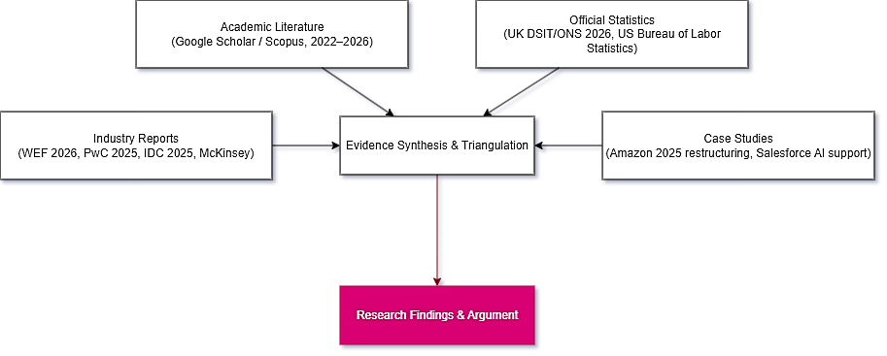
Case studies will demonstrate actual displacement processes and adaption tactics, such as Salesforce's AI-led customer service revolution and Amazon's 2025 staff restructure. These will be handled as instances to explain rather than as proof that can be applied generally. Five uniform criteria - author credibility, methodological transparency, recentness, definitional clarity, and corroboration from at least one independent source - will be used to assess all sources.
Figure 1 Evidence triangulation framework for this research. (Created via draw.io)

2.2 Research scope, parameters and objectives
Well-defined parameters will help maintain the focus of the study and guarantee that sources are consistently assessed using the same framework.
Time frame: 2025 - 2030 - encompassing the time frame from testing to regular corporate use of generative AI, while staying within a range backed by reliable datasets and documented proof. Projections after 2030 will only be mentioned if they are explicitly marked as such.
Geographical boundary: Where there is little evidence particular to the UK, US and EU data are utilised as comparators. The UK is the main emphasis ( consistent with the vocational scenario).
Technology, professional services, customer operations/ support, and administrative professions are among the industry’s most vulnerable to AI- related change because they involve a large percentage of routine, cognitive digital work. Because entry-level task bundles represent a higher risk of automation, early-career worker exposure will also be investigated.
The following working definitions are used consistently across all sources:
- Job displacement, which refers to employment or role reductions associated with AI adoption.
- Job transformation, which refers to major adjustments to tasks or skills within an existing role.
- Job creation, which refers to new roles and specialisations arising from AI development, deployment, or governance.

The four research questions will include:
RQ1: What quantifiable proof of displacement due to AI has been accessible since 2025, and what limitations are there on its attribution?
RQ2: What skills are required for the new positions that are emerging?
RQ3: How does the UK's workforce preparedness and growth rate correlate with AI?
RQ4: Which sectors and demographics are most in danger, and why?
The first objective of a well-rounded argument, the second objective of quantifiable indicators, and the third objective of findings that can be used to generate suggestions are all included in the four research questions.

2.3 Methodology and theoretical frameworks
The mixed- methods approach will be utilized, and only secondary data will be used in this study. Quantitative data analysis will be used to examine the patterns in employment transitions in AI-exposed occupations, salary premiums, new positions, and projected demand. Thematic analysis will be used to examine the reports and case studies qualitatively to identify the recurring themes in the ways in which companies are restructuring, the obstacles they are facing, and the new positions that are emerging.
The study will be informed by three basic principles: objectivity, which will be ensured through the use of multiple sources; transparency, which will be ensured through the clear explanation of the limitations of the data and definitional differences; and criticality, which will be ensured through the consideration of alternative factors that may have led to the trends, such as outsourcing, hiring corrections following the pandemic, and other macroeconomic factors, rather than attributing everything to AI.

The study will be informed by four theoretical frameworks:
1. the task-based model of technological change, as discussed in Acemoglu and Autor (2011 ), to explain the basis for task-level vulnerability and augmentation, moving beyond oversimplified accounts.
2. human capital theory and skills mismatch, to explain the phenomenon of simultaneous job creation and destruction, and the inability of training systems to keep up with the pace of technological and structural changes.
3. the theory of technology adoption and diffusion, to understand the varying rates and degrees of AI adoption in the labour market.
4. scenario thinking, based on the WEF's Four Futures for Jobs in the New Economy report (2026), to address the issue of uncertainty in the projection of the future.

References
Acemoglu, D. and Autor, D. (2011) 'Skills, tasks and technologies: Implications for employment and earnings', in Ashenfelter, O. and Card, D. (eds) Handbook of Labor Economics. Amsterdam: Elsevier, vol. 4, pp. 1043–1171.
Econofact (2025) 'Fact Check: Has AI already caused some job displacement?'. Available at: https://econofact.org/factbrief/fact-check-has-ai-already-caused-some-job-displacement (Accessed: 19 February 2026).
IDC (2025) Closing the Gap: Verifying AI Skills in the Enterprise. IDC Analyst Brief. Available at: https://www.idc.com (Accessed: 19 February 2026).
PwC (2025) AI Jobs Barometer 2025. Available at: https://www.pwc.com/us/en/tech-effect/ai-analytics/ai-predictions.html (Accessed: 19 February 2026).
UK Government — Department for Science, Innovation and Technology (2026) AI Skills for Life and Work: Labour Market and Skills Projections. Available at: https://www.gov.uk/government/publications/ai-skills-for-life-and-work-labour-market-and-skills-projections (Accessed: 19 February 2026).
World Economic Forum (2026) Four Futures for Jobs in the New Economy: AI and Talent in 2030. Available at: https://reports.weforum.org/docs/WEF_Four_Futures_for_Jobs_in_the_New_Economy_AI_and_Talent_in_2030_2025.pdf (Accessed: 19 February 2026).

