Independent Research Assignment

Task 3: Using Data to Substantiate an Argument
Student Name: | Tarek Ahmed Umar
Unit Title: | Independent Research
Unit Code: | WNI860
Assessment Criteria: | 3.1, 3.2, 3.3
Assessor Name: | Muryum Bhayat
Due Date: | 27th February 2026
Table of Contents
Task 3: Using Data to Substantiate an Argument 1
3.1 The central argument 1
3.2 Counterarguments and alternative perspectives 2
3.3 Critical assessment of the data 3
References 4

3.1 The central argument
This study argues that while AI poses a pressing structural transition challenge, it does not pose a net threat to employment in the UK. Even though there is actual and quantifiable displacement, net job creation is the anticipated overall result. Whether or not the labour can reskill quickly enough is the crucial factor, not the technology in se. Hence, systemic failure to train people for the tasks AI is creating poses a greater risk to the UK than technological unemployment.
Compared to its counterparts, the UK is especially exposed to AI. According to the UK Government's DSIT (2026 ), 35 % of UK workers are employed in high-exposure, high-complementarity jobs, which is higher than the norm for the advanced economy ( 26%) and the US (30%). The same analysis predicts that direct AI employment will increase from 158,000 in 2024 to 3.9 million by 2035, or 12 % of the UK workforce, despite this increased exposure. This is further supported by the WEF (2026 ), which projects a net gain of 78 million jobs globally after taking displacement into account. The UK is at the forefront of AI disruption, but if reskilling is given priority, it will also be well-positioned to benefit from growth.
But there is an unequal distribution of transition costs. Even while apprenticeships as a percentage of AI jobs increased from 3% in 2020 to 19% in 2025 (UK Government, 2026), just 13% of graduate programs in the UK presently offer AI training, suggesting unequal and sluggish progress. AI-exposed positions currently attract a 56% wage premium, according to PwC (2025). This indicates that new employment is of higher quality but are only available to people with the necessary skills.
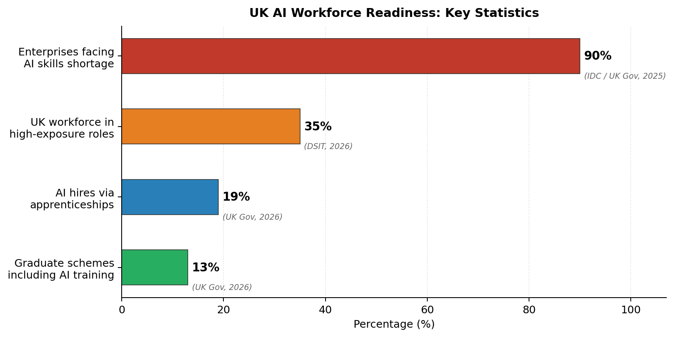
Figure 1: UK AI workforce readiness - key statistics (IDC, 2025; DSIT, 2026; UK Government, 2026).

3.2 Counterarguments and alternative perspectives
In the UK, the techno-pessimistic viewpoint is very persuasive. In the worst-case scenario, up to 8 million UK jobs might be at risk, with back-office, entry-level, and part-time professions being the most vulnerable. According to IPPR (2024 ), which examined 22,000 tasks throughout the UK economy, 11% of businesses are now exposed to generative AI, and that number will rise to 59% if businesses incorporate AI more thoroughly. Research from King's College London in 2025 offers more solid empirical support: High AI exposure UK companies decreased overall employment by an average of 4.5 %, with junior positions declining 5.8 % and job listings for high-exposure roles declining 23.4%. Concerns unique to the UK are further illustrated in Figure 2, which indicates that the occupational categories most exposed to AI are sales, secretarial, and administrative staff, who are most likely to see it as a danger to their jobs.
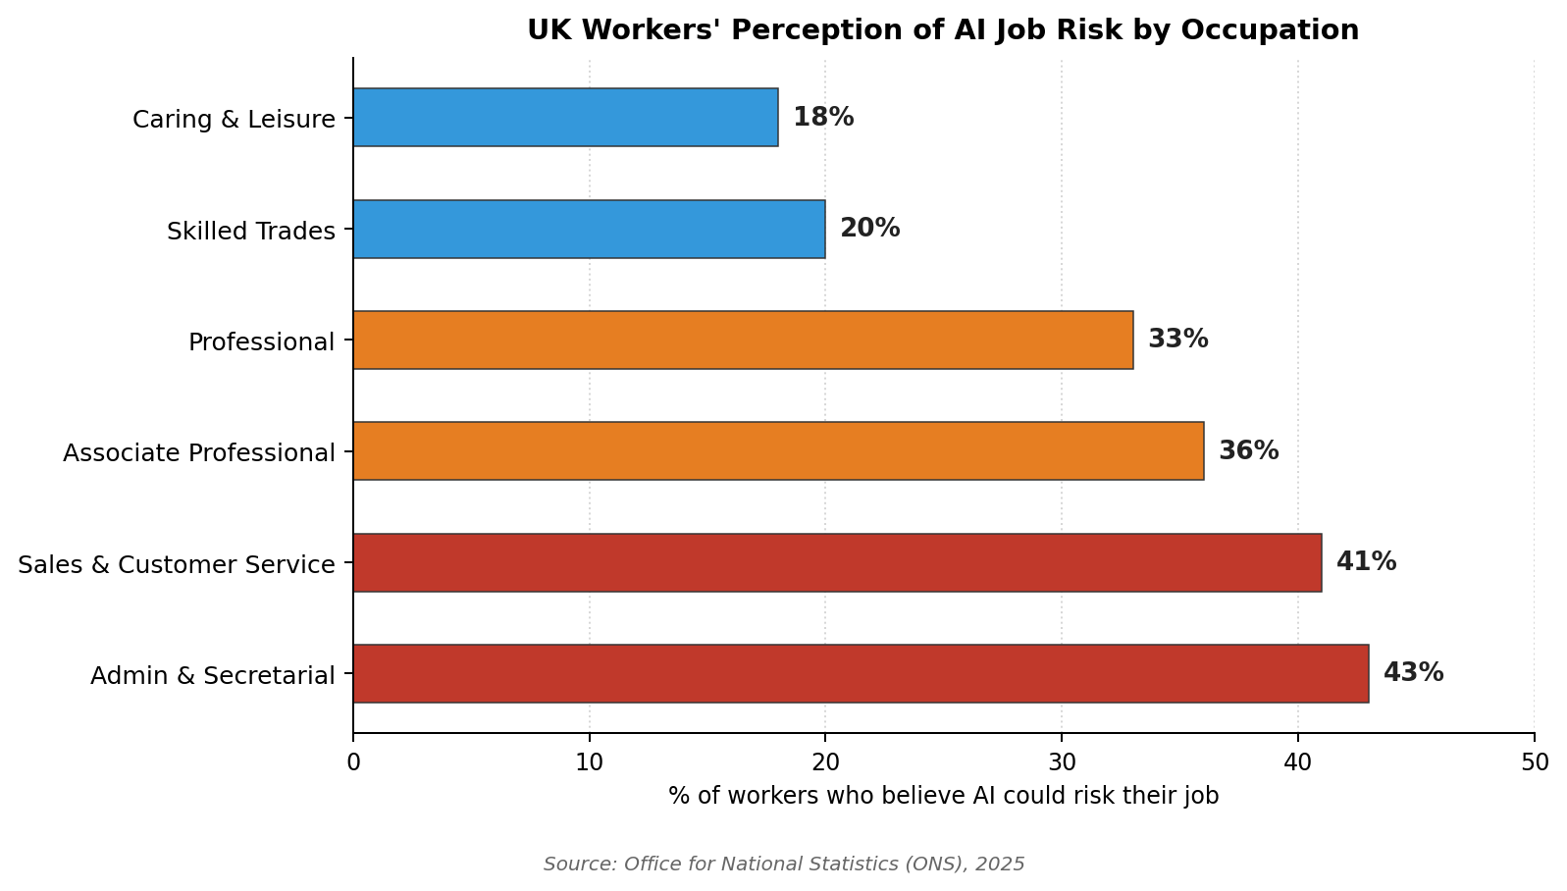
Figure 2: UK workers' perception of AI job risk by occupation (ONS, 2025).
Whether the current displacement is truly due to technology is a more complex matter. Only 14% of businesses have solutions ready for deployment, according to the Harvard Business Review (2026), and 60% of organisations have reduced personnel in anticipation of AI's future capabilities rather than because AI is now doing those functions. This implies that a sizable portion of displacement that has been recorded might be preventable and perhaps predictable. The techno-optimist argument is based on DSIT's prediction of 3.9 million AI jobs in the UK, but this is dependent on reskilling investment, which current graduate program data indicates is not currently in place.

3.3 Critical assessment of the data
Since the KCL (2025 ) study uses real UK employment microdata rather than surveys or simulations, it is the most compelling piece of evidence in this study. The most reliable factual foundation for determining that displacement is already taking place in the UK comes from the 4.5% employment loss and 23.4% job posting decline in AI-exposed UK enterprises, which are observable, quantifiable results rather than predictions.
The 3.9 million additional roles projected by DSIT and the 8 million at-risk estimate by IPPR, however, are not in conflict because they measure different things. The DSIT number indicates net new direct AI employment, while the IPPR figure shows maximum task-level exposure under deep AI integration. When taken as a whole, they strongly support the main point by suggesting extensive workforce restructuring as opposed to net annihilation. The DSIT data also has the advantage of being produced by the UK Government, which provides methodological transparency and national representativeness.
The most important piece of information for determining the actual scope of the current displacement is the HBR ( 2026) finding on anticipatory layoffs. Near-term displacement statistics overestimate AI's operational impact if 60% of reported cuts are motivated by expectations rather than proven AI competence. This lends more credence to a transitional rather than catastrophic interpretation of the data. When combined, the data most clearly suggests that the UK's problem should be framed as an institutional preparation issue rather than a technical unemployment issue. Jobs and productivity increases are expected to materialise, but only if employer investment, legislation, and training keep up.

References
Harvard Business Review (2026) 'Companies Are Laying Off Workers Because of AI's Potential — Not Its Performance'. Available at: https://hbr.org/2026/01/companies-are-laying-off-workers-because-of-ais-potential-not-its-performance (Accessed: 22 February 2026).
Institute for Public Policy Research (IPPR) (2024) 'Up to 8 Million UK Jobs at Risk from AI Unless Government Acts'. Available at: https://www.ippr.org/media-office/up-to-8-million-uk-jobs-at-risk-from-ai-unless-government-acts-finds-ippr (Accessed: 22 February 2026).
King's College London (2025) 'New Study Reveals Early Impact of AI on Job Market in UK'. Available at: https://www.kcl.ac.uk/news/new-study-reveals-early-impact-of-ai-on-job-market-in-uk (Accessed: 22 February 2026).
Office for National Statistics (2025) Research into How Artificial Intelligence (AI) is Affecting Employment. Available at: https://www.ons.gov.uk (Accessed: 22 February 2026).
PwC (2025) AI Jobs Barometer 2025. Available at: https://www.pwc.com/us/en/tech-effect/ai-analytics/ai-predictions.html (Accessed: 22 February 2026).
UK Government — Department for Science, Innovation and Technology (2026) AI Skills for Life and Work: Labour Market and Skills Projections. Available at: https://www.gov.uk/government/publications/ai-skills-for-life-and-work-labour-market-and-skills-projections (Accessed: 22 February 2026).
UK Government — Department for Science, Innovation and Technology (2026) AI Labour Market Survey 2025 Report. Available at: https://www.gov.uk/government/publications/ai-labour-market-survey-2025-report (Accessed: 22 February 2026).
World Economic Forum (2026) Four Futures for Jobs in the New Economy: AI and Talent in 2030. Available at: https://reports.weforum.org/docs/WEF_Four_Futures_for_Jobs_in_the_New_Economy_AI_and_Talent_in_2030_2025.pdf (Accessed: 22 February 2026).

