Independent Research Assignment

Task 5: Presenting Research Findings
Student Name: | Tarek Ahmed Umar
Unit Title: | Independent Research
Unit Code: | WNI860
Assessment Criteria: | 5.1, 5.2, 5.3
Assessor Name: | Muryum Bhayat
Due Date: | 27th February 2026

Table of Contents
Task 5: Presenting Research Findings 1
5.1 Key findings 1
5.2 Conclusions 2
5.3 Recommendations 2
References 4

5.1 Key findings
The main conclusion is that while AI does not directly threaten jobs in the UK, it does cause a substantial structural shift that is already quantifiably under way. The WEF (2026) predicts a global net gain of 78 million jobs, whereas DSIT (2026) anticipates direct AI employment to increase from 158,000 to 3.9 million by 2035, or 12% of the total UK workforce. The gap between anticipated expansion and existing training availability is the major concern, even though overall job creation exceeds displacement.
Displacement is exaggerated and real at the same time. According to actual, current results, King's College London (2025 ) revealed that UK companies with strong AI exposure decreased employment by 4.5% on average, with junior posts falling 5.8% and job advertisements declining 23.4%. However, according to HBR (2026 ), only 14 % of those organisations had operationally ready AI solutions, and 60 % of AI-related layoffs were anticipatory. Therefore, business expectations rather than technology necessity are responsible for a significant portion of the present displacement in the UK.
This barrier is defined by the skills gap. Only 13% of UK graduate programs offer AI training (UK Government, 2026), despite 90% of businesses experiencing severe AI skills shortages (IDC, 2025). The most vulnerable are those in sales, secretarial, and administrative positions (ONS, 2025), and employment rates for those aged 22 to 25 in AI-impacted occupations have decreased by 13% (Stanford, 2025). The four research questions are mapped to their evidence-based responses in the table below.
Research Question | Key Finding | Primary Evidence
RQ1: Quantifiable AI displacement since 2025? | Real and measurable - but substantially anticipatory | KCL (2025), HBR (2026)
RQ2: What skills do new AI roles require? | AI literacy plus human complementary skills ( judgement, creativity ) | PwC (2025), DSIT (2026)
RQ3: UK workforce growth vs. ai adoption? | Training provision critically lags AI adoption speed | UK Gov (2026), IDC (2025)
RQ4: Most at -risk sectors and demographics? | Admin, sales, customer service; young and entry- level workers | ONS (2025), Stanford (2025)

5.2 Conclusions
There is no doubt that the evidence answers the main research question: AI is changing, not eliminating, employment in the UK. There is no evidence to support the techno-catastrophist narrative. The data demonstrates a swift shift with a highly uneven cost distribution: routine, administrative, and entry- level personnel are at immediate risk, whereas AI-complementary professions command a 56% pay premium (PwC, 2025 ). Conditions for growth are being created in the UK, but there is still a severe lack of institutional infrastructure to assist who can access that growth.
The most important finding is that institutional, not technological, risk exists in the UK. Regardless of policy, there will be 3.9 million AI jobs by 2035. Who can access them is decided by policy. The UK runs the risk of having a two-tiered labour market without systemic reskilling investment, with high-paying jobs for a trained few and chronic unemployment for those who are displaced. There is not much time to take preventive measures before the 2030 turning point.

5.3 Recommendations
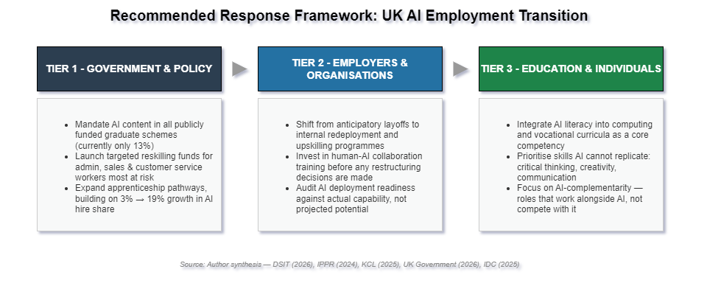
Three layers of action - government, employer, and education, that each address a different failing seen in the data are supported by the research. These are shown in Figure 1 as an organised response architecture.
Figure 1 Recommended response framework for the UK AI employment transition (Author synthesis: DSIT, 2026; IPPR, 2024; KCL, 2025; UK Government, 2026; IDC, 2025).
The 13% graduate scheme number indicates a clear policy failure at the government level that calls for regulatory action. Addressing the supply-side constraint most effectively would involve requiring AI training content in publicly funded programs, rerouting apprenticeship funding towards AI-adjacent roles (building on growth from 3 % to 19% of AI hires ), and creating targeted reskilling funds for the highest-risk occupational groups identified by ONS (2025 ).
60 percent of AI-related layoffs are anticipatory, according to HBR (2026), which should be viewed as a governance failure at the company level. Prior to staff cutbacks, employers should be forced by law or provided with incentives to demonstrate operational AI competence. Investing in internal redeployment and human-AI partnership training will conserve institutional knowledge and minimise needless labour market upheaval.
AI literacy must be viewed as a fundamental skill rather than an elective in computing and vocational curriculum, including Access to HE programs, at the individual and educational levels. Complementary skills should be given top importance, enabling students to collaborate with AI through critical analysis, communication, and practical problem-solving. PwC's ( 2025) 56% salary premium is based on these exact qualities, which AI is unable to match.

References
Harvard Business Review (2026) 'Companies Are Laying Off Workers Because of AI's Potential - Not Its Performance'. Available at: https://hbr.org/2026/01/companies-are-laying-off-workers-because-of-ais-potential-not-its-performance (Accessed: 22 February 2026).
IDC (2025) Closing the Gap: Verifying AI Skills in the Enterprise. IDC Analyst Brief. Available at: https://www.idc.com (Accessed: 22 February 2026).
Institute for Public Policy Research (IPPR) (2024) 'Up to 8 Million UK Jobs at Risk from AI Unless Government Acts'. Available at: https://www.ippr.org/media-office/up-to-8-million-uk-jobs-at-risk-from-ai-unless-government-acts-finds-ippr (Accessed: 22 February 2026).
King's College London (2025) 'New Study Reveals Early Impact of AI on Job Market in UK'. Available at: https://www.kcl.ac.uk/news/new-study-reveals-early-impact-of-ai-on-job-market-in-uk (Accessed: 22 February 2026).
Office for National Statistics (2025) Research into How Artificial Intelligence (AI) is Affecting Employment. Available at: https://www.ons.gov.uk (Accessed: 22 February 2026).
PwC (2025) AI Jobs Barometer 2025. Available at: https://www.pwc.com/us/en/tech-effect/ai-analytics/ai-predictions.html (Accessed: 22 February 2026).
Stanford University (2025) Early-Career Workers in AI-Exposed Occupations: An Analysis of Employment Trends. Stanford Working Paper Series. Available at: https://econofact.org (Accessed: 16 February 2026).
UK Government - Department for Science, Innovation and Technology (2026) AI Skills for Life and Work: Labour Market and Skills Projections. Available at: https://www.gov.uk/government/publications/ai-skills-for-life-and-work-labour-market-and-skills-projections (Accessed: 22 February 2026).
UK Government - Department for Science, Innovation and Technology (2026) AI Labour Market Survey 2025 Report. Available at: https://www.gov.uk/government/publications/ai-labour-market-survey-2025-report (Accessed: 22 February 2026).
World Economic Forum (2026) Four Futures for Jobs in the New Economy: AI and Talent in 2030. Available at: https://reports.weforum.org/docs/WEF_Four_Futures_for_Jobs_in_the_New_Economy_AI_and_Talent_in_2030_2025.pdf (Accessed: 22 February 2026).

