TASK 1: Types of Networks and Devices
Student Name: | Tarek Ahmed Umar
Unit Title: | Networking
Unit Code: | WNI518
Assessment Criteria: | 1.1, 1.2, 1.3, 1.4, 1.5
Assessor Name: | Shafaat Shah
Due Date: | 06/03/2026

Table of Contents
Task 1.1 - Types of Networks 2
(a) Local Area Network (LAN) 2
(b) Personal Area Network (PAN) 2
(c) Metropolitan Area Network (MAN) 2
(d) Wide Area Network (WAN) 2
Task 1.2 - Hardware Devices Required for Each Network Type 3
Task 1.3 - Comparison of Hub, Switch, and Router 4
Task 1.4 - Device Selection for a Small LAN 5
Task 1.5 - Justification of Device Selection 6
References 8

Task 1.1 - Types of Networks

(a) Local Area Network (LAN)
A Local Area Network, or LAN, is defined as a computer network that provides devices within a defined geographic region, such as a house, office, or educational center, with the ability to share resources and communicate with one another quickly. It is the most popular network technology, with Ethernet or IEEE 802.3, which supports network speeds from 100 Mbps to 10 Gbps, being the dominant LAN technology.
IEEE 802.11, or Wi-Fi, which defines wireless LANs, also supports mobile devices using cable-free technology. Local Area Networks are regulated, fast connections within a defined boundary are necessary, which makes LANs popular in corporate offices, hospitals, and educational institutions.

(b) Personal Area Network (PAN)
A Personal Area Network, or PAN, is defined as a network that connects various devices, such as wearables, computers, and smartphones, within the user's vicinity, or within 10 meters. It is the primary means of communication between devices, and the primary technology used is Bluetooth, or IEEE 802.15.1. Other technologies, such as Infrared, NFC, and USB, are also used. Some scenarios where PANs are used include syncing the user's smartwatch with their mobile phone or using wireless earphones with the user's smartphone.

(c) Metropolitan Area Network (MAN)
A Metropolitan Area Network, or MAN, which usually spans a city or metropolitan district, or an area within 50 kilometers of the user, is smaller in scale compared to WANs, which are wide area networks, and larger compared to Local Area Networks, or LANs. MANs are used to connect various Local Area Networks, or LANs, within the same geographic region, such as within the same city, using microwave or fiber optic media. Local governments, educational institutions, and internet service providers make use of MANs, such as when linking the offices, libraries, and other city or town halls.

(d) Wide Area Network (WAN)
The Internet is the most commonly used example of a WAN that spans large distances and can extend across national boundaries (Scribd, 2025). Several LANs and MANs can be interconnected with the help of WANs to enable the sharing of data worldwide. Technologies that assist in the process include MPLS, leased lines, satellite connections, undersea fiber-optic cables, and VPNs (Tanenbaum & Wetherall, 2011 ).

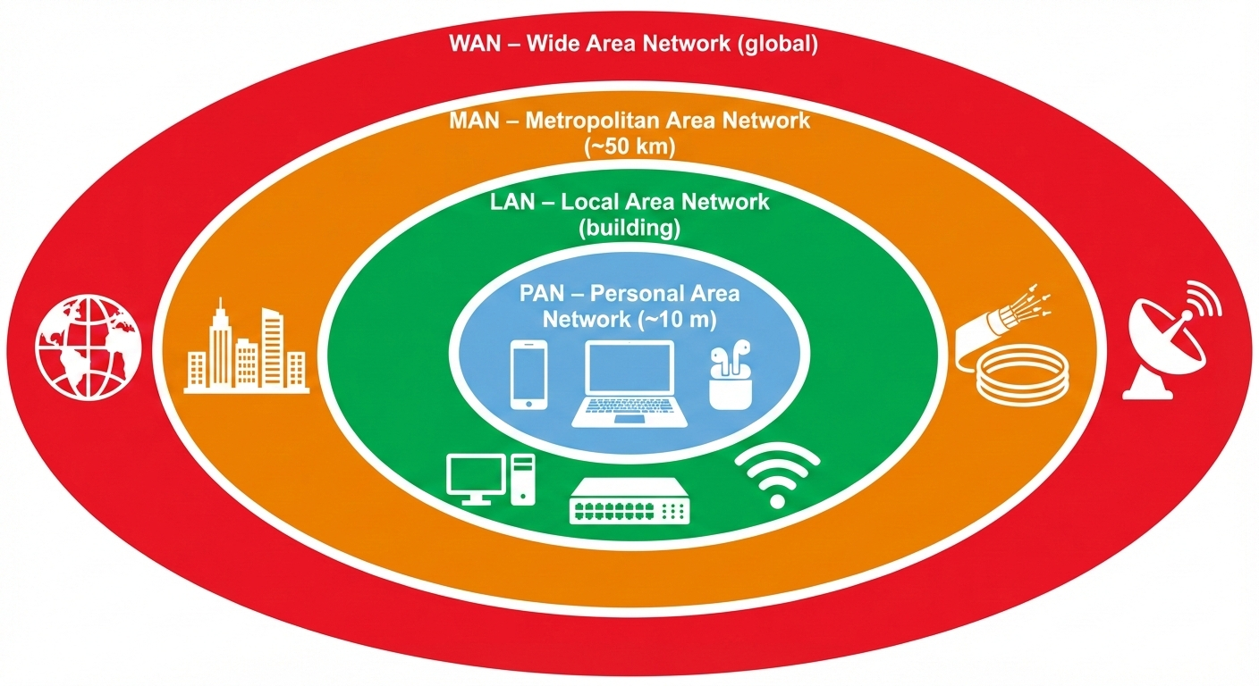
Task 1.2 - Hardware Devices Required for Each Network Type
Figure 1 Hierarchical overview of PAN, LAN, MAN, and WAN coverage areas
Each network type requires distinct hardware to fulfil its operational requirements, as summarised below.
Network Type | Required Hardware Devices
LAN | NICs, managed/unmanaged Gigabit switches, broadband router, Ethernet cabling (Cat5e/Cat6 ), Wireless Access Points (WAPs ), patch panels, and firewalls.
PAN | Bluetooth- enabled devices (smartphones, laptops, wearables ), Bluetooth USB adapters, NFC-enabled devices. No dedicated infrastructure is typically required.
MAN | High-capacity fibre- optic cabling, metropolitan- grade switches and routers, optical amplifiers, microwave relay towers, and SONET/ SDH equipment.
WAN | WAN routers, DSL/ fibre modems, CSU/ DSU units, satellite dishes, leased line termination equipment, enterprise firewalls, and VPN concentrators.

The cost and complexity of hardware increase intensely as networks expand from PAN to WAN. While WANs need carrier-grade gear that can handle high- volume, long-distance traffic, LANs use consumer-grade equipment ( Tanenbaum and Wetherall, 2011).

Task 1.3 - Comparison of Hub, Switch, and Router
Hubs, switches, and routers operate at different OSI model layers and serve distinct network roles, as outlined in the table below.

Feature | Hub | Switch | Router
OSI Layer | Layer 1 – Physical | Layer 2 - Data Link | Layer 3 - Network
Addressing | None | MAC Addresses | IP Addresses
Data Forwarding | Broadcasts to all ports | Forwards to specific MAC only | Routes between separate networks
Collision Domain | Single shared domain | Separate per port | Separate per interface
Duplex Mode | Half- duplex only | Full-duplex supported | Full- duplex supported
Modern Usage | Obsolete | Standard LAN device | Internet/ inter-network gateway

Hubs are not required in modern networking as they forward all the data to all the ports at the same time, thereby causing congestion and data collision (Versitron, 2025 ). Switches improve upon this feature by using a MAC address table to forward data only to the destination port, thereby minimizing data collision (PyNet Labs, 2025 ). Routers play an essential role in the provision of internet services as well as inter-site communication as they operate at a higher layer than switches and forward data packets from one theoretically different network to another using IP routing tables (Cisco, 2024 ).

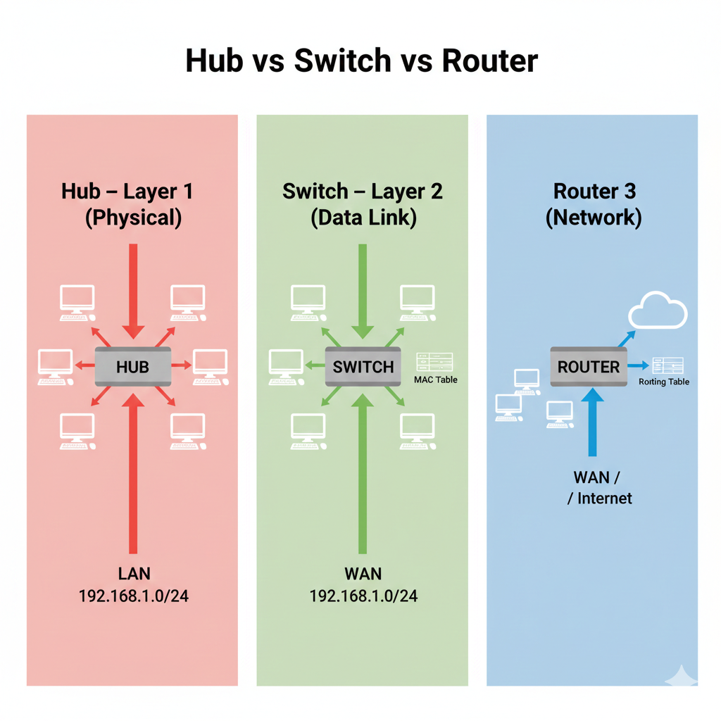
Figure 2 Comparison of data forwarding behaviour - Hub, Switch, and Router

Task 1.4 - Device Selection for a Small LAN
For a small office LAN supporting approximately 15- 20 users, the following hardware is selected:
Device | Specification / Example | Qty
Managed Gigabit Switch | 24-port, 1 Gbps per port (e.g., TP-Link TL-SG1024DE ) | 1
Broadband Router | Dual-band, integrated firewall and NAT (e.g., TP-Link Archer AX55 ) | 1
Wireless Access Point (WAP) | IEEE 802.11ax (Wi-Fi 6), ceiling/ wall-mounted | - 2
Cat6 UTP Cabling | TIA-568- C.2, supports up to 10 Gbps over 55 m | As required
Patch Panel | 24-port 1U rack-mounted with cable management tray | 1
NICs | Integrated Gigabit Ethernet NIC ( standard on modern PCs/ laptops) | 1 per device

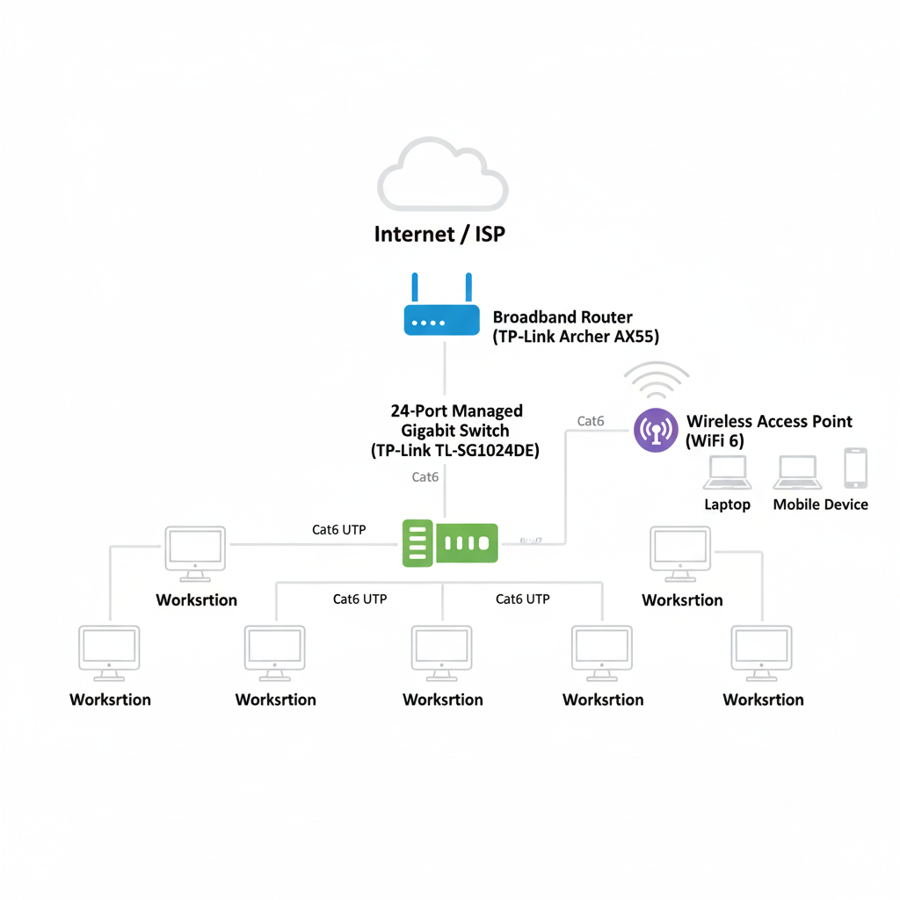
Figure 3 Proposed network topology for the small office LAN (15-20 users)

Task 1.5 - Justification of Device Selection
Each device meets the performance, security, and scalability requirements of the network.

A controlled gigabit switch is the essential component of the LAN architecture. VLAN support provides the necessary security as it segregates internal systems from guest Wi- Fi. VoIP traffic is given priority using QOS regulations that prevent performance degradation owing to large data transfers (Versitron, 2025 ). All users can be catered to with the 24 ports that the switch supports.

The broadband router that interconnects the LAN with the internet is the second component of the LAN. It uses NAT that allows all the devices in the LAN to use a single IP address (Cisco, 2024). The stateful firewall acts as the first line of defense against any potential threats from the internet.
Without the need for physical wiring, the Wi-Fi 6 (IEEE 802.11ax) access point allows for a definite increase in connectivity to mobile devices. Its OFDMA and MU-MIMO capabilities ensure a definite performance advantage over outdated Wi-Fi 5 access points by increasing throughput and reducing latency in multi-user environments (PyNet Labs, 2025 ).
Cat6 UTP cables have become the industry standard for modern LANs due to their capabilities of achieving 10 Gbps over 55 meters and 1 Gbps over 100 meters (Forouzan, 2013 ). By centralising all wiring to a single termination point, the patch panel makes it easier to diagnose issues with the network configuration. Overall, this provides a small office environment with a solid infrastructure solution that is cost-effective.

References
Cisco Systems (2024) What is a Router? Available at: https://www.cisco.com/c/en/us/solutions/small-business/resource-center/networking/what-is-a-router.html (Accessed: 23 February 2026).
Forouzan, B.A. (2013) Data Communications and Networking. 5th edn. New York: McGraw-Hill.
GeeksforGeeks (2024) Types of Area Networks - LAN, MAN and WAN. Available at: https://www.geeksforgeeks.org/types-of-area-networks-lan-man-and-wan/ (Accessed: 23 February 2026).
HardwareTechHub (n.d.) Understanding Network Types: LAN, WAN, MAN, & PAN Explained. Available at: https://hardwaretechhub.co.uk/comprehensive-guide-to-types-of-networks-lan-wan-man-and-more/ (Accessed: 23 February 2026).
IONOS (2019) Network types at a glance - LAN, MAN, WAN & GAN. Available at: https://www.ionos.co.uk/digitalguide/server/know-how/the-different-network-types/ (Accessed: 23 February 2026).
PyNet Labs (2025) Hub vs Switch vs Router - What's the Difference? Available at: https://www.pynetlabs.com/hub-vs-switch-vs-router/ (Accessed: 23 February 2026).
Scribd (2025) Module Network Types PAN LAN MAN WAN. Available at: https://www.scribd.com/document/945451759/Module-Network-Types-PAN-LAN-MAN-WAN (Accessed: 23 February 2026).
Tanenbaum, A.S. and Wetherall, D. (2011) Computer Networks. 5th edn. Harlow: Pearson Education.
Versitron (2025) Which is the Best Network Device - Hub or Switch or Router? Available at: https://www.versitron.com/blogs/post/which-is-the-best-network-device-hub-or-switch-or-router (Accessed: 23 February 2026).

