TASK 2: Bandwidth and Network Performance
Student Name: | Tarek Ahmed Umar
Unit Title: | Networking
Unit Code: | WNI518
Assessment Criteria: | 2.1, 2.2, 2.3, 2.4
Assessor Name: | Shafaat Shah
Due Date: | 06/03/2026

Table of Contents
Task 2.1 – Data Transfer Rate Units: Kbps, Mbps, and Gbps 2
Kbps – Kilobits per Second 2
Mbps – Megabits per Second 2
Gbps – Gigabits per Second 2
Task 2.2 – How Bandwidth Impacts Network Performance 2
Task 2.3 – Bandwidth vs Throughput 3
Task 2.4 – Per-User Bandwidth Calculations 4
References 6

Task 2.1 - Data Transfer Rate Units: Kbps, Mbps, and Gbps

Kbps - Kilobits per Second
Kilobits per second, or Kbps, is a unit of measurement for a thousand bits transmitted every second. It is the most commonly used unit for internet connections like 56 Kbps dial-up modems. It is used in low-bandwidth applications like IoT devices, SMS services, and VoIP voice channels that require a minimum of 64 Kbps (Meter, n.d.). However, it is inadequate for multimedia content in modern broadband internet services.

Mbps - Megabits per Second
Megabits per second (Mbps) is 1,000 times faster than Kbps. It is equal to a million bits transmitted every second. It is the most important part of modern internet services with Wi-Fi, broadband internet services at home, and business internet services (Network-Switch, 2025). It is used in the real world for services like 4K content streaming at a rate of 25 Mbps, HD content streaming at a rate of 5 - 8 Mbps, broadband internet services with a bandwidth of 50 - 500 Mbps. It is the most important unit used for the normal performance of internet services.

Gbps - Gigabits per Second
Gigabits per second (Gbps) is 1,000 times faster than Mbps. It is equal to a billion bits transmitted every second. It is used in modern internet services like data centers, fiber optic infrastructure, and enterprise networks (Fiber Life, 2025). It is used in the real world for gigabit and 10-gigabit LAN connections in modern offices with Ethernet standards like 1000Base-T (1 Gbps) and 10GBase-T (10 Gbps) for cloud computing services, server-to-server services, and content creation services like 4K and 8K content creation that require constant transfer of data.

Task 2.2 - How Bandwidth Impacts Network Performance
A network link's bandwidth, measured in Mbps or Gbps, is the maximum capacity or the total amount of data that can be carried by a network link in a certain period of time. Performance and bandwidth go hand in hand. A larger bandwidth means more data can be sent at a given time, thus reducing the time it takes to get a response, transfer files, or allow more users to work simultaneously without experiencing a noticeable lag (DNSstuff, 2022).
Congestion in a network is a condition that exists when the amount of network traffic exceeds the bandwidth. Routers have buffers that store the packets; however, routers drop the packets when the buffers become full. This makes the problem worse, increasing the overall time it takes for a round trip through all the current connections by 50% when TCP recognizes the dropped packets and initiates the slow-start algorithm to reduce the congestion window by half (Allegro Packets, 2019).
When there is a large number of users in a network, the bandwidth is divided equally among all the users who have an open connection. Increased latency, lag in applications, and buffering occur due to a proportional decrease in bandwidth allocation to a single user with an increase in the overall number of users. This means that only 5 Mbps is allocated to a single user when a 100 Mbps bandwidth is equally divided by 20 people. This is inadequate for a 4K stream. By giving priority to certain applications over others, Quality of Service (QoS) ensures that important services run even when there is a huge amount of traffic (Obkio, 2025).

Task 2.3 - Bandwidth vs Throughput
In theory, bandwidth represents the fastest rate at which data can be transferred over a network connection. It is determined by hardware and the physical connection itself, usually given in Mbps or Gbps, and is not affected by the amount of activity over the network at any given time (Kentik, 2026). It represents the capacity ceiling, or the amount attainable under perfect conditions, unhindered in any way.
Throughput represents the rate at which data is transferred from its originating location to its destination over a given period of time. Due to inefficiencies in data transfer, which slow the rate of data transfer, throughput is always equal to or slower than bandwidth (DNSstuff, 2022). For example, under normal conditions, a 10 Gbps connection would be able to handle no more than a 7 Gbps throughput.
The following items will decrease throughput from its given bandwidth without changing the bandwidth itself:

Factor | Effect on Throughput
Latency | High round-trip delay slows TCP acknowledgement cycles. At 30 ms RTT, throughput drops from 93.5 Mbps to 16.2 Mbps on a 100 Mbps link (Netskope, 2024 ).
Packet Loss | A 2 % packet loss rate can reduce TCP throughput by 6–25× due to forced retransmissions and congestion window reduction (Netskope, 2024 ).
Protocol Overhead | VPN tunnelling, encryption, and packet headers typically consume 10–20% of available bandwidth, reducing effective throughput (Obkio, 2025).
Network Congestion | Shared or saturated links cause queuing and buffer delays, reducing the rate at which data reaches its destination.

A good example of this is bandwidth being the physical capacity of the motorway or the number of lanes. The cars actually arriving at their destination every hour refers to throughput. For instance, if there are traffic jams along the motorway, adding lanes will not improve the speed of the cars. Similarly, if latency, packet loss, and congestion are still the main problems with internet speed, then increasing bandwidth will not improve throughput (DNSstuff, 2022).

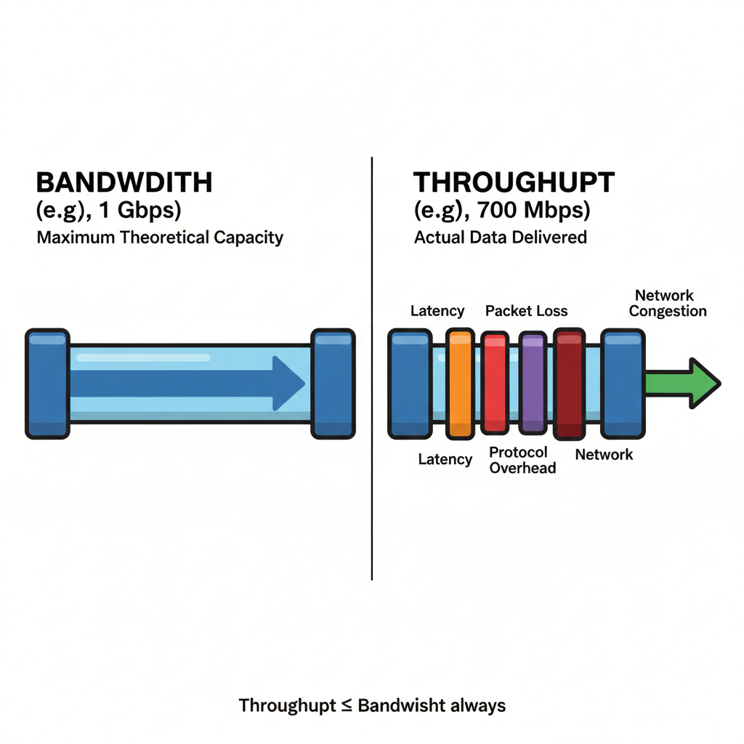
Figure 1 Bandwidth vs Throughput the gap caused by latency, packet loss, and overhead

Task 2.4 - Per-User Bandwidth Calculations
The calculations below determine the per-user bandwidth available under equal-share distribution for each of the two network scenarios.
Scenario 1 - 1 Gb (1000Base-T) Network, 50 Users
Total available bandwidth = 1,000 Mbps
Number of users = 50
Bandwidth per user = 1,000 ÷ 50 = 20 Mbps per user
Scenario 2 - 10 Gb (10GBase-T) Network, 200 Users
Total available bandwidth = 10,000 Mbps
Number of users = 200
Bandwidth per user = 10,000 ÷ 200 = 50 Mbps per user
The table below summarises both results and their impact on user experience:
Scenario | Network Standard | Users | Per-User Bandwidth
Scenario 1 | 1 Gbps ( 1000Base-T ) | 50 | 20 Mbps each
Scenario 2 | 10 Gbps (10GBase-T ) | 200 | 50 Mbps each

In Scenario 1 , every user will be allocated 20 Mbps. This will allow for comfortable internet usage for web surfing, regular VoIP usage (64 Kbps to 1 Mbps), and even HD video streaming (5 to 8 Mbps). However, the allocation will be exceeded if many users are streaming 4K videos simultaneously since each 4K stream will require 25 Mbps (Meter, n.d. ).
In Scenario 2, four times more users are supported than Scenario 1. However, each of these users will be allocated 50 Mbps, which is 2.5 times faster than Scenario 1. This shows how much better the 10GBase-T setting will be for business environments since it will be able to handle bandwidth-intensive applications like huge file transfers and cloud video conferencing (Fiber Life, 2025), and 4K videos will be no problem for it.

References
Allegro Packets (2019) Bandwidth and Congestion in Networks. Available at: https://allegro-packets.com/en/blog-posts/bandwidth-and-congestion-in-networks (Accessed: 24 February 2026).
DNSstuff (2022) Network Latency vs. Throughput vs. Bandwidth Guide. Available at: https://www.dnsstuff.com/latency-throughput-bandwidth (Accessed: 24 February 2026).
Fiber Life (2025) Understanding Data Speeds: How Many Mbps Are in 1 Gig? Available at: https://fiber-life.com/blog-understanding-data-speeds-how-many-mbps-are-in-1-gig/ (Accessed: 24 February 2026).
Kentik (2026) What Is Throughput? Latency vs Throughput vs Bandwidth. Available at: https://www.kentik.com/kentipedia/latency-vs-throughput-vs-bandwidth/ (Accessed: 24 February 2026).
Meter (n.d.) What is Kbps vs. Mbps vs. Gbps? Available at: https://www.meter.com/resources/what-is-kbps (Accessed: 24 February 2026).
Network-Switch.com (2025) MB, GB, KB, TB vs Kbps, Mbps, Gbps, Tbps. Available at: https://network-switch.com/blogs/networking/mb-gb-kb-tb-vs-kbps-mbps-gbps-tbps-difference-explained (Accessed: 24 February 2026).
Netskope (2024) Network Performance and User Experience: Latency vs Throughput vs Packet Loss. Available at: https://www.netskope.com/blog/network-performance-and-user-experience-network-latency-vs-throughput-vs-packet-loss (Accessed: 24 February 2026).
Obkio (2025) 10 Factors Affecting Network Performance. Available at: https://obkio.com/blog/factors-affecting-network-performance/ (Accessed: 24 February 2026).
Tanenbaum, A.S. and Wetherall, D. (2011) Computer Networks. 5th edn. Harlow: Pearson Education.

