Task 2: Applying Security Techniques to Prevent System Attacks
Student Name: | Tarek Ahmed Umar
Unit Title: | Cyber Security
Unit Code: | WNI503
Assessment Criteria: | 2.1
Assessor Name: | Shafaat Shah
Due Date: | 06 March 2026
Table of Contents
Introduction 2
Technique 1: Windows Defender Firewall Configuration 2
Purpose 2
Step by Step Implementation 2
Effectiveness Evaluation 4
Technique 2: Multi-Factor Authentication (MFA ) 4
Purpose 4
Step-by-Step Implementation 4
Effectiveness Evaluation 5
Technique 3: File Encryption Using 7-Zip (AES-256 ) 5
Purpose 5
Step-by-Step Implementation 5
Effectiveness Evaluation 8
Conclusion 8
References 9

Introduction
In order to defend a Windows 10 workstation from both internal and external cyber threats, this report presents three security techniques. A workstation is a prime target since it houses critical files, network access, and login credentials. Windows Defender Firewall setting, Microsoft Authenticator Multi-Factor Authentication ( MFA), and 7- Zip AES- 256 file encryption are the methods used to create a layered defence in depth strategy.[1]

Technique 1: Windows Defender Firewall Configuration

Purpose
A firewall filters inbound and outbound traffic using security rules, blocking unauthorized external connections. Windows Defender Firewall uses stateful packet inspection, mitigating external threats such as remote exploitation, port scanning, and malware propagation. Custom rules also restrict which applications can communicate over the network, reducing internal misuse risks.[2]

Step by Step Implementation
Step 1: Open Windows Defender Firewall via Control Panel → System and Security → Windows Defender Firewall. Verify firewall is active across all network profiles.
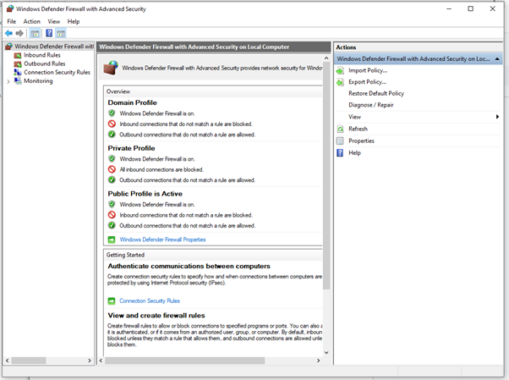
Figure 1 Windows Defender Firewall main interface showing active status
Step 2: Click 'Advanced Settings' to open wf.msc. Select “Inbound Rules” → “New Rule” → set rule type to “Custom”.
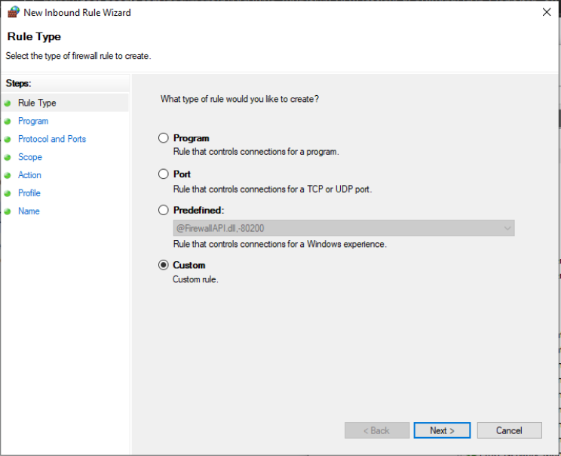
Figure 2 Custom inbound rule creation wizard in Advanced Security
Step 3: Configure protocol, ports, and set Action to “Block”. Apply to the Public network profile. Verify the new rule appears in the inbound rules list.
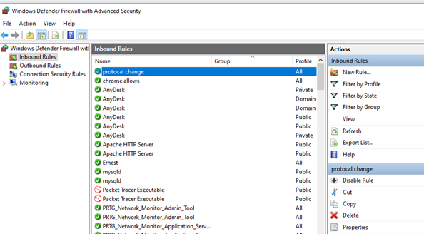
Figure 3 Custom inbound rule verified in the rules list

Effectiveness Evaluation
The firewall enforces default-deny on inbound traffic, preventing external attackers from initiating connections. Application rules stop malware from contacting command-and-control servers. Limitation: phishing-delivered threats bypass the firewall, requiring additional controls such as MFA. [2]

Technique 2: Multi-Factor Authentication (MFA )

Purpose
By requiring two verification factors - a password and an authenticator app approval - MFA eliminates the single point of failure that passwords by themselves have. An attacker cannot obtain access without the registered device, even if credentials are obtained through phishing or a data breach. Both external credential theft and internal unauthorised account sharing are addressed by this. [3].

Step-by-Step Implementation
Step 1: Navigate to https://account.microsoft.com/security “Security info” “Add sign-in method” select “Authenticator app”.
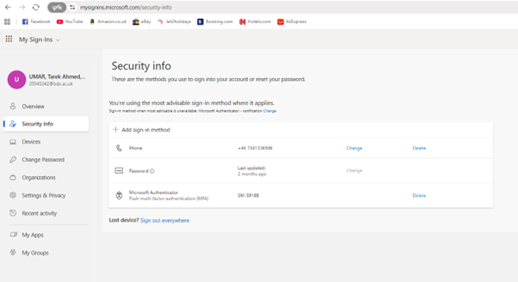
Figure 4 Microsoft Account Security Info page with 2FA options
Step 2: Download Microsoft Authenticator and scan the QR code shown on the account page to link the app. When signing in from a new device, approve the push notification sent to the app to complete login.
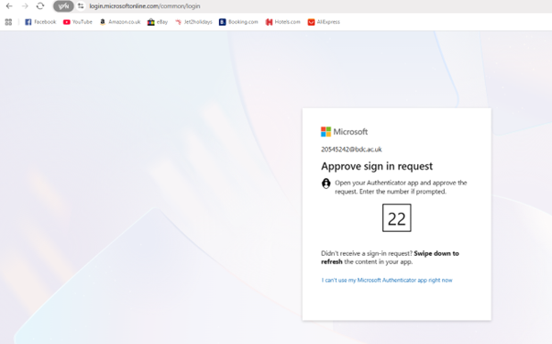
Figure 5 Microsoft Authenticator push notification requiring login approval

Effectiveness Evaluation
MFA prevents 99.9 % of automated account compromise attacks, according to Microsoft research.[3] Because attackers cannot remotely approve authentication, push notifications thwart real-time phishing efforts. Limitation: backup recovery methods reduce the loss of access in the event that the registered device is unavailable. [1].

Technique 3: File Encryption Using 7-Zip (AES-256 )

Purpose
Sensitive data is encrypted into unintelligible ciphertext that can only be accessed with the right password. 7-Zip employs AES-256, which is computationally impossible to brute-force and is the same standard employed by governments and militaries. This guards against internal data exfiltration and external physical device theft.[4]

Step-by-Step Implementation
Step 1: Install 7-Zip from https://www.7-zip.org. Open 7-Zip File Manager and navigate to the folder containing sensitive data.
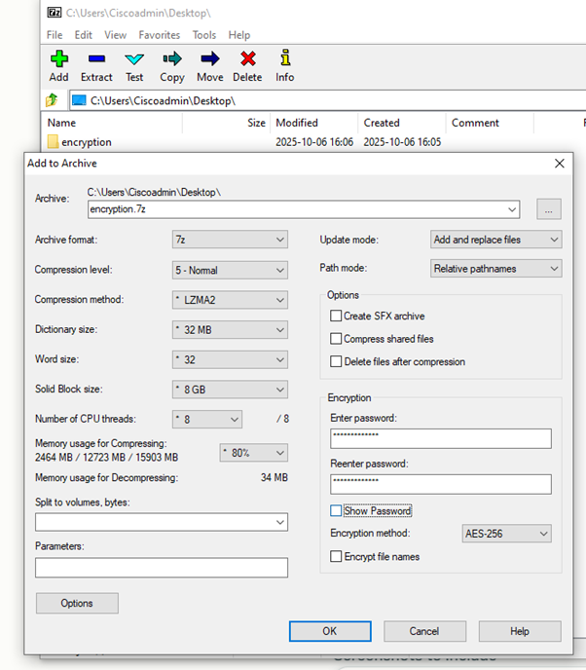
Figure 6 7-Zip File Manager with target folder selected for encryption

Step 2: Right-click folder “7-Zip” “Add to archive”. Set format to “.7z”, encryption method to “AES-256”, enable “Encrypt file names”, and enter a strong password. Click OK to create the encrypted archive.
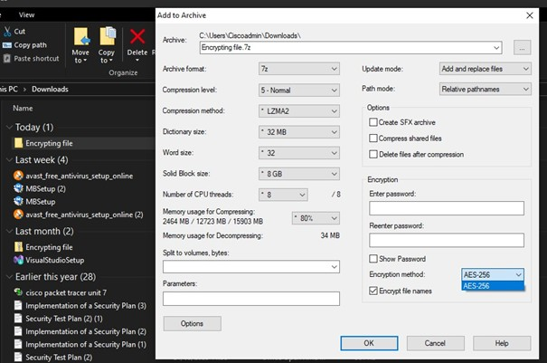
Figure 7 Add to Archive dialog configured with AES-256 encryption and password

Step 3: Verify by double-clicking the archive - a password prompt confirms successful encryption.
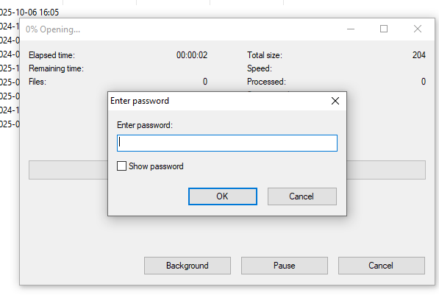
Password prompt confirms AES-256 encryption active
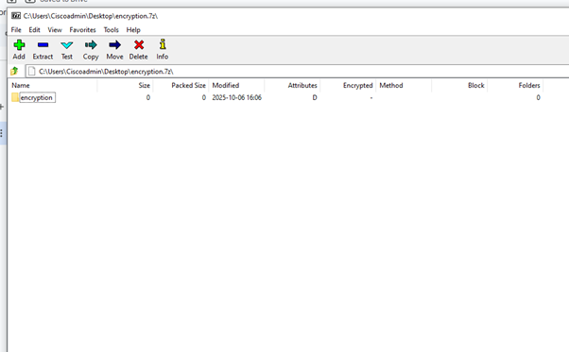
Figure 9 Encrypted folder was decrypted.

Effectiveness Evaluation
Stolen data is useless without the decryption password thanks to AES-256. Files are safe even in the event that the device is physically taken or corrupted remotely. Limitation: Use a secure password manager to avoid permanent data loss caused by forgotten passwords. In [4]

Conclusion
The three tactics build a layered defence by addressing many attack routes. The firewall shields the network perimeter against external intrusions. MFA protects account identity from credential theft and internal abuse. Encryption protects data while it's at rest, rendering stolen files unreadable. Importantly, each technique compensates for the drawbacks of the others: MFA guards against account compromise, while encryption safeguards extracted files. When integrated, they significantly reduce the workstation's attack surface against both internal and external attacks.[1] [2]

References
- [1] National Institute of Standards and Technology (NIST). (2022). Cybersecurity Framework: Version 1.1. Available at: https://www.nist.gov/cyberframework (Accessed: 02 March 2026)
- [2] Microsoft Corporation. (2025). Windows Defender Firewall with Advanced Security. Available at: https://docs.microsoft.com/en-us/windows/security/threat-protection/windows-firewall/ (Accessed: 02 March 2026)
- [3] Microsoft Corporation. (2025). Multi-Factor Authentication and Microsoft Authenticator. Available at: https://account.microsoft.com/security (Accessed: 02 March 2026)
- [4] Pavlov, I. (2024). 7-Zip File Archiver – AES-256 Encryption Documentation. Available at: https://www.7-zip.org/ (Accessed: 02 March 2026)
- [5] National Cyber Security Centre (NCSC). (2024). Cyber Security Best Practices. Available at: https://www.ncsc.gov.uk/ (Accessed: 02 March 2026)

