Task 3: INTERROGATING THE DATABASE AND CREATING REPORTS
Student Name: | Tarek Ahmed Umar
Unit Code: | WNI504
Unit Title: | Database Applications
Assessor: | Billy Madlela
Table of Contents
PART A: QUERIES (Assessment Criteria 3.1) 3
QUERY 1: DELETE CANCELLED ORDERS 3
Explanation: 5
QUERY 2: UPDATE PRODUCT PRICES 6
Explanation: 7
QUERY 3: ARCHIVE INACTIVE CUSTOMERS 8
Explanation: 10
QUERY 4: PRODUCTS UNDER £50 11
Explanation: 12
QUERY 5: LONDON CUSTOMERS WITH HIGH CREDIT 13
Explanation: 14
QUERY 6: CUSTOMER ORDER TOTALS 15
Explanation: 15
QUERY 7: ELECTRONICS ORDERS IN 2024 17
Explanation: 17
PART B: REPORTS (Assessment Criteria 3.2) 19
REPORT 1: COMPLETE DATABASE 19
Explanation: 19
REPORT 2: CUSTOMER CONTACT LIST 20
Explanation: 20
REPORT 3: ACTIVE CUSTOMERS ONLY 21
Explanation: 21
REPORT 4: AFFORDABLE PRODUCTS 22
Explanation: 22
REPORT 5: HIGH-VALUE ORDERS 23
Explanation: 23
CONCLUSION 24

PART A: QUERIES ( Assessment Criteria 3.1)

QUERY 1: DELETE CANCELLED ORDERS
Query Name: Q1_DeleteCancelledOrders
Query Type: DELETE Query
Assessment Criteria: 3.1(a ) - Delete records based on specific criteria
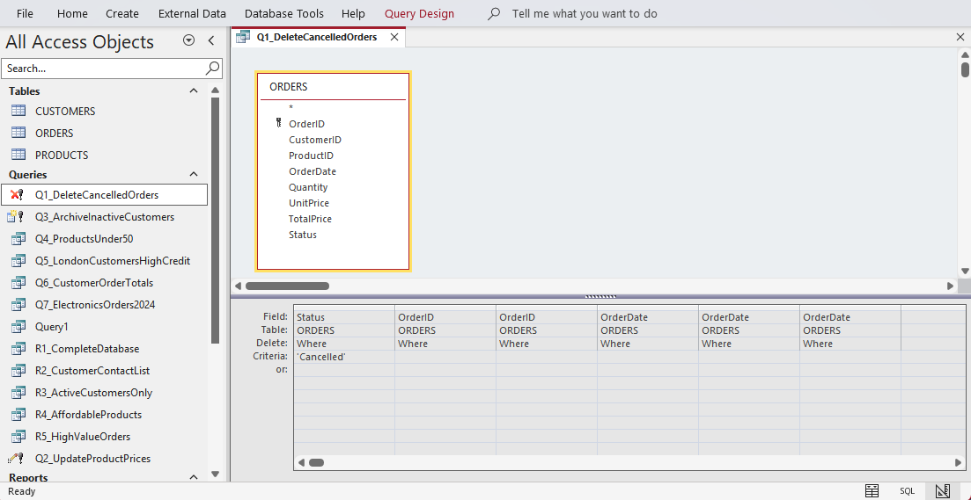
Design View:

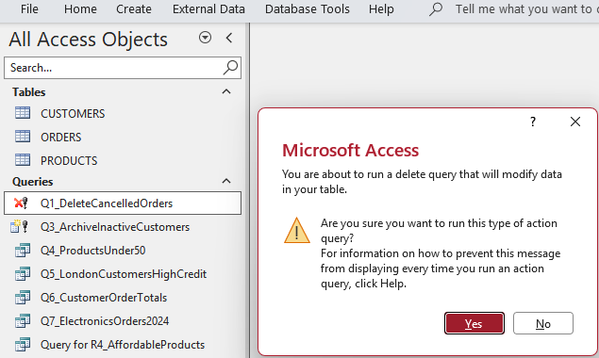
Results:
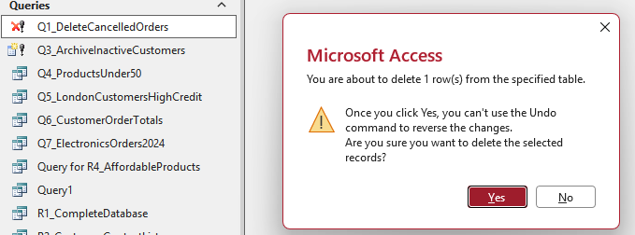

Explanation:
This DELETE query eliminates all orders that are in the “Cancelled” status from the ORDERS table. This query ensures the cleanliness of the database by removing old information that is no longer relevant. This query uses the command DELETE FROM ORDERS WHERE Status = “Cancelled”.

QUERY 2: UPDATE PRODUCT PRICES
Query Name: Q2_UpdateProductPrices
Query Type: UPDATE Query
Assessment Criteria: 3.1(b ) - Update datа automatically
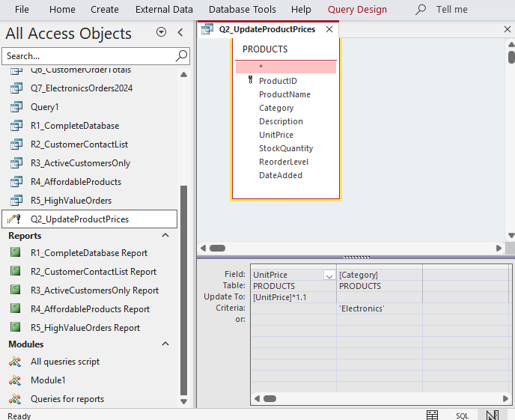
Design View:

Result:
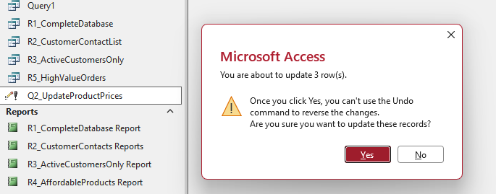
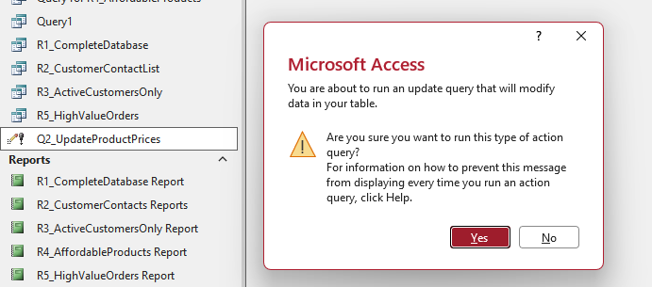

Explanation:
This UPDATE query updates all the product prices in the database by 10%, for all products in the Electronics category. This query allows the business to modify all the products in the database. This query uses the SQL command UPDATE PRODUCTS SET UnitPrice = [UnitPrice] * 1.1 WHERE Category = “Electronics”.

QUERY 3: ARCHIVE INACTIVE CUSTOMERS
Query Name: Q3_ArchiveInactiveCustomers
Query Type: MAKE TABLE Query
Assessment Criteria: 3.1( c) - Output data to other tables
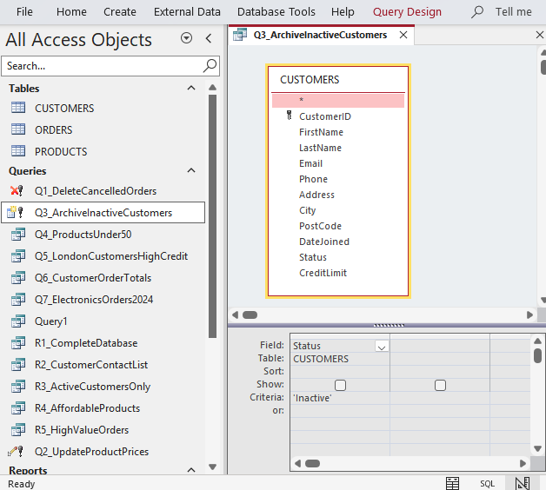
Design View:

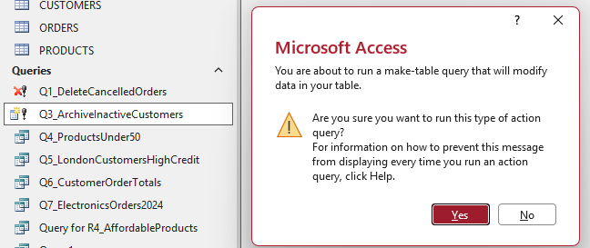
Results:
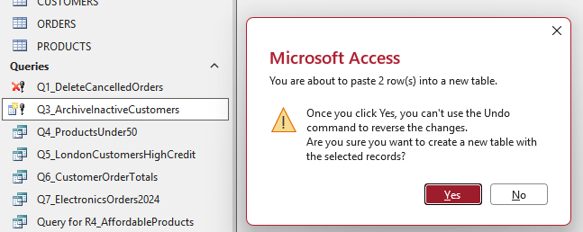

New table generated to list inactive customers:
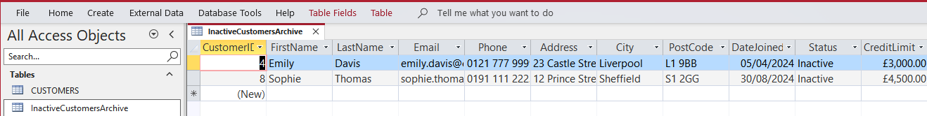

Explanation:
This MAKE TABLE query creates a table named “InactiveCustomersArchive” thаt contains all the inactive customers. This query allows the business to archive old information in the database. This query uses the SQL command SELECT * INTO InactiveCustomersArchive FROM CUSTOMERS WHERE Status = “Inactive”.

QUERY 4: PRODUCTS UNDER £ 50
Query Name: Q4_ProductsUnder50
Query Type: SELECT Query ( Single Table)
Assessment Criteria: 3.1(d )( i) - Advanced searching and sorting on a single table
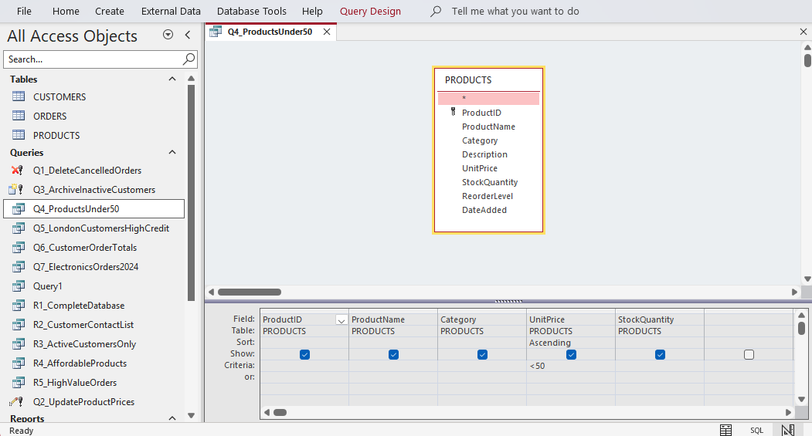
Design View:

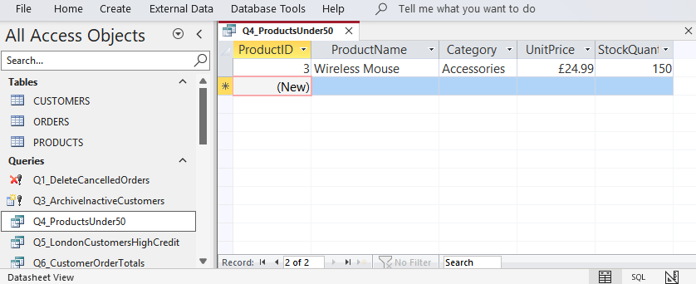
Results

Explanation:
This query retrieves all the products in the datаbase that cost under 50 pounds, which is sorted in ascending order. This query allows the business to find products that are priced low. This query uses the WHERE UnitPrice < 50 and ORDER BY UnitPrice commands.
This query retrieves all London customers with credit limits exceeding £5,000 OR all Manchester customers. This shows the use of AND/OR logical operators in complex queries.

QUERY 5: LONDON CUSTOMERS WITH HIGH CREDIT
Query Name: Q5_LondonCustomersHighCredit
Query Type: SELECT Query (Logical Operators)
Assessment Criteria: 3.1 ( d)(i) - Logical operators on single table
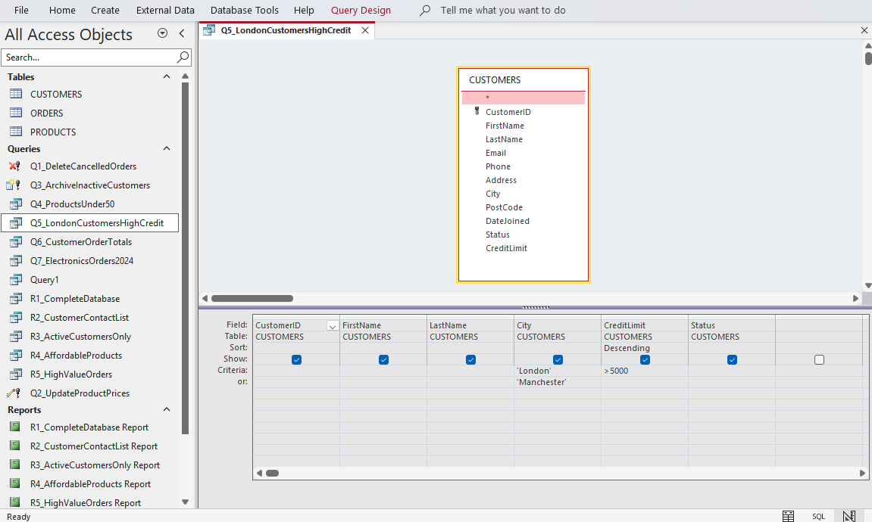
Desing View:

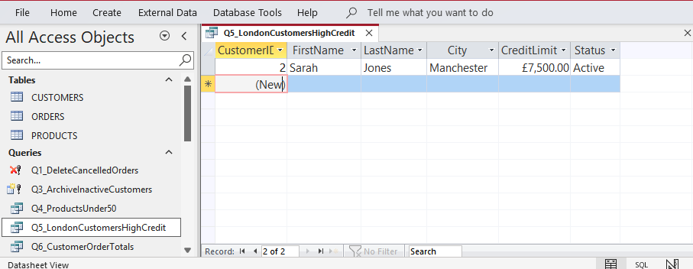
Results:

Explanation:
This query finds London customers who have credit limits over £5,000 OR all Manchester customers. It demonstrates AND/OR logical operators for complex filtering. The query uses WHERE (City = “London” AND CreditLimit > 5000) OR City = “Manchester”, sorted by credit limit descending to prioritize the high value customers.

QUERY 6: CUSTOMER ORDER TOTALS
Query Name: Q6_CustomerOrderTotals
Query Type: SELECT Query (Multi -Table Join)
Assessment Criteria: 3.1(d) (ii ) - Multiple tables with aggregation

Explanation:
This given query combines the CUSTOMERS and ORDERS tables & calculates the total number of orders and spending for all the customers. The INNER JOIN keyword selects all records from two or more tables where the join condition is met.
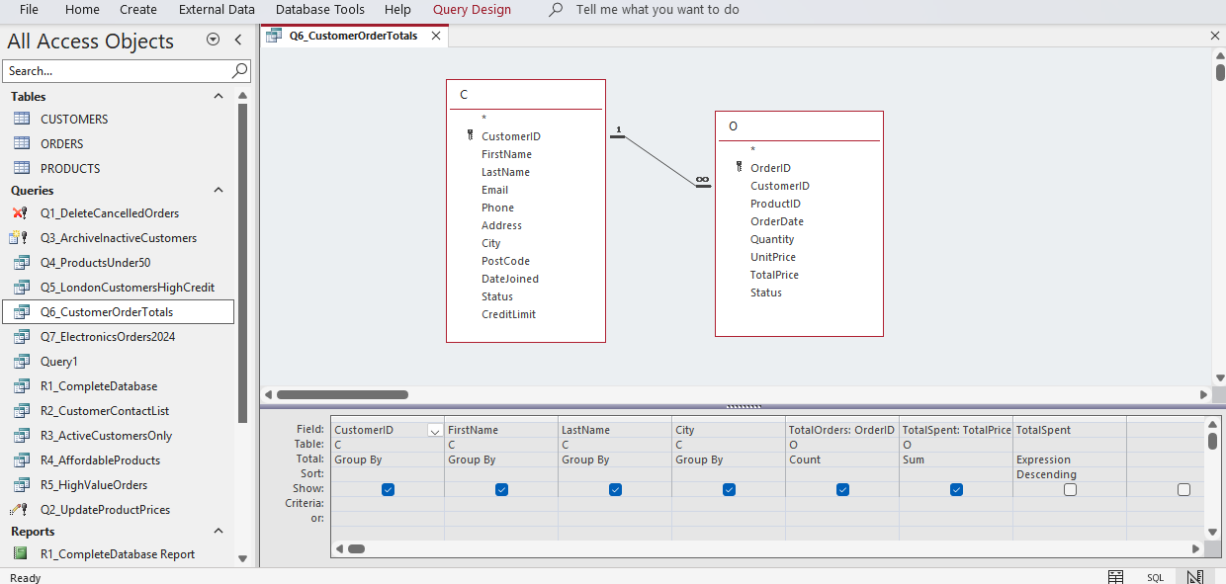
Desing View:

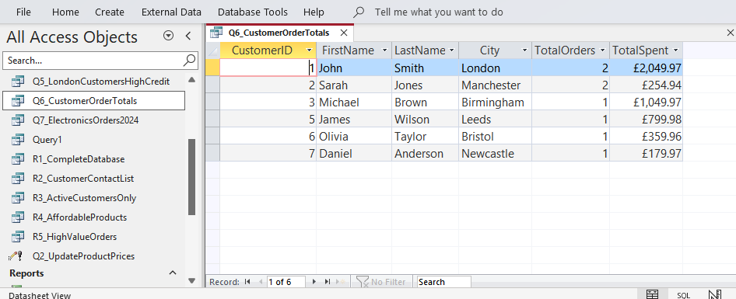
Results:

QUERY 7: ELECTRONICS ORDERS IN 2024
Query Name: Q7_ElectronicsOrders2024
Query Type: SELECT Query ( Complex Multi-Table)
Assessment Criteria: 3.1 (d)( ii) - Complex multi-table query
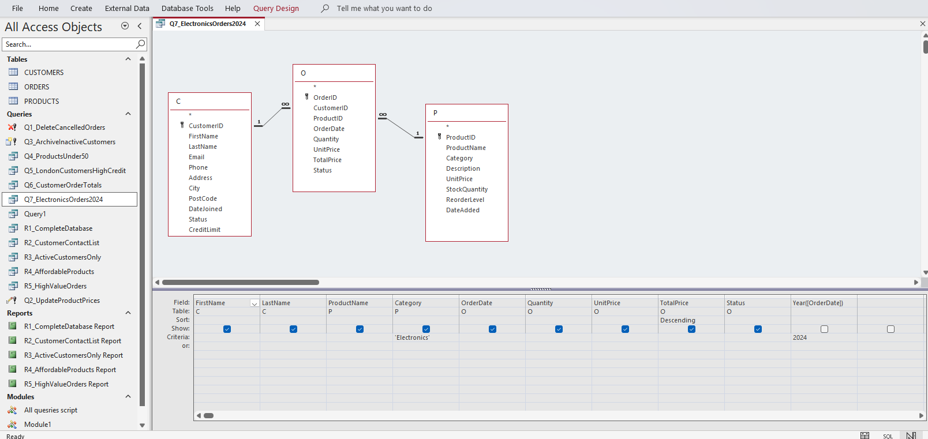
Design View:

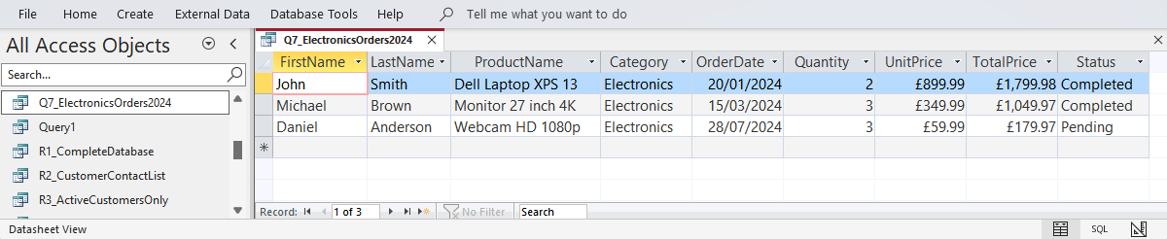
Results:

Explanation:
The given advanced query combines three tables, namely CUSTOMERS, ORDERS, and PRODUCTS, and returns all Electronics orders placed in 2024. The results are sorted in descending order by total price. It demonstrates complex joins with multiple criteria filtering using WHERE Category = “Electronics” AND Year([ OrderDate]) = 2024. Results are sorted by total price descending to highlight highest-value orders.

PART B: REPORTS (Assessment Criteria 3.2 )

REPORT 1: COMPLETE DATABASE
Report Name: Report1_CompleteDatabase
Assessment Criteria: 3.2(a ) - Complete database
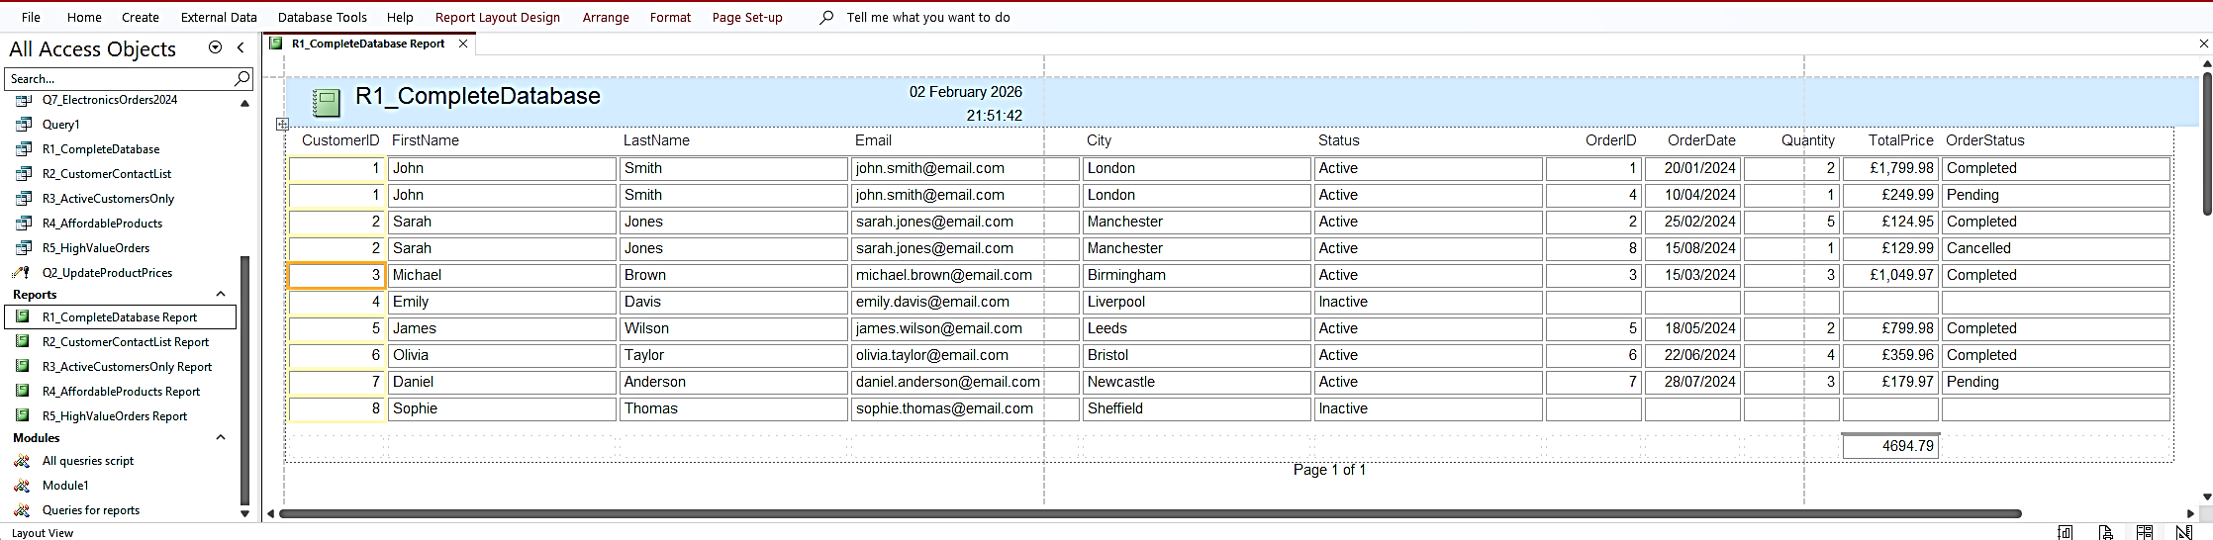
Generated Report:

Explanation:
The given report shows all data from the database using a LEFT JOIN, which returns all records from the left table and the matched records from the right table.

REPORT 2: CUSTOMER CONTACT LIST
Report Name: Report2_CustomerContactList
Assessment Criteria: 3.2 (b ) - Selected fields only
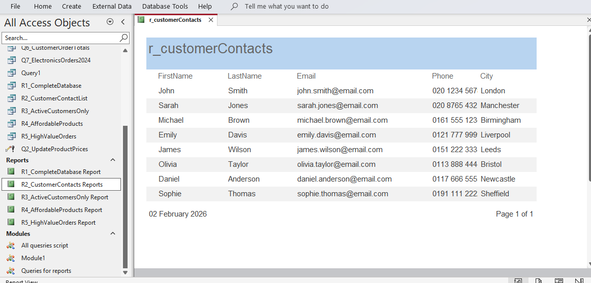
Generated Report:

Explanation:
This report shows only customer contact fields ( FirstName, LastName, Email, Phone , City), excluding sensitive information like credit limits. It is useful for marketing campaigns and customer service teams who need contact details without full database access.

REPORT 3: ACTIVE CUSTOMERS ONLY
Report Name: Report3_ActiveCustomersOnly
Assessment Criteria: 3.2( c) - Selected values
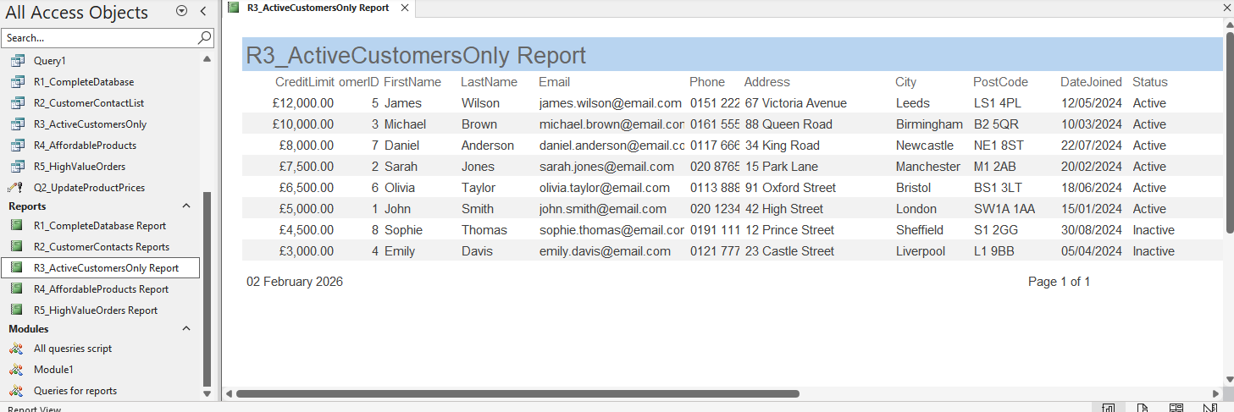
Generated Report:

Explanation:
This report filters to show only customers with Active status, sorted by credit limit in descending order. This helps to target business efforts on existing customers.

REPORT 4: AFFORDABLE PRODUCTS
Report Name: Report4_AffordableProducts
Assessment Criteria: 3.2( d) - Selected fields and values
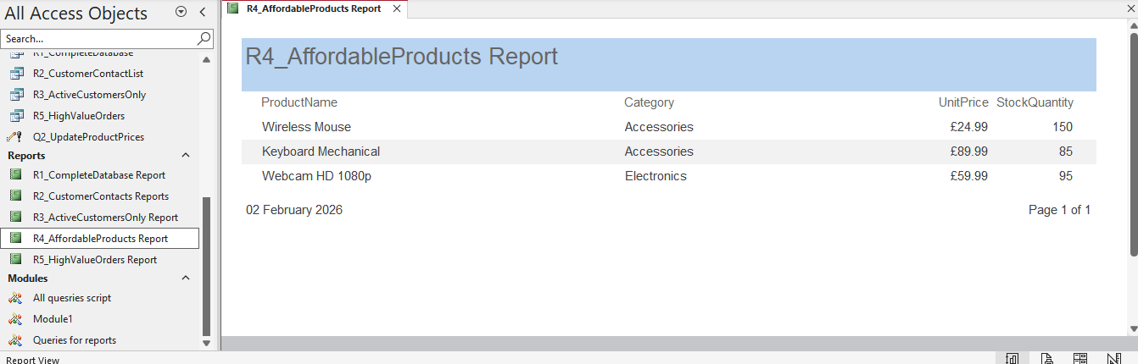
Generated Report:

Explanation:
This report uses a combination of field selection ( ProductName, Category, UnitPrice, StockQuantity) and value filtering ( UnitPrice < £100). This report will show only affordable products with all the required fields.

REPORT 5: HIGH-VALUE ORDERS
Report Name: Report5_HighValueOrders
Assessment Criteria: 3.2(e) - Logical operations
Generated Report:
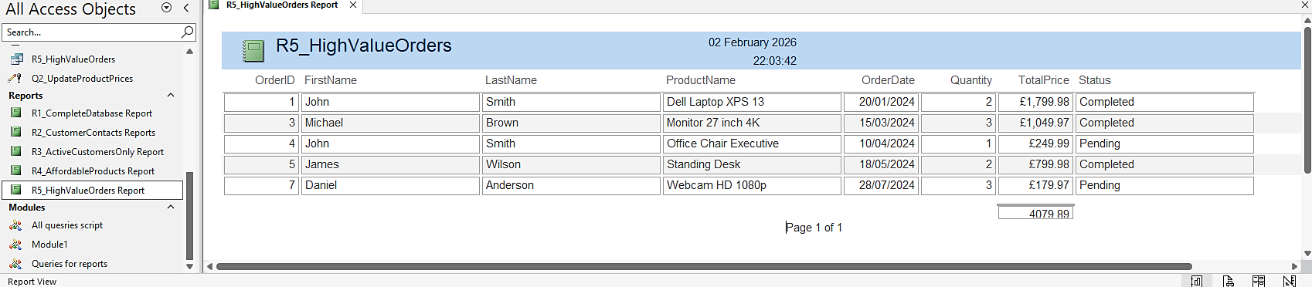

Explanation:
This report uses OR logic to show orders where TotalPrice > £500 or Status = “Pending”. This report joins all three tables to show all the required fields for orders that need attention due to high price or pending status.

CONCLUSION
The above task covered all aspects of database interrogation and reporting. All seven queries covered Assessment Criteria 3.1, as all queries include DELETE, UPDATE, MAKE TABLE, and various SELECT queries using joins, logical operators, and other complex queries. The five reports have covered Assessment Criteria 3.2, as various reporting styles have been used for business needs.

