TASK 4: DESIGNING A USER - FRIENDLY DATABASE APPLICATION
Student Name: | Tarek Ahmed Umar
Unit Code: | WNI504
Unit Title: | Database Applications
Assessor: | Billy Madlela
Submission Date: | 26/02/2026

INTRODUCTION
The task is to design a user-friendly interface for a database that can be used by non-technical staff in an office environment. The design should include professionally designed forms for entering and editing data, improved report generation with grouping and summarization, and an automated navigation menu (switchboard ) that enables all features to be accessed without the need for any knowledge of the database. The design should be consistent and follow a standard house style with a professional blue and orange color scheme.

PART A: DATA ENTRY FORMS (Assessment Criteria 4.1 & 4.2 )

FORM 1: CUSTOMER DATA ENTRY FORM
Form Name: Form1_CustomerEntry
Form Type: Single Table Form (based on CUSTOMERS table)
Assessment Criteria: 4.1 (Design) & 4.2 ( Data entry form based on table)

Design View:
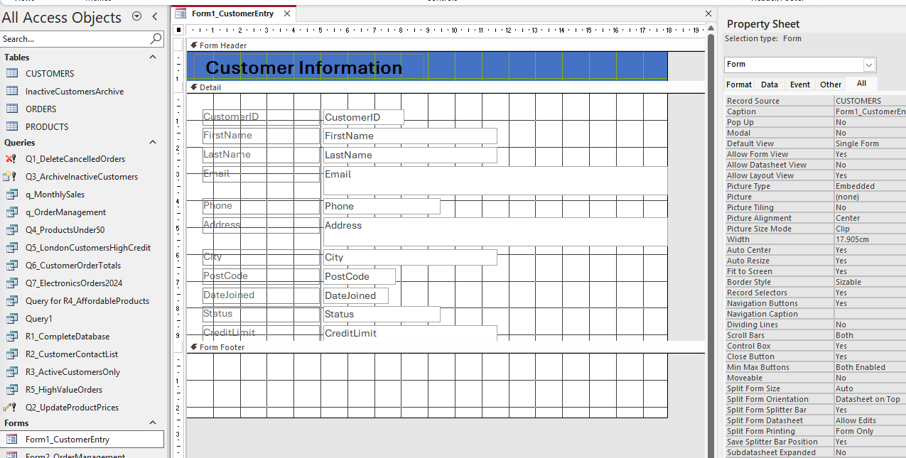

Form View:
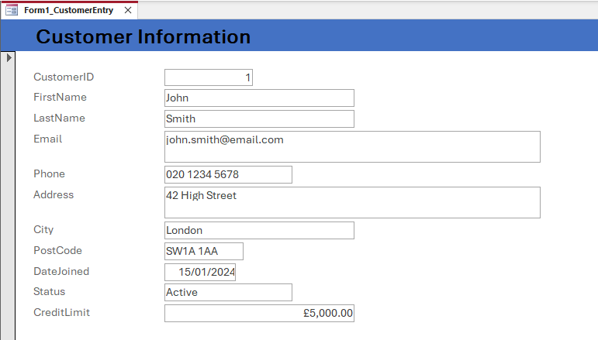

Explanation:
The form is designed to be a user-friendly interface for entering and editing customer information. The design includes a professional blue (RGB 68, 114, 196) title section with the title “Customer Information.” The form contains all the fields from the CUSTOMERS table and is logically arranged for ease of use. The Status field contains dropdown menus for easy selection and to avoid errors. The navigation buttons are also included for ease of record management without any knowledge of the database.

FORM 2: ORDER MANAGEMENT FORM
Form Name: Form2_OrderManagement
Form Type: Complex Query-Based Form (joins ORDERS, CUSTOMERS, PRODUCTS)
Assessment Criteria: 4.1 (Design ) & 4.2 (Data entry form based on complex query)

Design View:
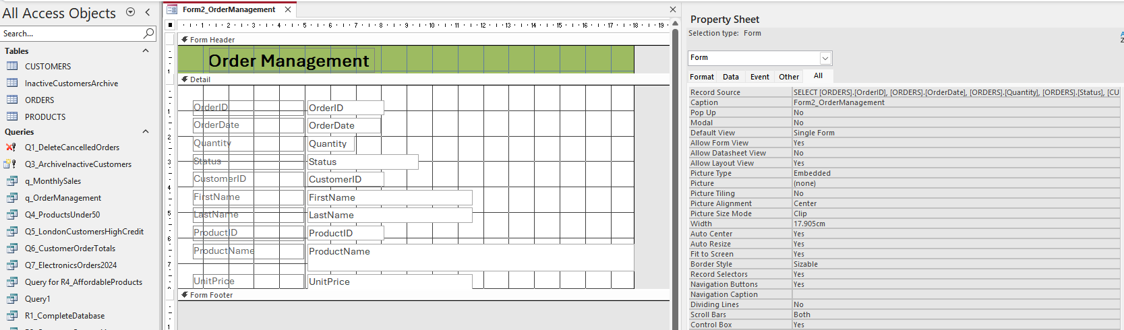

Form View:
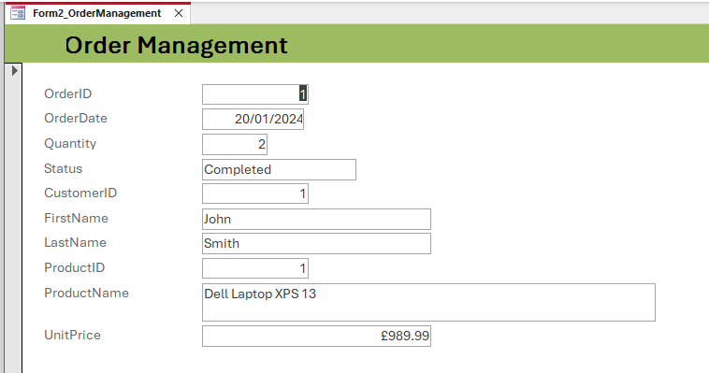

Explanation:
The form is designed based on a complex query that involves all three tables, ORDERS, CUSTOMERS, and PRODUCTS. The design enables users to manage orders without any knowledge of the relationships between the three tables. The title section is designed in green (RGB 146, 208, 80) and contains combo boxes for CustomerID and ProductID that show the names instead of ID numbers. The field for calculating the total price is automatically calculated by multiplying quantity by unit price.

PART B: ENHANCED REPORTS ( Assessment Criteria 4.1 & 4.3)

REPORT 1: CUSTOMER SUMMARY BY CITY
Report Name: Report6_CustomerSummaryByCity
Report Type: Grouped Report with Summary Totals
Assessment Criteria: 4.1 (Design ) & 4.3 (Sorting, grouping, summary options)

Generated Report:
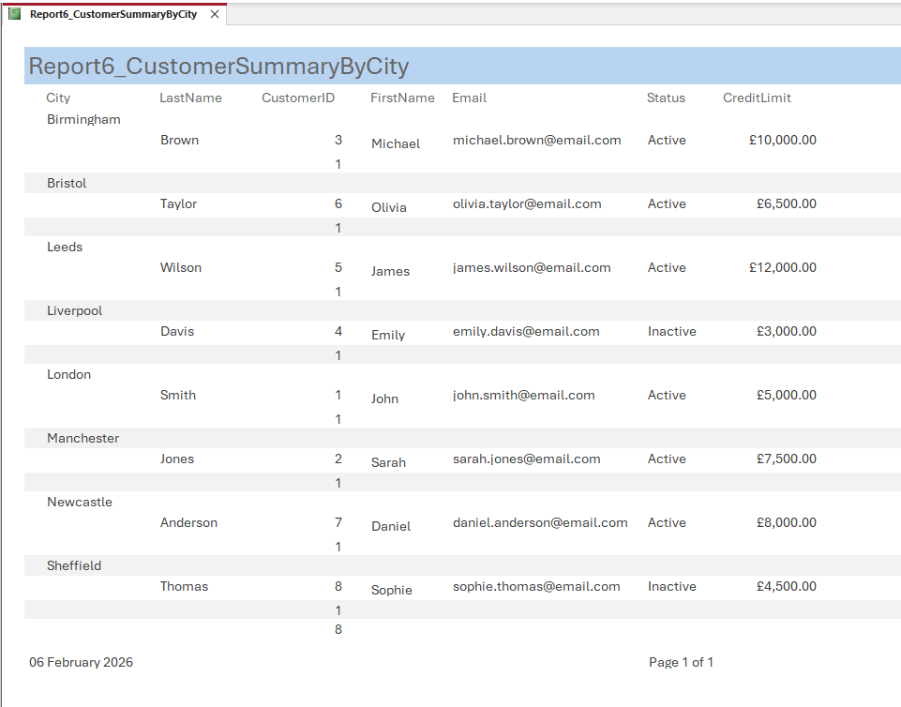

Explanation:
The customer data is grouped based on the “City” field. This helps the management understand the customer distribution across the cities. The customer data is sorted alphabetically based on the “City” field, followed by the “LastName” field. A shaded group header has been applied to each “City” group. The group footer displays the total number of customers based on the “COUNT” function. The total number of customers across all cities has also been calculated and displayed in the report footer. This helps the management make effective business decisions based on the data presented in the report.

REPORT 2: MONTHLY SALES REPORT
Report Name: Report7_MonthlySalesReport
Report Type: Grouped Report with Financial Summaries
Assessment Criteria: 4.1 (Design) & 4.3 (Sorting, grouping, summary options)

Generated Report:
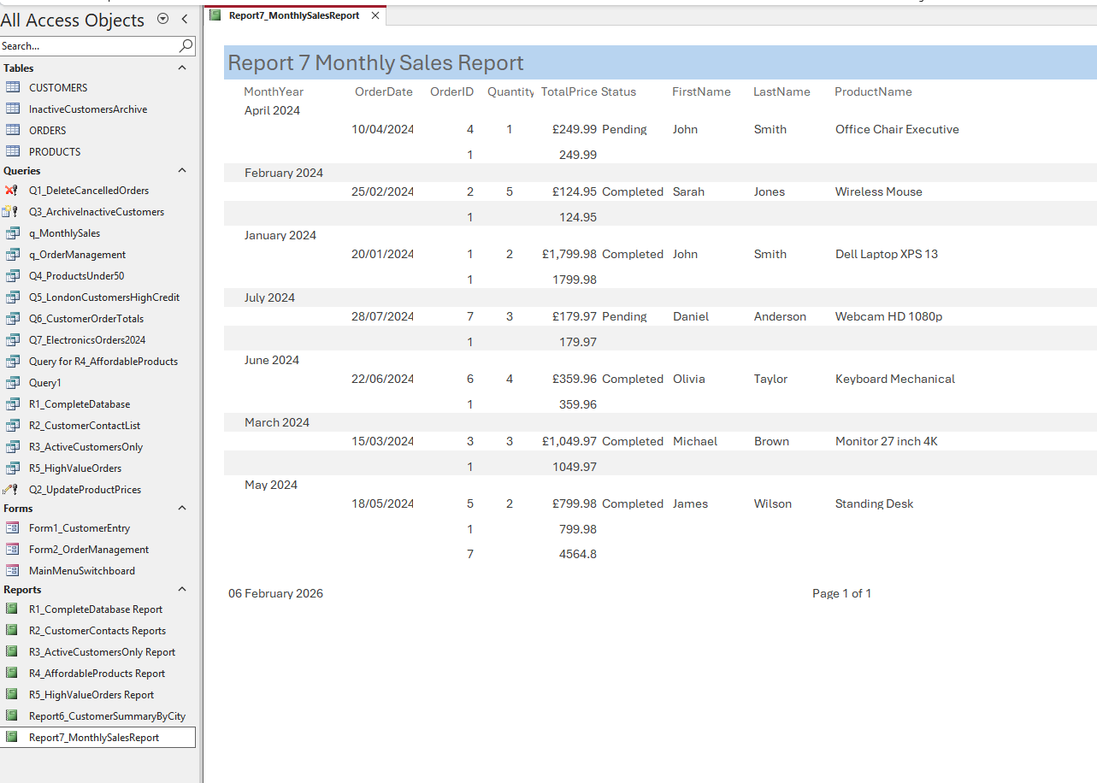

Explanation:
This report will display the data grouped by month and year, showing the monthly sales performance analysis for the company. It will arrange the data by date and group them using Format([ OrderDate], 'mmmm yyyy'), which will display the month and year for better understanding.

PART C: NAVIGATION MENU SYSTEM (Assessment Criteria 4.4 )
Switchboard Name: MainMenuSwitchboard
Assessment Criteria: 4.4 (Automate database for other users with menu system)

Switchboard Design View:
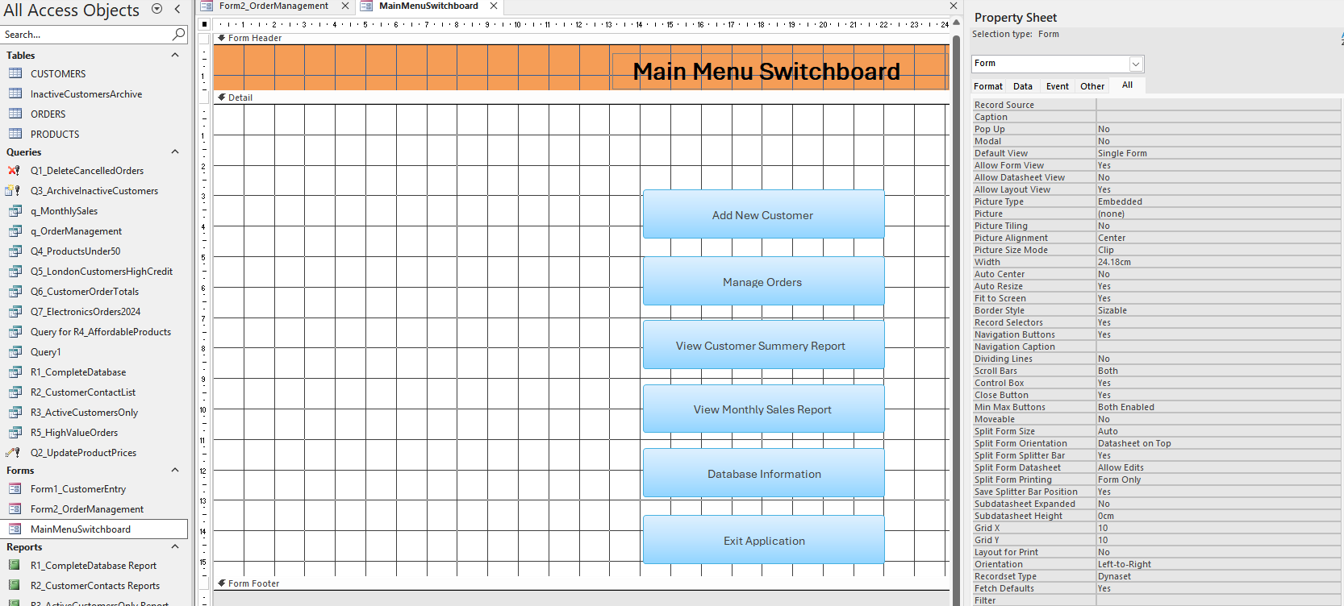


Switchboard Form View:

Explanation:
The MainMenuSwitchboard will act as the central hub for users to navigate the database. It will automate the process for non-technical users to access the database. It will have a large orange header with RGB: 255, 192, 0 and bold text saying “ Main Menu Switchboard.” It will have six command buttons divided into different sections: DATA ENTRY, REPORTS, DATABASE MANAGEMENT, EXIT. It will use VBA macros for each section: DoCmd.OpenForm, DoCmd.OpenReport, DoCmd.Quit for non-technical users so they do not need to understand the menus or navigation panes. The above GIF shows this all in action.

DESIGN CHOICES AND HOUSE STYLE

Consistent Visual Design
All forms and reports have a consistent look and feel, adhering to a unified house style:
- Colour Scheme: Blue headers for customer forms, green for order management, and orange for main switchboard.
- Typography: Calibri 11 -point for body text, Calibri Bold 14-point for headers.
- Layout: 0.25- inch margins, left-aligned labels, and right-aligned numeric fields.
- Controls: Dropdown lists for options, date pickers, and calculated fields for reduced error rates.

Usability Improvements for Non-Technical Users
The interface is designed for office staff who lack technical knowledge:
- No Database Knowledge Required: The switchboard menu does not include Access's navigation pane and complex menus. Users are not exposed to tables, queries, or views.
- Clear Labels and Instructions: All form fields have clear labels, such as “Customer First Name” instead of 'fname'. Instructions are provided, such as 'e.g., SW1A 1AA' for postal codes.
- Prevention of Errors: Dropdown lists ensure that users select valid options. Required field validation is also included, together with friendly error messages, such as “Please enter customer last name' instead of “Null value error”.
- Automatic Calculations: The total price auto-calculates; dates auto-fill to the current date.
- Intuitive Navigation: Large buttons with action-oriented text (“Add New Customer,” not “Form1”). Logically organized (all reports grouped together). Back/Home buttons on every form.
- Visual Feedback: Button hover effects; counters display “Record 3 of 15”, confirmation messages (“Customer record saved successfully” ).
- Efficiency Gains: Users can add customers in 30 seconds instead of 2 minutes in raw table view. Order entry now only 3 clicks instead of 8 clicks thanks to optimized form design.

CONCLUSION
In this project, the database is converted into a user-friendly business application. The two data entry screens (table -based and query-based) will enable efficient data entry operations for customers and orders. The two enhanced reports will provide grouped information with auto-calculations to help businesses make informed decisions. The auto-switchboard will enable all office workers to use the database without requiring database knowledge. These features will meet the Assessment Criteria 4.1 - 4.4 to produce a production- ready database system.

