The Internet of Things
Student Name: | Tarek Ahmed Umar
Unit Title: | The Internet of Things
Unit Code: | WNI529
Assessor Name: | Shafaat Shah
Due Date: | 15 May 2026
Table of Contents
Introduction 2
1. IoT in the Health Sector 2
1.1 Example: Remote Patient Monitoring 2
2. IoT in the Industrial Sector 2
2.1 Example: Smart Factories and Cold-Chain Logistics 2
3. IoT in the Retail and Commerce Sector 3
3.1 Example: Smart Shelves and Beacon Technology 3
4. IoT in the Home 5
4.1 Example: Smart Thermostats and Home Security 5
Conclusion 5
References 6

Introduction
Task 2 looks at how the Internet of Things is utilised across four vital industries: health, industry, commerce/retail, and homes. In all these industries, the Internet of Things helps with monitoring the situation, automating operations, and improving results for businesses and people.

1. IoT in the Health Sector
Assessment Criterion 2.1 (a ) - Health
IoT has contributed significantly to healthcare by enabling constant monitoring of patients and offering proactive care.

1.1 Example: Remote Patient Monitoring
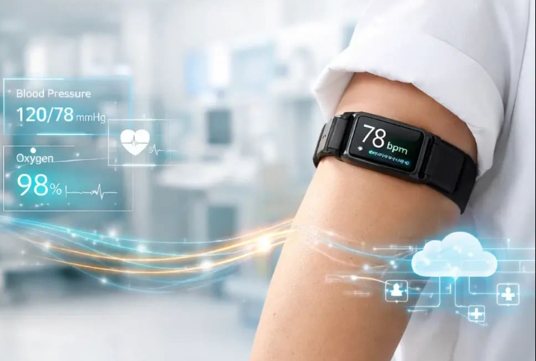
One classic example is remote patient monitoring (RPM). Devices such as smartwatches, electrocardiograms, and glucose monitoring equipment enable collecting patient information about their vital functions like heart rate, blood pressure, oxygen level, and sugar content. The information is relayed to medical personnel, allowing the tracking of patients' condition without visiting a doctor (Semtech, n. d.). Patients with chronic diseases benefit from not having to attend the doctor's office, while the medical staff receives information in real-time to make necessary interventions faster. Hospitals also make use of connected devices in order to locate equipment such as infusion machines and beds used for treatment.
Figure 1 Remote patient monitoring wearable IoT

2. IoT in the Industrial Sector
Assessment Criterion 2.1( b) - Industrial
The IoT, also called the Industrial Intrrnet of Things ( IIoT), is widely applied in industry to monitor equipment, logistics, and manage quality control.

2.1 Example: Smart Factories and Cold-Chain Logistics
An example of the use of the Industrial Internet of Things is monitoring of equipment, performance, and manufacturing processes in factories. The machinery is equipped with sensors that gather information on its performance and temperature and transmit it for analysis (Digi International, 2024). The data is analysed, problems are diagnosed and solved in advance, and production processes are optimized. One other application of the IoT technology is IoT sensors used in logistics, particularly in cold chain logistics. The sensors located in the refrigeration equipment constantly monitor the temperature level. Should there be any deviation from the norm, an immediate notification is provided to avoid damaging the product (food or medication).
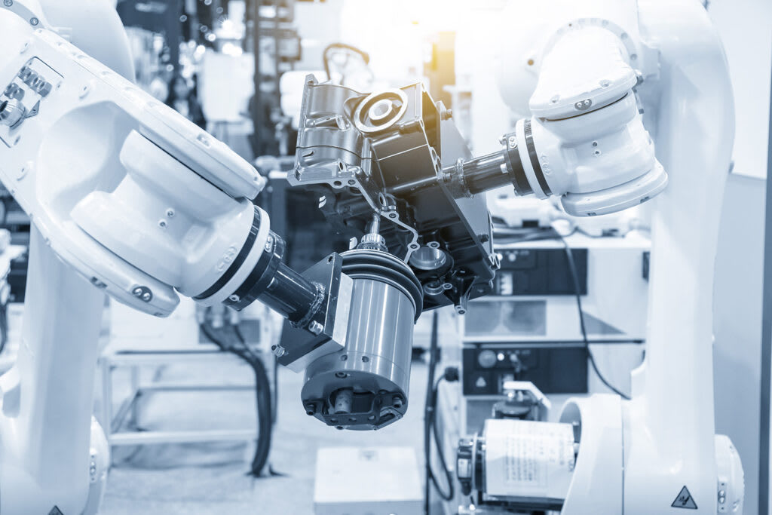
Figure 2 IoT sensors in a factory

3. IoT in the Retail and Commerce Sector
Assessment Criterion 2.1(c ) – Retail /Commerce
The retail and commerce sector uses IoT to improve stock management, enhance the customer experience and gather useful business insight.

3.1 Example : Smart Shelves and Beacon Technology
Shelves embedded with weight sensor or RFID technologies can be programmed to detect low inventory levels and notify staff about the necessity of restocking. Consequently, the chances of an empty shelf and lost sales are drastically reduced (Bright Inventions, 2023). Another example of IoT technologies used in retail includes location-based offers or product recommendations delivered to a consumer's smartphone via IoT-enabled beacon technology. Finally, in eCommerce, delivery tracking powered by IoT provides customers and businesses with complete parcel tracking capabilities.

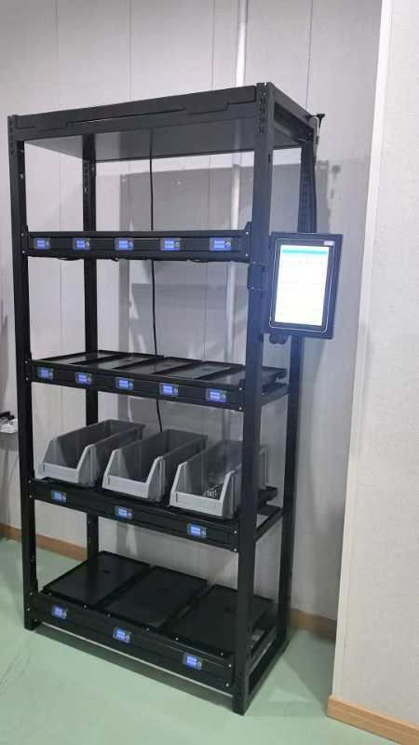
Figure 3 Smart shelves retail (RFID) IoT

4. IoT in the Home
Assessment Criterion 2.1 (d) - Home
One of the most noticeable areas where consumers have started employing IoT is the home sector where the usage of connected gadgets can help maintain a comfortable, energy-saving and safe living space

4.1 Example: Smart Thermostats and Home Security
Connected thermostats, such as Nest or Hive models, learn household habits and schedule adjustments in heating and cooling accordingly to save additional energy on temperature management. Moreover, connected lights can turn off when nobody is inside, reducing expenses even further. When it comes to security-related solutions, the user will be able to remotely monitor his or her premises by using smart doorbells, smart locks, or motion detectors coupled with cameras (Amazon Web Services, 2026 ).
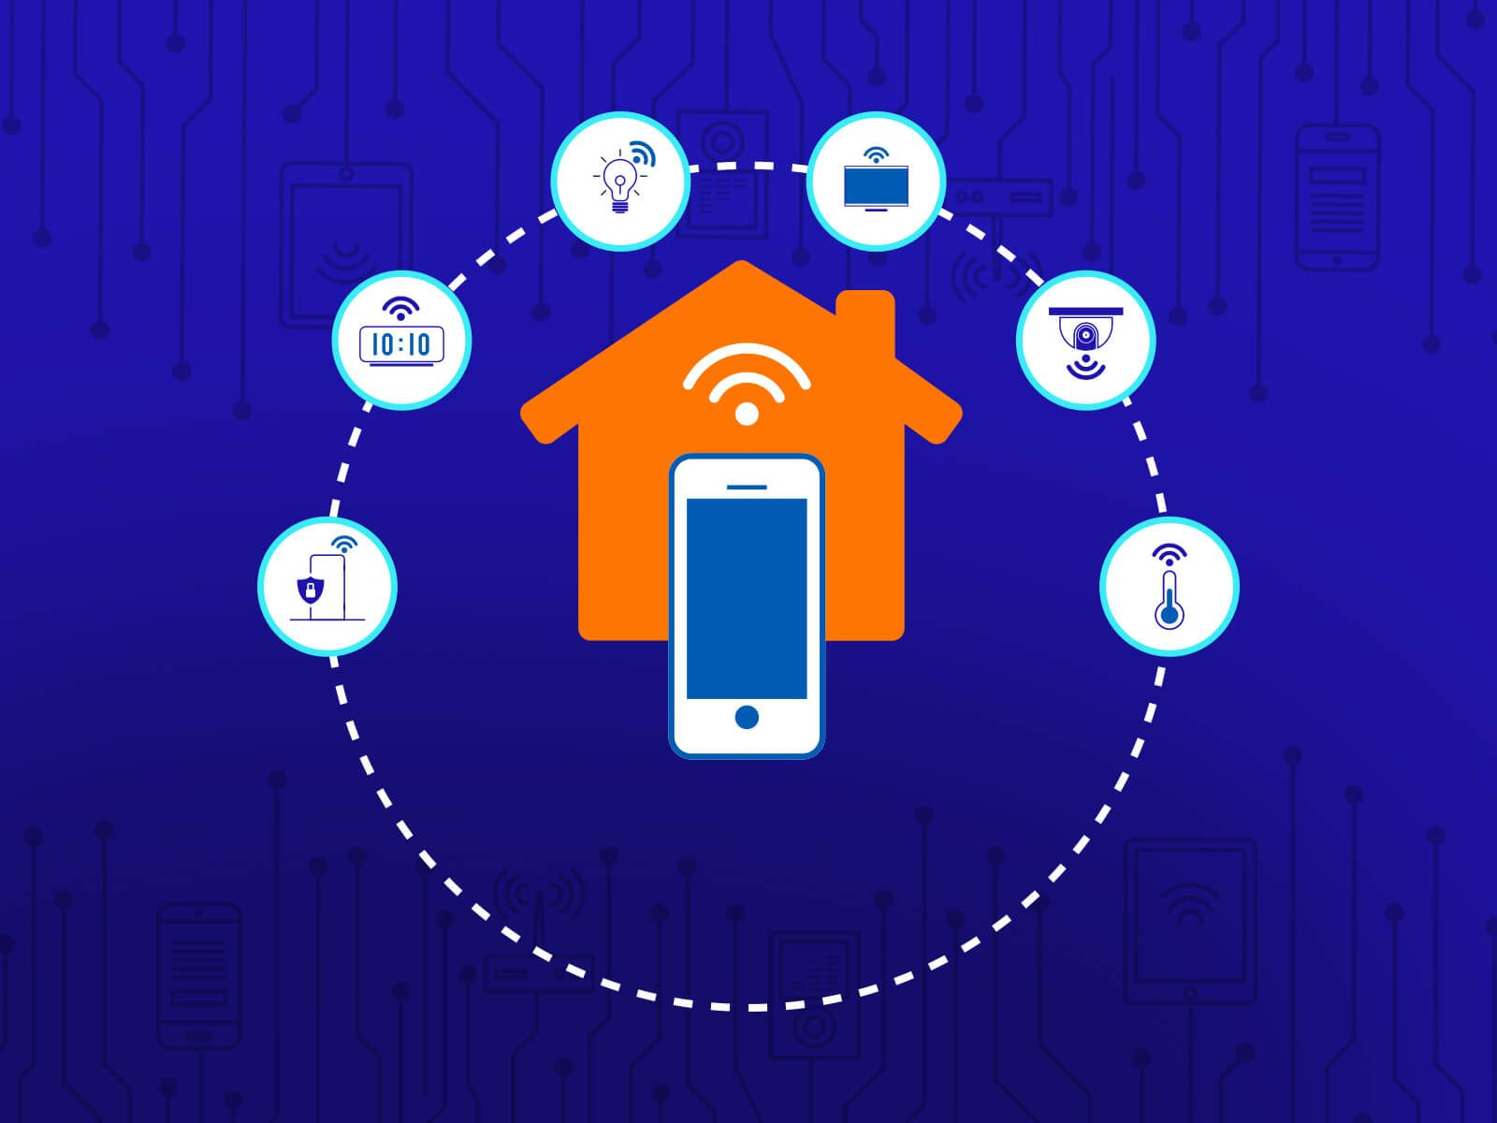
Figure 4 Smart home IoT devic es

Conclusion
As evidenced above, IoT finds applications in v arious fields and has already started showing tangible results, regardless whether it is health monitoring, tracking shipments in a cold chain, alerting about inventory levels or securing the premises. All these use cases demonstrate how powerful connected devices are for individuals and organizations. As for Robocop, IoT has plenty of business applications.

References
Amazon Web Services (2026) What is IoT? Internet of Things explained. Available at: https://aws.amazon.com/what-is/iot/ (Accessed: 27 April 2026).
Bright Inventions (2023) Examples of the Internet of Things for retail, healthcare and more. Available at: https://brightinventions.pl/blog/examples-of-the-internet-of-things-for-retail-healthcare-and-more-with-case-studies/ (Accessed: 27 April 2026).
Digi International (2024) IoT in manufacturing: benefits of smart factories. Available at: https://www.digi.com/blog/post/iot-in-manufacturing (Accessed: 27 April 2026).
Semtech (n.d.) Internet of Things (IoT) applications for smart healthcare. Available at: https://www.semtech.com/applications/internet-of-things/smart-healthcare (Accessed: 27 April 2026).

