The Internet of Things
Student Name: | Tarek Ahmed Umar
Unit Title: | The Internet of Things
Unit Code: | WNI529
Assessor Name: | Shafaat Shah
Due Date: | 15 May 2026

Table of Contents
Introduction 1
1. How IoT Can Be Misused 1
1.1 Example 1: Unauthorised Surveillance via Smart Home Devices 1
1.2 Example 2: IoT Botnet Attacks 2
2. Ethical Considerations 3
3. Legal Considerations 3
Conclusion 4
References 4

Introduction
Though the Internet of Things (IoT) is very beneficial in several fields, its misuse can result in negative consequences. Hence, this report will provide a discussion of the IoT misuse in two important instances and analyse associated ethical and legal issues.

1. How IoT Can Be Misused
Assessment Criterion 3.1 - Explain using 2 examples how the IoT can be misused

1.1 Example 1: Unauthorised Surveillance via Smart Home Devices
One of the ways IoT can be misused is the use of connected smart home devices for unauthorized surveillance purposes.
Smart home devices are supposed to simplify life and monitor homes. However, the problem arises when weak security and/or unchanged passwords are used, as any person can easily hack into these devices and conduct monitoring without the user's awareness. In some cases, hackers have managed to gain access to home security cameras remotely and observe users (ICO, n.d.). Thus, the use of IoT devices intended for enhancing safety results in violation of people's privacy. Furthermore, certain companies are collecting audio or other types of data that may be regarded as overhanded and unethical.

1.2 Example 2: IoT Botnet Attacks
Another method of IoT misuse includes hacking devices that are insecure in order to perform cyberattacks known as botnets.
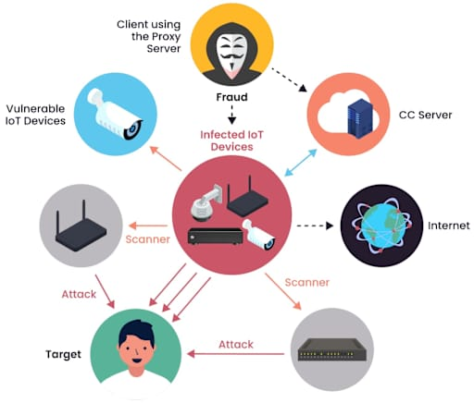
Many IoT devices lack sufficient security features and cannot be updated automatically. Thus, hackers can hijack numerous devices at once and create a botnet with which they would perform large-scale DDoS attacks. For instance, in 2016, hackers took advantage of thousands of devices that were vulnerable to attacks and conducted DDoS attacks, causing serious inconveniences for many website visitors (TechTarget, 2025). Device owners remained completely unaware of their devices' usage in cyberattacks.
Figure 1 IoT device vulnerability
Figure 2 Iot Botnet attack
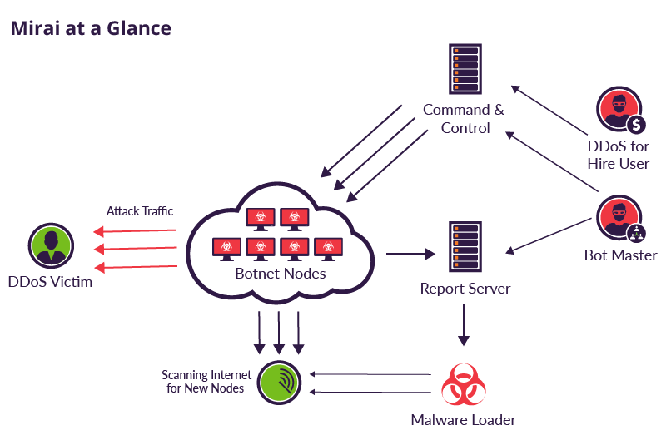
Figure 3 Mirai botnet IoT attack diagram

2. Ethical Considerations
Assessment Criterion 3.2 - Explain the ethical and legal considerations that this may bring about
Both examples pose some ethical issues. The first issue is privacy and consent. Personal IoT devices can record sensitive information constantly. From an ethical perspective, the user should know what type of data is gathered and who gathers it. If manufacturers are unclear on that point, then it goes against the principle of informed consent (ICO, n.d.).
The other issue is that of manufacturer responsibility. Using weak security for cost-saving purposes can cause great risks for users and the general public. As we have seen, the insecure devices can hurt anyone who is not involved in the original transaction. Ethical principles like fairness and accountability should define the manufacturing and selling process of IoT products.

3. Legal Considerations
On the other hand, there are legal considerations to account for. In the UK, organizations using IoT devices as part of processing personal data are required to comply with UK GDPR and the Data Protection Act 2018. They require that the gathering of data takes place legally and transparently. The failure to do so can be punished by enforcement measures on the part of the ICO (n.d.).
The PSTI Act 2022 has created new legal requirements regarding IoT products, including restrictions on default passwords and vulnerability disclosure (DSIT, 2023). Unauthorized access can be considered an offense according to the Computer Misuse Act 1990.

Conclusion
As can be seen, misusing IoT poses some risks that can cause considerable damage. Insecure IoT products can allow violating the privacy of individuals and organizations and even facilitate large-scale cyberattacks. Ethical responsibilities and informed behaviour of IoT manufacturers and consumers respectively and effective legislation are essential in overcoming such threats. For instance, RoboShop should consider all risks alongside the advantages of IoT use.

References
- Department for Science, Innovation and Technology (DSIT) (2023) Product Security and Telecommunications Infrastructure (PSTI) Act 2022: factsheet. Available at: https://www.gov.uk/government/publications/product-security-and-telecommunications-infrastructure-psti-act-2022-factsheet (Accessed: 27 April 2026).
- Information Commissioner's Office (ICO) (n.d.) Guidance for consumer Internet of Things products. Available at: https://ico.org.uk/for-organisations/uk-gdpr-guidance-and-resources/online-tracking/guidance-for-consumer-internet-of-things-products/ (Accessed: 27 April 2026).
- TechTarget (2025) What is IoT (Internet of Things)? Available at: https://www.techtarget.com/iotagenda/definition/Internet-of-Things-IoT (Accessed: 27 April 2026).

