Task 2: Plan and Design a Website
Student Name: | Tarek Ahmed Umar
Unit Title: | Website Design
Unit Code: | WNI534
Assessor Name: | Billy Madlela
Due Date: | 22 May 2026

Table of Contents
1. Purpose and Target Audience 2
1.1 Target Audience 2
2. Site Map 3
3. Four-Page Outline Design 4
4. Wireframes with CSS Annotations 5
4.1 Home Page ( index.html) 5
4.2 About Page (about.html) 8
4.3 Portfolio Page (portfolio.html ) 10
4.4 Contact Page (contact.html) 11
5. Global CSS Decisions 13
6. Justification of Design Choices 14
6.1 Colour Palette 14
6.2 Scattered Hero Layout 14
6.3 Windows 11 File Explorer for Certifications 14
6.4 Usability 14
7. Webpage Asset Table 15
8. References 17

1. Purpose and Target Audience
The website that I have created is a personal portfolio website. The website's theme is based on personal branding where I will bring together all of my achievements, certifications, and coding projects on one platform.
The primary purpose of the website is to demonstrate the things that I have accomplished during my Access to HE course such as Cisco Networking Academy certifications as well as the coding projects that I have created on GitHub. At the same time, the website will serve as a demonstration of my ability to create a correctly structured and styled website through HTML, CSS, and JavaScript.

1.1 Target Audience
The site is aimed at two groups of people:
- Admissiona tutors of universities who will be interested in seeing evidence of my personal initiative outside of academic performance.
- Employers within the tech industry who will be looking for junior web developers and IT support specialists and who will want to determine my suitability quickly.
It is safe to assume that both types of visitors will spend a relatively short period of time on the website, which makes layout, navigation, and speed the primary considerations.

2. Site Map
Below is the site map showing the structure of the website. The home page is the entry point. The other three pages (About, Portfolio and Contact) are all directly accessible from the top navigation bar. This structure allows every page to be available within one click from any page.
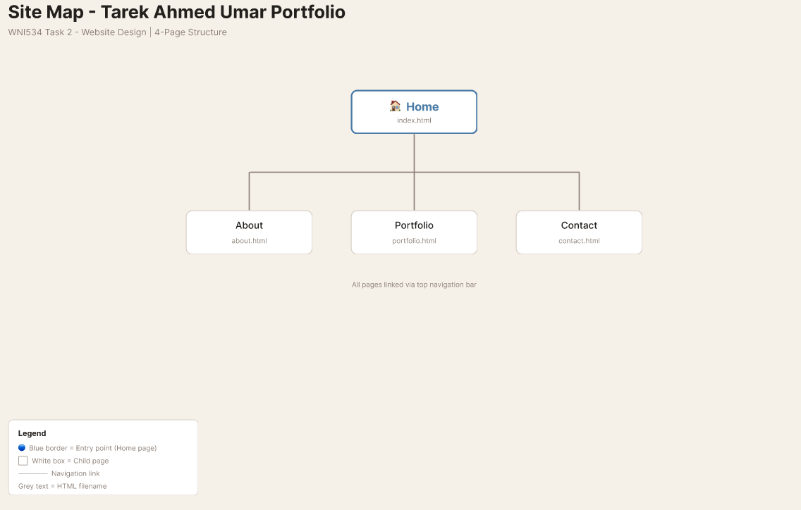
Home and Contact page
About and Portfolio page
Figure 1 Site Map

Navigation bar on every page will make it easy to access any of the pages at any time. There are no sub-pages or hidden sections on this version of the website.

3. Four-Page Outline Design
The following table provides a brief description of the website's pages - content, layout, navigation, and CSS considerations. Detailed annotated wireframes can be found in Section 4.
Page | Content | Layout | Navigation | CSS Notes
Home (index.html ) | Scattered hero section with ID badge, ripped paper note, event ticket, large name, tech stickers, terminal window, music card and personal photos. Bulletin board of project screenshots below. Large typographic footer. | Scattered layout - elements use position:absolute in the hero with individual rotations. Bulletin board below uses CSS Grid. | Fixed navigation bar at top. Logo name left, page links right. Active page shown with underline . | position:absolute for hero items. transform:rotate(Ndeg) per element. AOS.js fade-up on scroll. Custom cursor via JavaScript.
About (about .html) | Profile photo with short bio paragraph. Yellow sticky note. Skill chips row. Cork-style bulletin board with personal photos pinned to it. Journey timeline showing certification dates. | Single-column page. Profile photo and bio use CSS Flexbox side by side. Timeline uses a vertical CSS line with dots. | Same fixed nav bar. About link shows active underline. | Photo: object-fit:cover, rotate(-2deg), hover:rotate(0deg). Sticky: background:#FEF9C3, rotate(1.5deg). Skill chips: flex-wrap. Timeline: : :before vertical line, AOS fade-left stagger.
Portfolio (portfolio.html) | Two filter tabs - Cisco Certifications and GitHub Projects. Windows 11-style File Explorer window with nine Cisco folder cards. Clicking a folder opens a slide-in detail panel. GitHub project cards shown when that tab is active. | Centred heading. Filter tabs row below. Explorer window fills the main area with a sidebar and card grid. Project cards use an auto-fill grid. | Same fixed nav bar. Portfolio link active. | JS classList toggle switches tabs. Folder cards: grid repeat(4,1fr), hover:translateY(-4px) scale(1.05). Detail panel: position:fixed, translateX(100%→0), transition:0.3s ease. Border-radius:8px on explorer window.
Contact (contact.html ) | Contact form with name, email and message fields. JavaScript validation with a slide-in success toast. GitHub QR code. Social link buttons. Pulsing availability dot. Large footer. | Centred single-column. Form: max-width:560px, margin:0 auto. QR code and social links in a flex row below the form. | Same fixed nav bar. Contact link active. | input:focus { border-colour:#D86C3D; box-shadow: 0 0 0 2px rgba(216,108,61,0.2) }. Toast: position:fixed, slide-in animation. Availability dot: @keyframes pulse. Background blob: @keyframes morph.

4. Wireframes with CSS Annotations
I created wireframes using software. Each wireframe includes the entire page layout at the desktop width with a series of annotated callouts. The annotations describe both the design rationale and the actual implementation method with CSS/JavaScript.

4.1 Home Page ( index.html)
For the home page, I've gone with the scattered theme to give the impression of objects scattered on a desk as opposed to the conventional hero banner. It gives a great first impression and displays creativity and personality from the beginning.
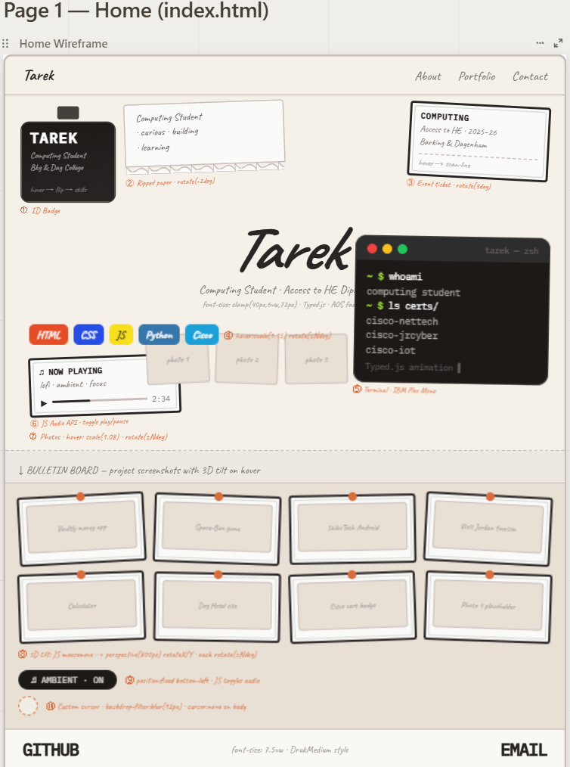
Figure 2 Home Page (index.html)
Annotation notes:
- Navigation: position:fixed; z-index:50; background:#F5F0E8; border-bottom:1px solid #C8BDBA. Fixed so the menu stays visible when scrolling. Font: Noto Sans.
- ID Badge: position:absolute; transform:rotate(-4deg). On hover, CSS rotateY(180deg) with backface-visibility:hidden flips the card to show my skills on the back . No JavaScript needed for the flip .
- Ripped paper note: transform:rotate(-2deg); CSS clip-path on the bottom edge creates the torn paper look; box-shadow:2px 3px 8px rgba(0,0,0,0.08).
- Tech stickers (HTML, CSS, JS, Python, Cisco): each uses its official brand colour and is given a random rotation. hover:scale(1.15) translateY(-4px); transition:transform 0.2s.
- Terminal window: background:#1c1917; font-family:'IBM Plex Mono'; border-radius:10px; transform:rotate(1deg). Typed.js types the text on load. Green text colour #A3E635.
- Music card: JavaScript HTMLAudioElement API. Click toggles play and pause. Card uses transform:rotate(-2deg); hover:scale(1.03).
- Scattered photos: position:absolute per photo with a unique rotation. hover:scale(1.08); transition:all 0.3s. Replaced with my own photographs.
- Bulletin board 3D tilt: JavaScript mousemove calculates cursor position relative to each card and applies perspective(800px) rotateX(Ydeg) rotateY(Xdeg). mouseleave resets it. AOS.js adds staggered entry delays.
- Ambient audio pill: position:fixed; bottom:20px; left:20px; z-index:50; border-radius:999px; font-family:”IBM Plex Mono”. Toggles lofi ambient audio. Equaliser bar animation plays when active.
- Custom cursor: body { cursor:none }. A div with position:fixed; pointer-events:none; backdrop-filter:blur(12px); background:rgba(255,255,255,0.6); border-radius:50%; width:25px; height:25px follows the mouse via JavaScript. All pages use this cursor.
- Footer: font-size:clamp(28px,7.5vw,56px); font-weight:700. GITHUB left-aligned, EMAIL right-aligned. hover::after underline slides from width:0 to width:100%.

4.2 About Page (about.html)
This page is more personal as it features a profile picture, brief biography, sticky note, skill chips, and my certification timeline. It's neat and easy to read.
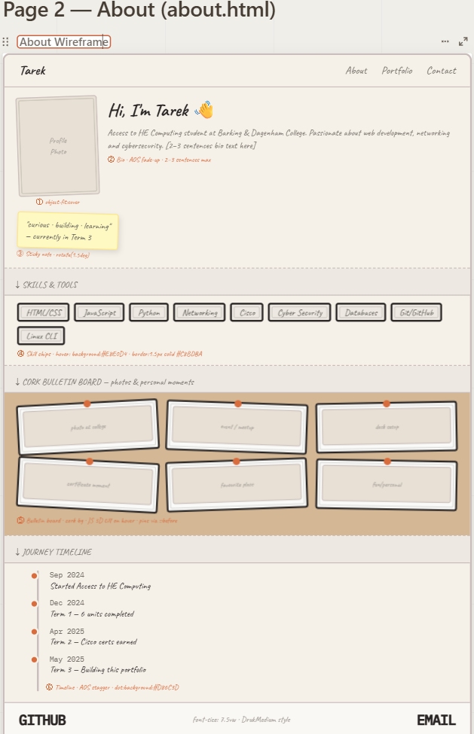
Figure 3 Wireframe - About Page (about.html)

Annotation notes:
- Profile photo : object-fit:cover; border-radius:4px; transform:rotate(-2deg). On hover, rotate(0deg) eases to flat. box-shadow:0 8px 24px rgba(0,0,0,0.1).
- Bio text: font-family:'Noto Sans'; max-width:65ch; line-height:1.7. AOS data-aos='fade-up'. The 65ch maximum keeps line lengths readable.
- Sticky note: background:#FEF9C3; border:1px solid #FDE68A; transform:rotate(1.5deg); hover:scale(1.04); box-shadow:2px 3px 6px rgba(0,0,0,0.1). Short personal statement inside.
- Skill chips: display:flex; flex-wrap:wrap; gap:8px. Each chip: border:1.5px solid #C8BDBA; border-radius:999px; padding:4px 14px. hover:background:#E8E0D4; transition:0.2s. AOS staggered delays.
- Cork bulletin board: background colour #D 4B896 for the cork look. Photos are pinned using small orange circles (background:#D86C3D; border-radius:50%; position:absolute). Same JS 3D tilt effect as the Home page.
- Journey timeline: position:relative; ::before creates a vertical dashed line (border-left:2px dashed #C8BDBA). Each entry uses AOS data-aos=”fade-left” with 100ms stagger. Current entry highlighted in a different colour.

4.3 Portfolio Page (portfolio.html )
The Portfolio page consists of two sections, which are controlled using tabs. The Cisco Certifications section features a Windows 11-style File Explorer where clicking the folder reveals more details such as the whole certificate. The GitHub Projects section contains project cards displayed in a grid.
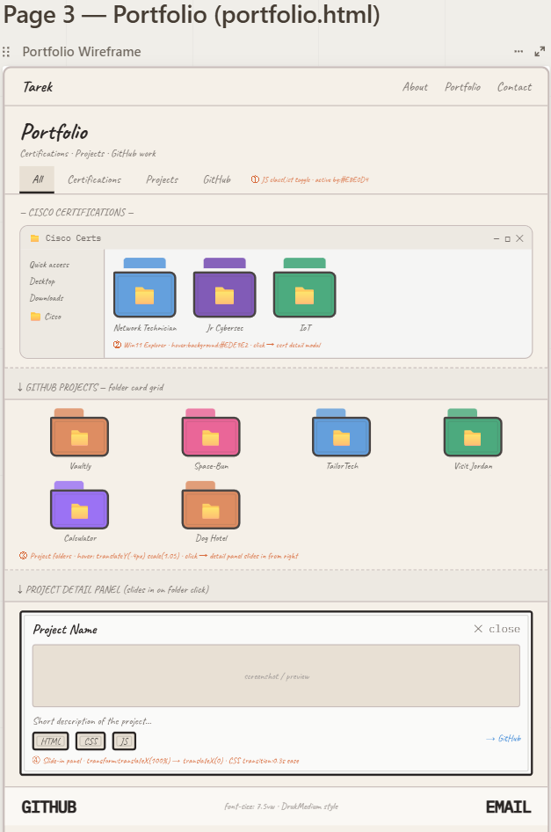
Figure 4 Wireframe - Portfolio Page (portfolio.html)

Annotation notes:
- Filter tabs: JavaScript onclick adds or removes an active class. Active tab: border-bottom:2px solid #292524; background:#E8E0D4. Inactive: background:#FFFFFF; border:1.5px solid #C8BDBA. CSS transition:background 0.2s. overflow-x:auto on small screens.
- Windows 11 Explorer window: border-radius:8px; background:#F5F5F4; border:1.5px solid #C8BDBA. Title bar: background:#EDE9E2; decorative window controls (- □ ✕) built in CSS. Sidebar: background:#EDE9E2; border-right:1px solid #C8BDBA.
- Folder cards : two-div stack - a small tab on top and a body below, both coloured by subject area. Grid: grid-template-columns:repeat(4,1fr); gap:12px. hover:translateY(-4px) scale(1.05); transition:0.2s. Nine Cisco course cards are shown.
- Detail panel: position:fixed; right:0; top:0; height:100vh; width:320px; transform:translateX(100%). JavaScript click on folder toggles translateX(0); transition:0.3s ease. Background overlay: position:fixed; inset:0; background:rgba(0,0,0,0.2); backdrop-filter:blur(2px). Shows the certificate and badge inside.
- GitHub project cards (Vaultly , Space-Bun, TailorTech, Visit Jordan, Calculator): grid-template-columns:repeat(auto-fill,minmax(172px,1fr)). hover:scale(1.03). AOS fade-up stagger.

4.4 Contact Page (contact.html)
The contact page maintains simplicity in its design so the user can quickly spot and fill out the form. In the background is a decorative animated blob. Below the form, a QR code linking to my GitHub, social links, and pulse animation indicating availability are displayed.
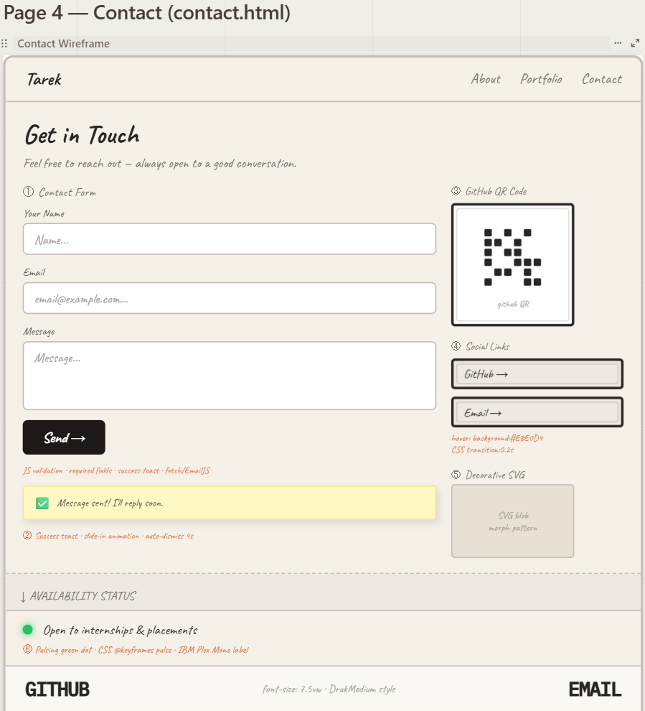
Figure 5 Wireframe - Contact Page (contact.html)

Annotation notes:
- Contact form: HTML5 required attributes plus JavaScript validation on submit. Checks fields are not empty and that the email matches the pattern /^[^\s@]+@[^\s@]+\.[^\s@]+$/. Focus state: border-colour:#D86C3D; box-shadow:0 0 0 2px rgba(216,108,61,0.2). Form: max-width:560px; margin:0 auto.
- Success toast: position:fixed; top:20px; right:20px; z-index:9999. Slide-in via transform:translateY(-20px)→translateY(0) and opacity:0→1. setTimeout(4000) auto-dismisses after four seconds.
- GitHub QR code: pre-exported PNG of my GitHub profile URL. width:100px; border:4px solid #fff; box-shadow. Lets mobile visitors follow the profile without typing.
- Social links: pill-shaped buttons. hover:background:#E8E0D4; transition:background 0.2s. All open in a new tab with rel='noopener noreferrer'.
- SVG blob : CSS @keyframes morph animates the path shape slowly. position:absolute; opacity:0.4; pointer-events:none; z-index:0 so it sits behind everything without blocking clicks.
- Availability dot: 10px circle, background:#22C55E. @keyframes pulse { 0%,100%{opacity:1} 50%{opacity:0.4} } with box-shadow:0 0 6px #22C55E creates a glowing effect

5. Global CSS Decisions
The following CSS properties are defined once in style.css and imported on all four pages' HTML files to maintain consistency throughout the website .

CSS Property | Value | Reason
--colour-bg | #F5F0E8 | Warm cream page background used on all pages. Avoids harsh white and keeps the site looking approachable.
--colour-sidebar | #EDE9E2 | Slightly darker warm grey for the Explorer sidebar and secondary surfaces.
--colour-card | #E8E0D4 | Card and input field backgrounds. Creates a layered depth effect across the palette.
--colour-text | #292524 | Near-black body text. Softer than pure black. Meets WCAG AA contrast ratio on the cream background.
--colour-mid | #78716C | Secondary text colour for subtitles, nav links and captions.
--colour-accent | #D86C3D | Burnt orange used for focus states, annotation badges and the availability dot.
font-family: “Noto Sans” | Nav, body, headings | Clean, readable sans-serif used for all general text. Loaded from Google Fonts.
font-family: 'IBM Plex Mono' | Terminal, footer, mono labels | Monospace font for technical sections. Creates clear contrast with Noto Sans.
body { cursor: none } | All pages | Hides the default cursor so the custom blur- circle cursor takes over .
backdrop-filter: blur(12px) | Custom cursor div | Creates a frosted-glass effect on the cursor element on all pages.
.transition-overlay | clip-path: circle(0→150%) | Clip-path circle wipe used for page transitions. JavaScript triggers it on every navigation click.
AOS data-aos attributes | All major content blocks | AOS.init({ duration:800, once:true }). Delays staggered in 100ms steps for sequential scroll reveals.
font-size: clamp(28px,7.5vw,56px ) | Footer GITHUB / EMAIL links | Fluid type size that scales with viewport width. No media query breakpoints needed for the footer text.

All color and font values are kept in CSS custom properties (:root) so they will have to be changed only in one place should any changes be made in the future.

6. Justification of Design Choices

6.1 Colour Palette
The chosen color scheme (from #F5F0E8 to #E8E0D4) is a warm, creamy palette that gives the website a warm feel, making it more personal, which is important for a portfolio about an individual. Most portfolio websites are either completely white or black in color, so it helps this site stand out. The contrast ratio between the dark text (#292524) and cream color background is sufficient (at least 4.5:1) according to W3C (2018).

6.2 Scattered Hero Layout
The scattered hero design layout on the Home page creates an impressive first impression. Every floating object, whether the ID badge, torn papers, stickers, terminal and photo, adds another level of meaning about myself at the same time as adding visual appeal to the page. This shows that I have put serious effort into designing the page rather than applying a template.

6.3 Windows 11 File Explorer for Certifications
To display my Cisco certifications, I decided to use a Windows 11-styled File Explorer window. This is something any person working in IT or computing is familiar with. It places the certification badges in a system context and not as a list of icons. Also, the click-to-open detail box reveals that I know how to use JavaScript.

6.4 Usability
A flattened navigation layout has been chosen so that all pages are accessible with one click. The navigation bar has been made static so that visitors know exactly where they are at any point in time. Every interactive component, be it buttons, input fields, folder cards, or hyperlinks, has a visible hover and focus style to ensure usability for all visitors.

7. Webpage Asset Table
The following table contains all assets needed on the four pages, including files I will create, images I will add, and external libraries. All filenames are lowercase and use hyphens.

Filename | Type | Page(s ) | Purpose | CSS / Technical Note
style.css | CSS | All | Global stylesheet - variables, layout, cursor, transitions | CSS custom properties. One file linked in every HTML page.
script.js | JavaScript | All | Custom cursor, page transitions, ambient audio toggle | mousemove updates cursor. JS Audio API. clip-path animation on nav click.
aos.min.js | JavaScript | All | AOS Animate on Scroll - scroll reveals | CDN import. AOS.init({ duration:800, once:true }) called in script.js.
typed.min.js | JavaScript | Home | Typed.js - typewriter animation for terminal text | CDN import. Starts on page load. Strings array holds the terminal lines.
aos.css | CSS | All | AOS library stylesheet | CDN link in all HTML head sections.
index.html | HTML | Home | Home page structure | Semantic elements: nav, header, section, footer.
about.html | HTML | About | About page structure | Google Fonts linked in head: Noto Sans and IBM Plex Mono.
portfolio.html | HTML | Portfolio | Portfolio page structure | Cisco badge images include descriptive alt text.
contact.html | HTML | Contact | Contact page structure | HTML5 required attributes on all form fields.
photo-moon.jpg | Image | Home | Personal photo - moon, scattered in hero | position:absolute; rotate(-3deg); hover:scale(1.08). My own photo.
photo-2.jpg | Imag e | Home | Personal photo 2 - scattered in hero | position:absolute; rotate(2deg). My own photo.
photo-3.jpg | Image | Home | Personal photo 3 - scattered in hero | position:absolute; rotate(-1deg). My own photo.
profile.jpg | Image | About | Headshot or informal photo for the About page | object-fit:cover; border-radius:4px; rotate(-2deg).
screenshot-vaultly.png | Image | Home, Portfolio | Vaultly project screenshot | position:absolute in Home bulletin. Card image in Portfolio.
screenshot-spacebun.png | Image | Home, Portfolio | Space-Bun game screenshot | position:absolute in Home bulletin. Card image in Portfolio.
screenshot-tailortech.png | Image | Home, Portfolio | TailorTech Android app screenshot | position:absolute in Home bulletin. Card image in Portfolio.
screenshot-visitjordan.png | Image | Home, Portfolio | Visit Jordan app screenshot | position:absolute in Home bulletin. Card image in Portfolio.
screenshot-calculator.png | Image | Home, Portfolio | Calculator project screenshot | position:absolute in Home bulletin. Card image in Portfolio.
badge-network-tech.png | Image | Portfolio | Cisco Network Technician Career Path badge | Explorer folder card. alt text included.
badge-jr-cybersec.png | Image | Portfolio | Cisco Jr Cybersecurity Analyst badge | Explorer folder card.
badge-iot.png | Image | Portfolio | Cisco Introduction to IoT badge | Explorer folder card.
badge-it-essentials.png | Image | Portfolio | Cisco IT Essentials badge | Explorer folder card.
badge-js-essentials.png | Image | Portfolio | Cisco JavaScript Essentials 1 badge | Explorer folder card.
badge-it-customer.png | Image | Portfolio | Cisco IT Customer Support Basics badge | Explorer folder card.
badge-hardware.png | Image | Portfolio | Cisco Hardware and Upgrade Support badge | Explorer folder card.
badge-os-support.png | Image | Portfolio | Cisco Operating Systems Support badge | Explorer folder card.
badge-security-conn.png | Image | Portfolio | Cisco Security and Connectivity Support badge | Explorer folder card.
github-qr.png | Image | Contact | QR code linking to my GitHub profile | width:100px; border:4px solid #fff; box-shadow.
Noto Sans (CDN) | Font | All | Main body and navigation font | Google Fonts CDN. font-family:'Noto Sans', sans-serif.
IBM Plex Mono (CDN ) | Font | Home, About, Footer | Terminal text and footer links | Google Fonts CDN. font-family:'IBM Plex Mono', monospace.
favicon.ico | Icon | All | Browser tab icon | link rel='icon' href='favicon.ico' in all HTML head sections.

8. References
Nielsen, J. (1994) 10 Usability Heuristics for User Interface Design. Nielsen Norman Group. Available at: https://www.nngroup.com/articles/ten-usability-heuristics/ (Accessed: 7 May 2026).

W3C (2018) Web Content Accessibility Guidelines (WCAG) 2.1. Available at: https://www.w3.org/TR/WCAG21/ (Accessed: 7 May 2026).

diagrams.net (2024) draw.io - Free Online Diagram Software. Available at: https://www.diagrams.net (Accessed: 7 May 2026).

Michalsnik (2023) AOS: Animate On Scroll Library. Available at: https://michalsnik.github.io/aos/ (Accessed: 7 May 2026).

Typed.js (2023) A JavaScript Typing Animation Library. Available at: https://mattboldt.com/demos/typed-js/ (Accessed: 7 May 2026).

