Access To HE Diploma – Trigonometry Answer Sheet
TRIGONOMETRY TASK TEMPLATES – Task 2
Student Name | Tarek Ahmed Umar
Student Number | 20545242
Unit Title | Trigonometry
Unit Code | WNI488
Assignment Title | Trigonometry
Submission Date | 13th February 2026

NB. Please use this answer sheet to submit your work for the Trigonometry assignment – task 2. You can write your solutions to task 2 questions here or copy and paste the photographic evidence of your task 2 solutions here, thanks.
Learning Outcome 2: Know about radian measure | Assessment Criteria  2.1, 2.2
Task 2: Radian Measure

- Convert angles between degrees and radians for circular ramps and paths.
- Calculate arc lengths and areas of sector-shaped pathways using radians.

Important instructions for all Task 2 questions

Note: For Radian measure questions:
- Show your working for all conversions using
- Give exact answers in terms of 𝜋 where possible. If you use decimals, round your final answer to 3 significant figures (or 2 decimal places) and state the rounding used

Note: For arc length and sector area questions:
For multi-stage questions, you are expected to:
- Convert degrees to radians where needed.
- Clearly show intermediate workings.
- Some questions may require rearranging the formulae to find 𝜃
- Give the final answer with correct units (cm, m, cm², m²).

Convert between degrees and radians and recognise common multiples of πc
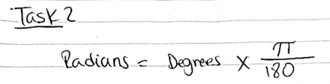

- Convert the following angles to radians:
a) 30°
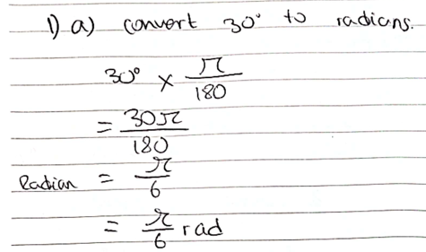
b) 120°
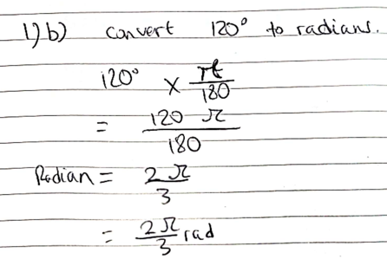
c) 225°
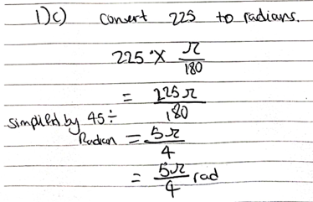
- Convert the following angles to degrees:
a) π/6
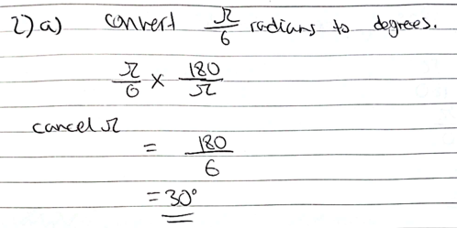
b) 5π/4
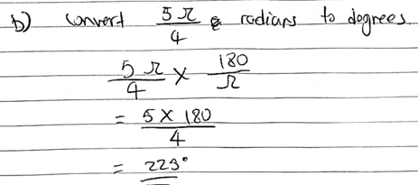
c) 3π/2
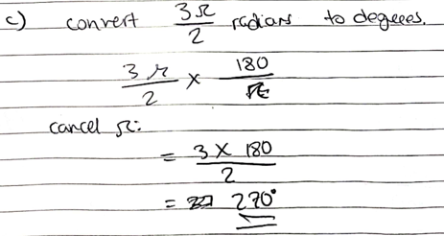

- Express the following angles in terms of π:
a) 90°
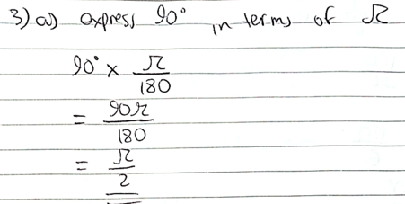
b) 150°
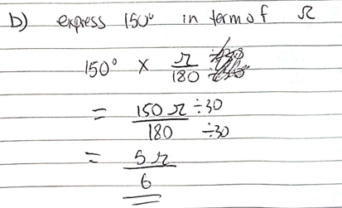
c) 270°
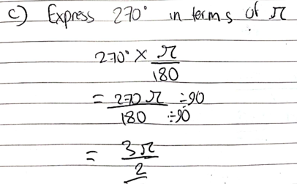

- Express the following angles in degrees:
a) 2π/3
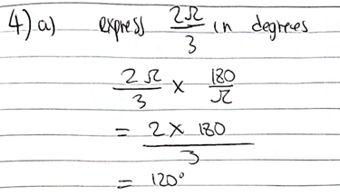
b) 7π/6
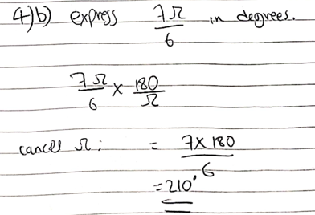
c) 5π/3
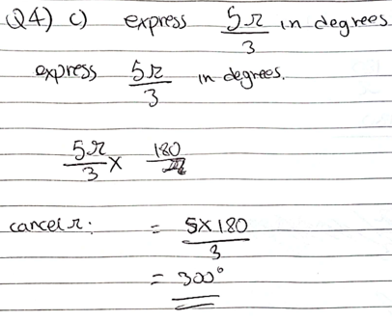

Challenge Questions

- A wheel rotates through an angle of 450°. Express this in radians.
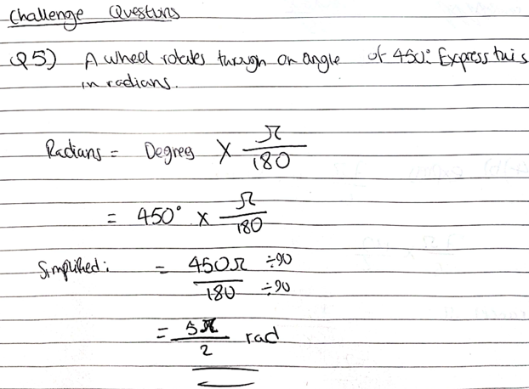
- A sector of a circle has angle 11π/6 radians. Convert this to degrees.
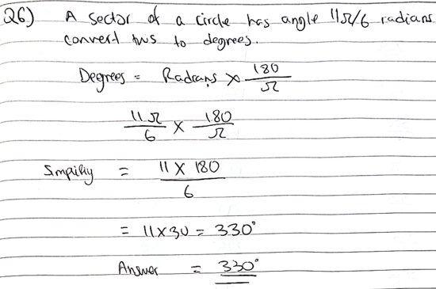
- List all the multiples of π between 0 and 2π in both degrees and radians.
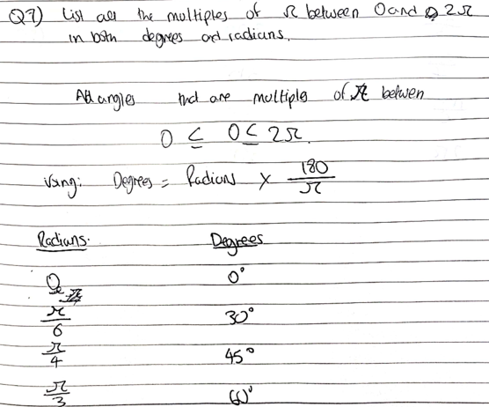
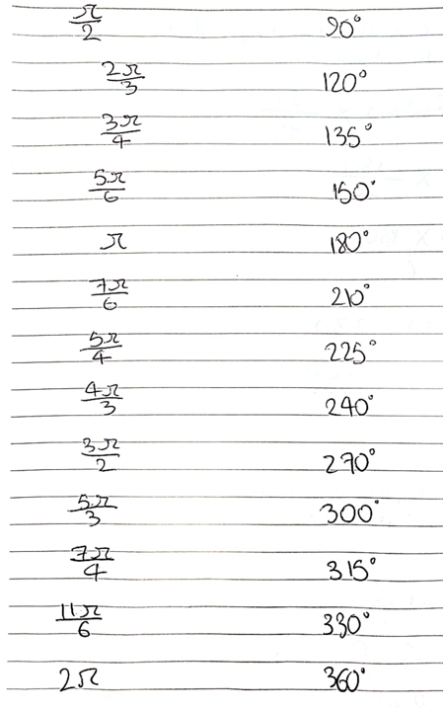
Use the formulae for arc length and area of a sector defined in radians

- Find the arc length of a circle with radius 10 cm and angle $π/6$rad.
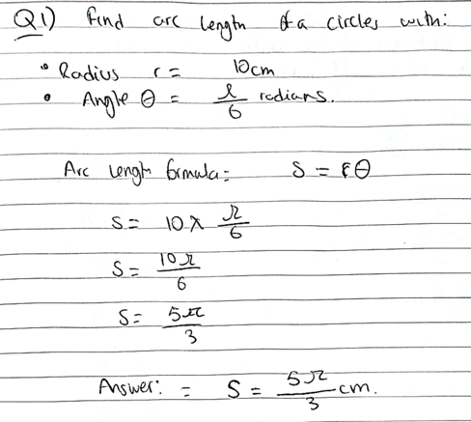
- A circle has radius 8 m. Find the arc length for a sector with angle $2π/3$rad.
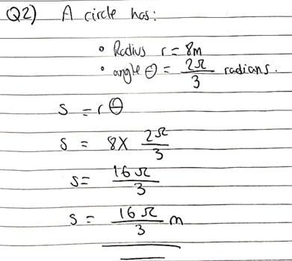
- The radius of a circular track is 50 m. How far does an athlete run along an arc subtending $π/4$rad at the centre?
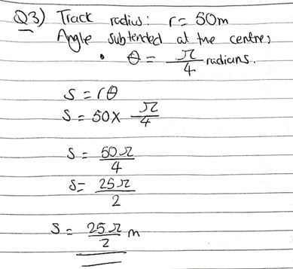
- Calculate the area of a sector with radius 12 cm and angle $π/3$rad.
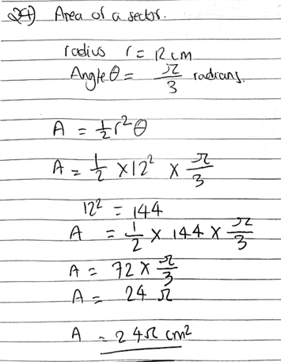
- A circular field has radius 20 m. Find the area of a sector with angle $5π/6$rad.
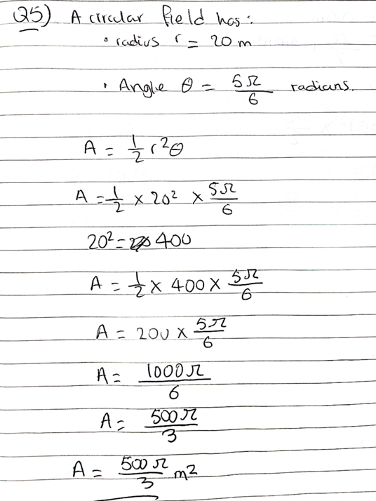
- A fan blade sweeps a sector of a circle with radius 0.5 m and angle $π/2$rad. Calculate the area of the sector.
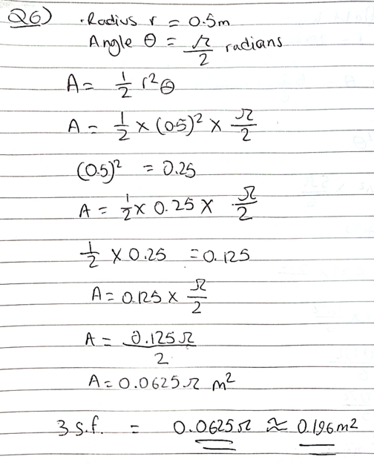
Challenge Questions

- The arc length of a sector is 15 m, and the radius of the circle is 10 m. Find the central angle in radians.
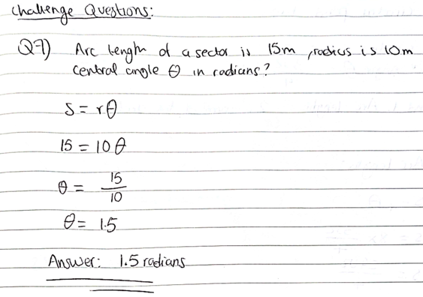
- The area of a sector is 50 cm², and the radius is 10 cm. Find the angle of the sector in radians.
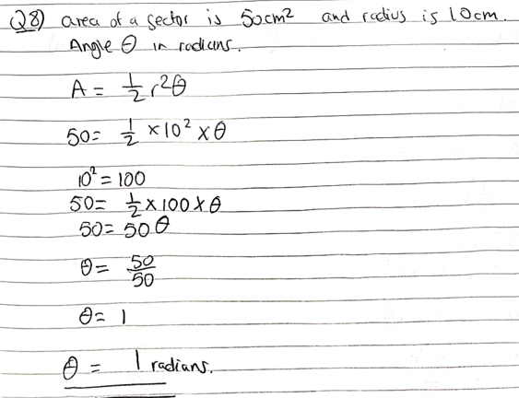

- A circular pond has radius 8 m. A boat travels along a sector with angle $3π/4$rad. Find both the arc length and the area of the sector.
